**NBS CONNECTOME – PLAYWORK BY TIMO NURMI AND DANIEL KRAHULEC**

**Trying different test-statistc thresholds. Below we have the axial (bottom), saggital (top left) and coronal view (top right). The network is measured with extent (the associated p-value is 0.039). With the threshold of 2.5, the significant network becomes excessively dense to enable inference.**

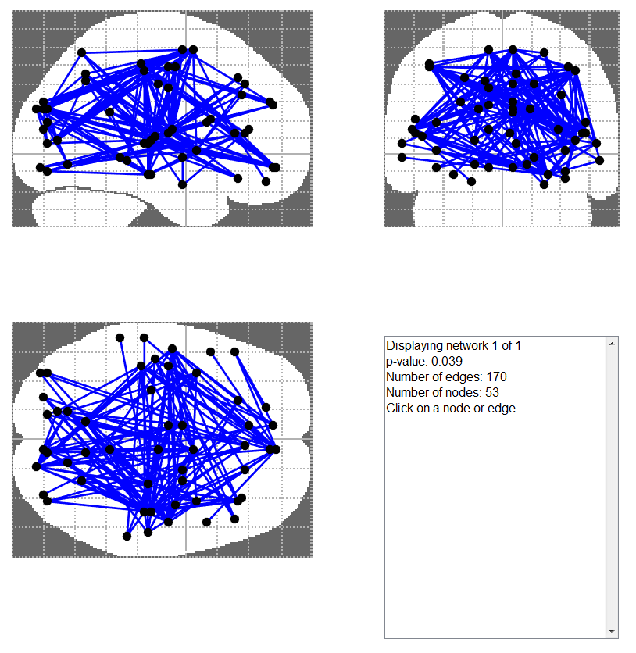

**Measuring network size with intensity. The network associated p-value has increased to 0.041).**

