Disordered Structure Refinement (DSR)

Enhanced modelling and refinement of disordered structures with SHELXL

Version: 200

Preface

The following user manual explains the usage of the program DSR. It allows for a semi-automatic modelling of disordered moieties. Its database contains molecular fragments and their corresponding restraints as well as a fitting procedure to place these fragments on the desired position in the unit cell.

The web page can be found at <https://www.xs3.uni-freiburg.de/research/dsr> and the development platform at <https://github.com/dkratzert/DSR>.

If you find any bugs in this program, have feature requests or just comments; please don’t hesitate to write an email to [dkratzert@gmx.de](mailto:dkratzert@gmx.de) to report these.

Please cite DSR as:

D. Kratzert, J.J. Holstein, I. Krossing, *J. Appl. Cryst.* **2015**. *48*, 933-938. [doi:10.1107/S1600576715005580](http://scripts.iucr.org/cgi-bin/paper?S1600576715005580)

**Disclaimer**

You are responsible for the correctness of restraints applied to your crystal structure. The restraints applied by DSR are only suggestions to stabilize a first model. **DSR does not replace the judgment of an expert.**

Preface 1

Program Overview 2

Installation 3

Windows 3

Linux 3

Mac OS X 3

Explanations 4

Command Syntax 4

Example 5

Command line Syntax 6

General Procedure 6

ShelXle Integration 7

Rename mode 9

Database Format Definition 10

Database Example 11

Step by Step Example 11

Step 0 12

Step 1 13

Step 2 13

Step 3 13

Step 4 14

Import fragments from GRADE 15

CF3-Groups 16

Tips and Tricks 17

Fragments Included in the Database 17

For Developers 18

Program Overview

The program-package consists of a simple text-database with fragments of molecules and the DSR program itself. It acts as a preprocessor for SHELXL res-files. The user has to insert a special command line in the SHELXL .res file and the DSR program reads this information. The command lines main purpose is to tell DSR, how to orient a molecular fragment from the database in the unit cell. In practice, the user has to choose a minimum of three target positions (atoms or Q-peaks) in the structure and the corresponding atoms from the database fragment (source atoms) that should be placed on the target positions.

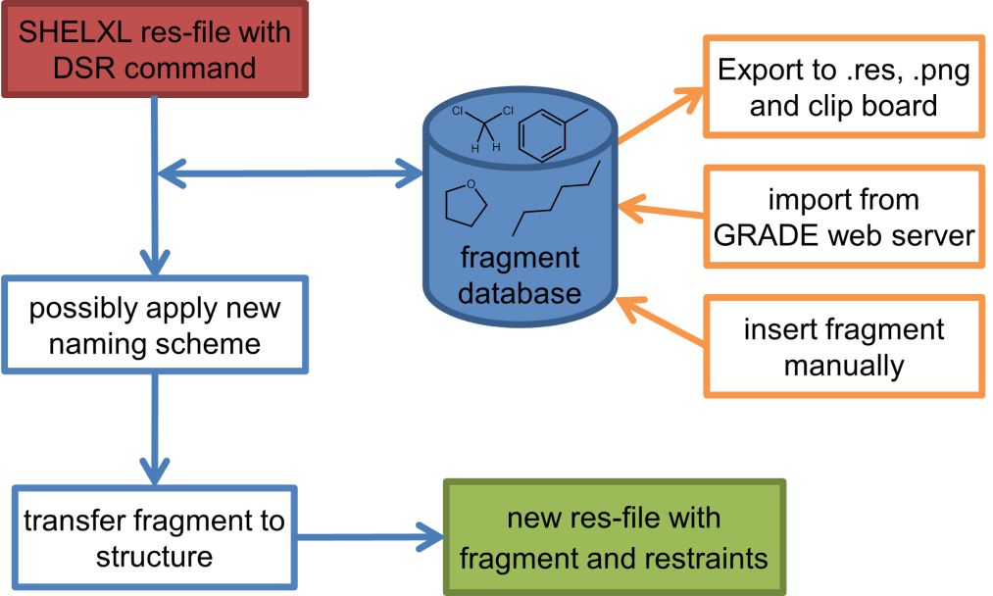

Installation

Since version 182, DSR expects the dsr_user_db.txt in the user’s home directory. The installation procedures create an empty user database in the following directories if no previous database exists:

Windows: C:\users*username*

Linux: /home/*username*

Mac OS X: /Users/*username*

Windows

Execute the "DSR-setup-[version number].exe" and follow the instructions.   
DSR expects a shelxl.exe or xl.exe version 2013 or above in the system path. Windows XP users might have to install the “Microsoft Visual C++ 2010 Redistributable Package” from Microsoft (You should not use Windows XP anyway!).

Linux

Install dsr-[version].deb or dsr-[version]-noarch.rpm according to the installation procedure of your LINUX distribution. Both packages depend on the xclip program. After a system restart DSR should work as shown in the command line syntax chapter later.  
DSR expects a shelxl or xl executable version 2013 or above in the system path.

For a manual installation create the directory /opt/DSR (or any other) and make the directory user accessible. Ex­tract the con­tent dsr_linux-[version].tar.gz to /opt/DSR. Then copy /opt/DSR/setup/dsr.sh to /etc/profile.d. An installation to /usr/local/[DSR and bin] is of cause also possible. Therefore you have to adopt the paths in the dsr shell script. If you want to install DSR in another location, please edit the DSR_DIR variables in the /etc/profile.d/dsr.sh accordingly.

Mac OS X

Open the .dmg file in the Finder and follow the instructions of the readme.txt included.

Explanations

Command Syntax

The DSR command has the following syntax:

REM DSR PUT/REPLACE fragment WITH atom1 atom2 atom3 ... ON atom2 atom3 atom4 ... PART n OCC mn RESI class num [alias] DFIX

The command is introduced with a REM because SHELXL should never interpret the DSR command line.

PUT Put the fragment on there, ignoring atoms on this position.

REPLACE Replace the target atoms. Hydrogen atoms of target atoms should be prior removed.

fragment The name of the desired molecule or fragment.

WITH Behind WITH are the source atoms. They are at least three atoms from the fragment.

ON Behind ON are the target atoms. They are at least three atoms or Q-peaks in the .res- file.

[atom n] Minimum three atoms each (including Q-peaks). Source and target have to include the same number of atoms and/or Q-peaks. Target atoms can be either regular atoms or atoms in residues. Atoms in residues can be addressed by the “_” notation. C1_2 would be atom C1 in residue number 2.

PART n Optional SHELXL PART definition.

OCC mn Optional occupancy and free variable definition for the fragment.

DFIX Optional, generates DFIX/DANG restraints instead of those from the database. All 1,2- and 1,3-distances in the fragment are restrained with DFIX and DANG respectively. DSR also searches for rings in the fragment and generates FLAT restraints for flat rings.

RESI class num [alias] Optional residue definition as in SHELXL.

SPLIT Only for a disordered CF3 group on two positions (CF6 fragment). Splits the pivot atom in two positions.

Use of Residues

To use the RESI command in DSR has several advantages. It places the fragment into a residue and therefore no renaming of the atoms in the fragment needs to be performed by DSR. If residues are used, the restraints like "SADI_class Atoms" are inserted only once, since they act on the atoms in all residues with the same class together.

In SHELXL you define residues as:

RESI 1 abc   
atoms   
RESI 2 abc   
atoms   
RESI 0   
  
RESI 3 xyz   
more atoms   
RESI 0   
  
A big plus is that you can use restraints like "SAME_class C1 > C20".   
A single atom inside a residue is now addressed with RESTRAINT_number, like "DFIX 1.5 C1_2 C3_0". Residue 0 are all atoms outside of residues.

Residues are especially useful if the same moiety is repeated several times in a crystal structure. Different moieties of the same residue class are distinguished by different residue numbers. Residue number must be unique in a .res file. The DSR command RESI without any further options is normally the best practice. DSR then uses the residue class name from the database and finds the next free residue number by itself. But the user can also specify a particular residue class and/or number after the RESI command, if desired.

The RESI option of DSR can be used in three ways:

1. If only a RESI command is given (best practice), the residue class is taken from the database entry and the residue number is automatically generated.
2. If RESI with only a number is given, DSR takes the residue class from the database with the given number.
3. RESI with a number and a class overwrites the information from the database and gives complete control over the residue.

A given class, number or alias always overwrites the information of the database. The manual on the SHELX website gives more detailed information: <http://shelx.uni-ac.gwdg.de/SHELX/wikis.php>

Example

The following command line can be inserted anywhere between the atoms of a res-file.

**REM DSR put toluene with C1 C2 C3 on Q1 C5 C2**

The command is always introduced with a REM. DSR is completely case insensitive. The DSR command line can be up to two lines with a trailing "=" for a continuation line like in SHELX. Please note that the second line of the DSR COMMAND after the "=" must begin with a leading whitespace.

The minimal requirement for DSR to work is rem dsr put/replace “fragment” with “three atoms/Q-peaks” on “three atoms/Q-peaks”.

The new molecule or fragment is placed in the line where the DSR command resides. DSR applies a new naming scheme to the fragment while inserting it into the res-file. Essentially it searches if any atom name from the database fragment is already used in the res-file. If this applies, the program places a suffix letter (A, B, ...) to the atom name in the res-file. This renaming is completely turned off if residues are used. Atoms of the new fragment are then addressed by their residue.

**put** DSR searches for the coordinates of the given atoms/Q-peaks and places the fragment on these coordinates leaving the given atoms in place. The above example will place the fragment on the coordinates of Q1, C5 and C2. The atoms C5 and C2 would remain where they were located before.

**replace** DSR searches for the coordinates of the given atoms/Q-peaks but in contrast to the former example, it replaces the target atoms and all atoms in 1.3 Å distance around each atom of the fitted fragment that are in PART 0. This mode is useful to quickly rename atoms from a solution by SHELXT.

It is highly advised to use residues with DSR. They make a lot of things easier and DSR takes care about all details regarding residues. Normally it is sufficient to simply use the RESI command without any options in DSR. This way, DSR takes the residue class from the database and finds the next residue number automatically. Restraints for the same residue class are only introduced once. Also the atoms in the fragment would not be renamed:

**REM DSR put toluene with C1 C2 C3 on Q1 C5 C2 RESI**

Command line Syntax

Following options are available in the Windows or Unix command line to control the behavior of DSR:

usage: dsr [-h] [-r "res file"] [-re "res file"] [-e "fragment"] [-c "fragment"] [-t] [-i "tgz file"] [-l] [-n]

optional arguments:

–h, --help Show a help message and exit.

–r "res file" res file with DSR command. Usually this option is used to process the SHELXL file with DSR.

–re "res file" Same as "-r", but a file called dsr_class_name.dfx or dsr_class_number_name.dfx is written which includes the restraints for the fragment for the .res file "name" in the residue "class" and "number".

–e "fragment" Exports a fragment from the database to the file [fragment].res. It includes the minimal requirements to view the fragment in a 3D molecule viewer. If a PLATON executable and ImageMagic installation is in the system path, it also creates a .png-picture of the molecule.

–c "fragment" Exports the fragment to the clipboard with Cartesian coordinates. This fragment can for example be used for modelling in the program Olex2.

–t Inverts the current fragment. Available for fragment fit, import and export.

–I "GRADE file" Imports a molecular fragment from .tgz file of the Grade server http://grade.globalphasing.org/ into the dsr_usr_db.txt.

–l Displays all fragments in the database with the line numbers where they occur.

–s "string" Search the database for given string.

–g Keep the fragment as rigid group (AFIX 9). The fragment will only move as a whole. Restraints will be omitted.

–u Updates DSR to the most recent version if any available. (In Linux, you need super-user rights to perform an update)

–n Only transfers the fragment. The fragment fit after the fragment transfer is disabled.

General Procedure

Edit the .res file according to the “Example” chapter. Run dsr −r filename.res. DSR will now insert the fragment, does a refinement with L.S. 0 to finally insert the fragment and removes the AFIX command. The resulting filename.res can now be reopened for further refinement. Before DSR changes anything in the .res file it creates a backup file in a subdirectory "dsrsaves" with the current date as file name.

ShelXle Integration

Since version 181, ShelXle has the ability to start a graphical user interface for DSR. A mouse click on Tools->DSR plugin will start the DSR GUI:

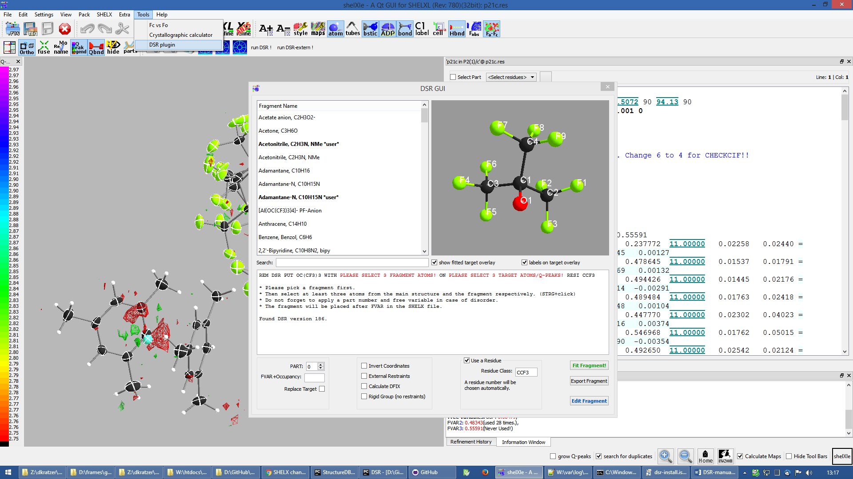

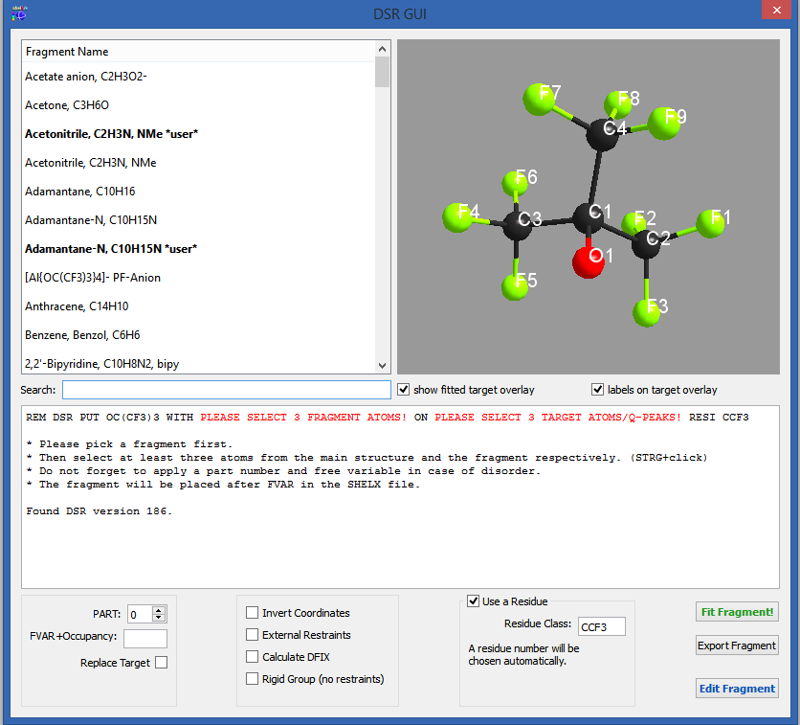

Now you need to select a fragment in the list. The list of fragment can be shortened via the search field.

To fit a fragment into the structure in ShelXle, select three atoms/Q-peaks in the target molecule (with a left mouse click while holding STRG) and the fragments 3D view (just left mouse click) each. The 3D view should now show a preview of the fitted fragment:

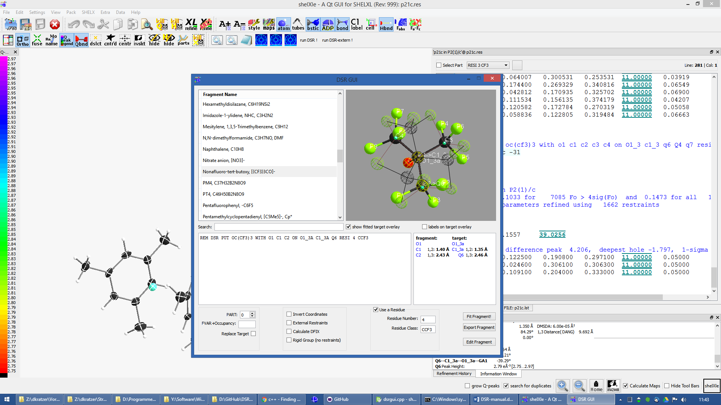

You can now control all the features of DSR with the options menu below:

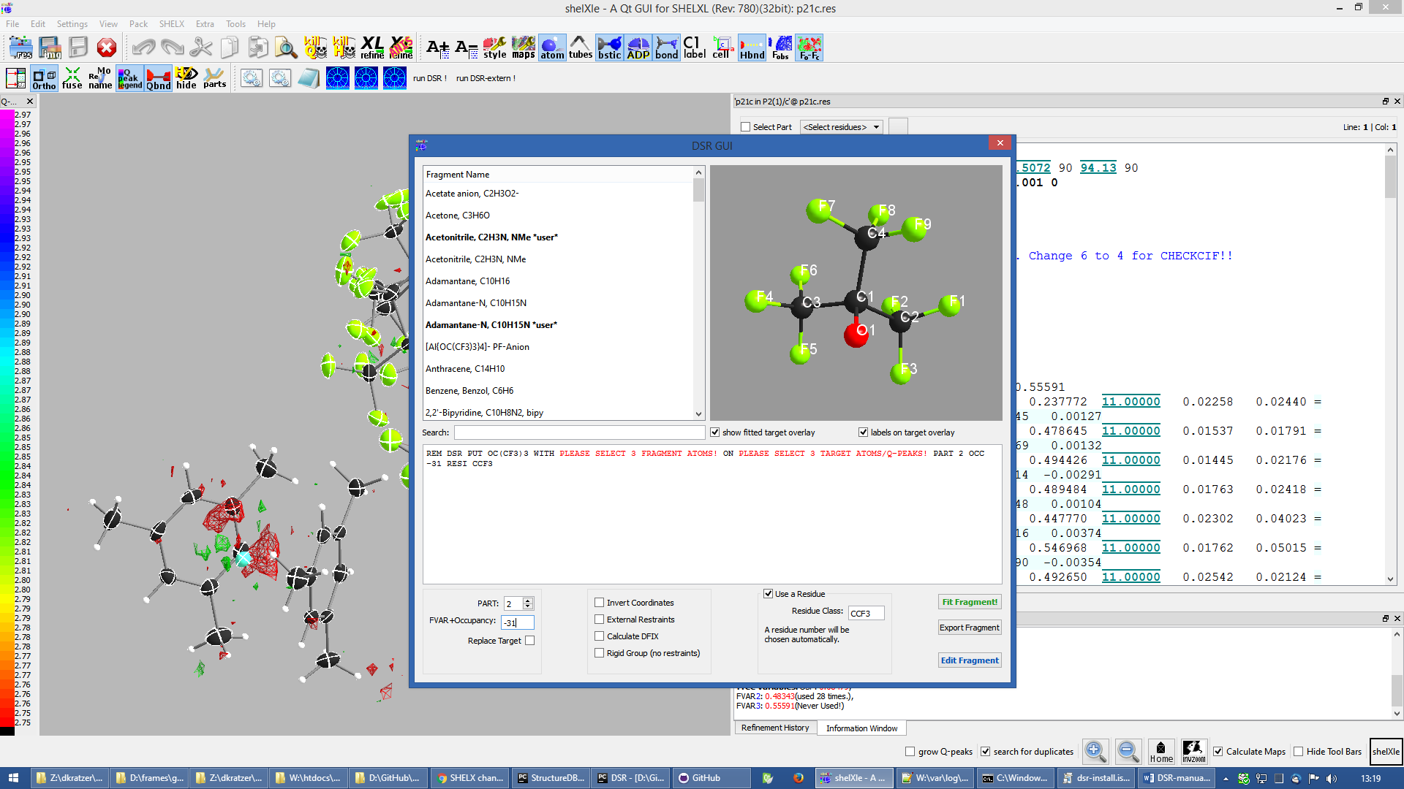

Setting PART or Residue Number to zero will disable them. The residue number will always be chosen as the next free available. You can safely leave this as it is or change the residue values.

The “FVAR+Occupancy” follows the SHELXL notation of a combined free variable plus the occupancy factor. The picture above for example shows an occupancy of one subtracted from the third free variable.

“External restraints” writes the restraints to an external file.

Calculate DFIX generates DFIX/DANG/FLAT restraints from the geometry of the fragment.

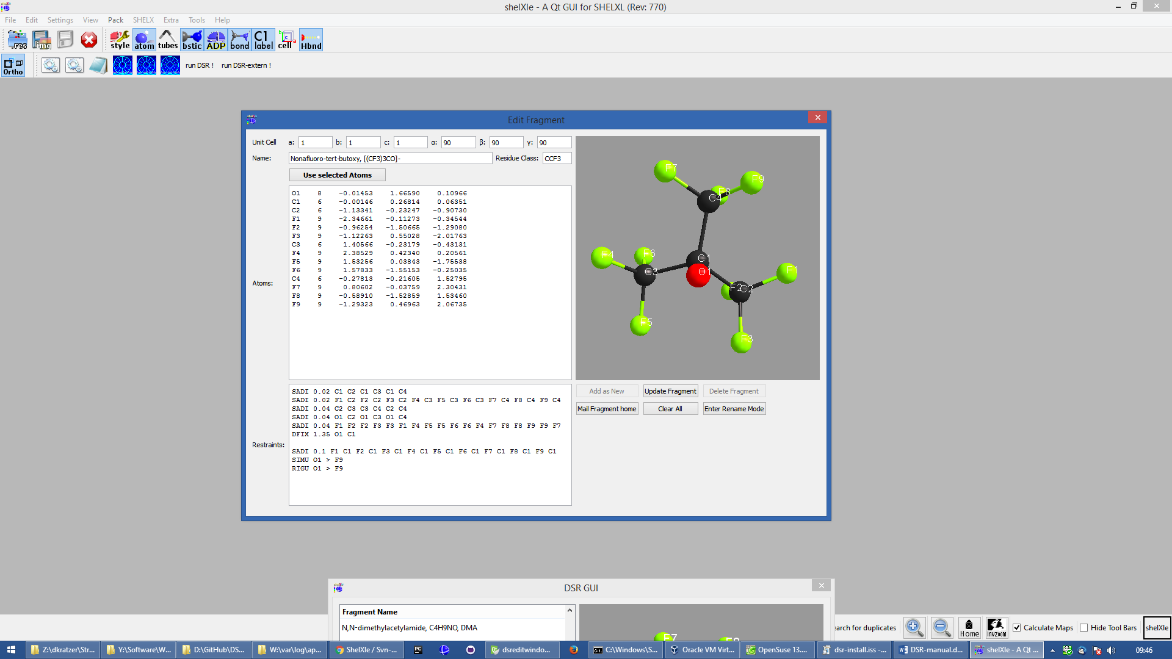

To create or edit a fragment, click on "Edit fragment". The edit window allows adding, updating and deleting of fragments.

Similar to the syntax in "dsr_usr_db.txt", you can choose to define the atom type by the name of the atom or with a negative atomic number.

They will be stored in the users fragment database "dsr_usr_db.txt" in your home directory. Different to the fragment creation by hand, you do not have to invent a database name tag. It will be randomly chosen, because the GUI will never show them. Instead the GUI always shows the real fragments names.

If you have a new fragment, you should consider sending it to me by clicking on "Mail Fragment Home".

## Rename mode

To rename the atoms in a fragment, click on “Enter Rename Mode”. The editor will you now only allow editing of atomic names. The restraints will be renamed accordingly while you are typing. Accept the changes with “OK” or discard them with “Abort”.

After renaming you can save the changes by clicking “Add as new” or “Update fragment”.

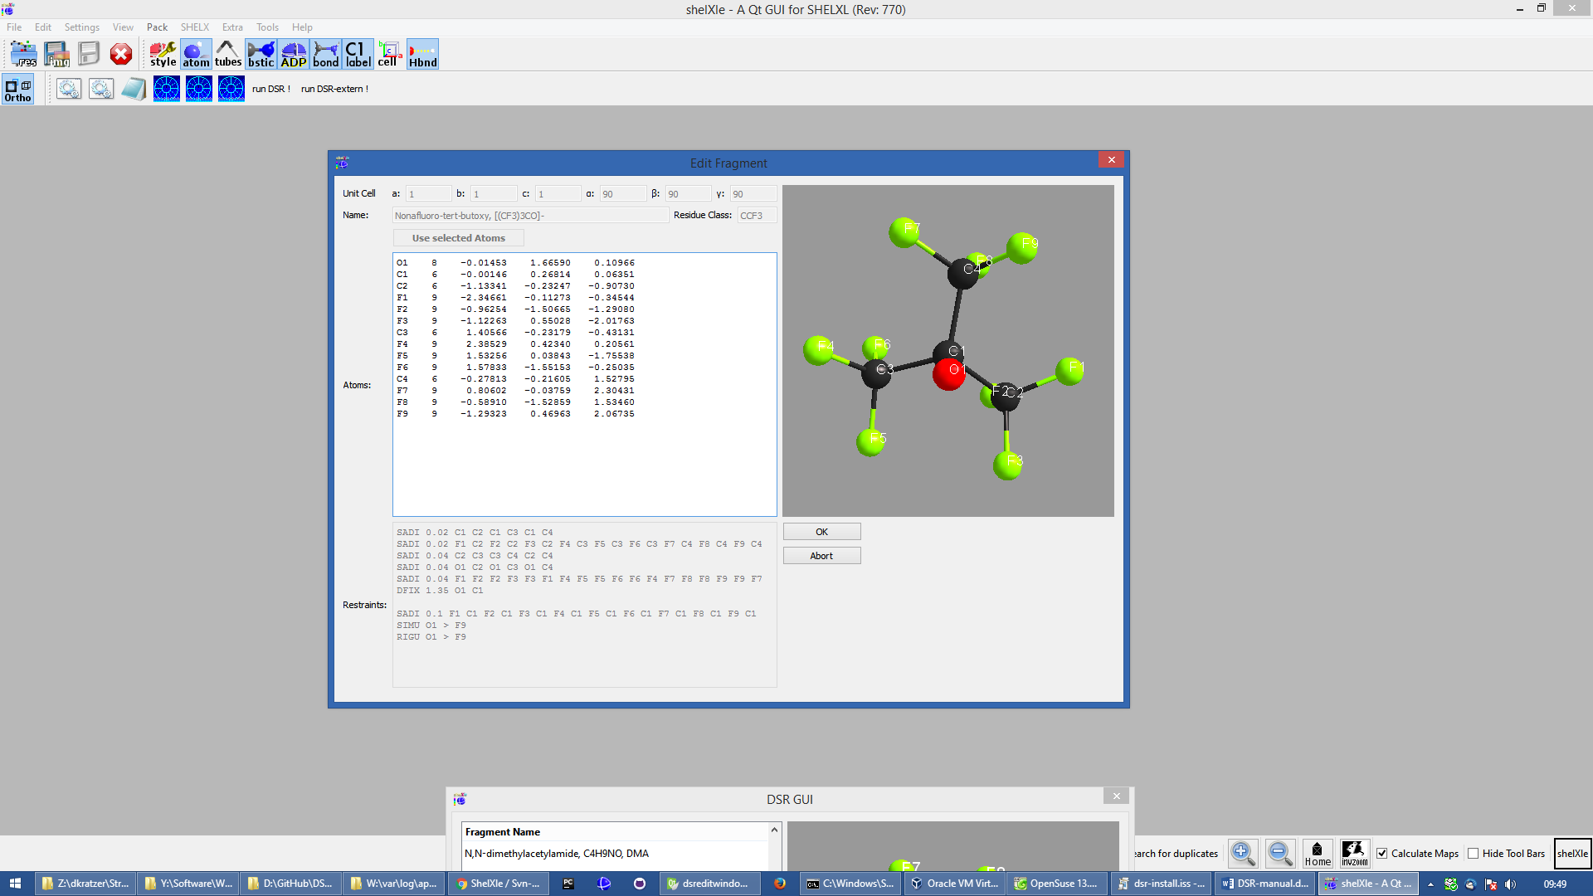

Database Format Definition

The database format was deliberately kept very simple. It consists of a system database in the dsr_db.txt and a user database in the dsr_user_db.txt. The system database is overwritten with every new program install while the user database will always stay untouched. So the user can easily add new fragments to its own dsr_user_db.txt database. The syntax mainly follows the SHELXL syntax:

**<fragment name>** <- Start tag. **RESI class** <- Required, defines the residue name of db entry. **restraints** <- Any restraints and comments following the SHELXL

syntax.You must enter at least one restraint!

e.g. RIGU C1 > C7 **FRAG 17 a b c alpha beta gamma** <- FRAG card with afix number and cell

parameters.

**Atom sfac-number coordinates** <- One isotropic atom per line following

SHELX syntax.

e.g.

**O1 1 1.2345 0.6734 0.8352** <- Either the atom type is recognized by

the atom name for positive Numbers in

the second column.

**C1 -6 0.2683 0.4783 0.1616**  <- Or the atom type is defined by the

negative atomic number in the second

column.

**</fragment name>**  <- End tag. Same as start tag but with /

- Anything not being an atom after FRAG is ignored.

- Fragment names CF3, CF6 and CF9 are reserved by DSR. Do not attempt to use them in database entries.

- Only lines beginning with valid SHELXL instructions are allowed in the header.

- Anything behind the 5th column in the atom list is ignored.

- Long lines can be wrapped with an equal sign (=) and a space character in the next line like in SHELXL, but the can also be of any length. All lines will be wrapped to fit in the SHELXL file automatically.

Database Example

A usual database entry looks like the following:

The restraints applied by DSR might be stricter than necessary. After introduction of a new fragment, the refinement can be proceeded as usual. In the course of you should review the restraints. Modifications to database fragments should always be done in the dsr_user_db.txt and not in the dsr_db.txt. The user database will not be overwritten during updates. The fragment names must be unique in both databases. Every valid restraints from SHELXL can be used, even HFIX is possible.

<Toluene>

rem CCDC: BUWME

rem Name: Toluene, C7H8

RESI TOL

SAME C2 > C6 C1

SAME C1 C6 < C2 C7

HFIX 137 C7

FLAT C1 > C7

SIMU C1 > C7

RIGU C1 > C7

FRAG 17 11.430 12.082 15.500 106.613 100.313 90.68

C1 1 0.268330 0.478380 0.161680

C2 1 0.205960 0.555770 0.217990

C3 1 0.249400 0.600760 0.310040

C4 1 0.357300 0.568990 0.348900

C5 1 0.420800 0.492470 0.294060

C6 1 0.376630 0.447580 0.201340

C7 1 0.221500 0.430400 0.060360

</TOLUENE>

The syntax follows the SHELXL syntax. All entries between the start tag <Toluene> and the FRAG command are considered as the database entry header. Comments can be introduced with REM. All lines with non-SHELX commands are ignored.

If a "rem Name:" statement is given, the name after this statement is printed in the list of available fragments.

After FRAG until the end tag </TOLUENE> only atoms with SHELX syntax are accepted.

Step by Step Example

You can find the following example in the DSR install directory. This example explains the procedures of using DSR via the command line. You can also use the graphical user interface for DSR in ShelXle if you do not like to type DSR commands (see chapter *ShelXle Integration*).

Step 0

* Open “p21c.res”.
* Residue number 3 turns out to be a part of a disorder.
* Apply a PART and the free variable 2 to this residue with “PART 1 21”:

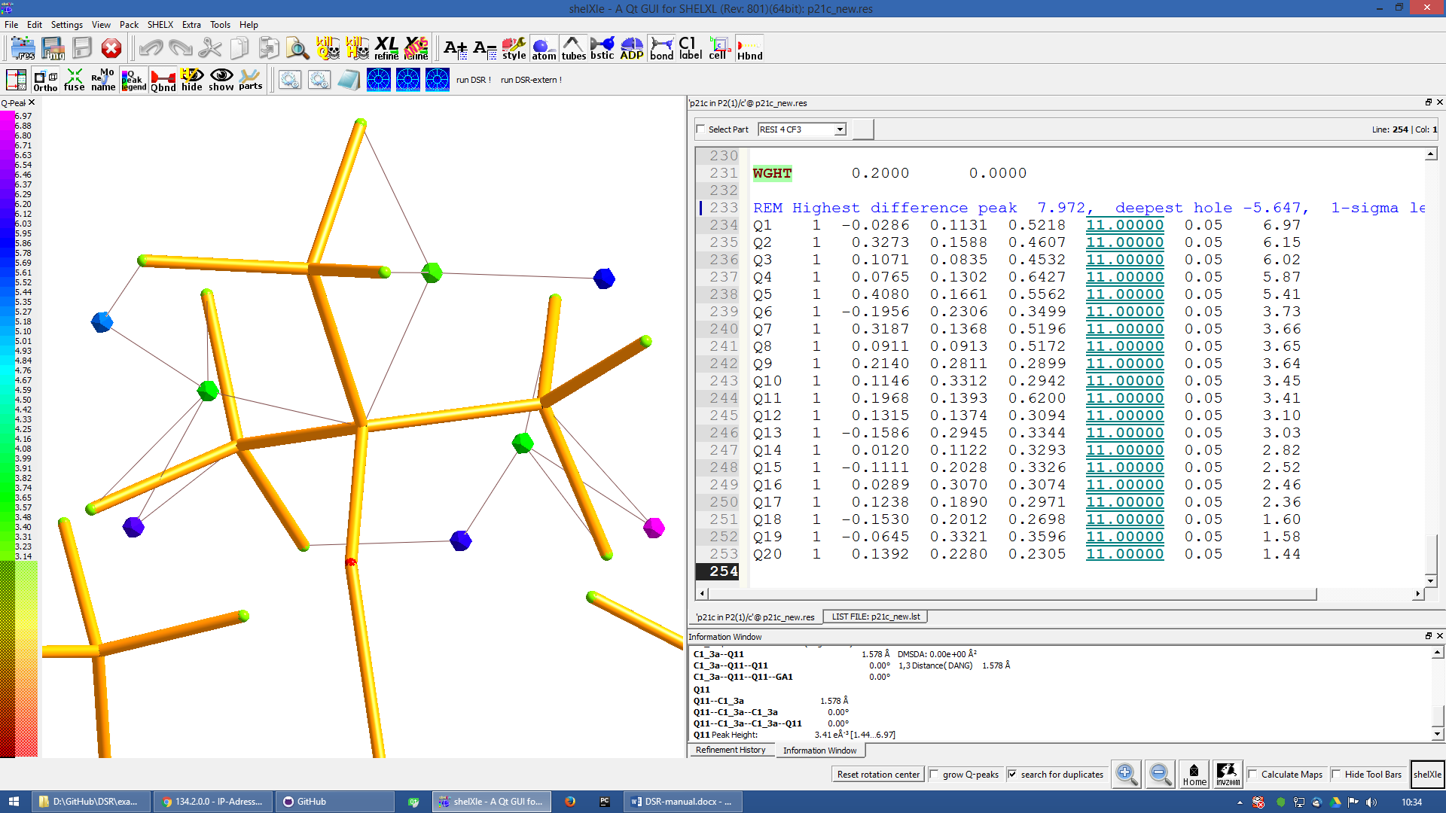

C1_3

O1_3

Q11

Q7

Q8

RESI 3 CCF3

**PART 1 21**

O1 3 0.156860 0.210330 0.529750 21.00000 0.05000

C1 1 0.198400 0.149690 0.543840 21.00000 0.05000

C2 1 0.283540 0.125060 0.490330 21.00000 0.05000

F1 4 0.357580 0.075160 0.511570 21.00000 0.05000

F2 4 0.359970 0.170660 0.471080 21.00000 0.05000

F3 4 0.212170 0.104000 0.438130 21.00000 0.05000

C3 1 0.086960 0.103360 0.549830 21.00000 0.05000

F4 4 0.118510 0.041260 0.547430 21.00000 0.05000

F5 4 -0.003540 0.114200 0.501240 21.00000 0.05000

F6 4 0.032040 0.112650 0.606550 21.00000 0.05000

C4 1 0.279960 0.152770 0.609930 21.00000 0.05000

F7 4 0.222220 0.188240 0.652750 21.00000 0.05000

F8 4 0.297220 0.093900 0.636590 21.00000 0.05000

F9 4 0.395450 0.177140 0.602220 21.00000 0.05000

**PART 0**

RESI 0

Step 1

* Now you can insert the command line for DSR after the residue 3.
* The command is

**rem dsr put oc(cf3)3 with O1 c1 c2 on O1_3 C1_3 Q11 part 2 occ -21 resi**

to place the fragment **OC(CF3)3** on the position of **O1_3 C1_3 q11**.

* In addition we want to have the fragment in a **PART 2** with the **occupancy** of **−21** and in a **residue**. DSR automatically finds a free residue number and uses a residue name from the database. All these options are placed in one line. As usual in SHELXL, lines longer than 80 characters can be continued with "=" at the end and a whitespace before the first character in the next line.
* Save the res file after editing.

Step 2

* Now run "dsr -r p21c.res" on the Windows/Unix command line.
* DSR will run over the res file, insert the fragment and makes a refinement with “L.S. 0”. This finally inserts the fragment. You can see the status before the refinement in the ”p21c_step2.ins” file.

D:\tmp\example>dsr -r p21c.res

----------------------------- D S R - v190 ------------------------------------

No residue number was given. Using residue number 5.

Inserting oc(cf3)3 into res File.

Source atoms: O1, C1, C2

Target atoms: O1_3, C1_3, Q11

RESI instruction is enabled. Leaving atom numbers as they are.

Fragment atom names: O1, C1, C2, F1, F2, F3, C3, F4, F5, F6, C4, F7, F8, F9

-------------------------------------------------------------------------------

Running SHELXL with "c:\bn\sxtl\xl.exe -b3000 p21c" and "L.S. 0"

SHELXL Version 2014/7

wR2 = 0.5454

GooF = 6.4660

R1 = 0.2101

Runtime: 0.3 s

DSR run complete.

* Reopen the resulting res file.

Step 3

* The fragment turned out to be successfully fitted on its desired position:

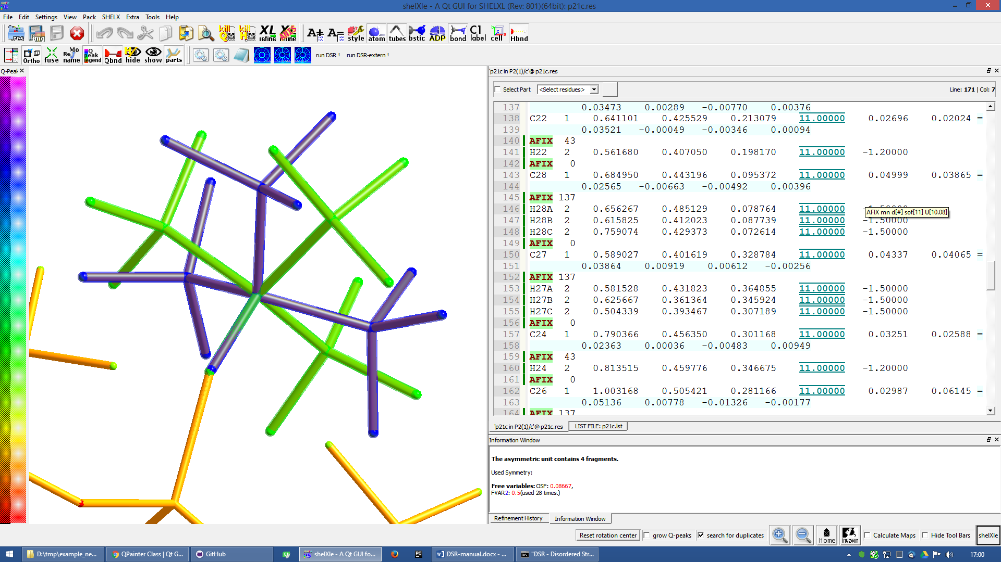

* The previously used DSR command line is now commented out with REM and will not be recognized by DSR again.

Step 4

* Do the same procedure from step 1 onwards to refine the second disorder.
* The final model of the anion should look like this:

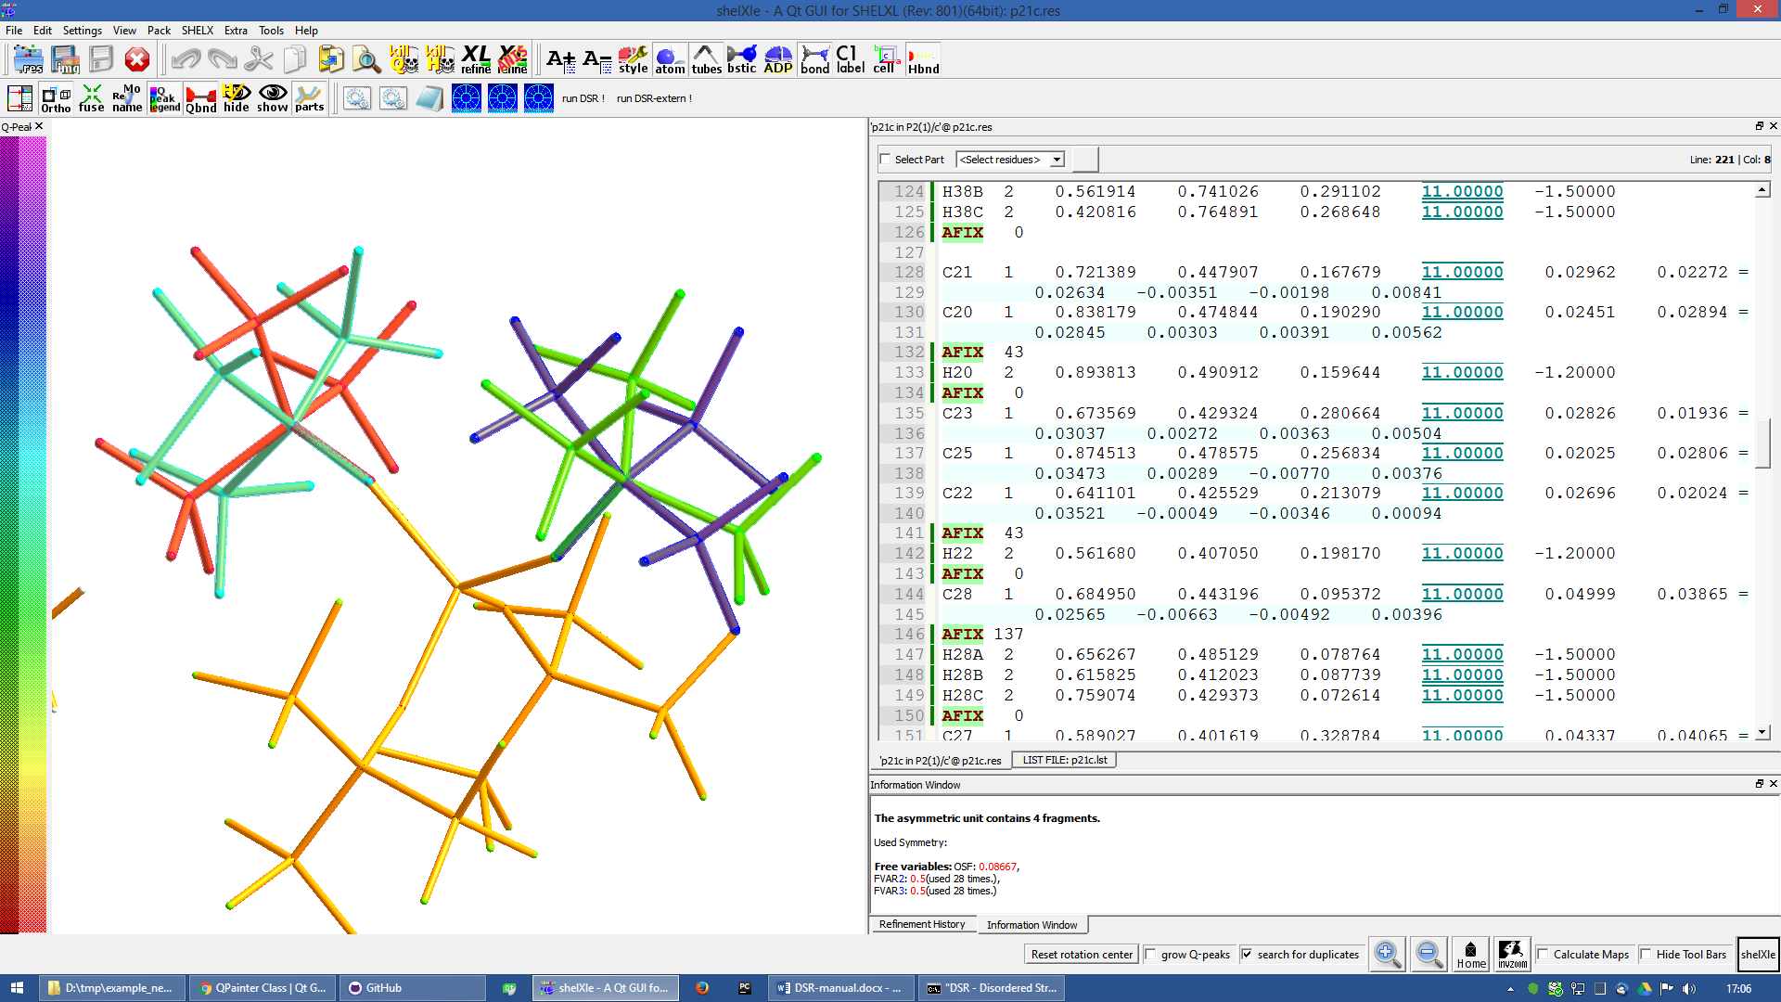

* Now you can add/remove additional restraints and further refine the structure as usual. Already existing restraints for an existing residue class will not be inserted again, because they already act for all residues together (with SADI_CCF3 for example).
* A good assumption for the model would also be that all Al–O distances are the same. Therefore, we should add the restraint   
  SADI Al1_0 O1_1 Al1_0 O1_2 Al1_0 O1_3 Al1_0 O1_4 Al1_0 O1_5 Al1_0 O1_6
* The central oxygen and carbon atoms of the disordered perfluorinated tert-butyl alcohol group are now in close proximity. Therefore, it is a good idea to safe parameters and stabilize their ADPs with an EADP constraint:

EADP C1_3 C1_5

EADP O1_5 O1_3

EADP C1_6 C1_4

EADP O1_4 O1_6

* After ten cycles of refinement, the structure should produce an R1 of 4% and should have no bigger residual density features left over (0.30 eÅ−3 level):

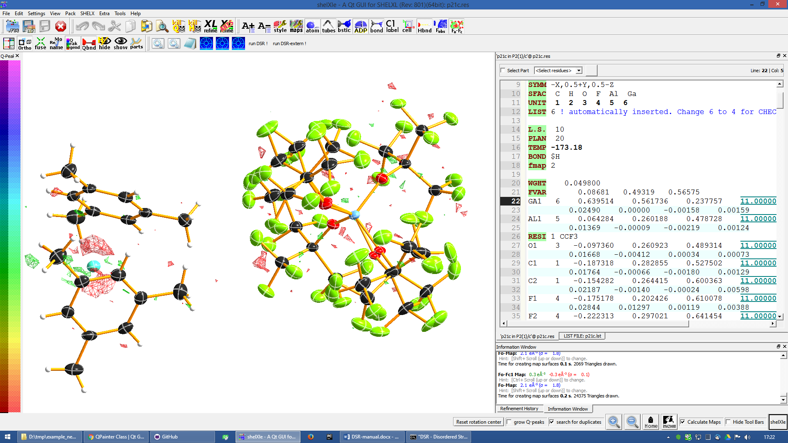

Import fragments from GRADE

GRADE from Global Phasing Ltd. <http://grade.globalphasing.org/> is a ligand restraint generator whose main source of restraint information is the Cambridge Structural Database (CSD) of small-molecule crystal structures, queried using the MOGUL program developed by the CCDC. Where small-molecule information is lacking, Grade uses quantum chemical procedures to obtain the restraint values.

Fragments obtained by GRADE can be imported to DSR with the –i command line option. The GRADE server outputs a .tgz file including several files. Execution of “dsr –i filename.tgz” will import a GRADE fragment from these files. The fragment gets imported to the “dsr-user-db.txt” in the DSR program directory. You also might need to change the fragment and residue name after the import. The best way is to supply the GRADE server with a .mol2 file. This way you can choose the atom names and their sorting yourself. mol2 files can be generated if you create a molecule with Avogadro (save as .res file) <http://sourceforge.net/projects/avogadro/> then you must rename the atoms and open the res file with mercury <http://www.ccdc.cam.ac.uk/Solutions/CSDSystem/Pages/Mercury.aspx>. Mercury can now save a .mol2 file for GRADE.

CF3-Groups

DSR is able to generate CF3 groups with the respective restraints automatically. The CF3 group can be modeled either as ordered group on one position (like an AFIX 130 would do), as well as a disordered group on two or three positions. The respective fragment names are CF3, CF6 and CF9. A disordered CF3 group on three positions would be modelled using:

REM DSR put CF9 on C1

The result is the following plus the respective free variables added to the FVAR line.

REM CF3 group made by DSR:

SUMP 1 0.0001 1 2 1 3 1 4

SADI 0.02 C1 F1B C1 F2B C1 F3B C1 F4B C1 F5B C1 F6B C1 F7B C1 F8B C1 F9B

SADI 0.04 F1B F2B F2B F3B F3B F1B F4B F5B F5B F6B F6B F4B F7B F8B F8B F9B =

F9B F7B

SADI 0.1 C2 F1B C2 F2B C2 F3B C2 F4B C2 F5B C2 F6B C2 F7B C2 F8B C2 F9B

RIGU C2 C1 F1B > F9B

PART 1 21

F1B 3 0.128560 -0.462510 0.547150 11.00000 0.04

F2B 3 0.047696 -0.372991 0.451178 11.00000 0.04

F3B 3 0.040064 -0.244730 0.559034 11.00000 0.04

PART 2 31

F4B 3 0.118185 -0.486145 0.500565 11.00000 0.04

F5B 3 0.020565 -0.289148 0.471484 11.00000 0.04

F6B 3 0.077571 -0.304938 0.585313 11.00000 0.04

PART 3 41

F7B 3 0.086249 -0.450791 0.462663 11.00000 0.04

F8B 3 0.017551 -0.238494 0.514080 11.00000 0.04

F9B 3 0.112520 -0.390946 0.580619 11.00000 0.04

PART 0

Existing fluorine atoms connected to the respective carbon atom will be deleted by DSR beforehand.

If you like DFIX instead of SADI, add DFIX to the DSR command line:

REM DSR put CF9 on C1 DFIX

The special command SPLIT in combination with the CF6 fragment tries to split the target carbon atom in two positions. The coordinates of the two positions are the principal axes of the carbon atom ellipsoid in its longest direction. The restraints will be adjusted accordingly.

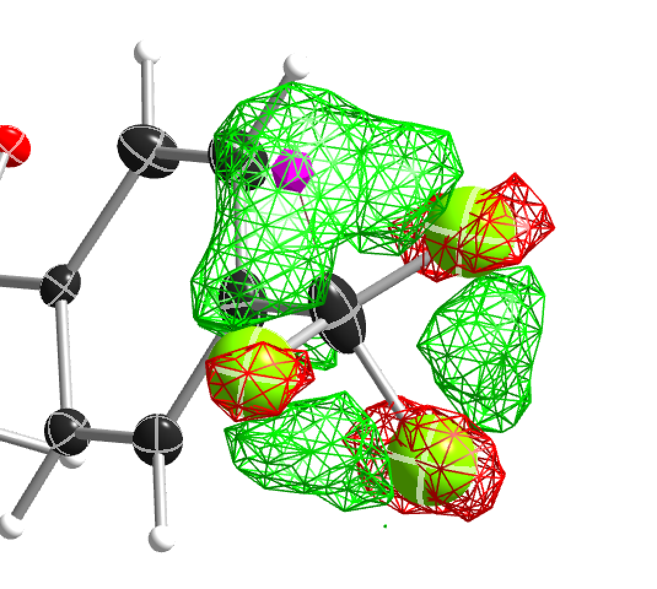 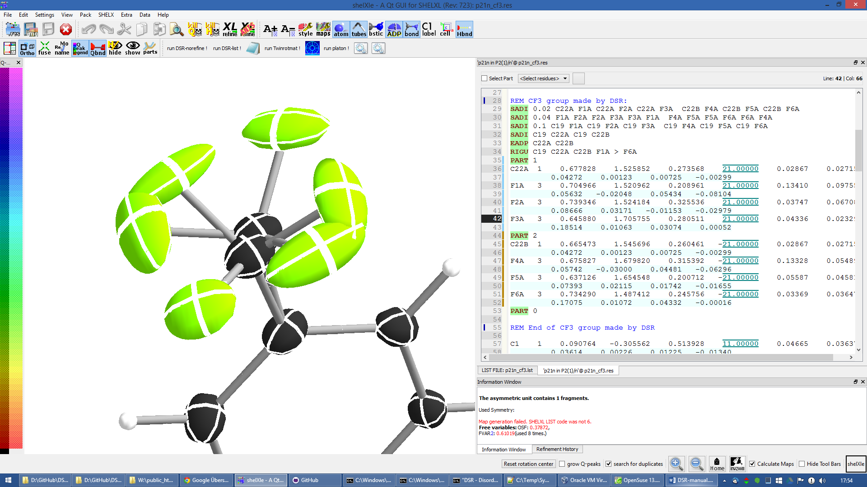

Figure 1 CF3 group split on two positions (rem dsr put CF6 on C22 split).

You should never use CF9 just because it is possible! Often CF6 is sufficient. CF9 often just uses more least-squares parameters without improving the model.

You can try the above example with the structure “p21n_cf3.res” located in the example directory of DSR. At the end of the file, there is already a command line to place a CF3 group on C22.

Tips and Tricks

* Some crystal structure refinement programs do not always show the Q-peaks at the position where you expect them to be. Especially around special positions, the Q-peaks appear at symmetry equivalent positions. If you then fit fragments to the Q-peaks, the fitting position will not be as expected. You can avoid this by renaming the Q-peaks first (e.g. to carbon atoms), place them in the correct symmetry equivalent position and start fitting with DSR.   
  The SchelXle DSR GUI handles these Q-peaks correctly since version 200 of DSR.
* You can quickly rename molecular moieties using DSR in the replace mode. This is useful directly after the solution with SHELXT for example. In the replace mode, DSR replaces all atoms that are in PART 0 and that are 1.3 Å near the atoms of the placed fragment. Using replace mode prevents you from renaming every single atom.
* You want to know typical bond lengths of fragments included in the DSR database? Export the respective fragment and either see 1,2 and 1,3 distances in the restraints lists or let the SHELX GUI of your choice find out any distance of the respective atoms.
* The command “dsr –l” will tell you about errors in the fragment database in case you created a frag­ment yourself and made a mistake.
* The ShelXle interface allows you to edit or create fragments. In the rename mode, you can rename atoms of a fragment and their respective restraints.

# Fragments Included in the Database

Type “dsr –l” to see a list of fragments supplied with DSR. Also the graphical user interfaces show a list of all fragments.

For Developers

Graphical user interfaces for SHELXL (like ShelXle) can use several special commands to control DSR:

**$ dsr –lc**

DSR version: 199

acetate;;Acetate anion, C2H3O2-;;1105;;dsr_db

acetone;;Acetone, C3H6O;;2312;;dsr_db

acetonitrile;;Acetonitrile, C2H3N, NMe;;1670;;dsr_db

adamantane;;Adamantane, C10H16;;2405;;dsr_db

...

The first line of the –lc output is the version of DSR. All other lines are separated by double semicolon. Each fragment uses one line. The first column is the name tag, the second is the full name and the third is the type of database (dsr_db/dsr_usr_db).

**$ dsr -x tol**

toluene;;Toluene, C7H8;;885;;dsr_db

tbu-o;;tert-Butanol (or tert-Butoxy);;2203;;dsr_db

tosylate;;Tosylate anion, CH3C6H4SO3-;;2447;;dsr_db

dmpz;;Dimethylpyrazolato anion, [C5H6N]-, pz*;;1126;;dsr_db

ile;;ISOLEUCINE;;4327;;dsr_db

pyr;;PYRROLYSINE;;3802;;dsr_db

acetonitrile;;Acetonitrile, C2H3N, NMe;;1670;;dsr_db

mquinolinol;;2-Methyl-8-quinolinol, C10H9NO;;2041;;dsr_db

The –x parameter searches for fragments and displays the result with the same syntax as –lc.

**$ dsr -ah toluene**

<atoms>

C1 6 1.78099 7.14907 12.00423;;C2 6 2.20089 8.30676 11.13758;;C3 6 1.26895 9.02168 10.39032;;C4 6 1.64225 10.07768 9.58845;;C5 6 2.98081 10.44432 9.51725;;C6 6 3.92045 9.74974 10.25408;;C7 6 3.53891 8.69091 11.05301

</atoms>

<tag>

toluene

</tag>

<comment>

Toluene, C7H8

</comment>

<source>

CCDC CESLUJ

</source>

<cell>

1;;1;;1;;90;;90;;90

</cell>

<residue>

TOL

</residue>

<dbtype>

dsr_db

</dbtype>

<restr>

SADI C2 C3 C3 C4 C4 C5 C5 C6 C6 C7 C7 C2;;SADI 0.04 C2 C6 C2 C4 C7 C5 C3 C7 C4 C6 C3 C5;;DFIX 1.51 C1 C2;;SADI 0.04 C1 C7 C1 C3;;FLAT C1 > C7;;SIMU C1 > C7;;RIGU C1 > C7

</restr>

The –ah command displays the content of the database entry for the respective fragment on screen. Each type of database entry has a start end an end tag. Each entry is a single delimited by double semicolon.

**-shx "c:\Program files\shelx\shelxl"**

Command to tell DSR where SHELXL is located.

**$ dsr –ea**

Exports **all** fragments at once to the current directory.

**$ dsr –target [coordinate triples]**

With the target option you are able to define the exact coordinates of the target position for the fragment fit. Coordinates are given in space separated coordinates.

In general you should implement parsers for DSR output in a way that can handle additional error messages anywhere (preferably at the end) that start with three stars and end with three stars (SHELXL has two stars). For example:

*** Check database entry. ***