

Quantum

Requirements for GSL schema

Document ID: quantum\database\design\116-13_GSL_DB_def

File Name: 0000.doc

Ver. | Date | Author | Description | Approved by | Approval date
1 | 24.2.05 | Sigal P and Avital G | - New GSL for Insight 4.05
 | 20.4.05 | Sigal paz | - Change field subscriber_id to subscriber_internal_id
 | 2.5.2005 | Sigal paz | - Change initial load of service domain table
 | 15.5.2005 | Sigal paz | - Change field Num_plan_ranges in gsl_sets and gsl_groups to varchar2(1000)
 | 10-Jul-05 | N. Pearlman | - Modifying default values in GSL Metadata to be coordinated with DNS
 | 29-Aug-05 | Avital Itzhakov | - Add to sys_params_gsl two parameters for GSL Group allocation logic. Change the initial data of the enum_gsl table.
 | 30/8/2005 | N perelman | Add trigger after insert on gsl_set tot Add the Subscriber_counter and the MAX_Subscribers of the inserted record to Subscriber_counter and Max_Subscribers in Gsl_groups table.
 | 11/9/05 | Atar Hason | Add DC to initial data of Services, Gsl_items, Service_domains tables
 | 26/10/05 | Atar Hason | Add ODS & SPM-Agent to initial data of Services, Gsl_items, Service_domains tables
 | 19/02/06 | Atar Hason | Add Max_Active_Subscribers and Active_Subscribers_counter to gsl_group table.  Modify default/initial data in gsl_group table and sys_parms table  Modify start value of sequence of gsl_group_id
 | 14.3.06 | Avital G. | Add Active_Subscribers_counter to Gsl_sets table and a trigger

This material is proprietary of Comverse Technology, Inc. Any unauthorized reproduction, use or disclosure of this material, or any part thereof, is strictly prohibited. This material is meant solely for the use by Comverse employees and authorized Comverse customers.

Table of Content
0. Abstract 5
1. Logical Schema 6
1.1 List of Tables 6
1.2 Domains 6
1.2.1 List of existing domains 6
1.3 Table GSL_SUBSCRIBER_KEYS 7
1.3.1 Columns definition 7
1.3.2 Index definition 7
1.3.3 Constraints 8
1.3.4 Initial Load 8
1.4 8
1.5 Table GSL_SETS 8
1.5.1 Columns definition 8
1.5.2 Index definition 9
1.5.3 Constraints 9
1.5.4 Triggers 9
1.5.5 Initial data 10
1.6 Table GSL_GROUPS 10
1.6.1 Columns definition 10
1.6.2 Index definition 12
1.6.3 Constraints 12
1.6.4 Triggers 12
1.6.5 Initial data 12
1.7 Table GSL_ITEMS 13
1.7.1 Columns definition 13
1.7.2 Index definition 13
1.7.3 Constraints 14
1.7.3.1 Triggers 14
1.7.4 Initial Load 14
1.8 Table SERVICES 15
1.8.1 Columns definition 15
1.8.2 Index definition 15
1.8.3 Constraints 15
1.8.3.1 Triggers 15
1.8.4 Initial data 16
1.9 Table SERVICE_DOMAINS 17
1.9.1 Columns definition 17
1.9.2 Index definition 18
1.9.3 Constraints 18
1.9.3.1 Triggers 18
1.9.4 Initial data 18
1.10 Table SERVICE_POINTS Error! Bookmark not defined.
1.10.1 Columns definition Error! Bookmark not defined.
1.10.2 Index definition Error! Bookmark not defined.
1.10.3 Constraints Error! Bookmark not defined.
1.10.3.1 Triggers Error! Bookmark not defined.
1.10.4 Initial data Error! Bookmark not defined.
1.11 Table MEDIA_TYPES Error! Bookmark not defined.
1.11.1 Columns definition Error! Bookmark not defined.
1.11.2 Index definition Error! Bookmark not defined.
1.11.3 Constraints Error! Bookmark not defined.
1.11.4 Initial Data Error! Bookmark not defined.
1.12 Table KEY_TYPES Error! Bookmark not defined.
1.12.1 Columns definition Error! Bookmark not defined.
1.12.2 Index definition Error! Bookmark not defined.
1.12.3 Constraints Error! Bookmark not defined.
1.12.4 Initial Data Error! Bookmark not defined.
1.13 Table SUBSCRIBER_TYPES Error! Bookmark not defined.
1.13.1 Columns definition Error! Bookmark not defined.
1.13.2 Index definition Error! Bookmark not defined.
1.13.3 Initial Data Error! Bookmark not defined.
1.14 Table ENUM_GSL 19
1.14.1 Columns definition 19
1.14.2 Index definition 19
1.14.3 Initial Data 20
1.14.4 Application Logic Error! Bookmark not defined.
1.15 Table SYS_PARAMS_GSL 20
1.15.1 Columns definition 20
1.15.2 Index definition 20
1.15.3 Constraints 20
1.15.3.1 Triggers 20
1.15.4 Initial Load 21
2. GSL Stored Procedures 22
2.1 PACKAGE GSL_PKG_V1 22
2.1.1 SET_SUBS_COUNTERS Stored Procedure 22
2.2 PACKAGE GSL_DB_ADMIN_PKG_V1 23
2.2.1 UPDATE_SUB_COUNTERS_JOB Stored Procedure 23
Input parameters: 23
3. System Parameters and Automatic Job Scheduling 24
3.1 Status after installation 24
3.2 Modifying UPDATE_INTERVAL value 24
3.3 View Schedule Job Table 24
4. Tables diagrams 28
5. Sequences 30
5.1.1 GSL_SET_ID_SEQ incremented by 1 - used for GSL_SETS.gsl_set_id 30
5.1.2 GSL_GROUP_ID_SEQ incremented by 1 - used for GSL_SETS.gsl_set_id 30
5.1.3 IID_SEQ incremented by 30 - used for IID number 30
5.1.4 SERVICE_ID_SEQ - incremented by 1 - used for SERVICES.service_id 30
5.1.5 SVCDOMAIN_ID_SEQ incremented by 1 – used for SERVICE_DOMAINS.svcdomain_id 30
5.1.6 30
5.1.7 30
6. Application Logic 31
7. Transactions Definition 32
8. Physical Requirements 33
8.1 Table <name> 33
8.1.1 Storage requirements 33
8.1.2 Operations Profile 33

Abstract
The purpose of this document is to present the guidelines for definition of the information required for the logical and physical planning of the database.
When deciding on database table names, column names, etc. it is mandatory to follow Database Naming Conventions ( Q:\Database\Design\118_03_DB_naming.com ).

Logical Schema

List of Tables

Table Name | New/Old | Comments
GSL_SUBSCRIBER_KEYS
GSL_ITEMS
GSL_GROUPS
GSL_SETS
SYS_PARAMS_GSL
SERVICE_POINTS
SERVICES
SERVICE_DOMAINS

Domains
A domain is a set of validation rules, format constraints and other properties that applies to a group of attributes.. For example, before entering attribute details of an entity, it is useful to define any domains that have been identified, such as ID. When a new attribute has been inserted, a domain can be specified that will apply to it, instead of entering all the attribute details again.

List of existing domains
In order to help the user, domains have been created, by the Database group, that correspond to the standard data types, so only domains specific for concrete application have to be defined.
Refer to the document Q:\Database\Design\173_Domains.xls

Table GSL_SUBSCRIBER_KEYS

Columns definition

Column Name | Domain | Datatype | Width/ Precision | Scale | Mandatory (not NULL) (Yes/No) | Primary Key (Yes/No) | Foreign Key (Related Table and column names) | Description
KEY_VALUE |  | VARCHAR2 | 325 |  | Yes | PK-1
GSL_SET_ID |  | NUMBER | 4 |  | Yes
SUBSCRIBER_Internal_ID |  | VARCHAR2 | 25 |  | Yes |  |  | Internal subscriber ID
Notes:
In the new GSL schema version:
When downgrading an upgraded version the following column should be added as follow:
- Populate Media_Type_ID when it is has null value as follows – if value has “@” – set to 1 (Internet), else set to 0 (Telepgony)
- Populate Key_Type_ID when it is has null value as follows – if value has “@” – set on as 16, else set as 2
- Set Subscriber_Type_ID to zero
- The constraints have to be added.

Index definition

Index Name | Column Names
key_subscriber_id_ix | subscriber_internal_id
key_set_id_ix | Gsl_set_id

Constraints

Initial Load

Table GSL_SETS

Columns definition
Column Name | Domain | Datatype | Width/ Precision | Scale | Mandatory (not NULL) (Yes/No) | Primary Key (Yes/  No) | Foreign Key (Related Table and column names) | Description
GSL_SET_ID |  | NUMBER | 4 |  | Yes | Yes
GSL_SET_NAME |  | Varchar2 | 40 |  | Yes
GSL_GROUP_ID |  | Number | 3 |  | Yes |  | Gsl_groups.  gsl_group_id  On delete casacde
Num_plan_ranges |  | Varchar | 1000 |  |  |  |  | For numbering plan allocation.  The format: 43534-6353;5343-5677;
Subscriber_counter |  | Number | 8 |  |  |  |  | Default = 0
In_load_share |  | Number | 1 |  | Yes |  |  | Indication for participates in load share allocation.  1 – true, 0- false
Max_subscribers |  | Number | 8 |  |  |  |  | Determines the load sharing ratio between GSL Sets.  Default = 0
Active_Subscribers_counter |  | Number | 8 |  |  |  |  | Default = 0
Notes:
When downgrading to the previous version – add the field system_type with 2 as default value.
When upgrading an existing schema – add the Subscriber_Active_counter column and set it with the value from as in Subscriber_counter.

Index definition

Index Name | Column Names

Constraints
Unique Key: Gsl_set_name

Triggers
1. AFTER update of SUBSCRIBER_COUNTER :
On any increase/decrease of Subscriber_counter, the correlated subscriber_counter in Gsl_groups table should be updated respectively.
2. AFTER update of MAX_SUBSCRIBERS:_
On any increase/decrease of Max_subscribers, the correlated Max_subscribers in Gsl_groups table should be updated respectively.
3. AFTER update of GSL_GROUP_ID:
Decrease from old group and increase the new group the values of subscriber_counter and max_subscribers.
4. BEFORE insert :
On insertion of GSL set without Gsl set id the trigger will take the highest number increased by one.
5. AFTER delete:
Deleting a Gsl set should decrease its Gsl group subscriber_counter and max_subscribers., (Gsl group counters minus the removed Gsl set counters).
6. BEFORE update of MAX_Subscribers:
Return an error if MAX_Subscribers is attempted to be set to be smaller than Subscriber_Counter in GSL_Sets.
(has to be also in GSL Web Admin application)
7. After Insert
Set current timestamp in SYS_PARAMS_GSL.Last_Metadata_Update_Timestamp
Add the Subscriber_counter & Active_Subscriber_counter and the MAX_Subscribers of the inserted record to Subscriber_counter and Max_Subscribers in Gsl_groups table.
8. After Delete
Set current timestamp in SYS_PARAMS_GSL.Last_Metadata_Update_Timestamp
9. After Update of any attribute except Subscriber_Counter and Active_Subscriber_Counter
Set current timestamp in SYS_PARAMS_GSL.Last_Metadata_Update_Timestamp
10. AFTER update of ACTIVE_SUBSCRIBER_COUNTER :
On any increase/decrease of Active_Subscribers_counter, the correlated subscriber_counter in Gsl_groups table should be updated respectively.

Initial data
When the schema is installed in a new database, add a single record with the following values:

Column Name | Value
GSL_SET_ID | 0
GSL_SET_NAME | default
GSL_GROUP_ID | 100
Num_plan_ranges | null
Subscriber_counter | 0
In_load_share | 1
Max_subscribers | Small Model – 500000  Medium Model – 1000000  Large Model - 3000000
Active_Subscribers_counter | 0

Table GSL_GROUPS

Columns definition
Column Name | Domain | Datatype | Width/ Precision | Scale | Mandatory (not NULL) (Yes/No) | Primary Key (Yes/  No) | Foreign Key (Related Table and column names) | Description
GSL_GROUP_ID |  | NUMBER | 4 |  | Yes | Yes
GSL_GROUP_NAME |  | Varchar2 | 40 |  | Yes
Defualt_gsl_set_id |  | Number | 4 |  |  |  | Gsl_sets.  Gsl_set_id
Num_plan_ranges |  | Varchar | 1000 |  |  |  |  | For numbering plan allocation.  The format: 43534-6353;5343-5677;
Subscriber_counter |  | Number | 8 |  |  |  |  | Default = 0
In_load_share |  | Boolean |  |  | Yes |  |  | Indication for participates in load share allocation.  Default = 1
Max_subscribers |  | Number | 8 |  |  |  |  | Determines the load sharing ratio between GSL Groups.  Default = 0
Auto_allocation_logic | ENUM | Number | 2 |  |  |  |  | 1 – Ratio load share  2 – Numbering plan  3 – Default  Default = 1
COSHostname |  | varChar2 | 30 |  | Yes |  |  | Hostname of LDAP Server storing COS of this system
Max_Active_subscribers |  | Number | 8 |  |  |  |  | Determines the maximum number of Active subscribers  Default = 0
Active_Subscribers_counter |  | Number | 8 |  |  |  |  | Determines the actual number of Active subscribers  Default = 0
Notes:
When upgrading an existing schema – add the column COSHostname and set it to” sys100.comverse.com”
For Naty and Avital:
GSL Web Admin has to verify the assigned value is defined in DNS
When upgrading an existing schema – add the Max_Active_subscribers and Subscriber_Active_counter columns., and set Max_Active_subscribers to max subscribers value and Active_Subscribers_counter to Subscriber_counter.

Index definition

Index Name | Column Names

Constraints
Unique Key: Gsl_group_name.

Triggers
1. BEFORE insert :
On insertion of GSL group without Gsl group id the trigger will take the highest number increased by one.
7. After Insert
Set current timestamp in SYS_PARAMS_GSL.Last_Metadata_Update_Timestamp
8. After Delete
Set current timestamp in SYS_PARAMS_GSL.Last_Metadata_Update_Timestamp
9. After Update of any attribute except Subscriber_Counter
Set current timestamp in SYS_PARAMS_GSL.Last_Metadata_Update_Timestamp

Initial data
Insert default Gsl_group_id definition as follow:
Column Name | Value
GSL_GROUP_ID | 100
GSL_GROUP_NAME | “Default”
Defualt_gsl_set_id | 0
Num_plan_ranges | null
Subscriber_counter | 0
In_load_share | 1(Yes)
Max_subscribers | Computed by trigger from initial value set in GSL_Sets table
Auto_allocation_logic | 1(ratio load share)
COSHostname | “Profile1.sys100.comverse.com”
Active_Subscribers_counter | 0
Max_Active subscribers | Small Model – 500000  Medium Model – 1000000  Large Model - 3000000

Table GSL_ITEMS

Columns definition
Column Name | Domain | Datatype | Width/ Precision | Scale | Mandatory (not NULL) (Yes/No) | Primary Key (Yes/No) | Foreign Key (Related Table and column names) | Description
GSL_SET_ID |  | NUMBER | 4 |  | No | Yes1 | Gsl_sets.  Gsl_set_id  On delete cascade
SERVICE_ID |  | NUMBER | 4 |  | Yes | Yes2
SVC_DOMAIN_ID |  | NUMBER |  |  | Yes |  | Service_domains.svc_domain_id
Notes:
When installing a new GSL Schema –The table will be as describe above.
When upgrading to the new schema:

- Set Max_Active_subscribers with the max subscribers value and Active_Subscribers_counter to Subscriber_counter
When downgrading to the previous version
Remove the Active_Subscribers_counter
Index definition

Index Name | Column Names

Constraints

Triggers
.
7. After Insert
Set current timestamp in SYS_PARAMS_GSL.Last_Metadata_Update_Timestamp
8. After Delete
Set current timestamp in SYS_PARAMS_GSL.Last_Metadata_Update_Timestamp
9. After Update
Set current timestamp in SYS_PARAMS_GSL.Last_Metadata_Update_Timestamp

Initial Load
When the schema is installed in a newly created database, the following records have to be inserted:

GSL_SET_ID | SERVICE_ID | SVCDOMAIN_ID
0 | 1 (Message Store) | 4
0 | 3 (File Server) | 5
0 | 7 (Profile Store) | 6
0 | 11 (Provisioning Gateway) | 1
0 | 12 (Voice Application) | 2
0 | 13 (Trilogue Gateway) | 3
0 | 14 (Data Consistency) | 7
0 | 15 (oracle database) | 8
0 | 16 (SPM Agent) | 9

.

Table SERVICES

Columns definition
Column Name | Domain | Datatype | Width/ Precision | Scale | Mandatory (Yes/No) | Primary Key (Yes/No) | Foreign Key | Description
SERVICE_ID |  | NUMBER | 4 |  | Yes
NAME | NAME |  |  |  | Yes | Yes
TYPE | NAME |  |  |  | Yes |  |  | (app/data/pa)
Description |  | Varchar2 | 60 |  | Yes

Index definition

Index Name | Column Names

Constraints

Unique key : SERVICE_ID

Triggers
1. BEFORE insert:
On insertion of SERVICE without service id the trigger will take the highest number increased by one.
7. After Insert
Set current timestamp in SYS_PARAMS_GSL.Last_Metadata_Update_Timestamp
8. After Delete
Set current timestamp in SYS_PARAMS_GSL.Last_Metadata_Update_Timestamp
9. After Update
Set current timestamp in SYS_PARAMS_GSL.Last_Metadata_Update_Timestamp

Initial data
Note :
When installing a new version –
- Set the default content as detailed below.
- Create table as describe above
When upgrading –
- Remove the following columns: IID and VERSION_ID.
- The new primary Key will be the column NAME.
- Add the following records :
SERVICE_ID | NAME | TYPE | DESCRIPTION
11 | SPM | app | Provisioning Gateway
12 | VXV | app | Voice Application
13 | TAG | app | Trilogue Gateway
1 | MIPS | data | Message Store
3 | HTTP | Data | File Server
7 | Profile | data | Profile Store
14 | DC | app | Data consistency
15 | ODS | data | Oracle Database
16 | SPMAgent | app | SPM Agent
- Update the MIPS name to be Data (instead of app)
When downgrade
- Remove the following records :
SERVICE_ID | NAME | TYPE | DESCRIPTION
3 | HTTP | Data | File Server
11 | SPM | app | Provisioning Gateway
12 | VXV | app | Voice Application
13 | TAG | app | Trilogue Gateway
14 | DC | app | Data Consistency
15 | ODS | data | Oracle Database
16 | SPMAgent | app | SPM Agent
- Update the MIPS name to be app (instead of Data)
- Add the following columns: IID and VERSION_ID as follows:
  - The VERSION_ID will be set will 0
  - The IID (primary Key) will be set with a running number.

Table SERVICE_DOMAINS

Columns definition
Column Name | Domain | Datatype | Width/ Precision | Scale | Mandatory (Yes/No) | Primary Key (Yes/No) | Foreign Key | Description
SERVICE_ID |  | NUMBER | 4 |  | Yes |  | Services.service_id  On Delete cascade
SVCDOMAIN_ID |  | NUMBER |  |  | Yes
NAME | NAME |  |  |  | Yes | Yes
When installing a new GSL Schema –The table will be as describe above.
When upgrading to the new schema:
- Remove the following columns: Domain_Provider, GCN, PGCN, IID and VERSION_ID
- The new primary key will be the NAME
When downgrading to the previous version
- Add the following columns: Domain_Provider, GCN, PGCN, IID and VERSION_ID as follows:
  - The VERSION_ID will be set will 0
  - The IID (primary key) will be set with a running number.
  - The Domain_Provider, GCN, PGCN will be set with null - not used by any application

Index definition

Index Name | Column Names

Constraints

Unique key: SVCDOMAIN_ID

Triggers
1. BEFORE insert:
On insertion of a service domain without svc_domain id the trigger will take the highest number increased by one.
7. After Insert
Set current timestamp in SYS_PARAMS_GSL.Last_Metadata_Update_Timestamp
8. After Delete
Set current timestamp in SYS_PARAMS_GSL.Last_Metadata_Update_Timestamp
9. After Update
Set current timestamp in SYS_PARAMS_GSL.Last_Metadata_Update_Timestamp

Initial data
When installing a new schema – all content has to be set
When upgrading – only SPM, VXV, TAG have to be added
When downgrading – remove VXV, SPM, TAG

SERVICE_ID | SVC_DOMAIN_ID | NAME | Comments
11 | 1 | SPM.sys100.comverse.com
12 | 2 | VXV.sys100.comverse.com
13 | 3 | TAG.sys100.comverse.com
1 | 4 | MIPS1.sys100.comverse.com
3 | 5 | DSUHTTP1.sys100.comverse.com
7 | 6 | Profile1.sys100.comverse.com
14 | 7 | DC.sys100.comverse.com
15 | 8 | ODS.sys100.comverse.com
16 | 9 | SPMAgent.sys100.comverse.com

Table ENUM_GSL
ENUM table.
All checks against ENUM_GSL table are implemented in triggers.

Columns definition
Logical Name | Column Name | Domain | Datatype | Width/ Precision | Scale | Mandatory (not NULL) (Yes/No) | Primary Key (Yes/No) | Foreign Key (Related Table and column names) | Description
 | ENUM_NAME |  | Varchar2 | 30 |  | YES | YES
 | ENUM_VALUE | ENUM |  |  |  | YES | YES
 | ENUM_DESCRIPTION |  | Varchar2 | 255 |  | YES

Index definition
Constraints
ENUM_PK – Primary index on ENUM_NAME and ENUM_VALUE
Triggers
Triggers are defined on tables that include ENUM values to verify that the value provided is supported. The triggers verify the value through ENUM_GSL table.

Initial Data
ENUM_NAME | ENUM_VALUE | ENUM_DESCRIPTION
AUTO_ALLOCATION_LOGIC | 1 | Ratio load share
 | 2 | Numbering plan
 | 3 | Default
 | 4 | Local

Table SYS_PARAMS_GSL

Columns definition
Column Name | Domain | Datatype | Width/ Precision | Scale | Mandatory (not NULL) (Yes/No) | Primary Key (Yes/No) | Foreign Key (Related Table and column names) | Description
NAME |  | Varchar2 | 50 |  | Yes | Yes
VALUE |  | Varchar2 | 250 |  | Yes

Index definition

Index Name | Column Names

Constraints

Triggers
1. AFTER update (of value field in a record that its column Name=Update_Interval):
execute the update_sub_counters_job stored procedure.

Initial Load
NAME | VALUE | Description
UPDATE_INTERVAL | 60 | The interval (in minutes) between job executions.
LAST_GSL_SETS_UPDATE | sysdate | The last time GSL set counters were updated.  The format of the time saved in this parameter is:  dd-mm-yyyy hh24:mi:ss
Last_Metadata_Update_Timestamp | sysdate | The last time ANY updates were done in GSL Metadata  The format of the time saved in this parameter is:  dd-mm-yyyy hh24:mi:ss
AUTO_ALLOCATION_LOGIC | 1 | The automatic allocation logic to choose a GSL Group, where:  1 – Ratio load share  2 – Numbering plan  3 – Default
DEFAULT_GSL_GROUP_ID | 100 | The default GSL Group ID – this value is used only when allocation logic above equals 3 (Default).

GSL Stored Procedures
NP> My intuition is that this mechanism is not reliable for large systems.

PACKAGE GSL_PKG_V1

SET_SUBS_COUNTERS Stored Procedure
Input parameters:

none
Output parameters:
Return code number
Return Code values:
- Successful
SQLCODE
Description:
The stored procedure purpose is to count the number of subscribers per GSL set and update the GSL_SETS.subscriber_counter with that value.
In addition the system parameter LAST_GSL_SETS_UPDATE should be updated with the time of the current update.
The stored procedure commits the update (only if the whole process was successful).
Logic:
- Go over all the GSL sets and count the number of subscribers per each set.
- Per each set, Update GSL_SETS.subscriber_counter columns with the counted value.
- Update SYS_PARAMS_GSL.LAST_GSL_SETS_UPDATE with the current time of the update.
- If the whole update process was done successfully – set the return code to 0.
- In any exception – set the return code to the SQLCODE returned by Oracle.

PACKAGE GSL_DB_ADMIN_PKG_V1

UPDATE_SUB_COUNTERS_JOB Stored Procedure

Input parameters:
Job_Interval number
Output parameters:
None.
Description:
The stored procedure purpose is to create/change an entry in Oracle scheduling mechanism, called USER_JOBS. The entry is the execution of GSL_PKG_V1.SET_SUBS_COUNTERS stored procedure that updates all GSL_SETS.subscriber_counters value.
The stored procedure gets the INTERVAL value from SYS_PARAMS_GSL table (UPDATE_INTERVAL record).
The scheduling entry is created during the GSL schema creation.
Upon update of SYS_PARAMS_GSL table, the scheduling entry is updated with the new setting of UPDATE_INTERVAL. This is done automatically using a trigger that calls the stored procedure every time an update is done on SYS_PARAMS_GSL table.
More details on the job scheduling and how to change the INTERVAL value are detailed in section 3.

System Parameters and Automatic Job Scheduling

Status after installation
Table SYS_PARAMS_GSL holds system parameters values, including UPDATE_INTERVAL (refer to section 1.13.4 for the parameter description and its default value).
As part of the schema installation, default value is assigned to the UPDATE_INTERVAL parameter.
As part of the schema installation, a job is scheduled to run starting from the current date + a fixed interval specified in UPDTAE_INTERVAL. The job activates SET_SUBS_COUNTERS stored procedure that counts the number of subscribers per GSL set and update the GSL_SETS.subscriber_counter with that value.
An example:
Default value assigned to UPDATE parameter is:
UPDATE_INTERVAL = 60
Installation date is 15-12-02.
The first time the job will run is on the 15-12-02 an hour from the time the schema was installed.
Starting from first run, the job will run every hour.

Modifying UPDATE_INTERVAL value
UPDATE_INTERVAL value in SYS_PARAMS_GSL table can only be updated while connecting to the database as GSL_OWNER user ONLY.
Any update of the value set in UPDATE_INTERVAL will be done via a provisioning tool.
Highlights:
- A COMMIT command MUST follow a successful update.

View Schedule Job Table
To view the current job’s status, do the following:
- Connect to the database, via SQL*Plus, as GSL_OWNER
- Do:
SQL> select JOB, LAST_DATE,NEXT_DATE,INTERVAL, SUBSTR(WHAT,1,30) from USER_JOBS;
As a result you will get information on:
JOB – the job ID
LAST_DATE – date of the last run
NEXT_DATE - date of the next run
INTERVAL – date function that compute the new next date when the job is executed.
WHAT – PL/SQL procedure to run

Tables diagrams

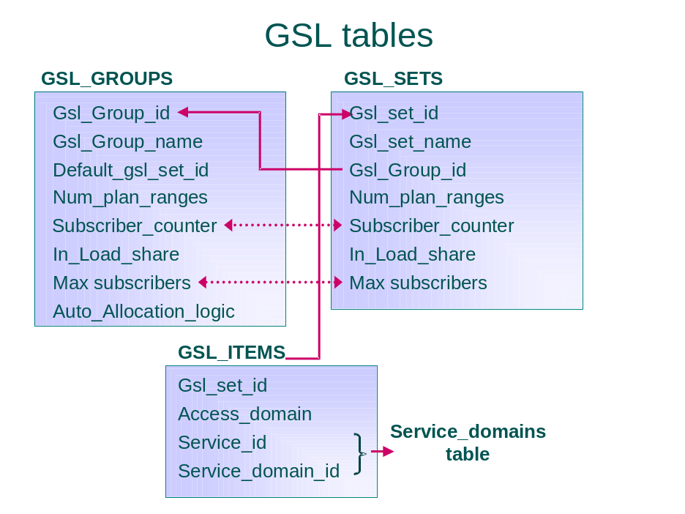

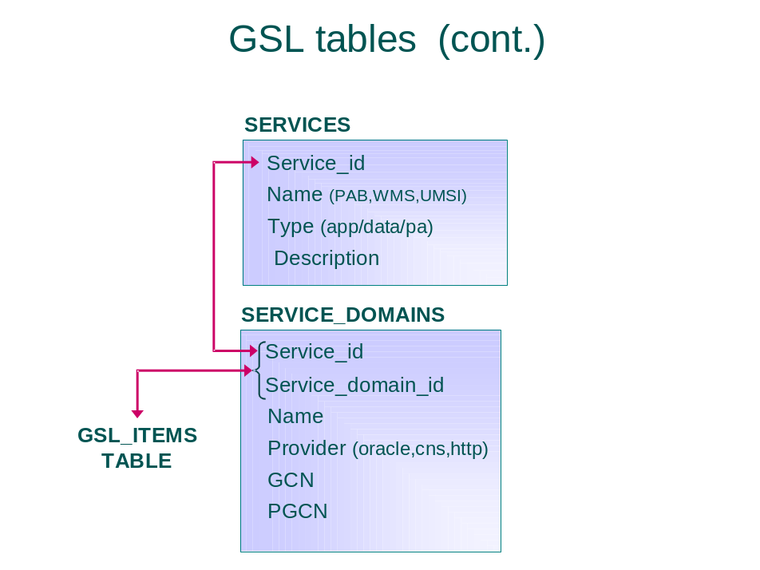

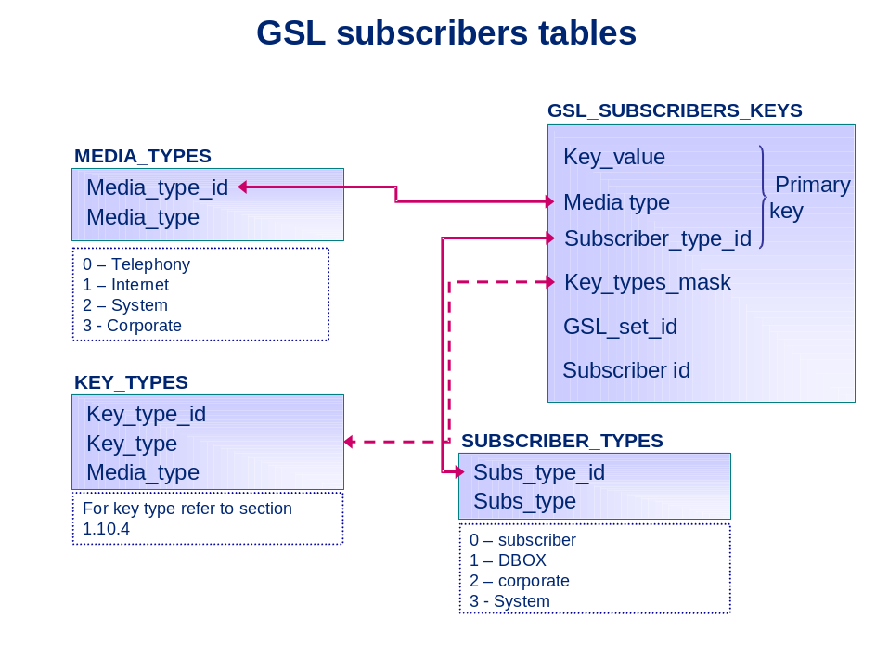

Sequences
This was never used, so it does not have to be returned in downgrade

GSL_SET_ID_SEQ incremented by 1 - used for GSL_SETS.gsl_set_id

GSL_GROUP_ID_SEQ start from 101, incremented by 1 - used for GSL_SETS.gsl_set_id → GSL_Groups.gsl_group_id
When upgrading an existing schema – the sequence shall not be modified

IID_SEQ incremented by 30 - used for IID number

SERVICE_ID_SEQ - incremented by 1 - used for SERVICES.service_id

SVCDOMAIN_ID_SEQ incremented by 1 – used for SERVICE_DOMAINS.svcdomain_id

Application Logic

Transactions Definition
For each planned transaction the following spreadsheet should be filled:
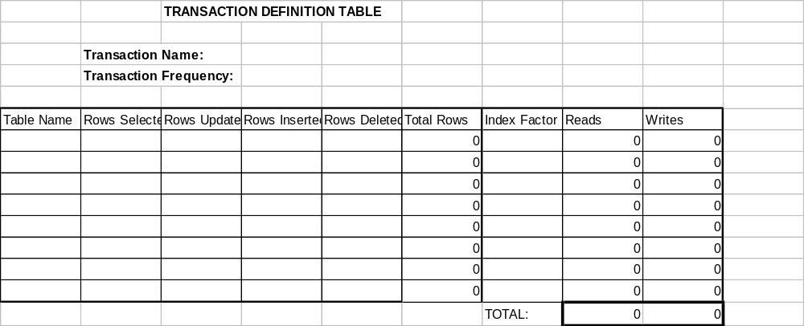

Transaction frequency should be defined per some time period (hour, day, etc.) or per some interaction period (e.g. telephony session).
The transaction can be made up of multiple SQL statements (DBI calls). Make a separate line for each table that is touched by the transaction. If a table is touched multiple times by different SQL statements, list it each time it is touched.
The first column is for the table name.
Enter the number of rows that will be selected/inserted/updated/ in the proper column.
In the sixth column the total sum of rows touched will be calculated.
Use the following rules to fill the index factor:
- index factor=5 when selected rows are accessed randomly according to the index (use 6 for the large tables);
- index factor=4 when inserted or updated rows are accessed randomly according to the index (use 5 for large tables);
- index factor=2.5 when selected rows are accessed sequentially according to the index (use 2.8 for less than 10 rows, use 2.3 for more than 100 rows);
- index factor=1.5 when inserted or updated rows are accessed sequentially according to the index;
- in other cases index factor=1.
Spreadsheet will automatically perform calculations of the total rows reads and writes.

Physical Requirements
The following sections should be repeated for each new table. All the quantitative data should be described relative to size definition of the target system (number of ports, number of subscribers, etc.).
For example, if it is considered that 1 telephony port supports 500 subscribers, then the typical system of 400 ports can be defined as system for 200000 subscribers.

Table <name>
This section (together with subsections) should be repeated for each new table.
<name> should be replaced with the corresponding table name.

Storage requirements

Initial Number of Rows | Maximum Number of Rows | Average Number of Rows | Annual Growth Rate (%)
This data will eventually be used in the algorithm for the storage allocation necessary for the table

Operations Profile
This paragraph contains the breakdown of common actions for the table.

% Select | % Insert | % Update | % Delete

This data will be used to optimize the physical structure of the database.
Numbers in the access breakdown may be very approximate, defining mostly relative access distribution. For example, telephony port definition may be defined as 80% query, 18% insert and 1% update and delete, while message would be 30% query, insert and delete, and 10% update.

Remove

