VI_SWIM_Integ CookBook

Description

VI_Swim_Integ is the Kit that in use by all VA Services (VI_Suite,MMG, and WHC ) to deploy the UAF/SAF Files of each service and create new System at SWIM. The Kit Deploy 2 separate Installation utilities:
- CreateSystem – which is use to create new Swim System for the VA Units Installation. For VI_Suite units are CAS,PROXY,MTS . For MMG MMSGW,MTS,PROXY,NDU. For WHC – NDU.
- AddServiceUtil – which is used for the VA AddServise Phase. The phase which bind the new service to the PVVM (Voice Hub or whatever you whish to call it).
The Kit is deployed as rpm file – and it install all the necessary files at the SWIM agent machine and configure all the relevant configuration – so after the rpm installation the Kits are ready to use ( no need to restart SWIM).
These utilities may run ONLY with the SwimManger system. The SwimManger System is create automatically at the swimManger when installing the VI_Swim_Integ rpm file.

Content Overview
Vi_swim_Integ contains 2 SWIM Installation Kits. That’s means after the rpm installation 2 new Folder should be create under the swim's kit Folder: CreateSystem and AddServiceUtil. Each such folder is independent SWIM Installation Kit with CAF and installation content:

CreateSystem Folder Structure
  - BuildCvl.pl - This script Build CVL File for each Kit Folder. It is called automatically from the CreateSystem CAF in the Relevant System ( usually system that should run MMG Installation ). Each CVL File would have the Kit Foldaer Name which is relevant to the CVL.
  - BuildSwimSystem.pl - This script creates New SwimSystem + UnitGroupfile + copy the relevant UAF/SAF to the system and update relevant Values / fields at the SAF/UAF.
  - createSystem-CAF.xml - This is the main CAF that handle the SWIM System creation. It expose the relevant parameters to installer and call the BuildSwimSystem.pl
  - MMG_UnitMap.csv - This is the Map Table which describe to the UnitGroup Builder what UnitType to use for each machine if the system that should be create is for MMG Services.
  - NDU-WHC_UnitMap.csv – This is the map table which describe to the UnitGroup Builder what UnitType to use for each machine if the system that should be create is for WHC Services.
  - VI_UnitMap.csv - This is the map table which describe to the UnitGroup Builder what UnitType to use for each machine if the system that should be create is for VI_Suite Services.
  - MMG Folder - contains all the Relevant SAF and UAF Files for MMG Services.
  - NDU-WHC - contains all the Relevant SAF and UAF Files for WHC Services.
  - VI - contains all the Relevant SAF and UAF Files for VI Services.

AddServiceUtil Folder Structure
- createSystem-CAF.xml - This is the main CAF that handle the SWIM System creation. It expose the relevant parameters to installer and call the CreatAddServiceSys.pl or CreatSys.pl scripts.
- MMG folder - contains all the relevant UAF and SAF for MMG AddService Installation.
- NDU-WHC folder - contains all the relevant UAF and SAF for WHC AddService Installation.
- scripts folder - contains all the scripts that is used by the CAF.
- VI folder - contains all the relevant UAF and SAF for WHC AddService Installation.

Create System UAF/SAF Format
Create System Utility – in additional of copying the Relevant UAF/SAF File of each relevant service to the new SWIM system – updates relevant Tags and parameters values at the UAF /SAF according to the user configuration. It updates relevant machine names at "OnlyOn" Tags and updates Values at "Parametes" Tags. It uses building Tokens at SAF/UAF in order to determine which value to assign.

Update component "onlyOn" Tags
"Createsystem" searches for all the tags that looks like bellow:
<Component Name="component Name" ExecutionOrder="Number">
<OnlyOn>
<UnitName>Balancer</UnitName>
</OnlyOn>
</Component>

Each token Balancer would be replace with the Unit Name that entered as relevant balancer at the createSystem. List of relevant balancers will retrieve accordingly to the Relevant balancer zone definition at the Map File.
Example – NDU-UAF.aml , NDU-WHC_UnitMap.csv, and the following

2 .Update parameters value
"CreateSystem" searches for all aliases and/or parameters with the
Following list of Tokens at the "Value" Element Node:
#BalancerIP# - would be replace with all MZ Balancer list
#BalancerIP1# - would be replace with First MZ Balancer IP
#BalancerIP2# - would be replace with second MZ Balancer IP
#DMZIP# - would be replace with all DMZ Balancer List
#DMZIP1# - would be replace with First DMZ Balancer IP
#DMZIP2# - would be replace with second DMZ Balancer IP
#AllBalacersIP# - would be replace with All Balancers IP ( DMZ + MZ )

For example :
For the following configuration
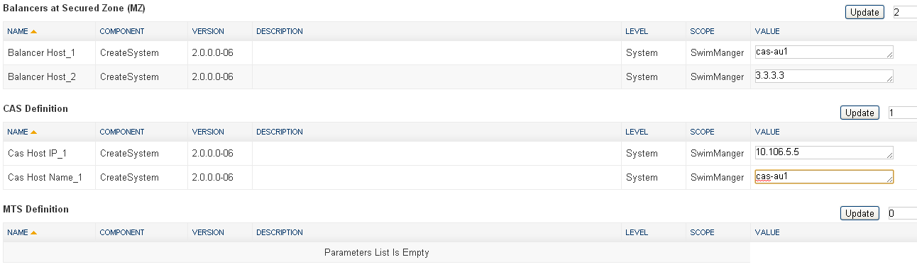

The value of Balancer IP Override would be replace
<Alias DisplayName="Balancer IP Override" Display="false">
<Value>#AllBalacersIP#</Value>
<Restrictions>
<Type>String</Type>
</Restrictions>
<Parameter Name="Babysitter - BalancerIPOverride" ComponentName="MMG_ServiceKit_MTS-U"/>
<Parameter Name="Babysitter - BalancerIPOverride" ComponentName="MMG_ServiceKit_NDU"/>
<Parameter Name="Babysitter - BalancerIPOverride" ComponentName="MMG_ServiceKit_MMSGW"/>
<Parameter Name="Babysitter - BalancerIPOverride" ComponentName="MMG_ServiceKit_PROXY"/>
<Parameter Name="Balancer IP Override" ComponentName="Babysitter"/>
</Alias>

with <Value>10.106.5.5, 3.3.3.3</Value>

AddServiceUtil UAF/SAF Format
AddServiceUtil – in additional of copying UAF/SAF of the relevant AddService Files . it updates some parameters values at UAF / SAF files. Update of parameters will be done according to the map definition at script CreateAddServiceSys.pl. This script contains definition of hash parameter named ServiceMap This Hash maps for each service ( VI / MMG / WHC ) list of parameters to change and which value should be assign to the parameter.

View Structure
The View folder at clearcase contains the main folder called Build. Under this folder the following folders exists:
- AddService – This folder contains all the AddServiceUtil kit content. in the same order and level that may appear at the SWIM Kits folder.
- Common - This folder contains all the CreateSystem kit content. in the same order and level that may appear at the SWIM Kits folder. + The UAF File that should be Installed into SwimManager ( The same UAF File is used for CreateSystem and AddServiceUtil – this is the reason that the CAF component name of Createsystem and AddServiceUtil has the same name ) system folder. And the UnitGroup.xml which contains single UnitInstance (The Local host )
- Linux – This folder contains the script that pack all the View into single rpm and the specs of the rpm. In order to add files (UAF/SAF) to one of the Kits you need to update the Spec file at this folder !!!
- Solaris – this folder contains the script that pack all the View into solaris package and the specs of the package. This is not relevant anymore cause SWIM is installed on SMU Linux ONLY.

UnitGroup Map files (CSV)
CreateSystem contains csv file which are use to map each UnitType (CAS, PROXT, MTS,NDU etc) to the relevant Physical UnitType at UnitGroup.xml file. Each service has its own Maping file.the convention of the mapping file name is Service Type_UnitMap.csv ( where service type may be MMG,VI, WHC). All the csv files has the same number of columns:
Octopus Unit Type - This column contains the Name of the parameter as the SWIM export. exluding the suffix _IPNumber.
GroupName at UnitGroup - This Column contains the relevant name of the UnitGroup Type at UnitGroup.xml file.
Network - This column contain the Network Type that the unit belong to – means if this unit is balancer it should be defined at the relevant balancer zone.

