Guided Capstone Project Report

Big Mountain Resort is looking to review the ticket prices for skiing at the resort and compare to the rest of the market to determine if their ticket prices are accurate or could handle an increase. Big Mountain has 105 trails with approximately 350,000 visitors per year. Additionally, they have 11 lifts, 2 T-bars, 1 magic carpet and recently installed a new chair lift which increases operating costs significantly. They have been taking the average ticket prices in its market share and charging a premium on top of that, but would like to explore a better way to capitalize on their facilities.

The data provided gave an overview of the market segment across the country. The first steps were to review the data and clean it as needed to be able to successfully compare across the market. It was also imperative to determine whether it was helpful or detrimental to take into account all states as they were spread out across the country. Would knowing the specific states be useful to the analysis? This question was answered during the exploratory data analysis phase and it was determined that knowing which states gave which data points was irrelevant to determining the best ticket price based on the data at our disposal.

During the pre-processing and training stage of the project, we were able to discover the best model to use which turned out to be a random forest generator pipeline. Throughout this process it was able determine which were the most significant variables to take into account to determine pricing. These variables were: Vertical Drop, Snow Making Coverage, Total Chairs, Fast Quads, Runs, Longest Run, Trams, and Skiable Terrain.

When finalizing the model, we evaluated Big Mountain’s stance on the key variables to see where it fell in comparison to the market share. Big Mountain fell towards the higher end within the segment on most of the key items. This is great news in the price increase department as it gives additional credence that Big Mountain’s prices are currently below where they should be. The model indicates that Big Mountain’s Adult Weekend ticket prices could go up as high as $96 based on the key variables and other resorts pricing.

Additionally, Big Mountain has come up with a couple other business options to reduce operating costs. The model has been built with the utility to examine pricing based on the facilities present in the resort.

The first option is to close down up to 10 runs. Below is a chart that shows the effect on potential ticket prices based on the runs closed. If 3 runs are closed, it’s worth it to close 5 since there is no noticeable impact. Closing 6 or more however shows a very steep drop but once 7 runs are closed, closing 10 has no impact.

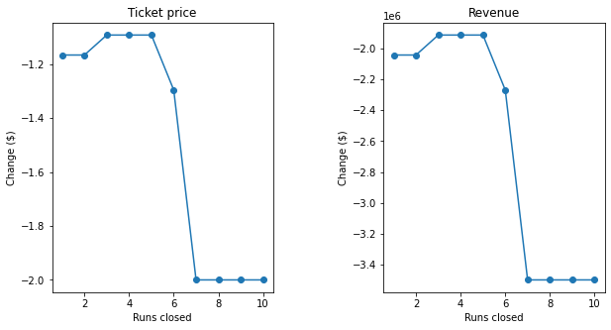

The second option is to increase the vertical drop by adding a run to a point 150 lower down, but requires an additional chair lift. This scenario supports increasing the ticket price by a small amount but does increase operating costs substantially given an additional chair lift.

The third option is the two options from the second option but also adding 2 acres of snow making coverage. This additional coverage offers no additional price increase from the second option.

The final option is to increase the longest run by .2 miles and add 4 acres of snow making capability, this option shows no difference in recommended price changing.

Overall, the Adult Weekend ticket prices at Big Mountain can support a price increase with its current infrastructure and facilities. The price recommended would be a large jump so it is recommended to increase the price over time. This slower pricing adjustment will also give additional information and data to see if it has any impacts on visitor numbers.