1. **CPU BENCHMARK**

GFLOPS:

1. Copy the folder CPUFLOPSBenchMark to the EC2 instance.
2. Run the below command for source code compilation

javac CPUFLOPSBenchMark/*.java

1. Run the below command for calculating the GFLOPS(1Thread,2Thread,4Thread)

java -DCompiler="NONE" CPUFLOPSBenchMark.FLOPSExecutor

Please find the results as below

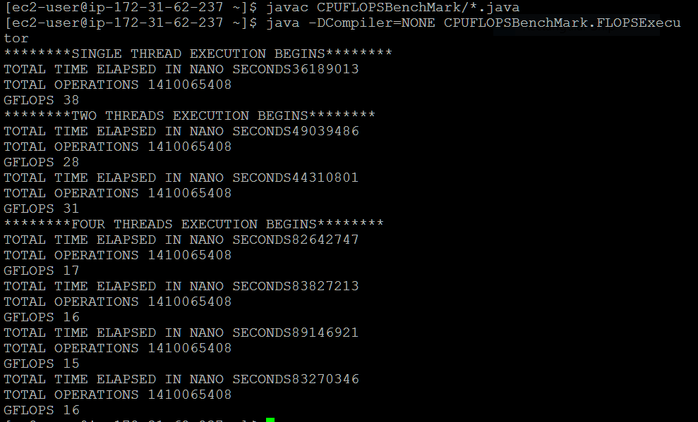

1. To collect FLOPS samples every second for 10 minutes , run the below command.

java -DCompiler="NONE" CPUFLOPSBenchMark.FLOPSSamplerExecutor

1. After 10 mins when the Sampling completes, open FLOPSSampler.txt to see the results.

IOPS:

1. Copy the folder CPUIOPSBenchMark
2. Run the below command for source code compilation

javac CPUIOPSBenchMark/*.java

1. Run the below command for calculating the GFLOPS(1Thread,2Thread,4Thread)

java -DCompiler="NONE" CPUIOPSBenchMark.IOPSExecutor

Please find the results as below

Please find the results as below

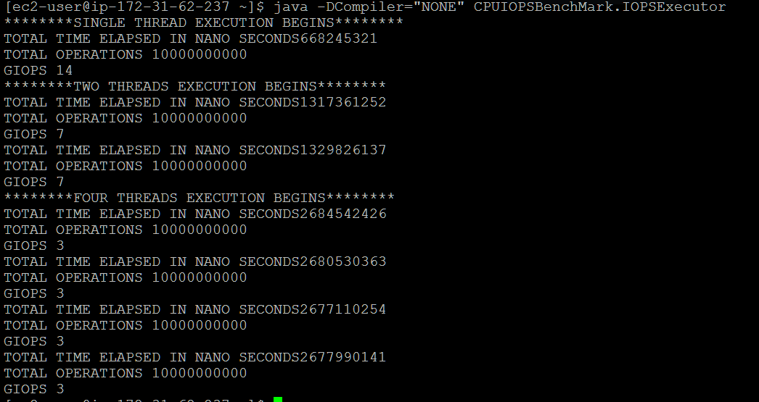

1. To collect IOPS samples every second for 10 minutes , run the below command.

java -DCompiler="NONE" CPUIOPSBenchMark.IOPSSamplerExecutor

1. After 10 mins when the Sampling complete , open IOPSSampler.txt to see the results.