1. **DISKBENCHMARK**
2. DISK SEQUENTIAL WRITE
3. Copy the folder DiskSequentialWrite to the EC2 instance
4. Run the below command for source code compilation

javac DiskSequentialWrite/*.java

1. Run the below command for calculating the MB/Sec and latency for single thread byte sizes ( 1B,1KB,1MB)

java -DCompiler="NONE" DiskSequentialWrite.SeqWriteSingleThreadExecutor

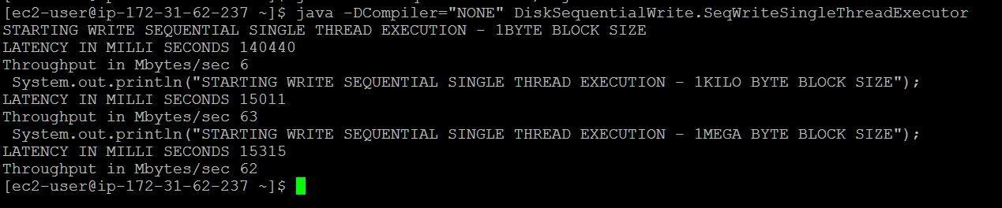

1. Run the below command for calculating the MB/Sec and latency for two threads byte sizes ( 1B,1KB,1MB)

java -DCompiler="NONE" DiskSequentialWrite.SeqWriteTwoThreadsExecutor

Sample output for two threads

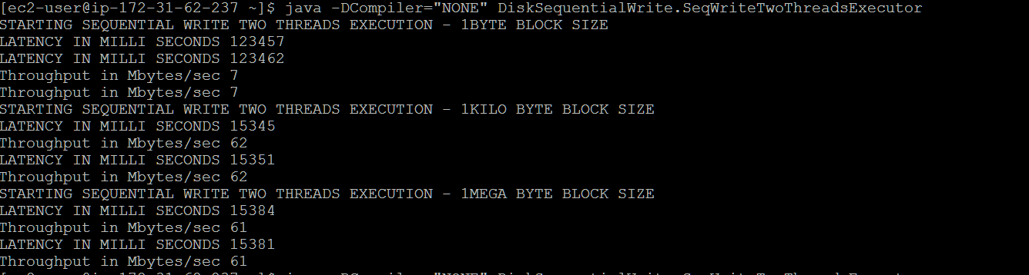

1. DISK SEQUENTIAL READ

Generate file.txt with the below command

1. base64 /dev/urandom | head -c 1000000000 > file.txt
2. Copy the folder DiskSequentialRead
3. Run the below command for source code compilation

javac DiskSequentialRead/*.java

1. Run the below command for calculating the MB/Sec and latency for single thread byte sizes ( 1B,1KB,1MB)

java -DCompiler="NONE" DiskSequentialRead.SequentialReadSingleThreadExec

1. Run the below command for calculating the MB/Sec and latency for single thread byte sizes ( 1B,1KB,1MB)

java -DCompiler="NONE" DiskSequentialRead.SequentialReadTwoThreadExec

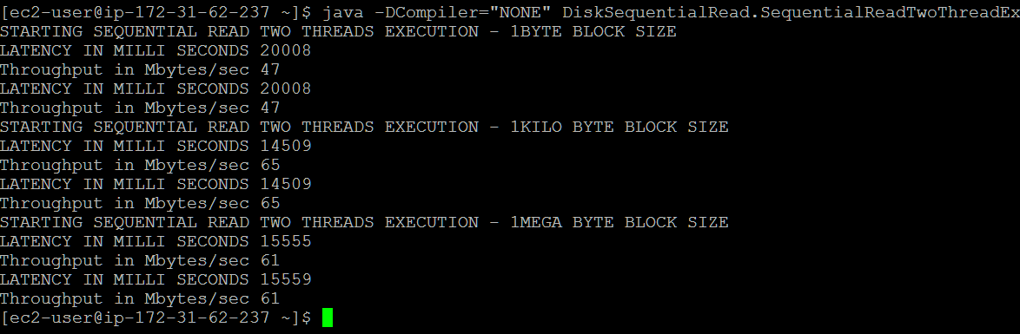

C) RANDOM READ

Generate file.txt using the below command

1. base64 /dev/urandom | head -c 100000000 > file.txt

2 . Copy the folder DiskRandomRead

1. Run the below command for source code compilation

javac DiskRandomRead/*.java

1. Run the below command for calculating the MB/Sec and latency for single thread byte sizes ( 1B,1KB,1MB)

java -DCompiler="NONE" DiskRandomRead.RandomReadSingleThreadExec

1. Run the below command for calculating the MB/Sec and latency for single thread byte sizes ( 1B,1KB,1MB)

java -DCompiler="NONE" DiskRandomRead.RandomReadTwoThreadExec

D) RANDOM WRITE

1. Copy the folder DiskRandomWrite
2. Run the below command for source code compilation

javac DiskRandomWrite/*.java

1. Run the below command for calculating the MB/Sec and latency for single thread byte sizes ( 1B,1KB,1MB)

java -DCompiler="NONE" DiskRandomWrite.RandomWriteSingleThreadExec

1. Run the below command for calculating the MB/Sec and latency for single thread byte sizes ( 1B,1KB,1MB)

java -DCompiler="NONE" DiskRandomWrite.RandomWriteTwoThreadExec

