**FT (Flowering Time) App**

Purpose: To score dates of maturity traits.

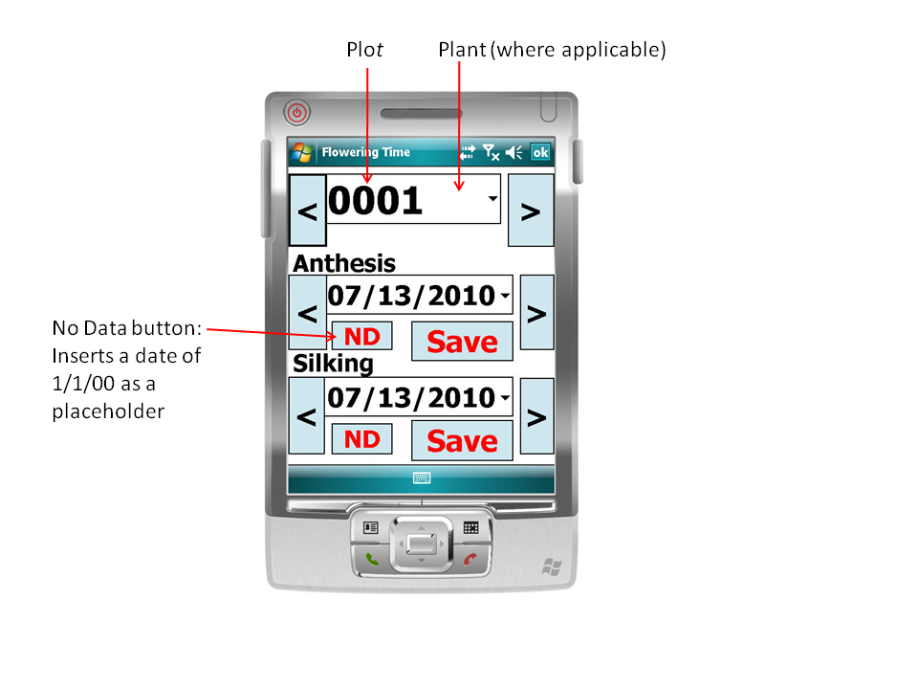

It utilizes a largely self-explanatory user interface which utilizes large buttons to minimize stylus use.

There are Next “>” and Last “<” buttons to navigation of plots/plants and dates. For navigating far from the shown location, both plots/plants and dates have combo-box pull-down arrows.

The combo box at the top provides a view of the plot number. If scoring individual plants, it will provide the plant number with a space between the 4-digit plant and 2-digit plant to simplify viewing.

When a date value is to be scored, pressing the “Save” button will write the value out to the MyData.txt file that is located within the My Device > Program Files > FTAppWM6 directory. Once the date has been saved, the Date combo-box as well as the “ND”, and “Save” buttons will become grayed out.

It was designed to leverage an individual’s ability to score the maximum number of plots or plants. Thus, the plot/plant Next “>” or Last “<” buttons will take the scorer to the next plot/plant needing to be scored, skipping over all rows for which both traits have already been scored. Thus, once both anthesis and silking have been scored for a given plot/plant, that plot/plant will not appear in the plant/plot combo-box again. However, if you wish to revisit a row for which both traits have been scored, the plot/plant combo-box allows navigation to any location.

If you observe a row that was scored incorrectly/prematurely, one can simply navigate to the new, correct date and press “Save”. The new date will over-write the previous value.

In the situation where no value currently or will ever exist and a value is accidentally scored, there is no way within the app to undo. The design directive of keeping the UI simple and usable without a stylus has prevented the addition of that functionality. To remove an accidentally scored value, one could manually edit the MyData.txt file on the device but the risk of fouling up the tab-delimiting within the file is high. It is better to make a note about the row/plant having the incorrectly scored value and, at a later time, edit the MyData.txt file on a computer.

**Installation**

Requirement:

For Windows XP ActiveSync 4.5

<http://www.microsoft.com/windowsmobile/en-us/downloads/microsoft/activesync-download.mspx>

For Windows Vista or Windows 7, use Windows Mobile Device Center

<http://www.microsoft.com/windowsmobile/en-us/downloads/microsoft/device-center-download.mspx>

The instructions below are based on using Windows XP. For Windows 7 and the Windows Mobile Device Center, the instructions are similar but even simpler.

Note: These instructions do not involve syncing with the device. One never needs to sync to install, use or manage this application. All that is necessary is some manner of accessing the device’s file system. The directory containing the application installer just needs to be placed on the device. If one can set up a Bluetooth connection and share a directory, then that is sufficient. If the device accepts a memory card and you can get the files onto that card and into the device, then that also works. If the device is WiFi-enabled and you can download it from a web-based email account, then that also works. Once the appropriate files are placed on the device, installation can be initiated.

Connect device to computer using data cord

For the HP iPAQ 111 or 211, this is a USB cable.

For the Motorola/Symbol Technologies devices require the charging cradle, the cradle’s power cord, and a USB cord to connect the computer to the cradle.

If you have it so configured, ActiveSync will automatically open and connect to the device.

Configuring ActiveSync:

Start > All Programs > Microsoft ActiveSync > File Menu > Connection Settings… > Check “Allow USB Connections” and “Open ActiveSync when my device connects”

Note: If ActiveSync tries to set up a synchronization, i.e., if you receive the “Welcome to the Pocket PC Sync Setup Wizard” or some facsimile thereof, just cancel out of it.

Click on Explore button to view file system on device:

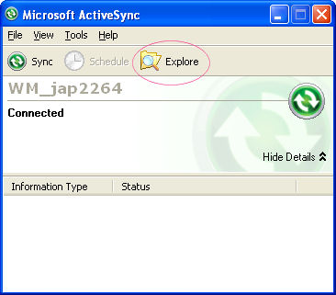

Now you should have a File Explorer window that shows you the device’s file system. Somewhere on your computer you should have the basic application. I generally call the directory “ReleaseX.XX”, e.g., Release0.05 for version 0.05, and it contains three files: CabWiz.log, FTAppWM6CAB.CAB, FTAppWM6CAB.inf. Move the directory onto the device. Now when you use the device’s File Explorer, look in My Documents and the directories should look familiar. Go into the ReleaseX.XX directory and you will see the following:

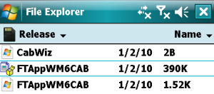

Click on the FTAppWM6CAB with the little box icon as shown above. The application will install.

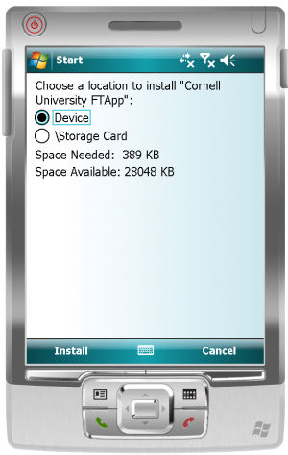 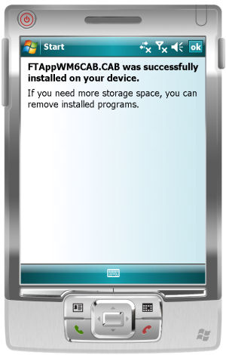 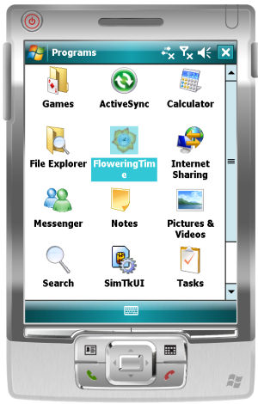

If you try to run the application at this point, you will receive an error:

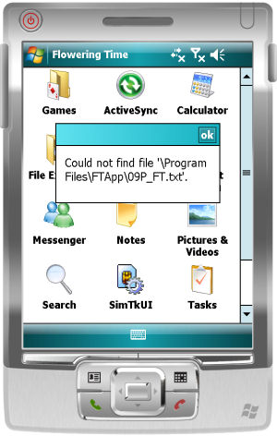

**Data File:**

The data file, MyData.txt is a tab-delimited file which has the following format properties:

1. It must be named MyData.txt
2. First line (can be anything but generally) is the column headers: plot_id anthesis_date silking_date
3. Subsequent lines are of the format: <plot_id> <mm/dd/yy> <mm/dd/yy>

For visualization purposes, I often put a dot (i.e., “.”) in the date column positions as placeholders, but this is not necessary.

1. For the application to run, it must be placed in the same directory as the application: My Device\Program Files\FTApp\MyData.txt
2. When “No Data” (the **ND** button) is scored, the application saves a date of 1/1/00 as a placeholder. Thus, if you wish to score only a single trait (Silking or Anthesis), one can pre-populate the MyData.txt file with a column of 1/1/00 placeholders.

This software was created by Dallas Kroon (dek29 at cornell…) and is licensed under the GNU General Public License version 3.

http://www.maizegenetics.net

Laboratory of Edward Buckler

USDA-ARS & Cornell University