GCP Private Service Connect Infrastructure
This document describes the PSC infrastructure that connects a ScyllaDB cluster running in a producer VPC to consumer applications in a separate VPC, using a Port Mapping NEG to route per-node traffic through a single PSC endpoint.

Architecture Diagram
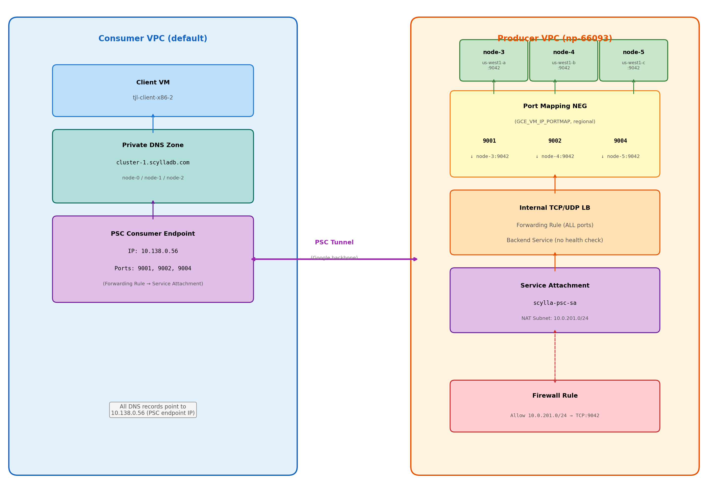

Traffic Flow
A client in the consumer VPC connects to the PSC endpoint IP (10.138.0.56) on a node-specific port. The traffic traverses Google’s backbone through the PSC tunnel and arrives at the producer-side Internal TCP/UDP Load Balancer. The Port Mapping NEG translates the destination port to the correct backend instance and port:
Client Connects To | Client Port | Routed To | Backend Port
10.138.0.56 | 9001 | node-3 (us-west1-a) | 9042
10.138.0.56 | 9002 | node-4 (us-west1-b) | 9042
10.138.0.56 | 9004 | node-5 (us-west1-c) | 9042

Producer Side Components
PSC NAT Subnet (10.0.201.0/24)
Dedicated subnet used by the PSC service attachment for network address translation. Traffic from consumers arrives with source IPs from this range.
Port Mapping NEG (GCE_VM_IP_PORTMAP (regional))
Regional Network Endpoint Group that maps client-facing ports to specific backend instances. Each endpoint entry maps one client port to one instance:port pair. Key constraint: each instance can only appear once in the NEG.
Backend Service (No health checks)
Regional backend service with the port mapping NEG attached. Health checks are not supported with port mapping NEG backends.
Forwarding Rule (Internal TCP/UDP LB, all ports)
Internal passthrough load balancer forwarding rule configured with all_ports=true. Required as the target for the PSC service attachment.
Service Attachment (scylla-psc-sa)
PSC service attachment that exposes the forwarding rule to consumer VPCs. Uses the NAT subnet for address translation. Connection preference: ACCEPT_AUTOMATIC.
Firewall Rule (Allow 10.0.201.0/24 → TCP:9042)
Permits traffic from the PSC NAT subnet to reach the ScyllaDB nodes on port 9042. Without this rule, PSC traffic is silently dropped.

Consumer Side Components
PSC Consumer Endpoint (IP: 10.138.0.56)
A forwarding rule in the consumer VPC that targets the producer’s service attachment. Allocated a static internal IP with GCE_ENDPOINT purpose.
Private DNS Zone (cluster-1.scylladb.com)
A private DNS zone visible within the consumer VPC. Allows clients to use hostnames instead of raw IPs.
DNS A Records (Root + per-node)
All records point to the PSC endpoint IP (10.138.0.56):
• cluster-1.scylladb.com → 10.138.0.56
• node-0.cluster-1.scylladb.com → 10.138.0.56
• node-1.cluster-1.scylladb.com → 10.138.0.56
• node-2.cluster-1.scylladb.com → 10.138.0.56

Port Mapping NEG: The Round-Robin Problem
The core limitation is straightforward: in a GCE_VM_IP_PORTMAP NEG, each VM instance can only appear once.

What We Have Today
Client Port | Backend Instance | Backend Port
9001 | node-3 (us-west1-a) | 9042
9002 | node-4 (us-west1-b) | 9042
9004 | node-5 (us-west1-c) | 9042
This works perfectly — each instance has exactly one mapping entry.

What Round-Robin on Port 9042 Would Require
To have PSC_IP:9042 load-balance across all 3 nodes, we would need to add three more endpoint mappings:
Client Port | Backend Instance | Backend Port | Result
9042 | node-3 | 9042 | FAILS: node-3 already has a mapping
9042 | node-4 | 9042 | FAILS: node-4 already has a mapping
9042 | node-5 | 9042 | FAILS: node-5 already has a mapping
GCP returns INVALID_ARGUMENT for every one of these because node-3, node-4, and node-5 already exist in the NEG. The constraint is per-instance, not per-port — you cannot add a second row for the same VM regardless of which ports you use.

Why GCP Designed It This Way
Port mapping NEGs are implemented as a 1:1 lookup table: (client_port) → (instance, backend_port). The NEG essentially acts as a port-based router, not a load balancer. There is no mechanism for multiple instances to share the same client-facing port because that would require load-balancing logic (health checks, session affinity, etc.) that port mapping NEGs do not have.

Workarounds
Approach | Trade-off
CQL driver with all 3 ports | Driver connects to 9001, 9002, 9004 directly — most ScyllaDB drivers handle multi-node topology natively. This is the recommended approach.
Proxy VM | Run a reverse proxy (e.g., HAProxy) on a dedicated VM that listens on 9042 and round-robins to the 3 nodes. Adds a hop and a single point of failure.
Multiple PSC endpoints | One PSC endpoint per node, each on port 9042. Consumer must create 3 forwarding rules + 3 IPs.
Second port mapping NEG + second PSC | Create a separate NEG with just 9042→node-X:9042 for one node, exposed via a second service attachment. Does not give true round-robin.

Recommendation for ScyllaDB
Use the per-node ports (9001, 9002, 9004) as contact points in the CQL driver. The driver discovers the full topology after initial connection and routes queries to the correct node automatically — round-robin on the connection port is unnecessary.

