
Sierra-Sacramento

Interagency UAS Utilization Guidelines
Version – February 9, 2026

Contents
Introduction
Guideline – Interagency UAS Utilization
Agency Expectations (Requesting agency)
Agency Expectations (Sending agency)
Pilot Expectations
Appendix
Preflight Checklists & Flight Log Examples
Flight Risk Assessment Example

This guideline delineates expectations for mutual aid UAS responses, including best practice expectations for interagency pilots and aircraft.
PURPOSE
GUIDELINE

Introduction
This guideline establishes standardized expectations and best practices for UAS deployment during mutual aid and multi-agency responses to ensure safe, coordinated, and legally compliant operations to mitigate risk, protect personnel, delineate liability, and enhance safety.

Section 1 – Agency Expectations (Requesting Agency)
Complex, long-duration, or multiple-jurisdiction incidents may require the operation of UAS from multiple agencies. Incident commanders (IC) should consider the following when requesting or utilizing UAS pilots and aircraft from other agencies.

  - Ensure a safe airspace over the incident for both crewed and uncrewed aircraft, as well as personnel and general public on the ground.
  - Consider establishing an Airspace Coordinator for the incident to coordinate the Incident Traffic Area (ITA).
  - Designate clear operational airspace zones to provide appropriate deconfliction.
  - Ensure positive two-way communications between all aircraft as well as the Airspace Coordinator.
  - Define specific incident objectives for UAS use (e.g. mapping, situational awareness, payload delivery, etc.)
  - Ensure all UAS operations comply with FAA regulations, particularly in regard to airspace.
    - Extreme caution and appropriate communication and steps should be utilized if operating near an active airport.

  - Notify the ECC/Dispatch Center having jurisdiction of on-going UAS operations
    - The ECC/Dispatch Center should pass this information to any responding aircraft, including law enforcement, medical, firefighting, or other.

Section 2 – Agency Expectations (Sending Agency)
First responder agencies sending or responding UAS to another agency’s incident should adhere to the following guidelines or best practices:

  - Ensure that pilots are properly trained, qualified, and currently carded to operate under FAA Part 107 regulations.
    - Agencies may opt to operate under a FAA Certificate of Authorization (COA) instead of Part 107 Commercial UAS Pilot regulations, but UAS pilots are still required to know and understand all elements of Commercial UAS operations, including FAA regulations for airspace utilization, weather minimums, and operating near public crowds.
    - Per FAA, pilots are required to have a copy of pilots license and a copy of a current COA, if appropriate.
    - Pilots have met currency requirements to operate the aircraft per their agency requirements.
  - Ensure that responding aircraft are airworthy and safe for operation. This includes (some of these points repeat earlier guidance):
    - The aircraft and pilot are certified, trained, or competent for the operation(s) they will be utilized for (e.g. commercial operation, night operations, external load, etc.).
    - Aircraft are registered in accordance with FAA requirements.
    - Aircraft are maintained and inspected in accordance with manufacturers’ specifications and recommendations.
    - No personally owned UAS shall be operated on an interagency incident without IC approval.

  - The sending agency shall assume responsibility and liability for the operation of UAS aircraft that they send to a mutual aid incident.

Section 3 – Pilot Expectations
UAS pilots, when responding as a mutual aid resource on another agency’s incident, should adhere to the following guidelines and best practices:
  - Ensure that you are properly trained and qualified to operate under FAA Part 107 or your agency’s COA.
  - Ensure that you are certified and current to operate the aircraft you are operating, per your agency’s requirements.
    - This includes licensing, carding, and periodic flight requirements.
    - If your aircraft is personally owned, that your agency accepts the liability for its operation, and you receive authorization from the IC prior to any operations on the incident.
    - If your aircraft is owned by an agency other than your own, validate that your agency is willing accept liability for the aircraft.
    - Verify that your aircraft is licensed and current per FAA Part 107 regulations.
  - Ensure you have a clear understanding of, and are operating within, FAA regulations regarding airspace, weather minimums, and other Part 107 regulations.
    - This includes See-and-Avoid, Visual Line of Sight (VLOS), weather minimums, and daytime/nighttime operations.
    - UAS pilots must maintain visual line-of-sight with the UAS at all times.
    - Avoid flights over people unless those people are directly involved in the operation.
    - Whenever possible, pilots should employ the use of a Visual Observer (VO) to assist in operations.
    - UAS shall only operate in Class G airspace unless permission has been received from Air Traffic Control (ATC) – SGI, LAANC, etc.
    - No flights are to take place within a Temporary Flight Restricted (TFR) area unless permission has been received from the aerial coordinator in charge of that TFR. (Please note that CAL FIRE and US Forest Service require QUALIFICATION of S-378 UAS Operations to operate on a wildland fire incident).
    - UAS pilots are to be particularly aware of UAS operations when near an operating airport. It may be legal to operate in some airspace, but not worth the risk.
  - Verify that your aircraft has been properly maintained as directed by the manufacturer’s specifications and recommendations.
  - Understand your position within the Incident Command System (ICS). Completion of ICS 100, 200, 700, and 800 is recommended.
  - Ensure that you have direct communications with the Airspace Coordinator and any other aircraft working within the ITA.

  - When applicable, verify that data or intel gathered from the flight is transmitted to the IC, or designee (e.g. SITL), that needs or can utilize that data.

  - Familiarity with the ROTr Airspace Deconfliction is highly recommended.

  - Unless deemed inappropriate, you will utilize a Pre-flight Checklist prior to operating your UAS. The Checklist will incorporate elements to ensure all safety and operational requirements are met prior to lifting off.

  - Recorded and/or streamed media must be approved by the IC.

    - All media releases must be coordinated through the Incident PIO and IC.

  - Flights will be logged and tracked per your agency’s requirements.

Appendix - Example Pre-flight Checklists & Flight Log

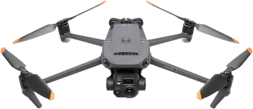
DJI Mavic Series Flight Check

Preflight
Controller | On – Battery Charged
Gimbal Protection | Removed
Payload | Configured and Attached
Arms/Props | Extended and Attached
Battery | Charged and Installed
Before Takeoff
Aircraft | Emplaced and Powered on
Antennas | Pointed properly
Flight App | On – Aircraft Connected
Aircraft Settings and Calibrations | Verified
Video | Displayed on Tablet
GPS | Flight Mode Set to Position
RSSI | Normal
Gimbal | Operating – Reset
Camera | SD card set and able to record
Takeoff Area | Clear
Takeoff
Aircraft | Report “Armed”
Aircraft | Report “Taking Off”
Takeoff Time | Recorded
After Takeoff | Aircraft 20’ Up and 20’ Out
Telemetry | Report Telemetry
Controllability Check | Ready to go
Note: Periodically report battery % and RSSI during flight
Before Landing
GPS | Flight Mode Set to Position
Aircraft Orientation | Nose Out
Gimbal | Reset
Landing Area | Clear
Landing
Aircraft | Report “Landing”
Aircraft | Report “Disarmed”
After Landing
Antennas | Stowed
Landing Time | Recorded
Aircraft | Powered Down

Emergency Fly Away Procedure
- Contact ECC or Aerial supervisor and report flyaway immediately with the following information
  - Aircraft type
  - Heading
  - Altitude
  - Remaining battery and expected flight time
  - Contact the appropriate center to close the loop regarding fly away
    - Seattle Center (253) 351-3520
    - Oakland Center (510) 745-3331
    - Los Angles Center (661) 265-8205
Call TAO duty line (916) 234-7309

Mission Planning
- Airspace verification complete LAANC and NOTAM filed if applicable
- Mission deliverables are valid and attainable
- Weather minimums are met
- Is icing a concern
- ECC notified

IMSAFE Checklist:
Illness: Do you have current or recent illnesses that could affect flight?
Medication: Have you been taking any meds that could impair your ability to fly?
Stress: Are you experiencing unusual psychological pressure and/or anxiety?
Alcohol: Have you had any alcohol in the last eight hours? Are you hungover?
Fatigue: Are you tired and/or not adequately rested, conducting high tempo flight operations, experienced long duty days or flight time near agency limits?
Emotion: Are you emotionally upset about anything?

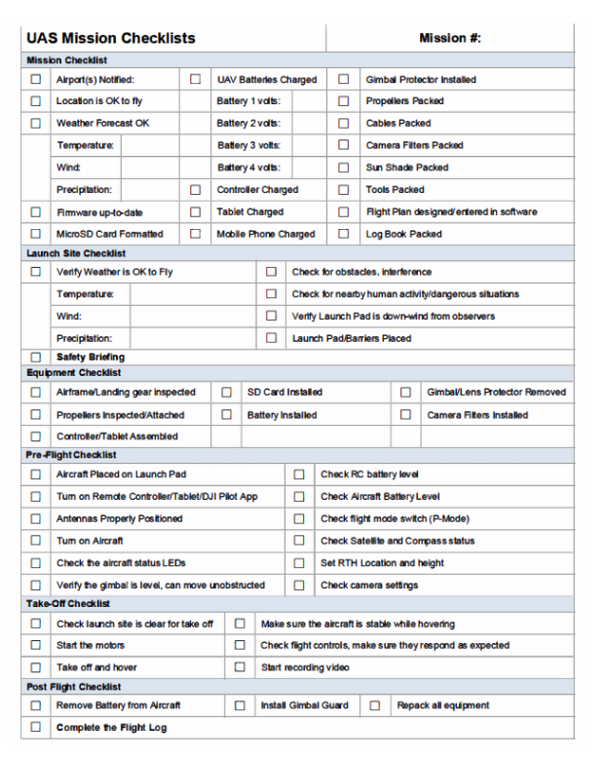
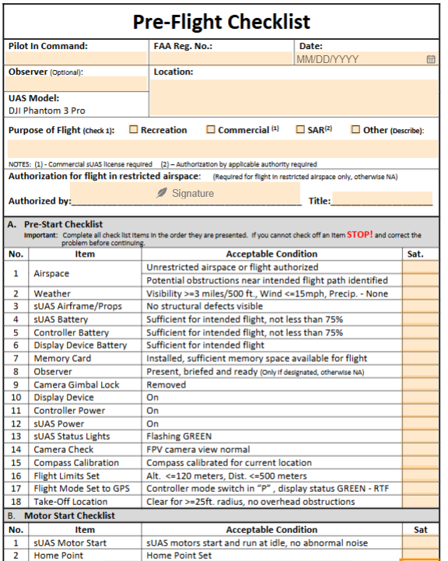
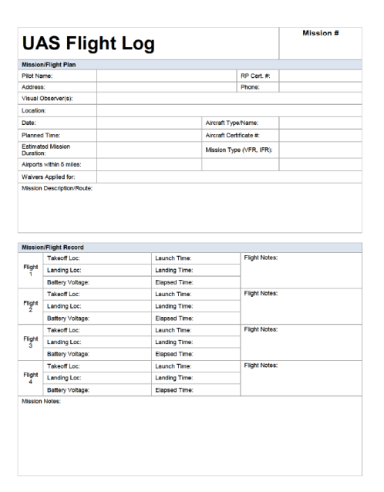
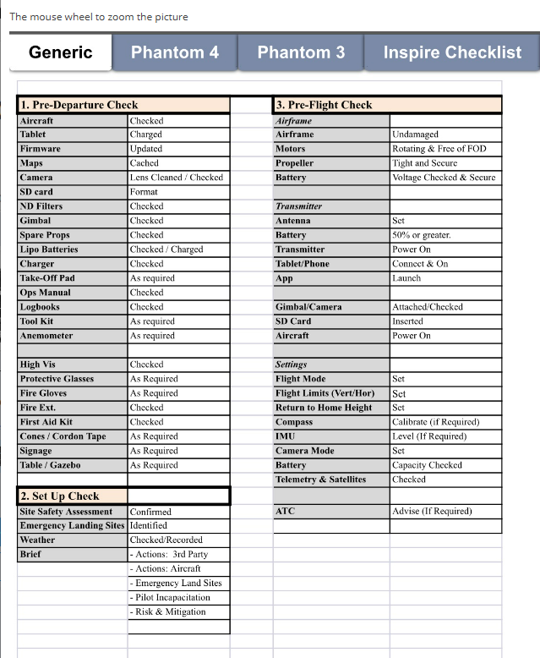
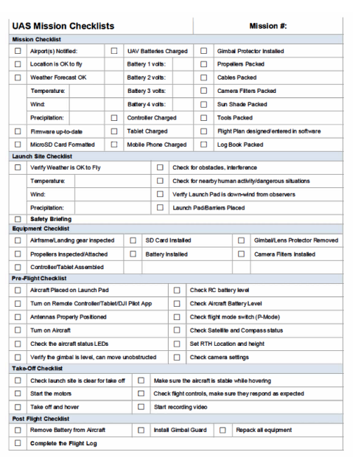
ICS Organization Chart (UAS Operations)

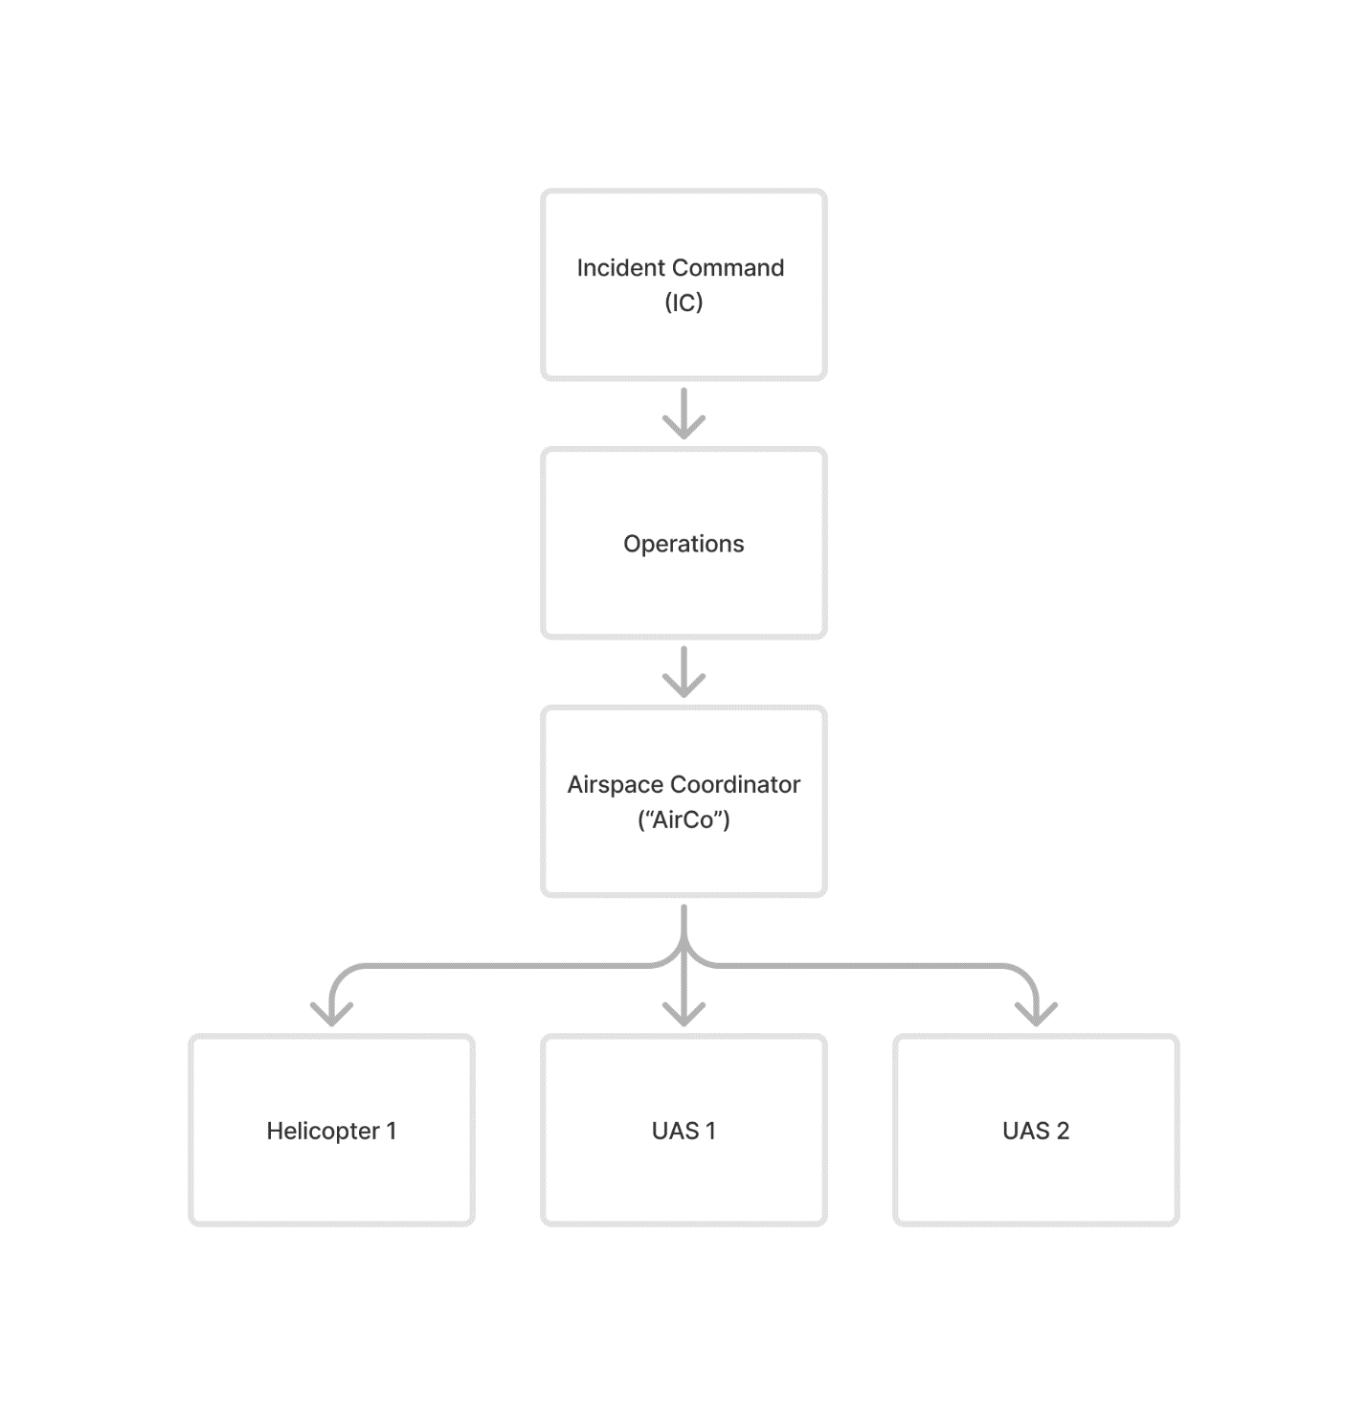

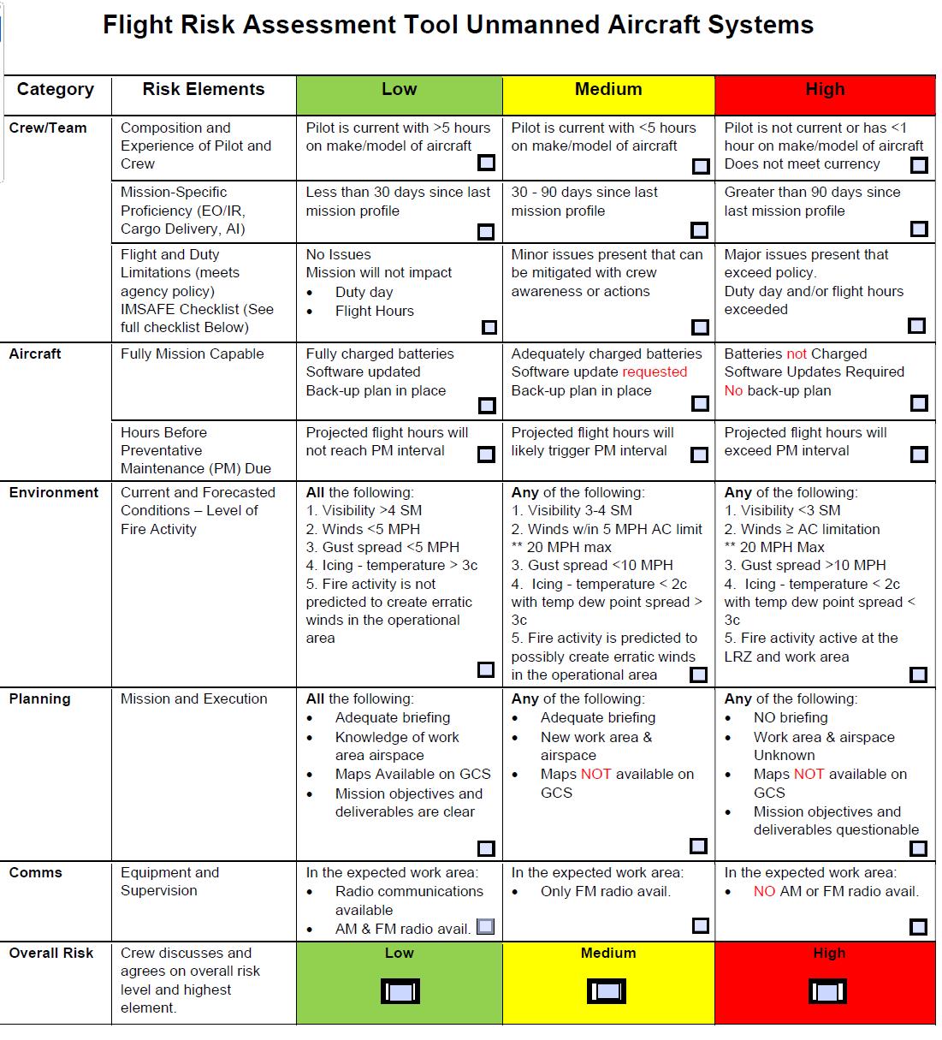
Flight Risk Assessment Example

