PIZZA SALES SQL QUERIES
A.KPI’s
1. Total Revenue:
SELECT SUM(total_price)AS Total_Revenue FROM pizza_sales;
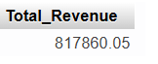
2. Average Order Value:
SELECT SUM(total_price) / COUNT(DISTINCT order_id) AS Avg_Order_Value FROM pizza_sales;
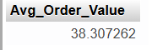
3. Total Pizza Sold:
SELECT SUM(quantity) AS Total_Pizza_Sold FROM pizza_sales;
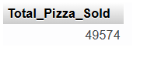
4. Total Order
SELECT COUNT(DISTINCT order_id) AS Total_Order FROM pizza_sales;
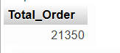
5. Average Pizza Per Order:
SELECT SUM(quantity) / COUNT(DISTINCT order_id) AS Avg_Pizzas_Per_Order FROM pizza_sales;
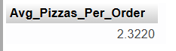

CHARTS REQUIRMENT
- Daily trend for Total Orders:

SELECT DAYNAME(STR_TO_DATE(order_date, '%d-%m-%Y')) AS order_day, COUNT(DISTINCT order_id) AS Total_orders FROM pizza_sales GROUP BY DAYOFWEEK(STR_TO_DATE(order_date, '%d-%m-%Y')), DAYNAME(STR_TO_DATE(order_date, '%d-%m-%Y')) ORDER BY DAYOFWEEK(STR_TO_DATE(order_date, '%d-%m-%Y'));
- Monthly Trend of total orders:
SELECT
DATE_FORMAT(STR_TO_DATE(order_date, '%d-%m-%Y'), '%Y-%m') AS order_month,
COUNT(DISTINCT order_id) AS total_orders
FROM
pizza_sales
GROUP BY
DATE_FORMAT(STR_TO_DATE(order_date, '%d-%m-%Y'), '%Y-%m')
ORDER BY
order_month;

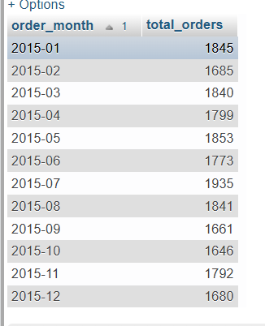
- Percentage of sales by pizza category
SELECT pizza_category, CAST(SUM(total_price) AS DECIMAL(10,2)) as total_revenue, CAST(SUM(total_price) * 100 / (SELECT SUM(total_price) from pizza_sales) AS DECIMAL(10,2)) AS PCT FROM pizza_sales GROUP BY pizza_category;

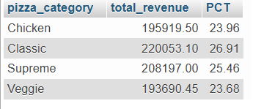
- % of Sales by Pizza Size

SELECT pizza_size, CAST(SUM(total_price) AS DECIMAL(10,2)) as total_revenue, CAST(SUM(total_price) * 100 / (SELECT SUM(total_price) from pizza_sales) AS DECIMAL(10,2)) AS PCT FROM pizza_sales GROUP BY pizza_size ORDER BY pizza_size;

