

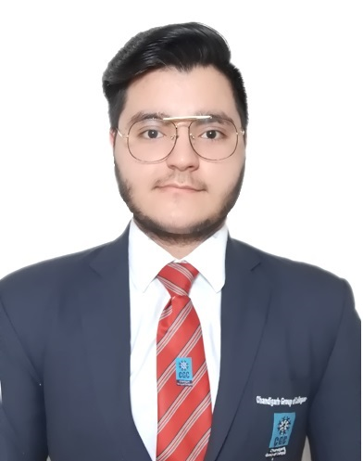

**DAKSH GROVER**

#617, Adarsh Nagar,

Malout-152107

+91-89682-83580

[dkshgrover@gmail.com](mailto:dkshgrover@gmail.com)

**EDUCATIONAL QUALIFICATIONS]**

|  |  |  |  |  |
| --- | --- | --- | --- | --- |
| **Year** | **Degree/Course** | **School/Institute** | **Board/University** | **Marks /Grade** |
| 2022 | Bachelor Of Technology (Cse) | CGC- Chandigarh Engineering college, Landran | Punjab Technical University | SGPA 8.045 |
| 2018 | 12th | D.A.V Edward Ganj Sen. Sec. Public School, Malout | Central Board of Secondary Education | 87% |
| 2016 | Matric | D.A.V Edward Ganj Sen. Sec. Public School, Malout | Central Board of Secondary Education | CGPA 9.0 |

**ACADEMIC ACHIEVEMENTS]**

* First position in Smart Hacks event organized by IIT, Kanpur in 2020.
* Reached final phase of Smart India Hackathon-2020 with project named Alumni Tracking system.
* First Position in “Mock Placement” – An Event organized by IEEE Student Branch in 2019.
* First Prize in “Declamation Competition” – Organized on Science Day at college level in 2019.
* Third Prize in 12th board exams at school level in 2018.

**SOFTWARE COMPETENCIES**

|  |  |  |
| --- | --- | --- |
| Operating Systems | : | Windows, Android |
| Languages known | : | C, C++, Java, HTML, CSS, Kotlin, Android with Kotlin |
| Database(s) known | : | MySQL |
| Other Interests | : | Rest API’s & Web Services, Photoshop |

**PROJECTS UNDERTAKEN**

|  |  |  |
| --- | --- | --- |
| 1. Project Name: PLACEMENT HELPER | | |
| Environment | : | Windows, Eclipse EE |
| Technologies | : | JAVA – 8, JSP, Servlets, MySQL – 5.6.17, HTML5, CSS3, Bootstrap |
| Project Description | : | * It is an application for helping student in preparing for their placements. * It has different roles assigned for college authority and students. Students can go through information like placement procedure, Aptitude and Interview questions asked by different companies to recruit students or projects selected. * All of them can login at their respective desktops and get all the information related to different companies , projects, etc. |
| Team Size/Role | : | 2/ Back-end(JSP, Servlets, JAVA, MySQL) |

|  |  |  |
| --- | --- | --- |
| 2. Project Name: Go-QUIZ APPLICATION | | |
| Environment | : | Android/Windows, Android Studio |
| Technologies | : | Android with Kotlin |
| Project Description | : | * It is a quiz application to enhance critical thinking and memorizing skills for children of age 5+ years. * Multiple types of quiz will be provided for students and they can attempt any of them and check their knowledge about the subject. * One can check simultaneously whether answer given is correct or not and also can check their overall score at end. |
| Team Size/ Role | : | 1/Front-end(UI with XML) and Back-end(Android, Kotlin) |

|  |  |  |
| --- | --- | --- |
| 3. Project Name: COLLEGE PORTAL | | |
| Environment | : | Windows, Eclipse EE |
| Technologies | : | JAVA - 8, JSP, Servlets, MySQL – 5.6.17, HTML5, CSS3 |
| Project Description | : | * It is a basic view of working of a College. * It has different roles assigned for Administrator, Payroll/HR, Teachers and Students. * All of them can login at their respective desktops and get all the information related to them, Students and their College. |
| Team Size/Role | : | 1/ Back-end(JSP, Servlets, JAVA, MySQL) and Front-end(HTML, CSS) |

**INDUSTRIAL TRAINING and EXPERIENTIAL LEARNING**

**Industrial Training:**

* **Language Learned:** Java
* **Organization:** MCP, Mohali
* **Project Details:** Placement Helper/College Portal

**Experiential Learning:**

* **Language Learned:** Studied C++ from Udemy (Online).
* **Language Learned:** Studied C language from Coursera.

**INTERPERSONAL SKILLS**

* Skills to listen others, use creative problem-solving, and arrive at an outcome that satisfies everyone.
* Ability to understand and show empathy for others as an employee, team player and colleague.
* Being able to motivate and encourage others and help a team achieve success.
* To develop a positive rapport with colleagues and maintain a proper networking.
* Being able to lead a team and promote productivity with quality.
* Good at making and maintaining strong relationship with team members and staff.

**EXTRA-CURRICULAR ACTIVITIES**

* Did various problem solving questions on Hackerrank platform and achieved 6 stars in it.
* Actively participated in various programming events like codevita, Coding Ninjas codeathon, Smart Hacks and many more in college.
* Member of virasat club and organized various events at college level.
* Actively participated in various singing and drama competitions in schools and played a leading role in them.

**HOBBIES/INTERESTS**

* Exploring different places to know their culture and history.
* Creating and organizing various fests and events to enhance critical thinking and leadership.
* To write quotations.
* Browsing internet to stay updated with current affairs and issues.

**PERSONAL INFORMATION**

|  |  |
| --- | --- |
| **Date of Birth** | 07 March 2001 |
| **Gender / Marital Status** | Male/Unmarried |
| **Language Proficiency** | English, Hindi, Punjabi |
| **GitHub Profile** | <https://github.com/dkshgrover/> |

**DECLARATION**

*I do hereby declare that the above information is true to the best of my knowledge****.***



**________________________**

**Name: Daksh Grover**  **Date:**

**Place: Malout**