Design Document

Version 1.0

Information System

File/Directory Information based Application

Sponsor:
Nuance

Development Team:
Deepak Singh

Table of Contents

Introduction
This document describes application’s architecture and their associated interfaces, database schemas, and the motivations behind the chosen design. Both high-level and low-level designs are included in this document.

The purpose of the document is to provide stakeholder’s a complete understanding of the System/Application, which includes System Overview, Design Consideration, System Architecture and detailed system design.

System Overview

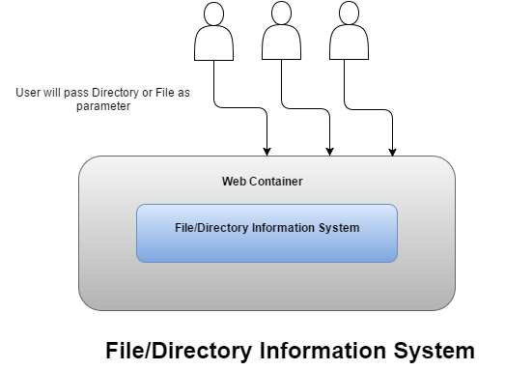
The File/Directory Information System.

Design Considerations
This section describes many of the issues that needed to be addressed or resolved before attempting to devise a complete design solution.

Decision

This is simple web application which returns information about File/Directory which needs to be developed using Spring MVC framework on Tomcat web server.

Maven is used as a packaging tool for this web application

Assumptions and Dependencies

Dependencies
- Java 1.6 version is required.
- Tomcat7.x Web Server
- Maven

Assumptions

- All above mentioned dependencies should be resolved.
- File Path/ Directory being passed to the server is from, where application is deployed.
- Since we have to return File/Directory Information passed as a parameter hence no need of database here.

Architectural Strategies

The application is divided into two part Server side application and client side application.

Server side application is further divided into Controller, Service Layer and Mapper.
Since application is not using Database for now so

High Level Architecture

Class Diagram
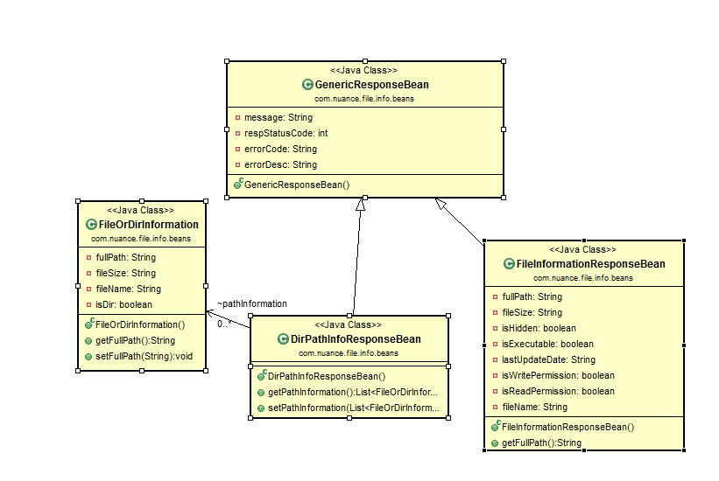

UX Design
The section contains UI look and feel details.

Directory Detail Screen

File Description Screen

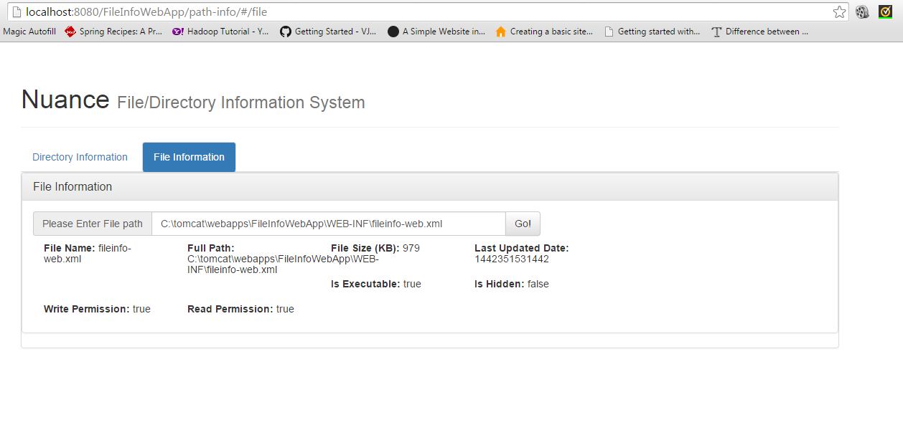

Services

getPathInformation

Request
Attribute Name | Data Type | Description
path | String | Full path to a directory.

Response

The response will contain List<FileOrDirInformation> which in turn contains following attributes.
Attribute Name | Data Type | Description
fullpath | String | Full path of File or Directory recursively found.
fileSize | String | Size of file in bytes if it is File otherwise For Directory size is not applicable and value will be null
isDir | boolean | True if it is Directory else false
fileName | String | Name of File

getFileInformation

Request
Attribute Name | Data Type | Description
path | String | Full path to a File

Response

Attribute Name | Data Type | Description
fullpath | String | Full path of File or Directory recursively found.
fileSize | String | Size of file in KB.
isHidden | Boolean | File is Hidden or not
isExecutable | Boolean | Is File exucatable
LastUpdatedDate | String | Last updated date
isWritePermission | Boolean | Return true if File can be written.
isReadPermission | Boolean | Return true, if File can be Read.
filename | String | Name of file

Application’s Info/Error Code and Description

Error Code | Error Message | Error Description
1 | SUCCESS | When operation completed successfully.
0 | FAILURE | When operation failed
E001 | Path is not pointing to File or it Does not exist! | When passed parameter contains invalid File Path
E002 | Path is not pointing to Folder or it Does not exist! | When passed parameter contains invalid Folder Path

Acronyms and Abbreviations

