05-sandwich-text-image-text
Project summary for Q3 results.
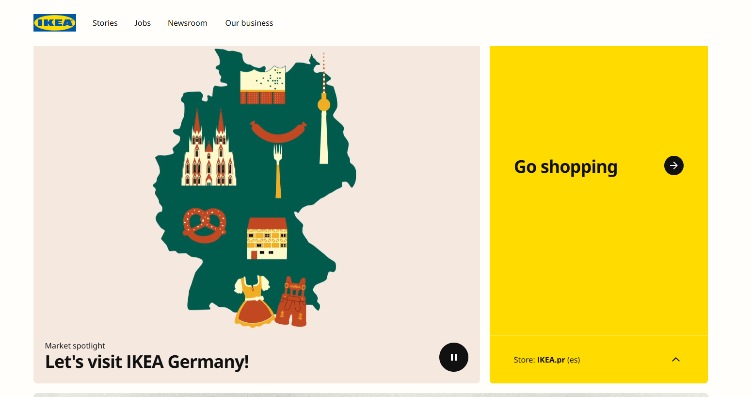
Key takeaways are listed below.

