09-image-between-texts
Performance benchmarks are shown here.
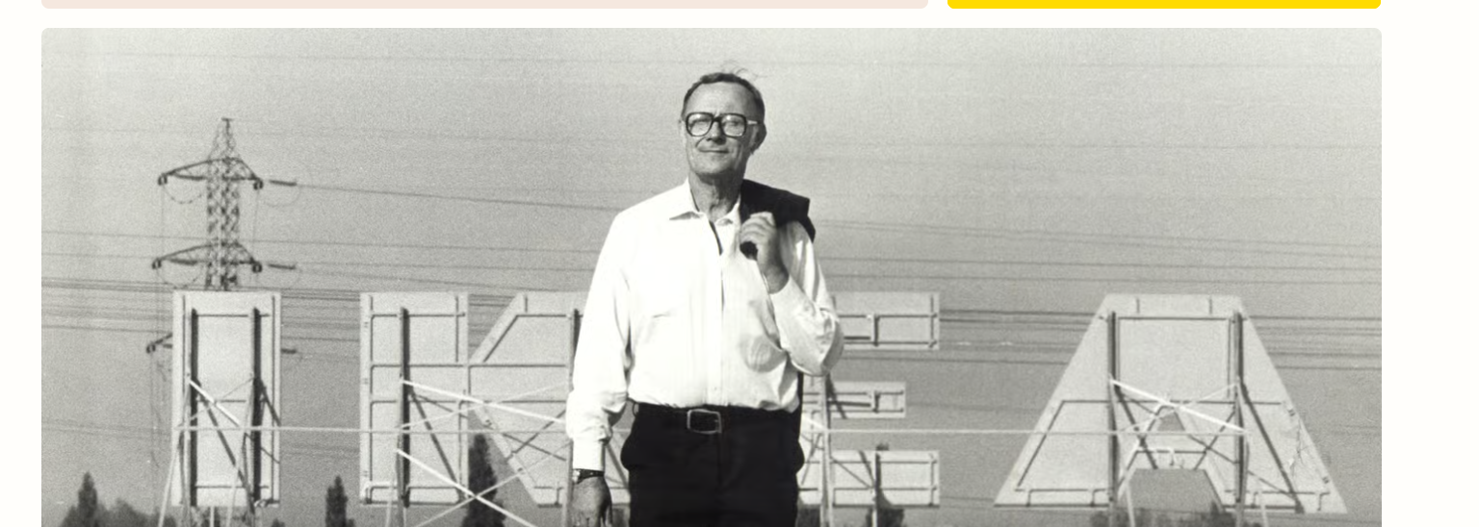
Results exceeded our initial expectations significantly.

