12-wide-image-with-caption
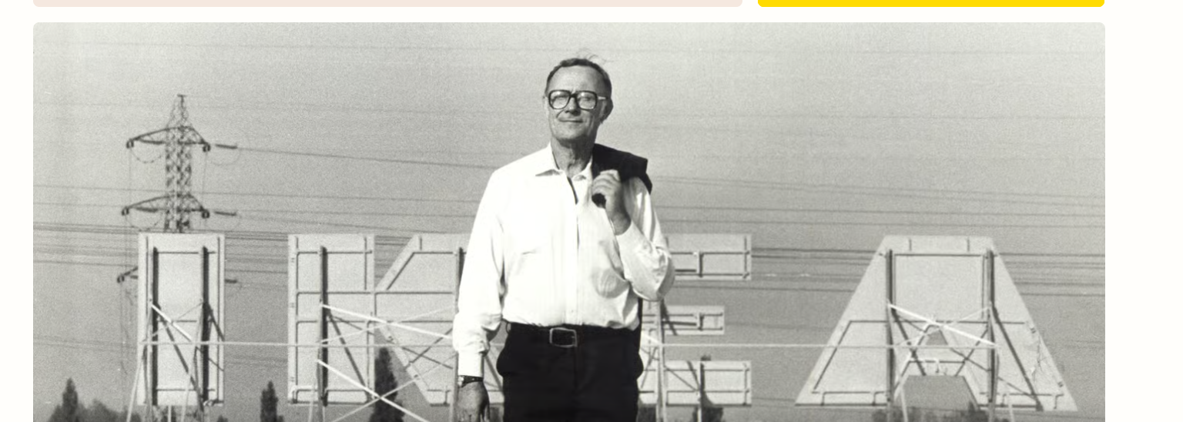
Figure 1: Network topology overview.

