31-image-pair-with-texts
Desktop view shown first.
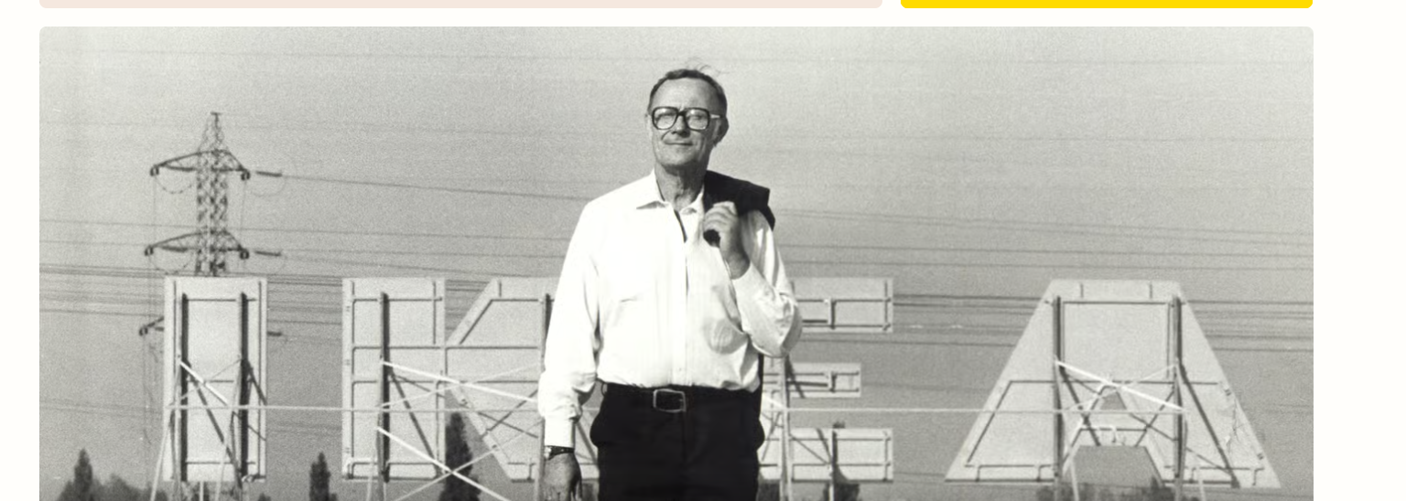
Mobile view shown second.
