39-tiny-image-big-text
The icon set was redesigned for better clarity.
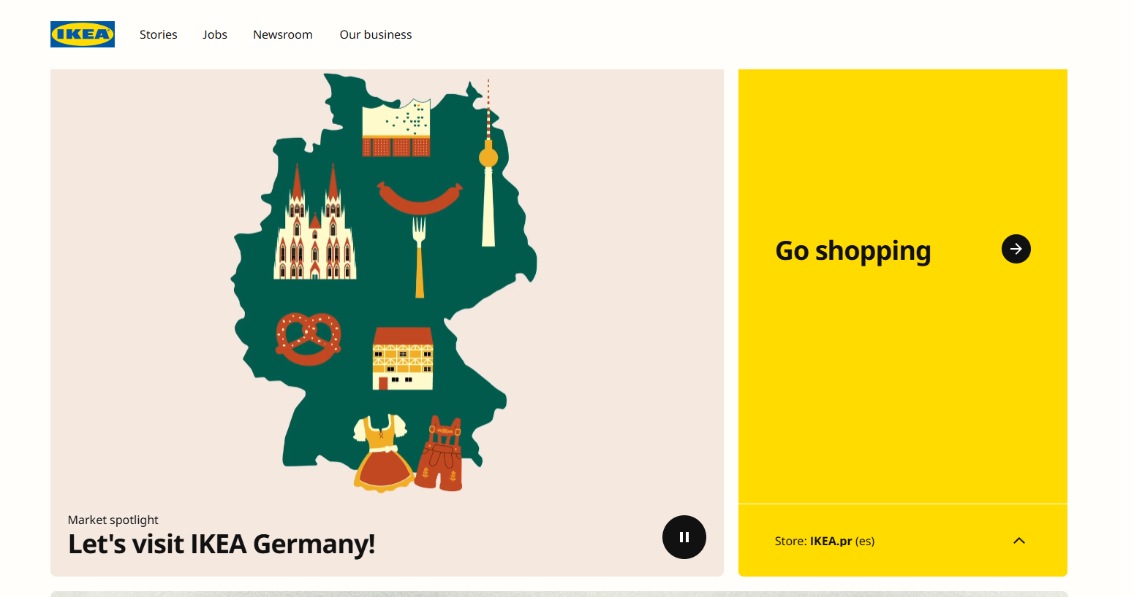
Each icon now supports dark mode natively.

