47-changelog-entry
Fixed navigation bug on tablet devices.

Improved loading speed for image galleries.
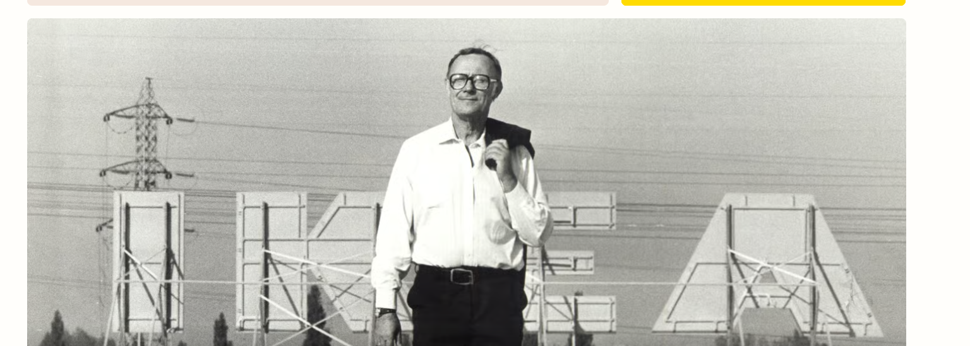
Added dark mode toggle in settings.

