49-mixed-long
Architecture review document.
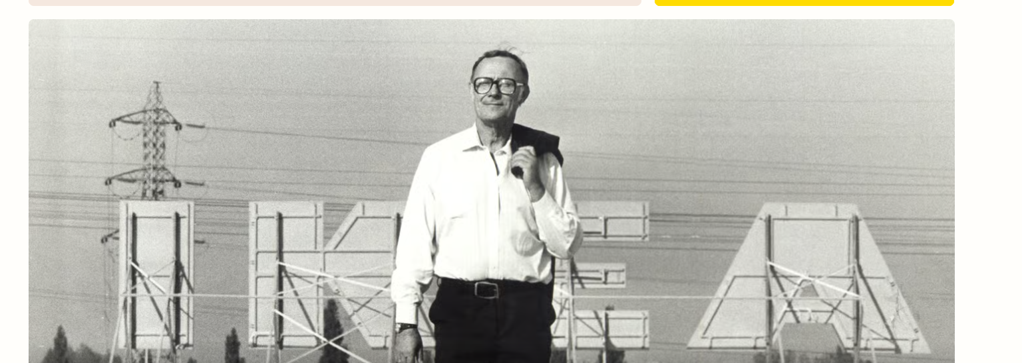

Both diagrams show the proposed structure.

Final approval pending from the tech lead.

