Daniel Steele

Lab #7

Verify experimentally the size of the largest datagram you can send and receive using a UDP socket (without fragmentation). What is the size? What happens if the datagram is larger than the limit?

My testing indicated that I could on my system send a UDP packet of 65507 bits but was not able to exceed that limit. After this limit the messages would have to fragmented to be able to send. I believe that the way that the it is implemented such that oversize messages cannot be sent is important to make sure that a receiver of the data does not receive incomplete data. I also imagine that this number may differ between system dependent on hardware and operating system. As seen below that information was both sent and received successfully but I was not able to exceed the bounds of 65507 bits of data.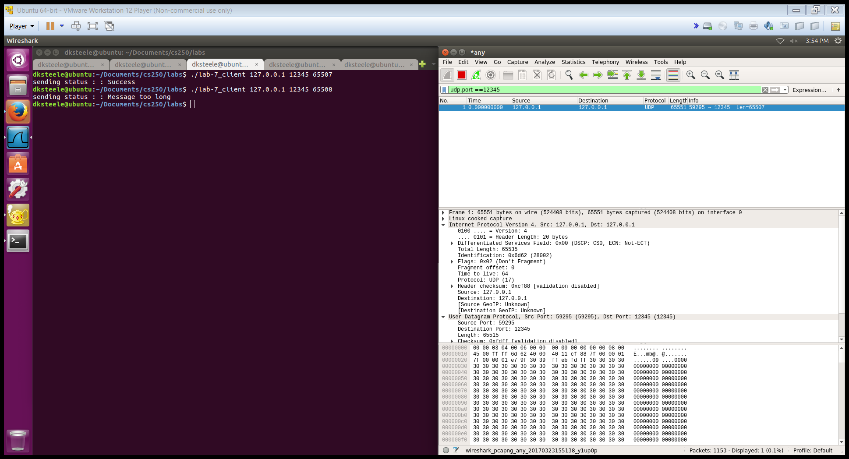

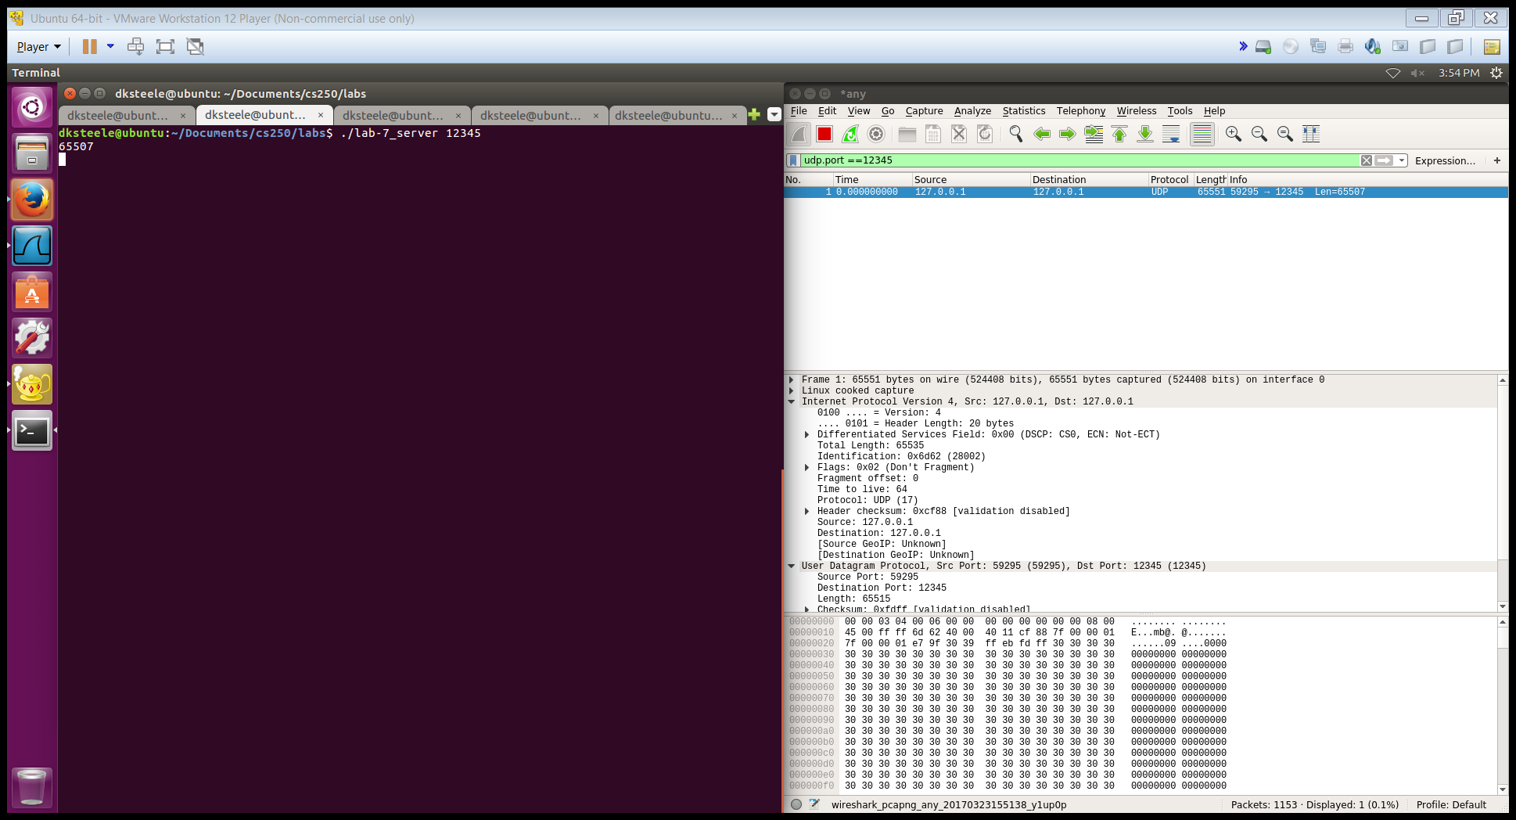

The code to run the test is below.

