**Exercise 1**

*Create a simple JSON HTTP server*

**Prior Knowledge**

Unix Command Line Shell

Some simple JavaScript (node.js)

**Learning Objectives**

Understand the basics of a Web Server

**Software Requirements**

Node.js

Npm

A Text Editor (e.g. Atom)

Creating a node.js program

1. Node.js is an effective framework for writing server-side programs using the JavaScript language. In this exercise we are going to create a simple program that returns a random number between 1 and 100.  
     
   Because we expect the result to be read by a machine not a human, we will return this as a JSON not as an HTML.
2. Make a directory called ex1. You can do this by starting a terminal window and typing:  
   mkdir ~/ex1  
   cd ~/ex1  
     
   *Hint: if you prefer to use the Ubuntu window system to do this, you may.*
3. Now we need to create a file and code the server.  
   In the terminal window type:  
   atom simplehttp.js

*Hint: There is a harmless bug with Atom on the 16.04 Ubuntu. You can simply close the bug notification window.*

*Hint: If you have another text editor on Ubuntu that you prefer, switch to that instead.*

1. You should see an Atom editor window: 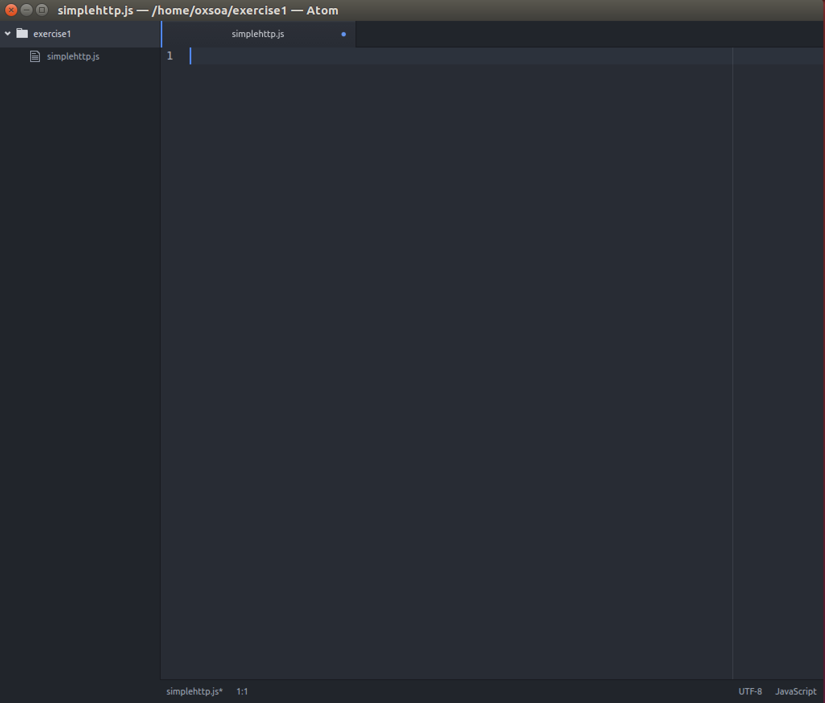
2. Type (or copy and paste) the following code:

var http = require('http'),

express = require('express'),

app = express();

app.get("/",function(req,res){

obj = {random : Math.floor((Math.random() * 100) + 1)};

res.json(obj);

});

var server = app.listen(8080, function() {

console.log("Random server listening on port 8080");

});

If you copy and past please make sure you understand the code.

The code is at <http://freo.me/ex1-js>

1. This uses a library called express.js which is a very popular framework for writing REST applications in JS. This code creates an HTTP server that responds to any HTTP GET request in the same way. It will instantiate a JavaScript object containing a random number and then return that as a JSON string.
2. To run this code, you need to type the following into a terminal window:  
   cd ~/ex1

npm install express   
node simplehttp.js  
  
This will install express.js (if it isn’t already).  
  
 You should see the server respond:  
oxsoa@oxsoa:~/ex1$ nodejs simplehttp.js  
Server listening on: http://localhost:8080

1. You can test this code by pulling up a browser window (e.g. Chromium or Firefox) and then browsing to <http://localhost:8080>  
     
   The result is this:  
   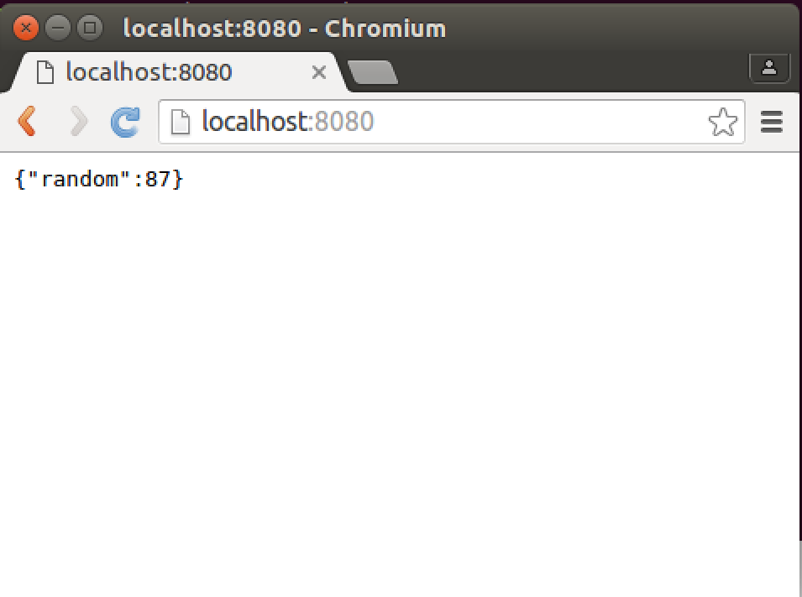
2. However, we do not want a human-/browser-enabled service. We want to call this service from machine-based clients. Let’s first try curl (a command-line URL / HTTP tool).  
     
   Type:  
   curl http://localhost:8080  
     
   You should see:  
   curl http://localhost:8080  
   {"random":71}oxsoa@oxsoa:~/ex1$  
     
   Hint: Because the HTTP response has no ‘\n’ line ending, the result is a bit hard to read as the next line merges with the output.
3. curl provides a useful debug facility. If you turn on verbose output, you can see the actual network messages as they are sent on the wire:  
     
   curl –v http://localhost:8080   
   You should see output similar to this:  
   The lines beginning with > indicate that these are sent to the server and < are received from the service.

* Rebuilt URL to: http://localhost:8080/

* Trying 127.0.0.1...

* Connected to localhost (127.0.0.1) port 8080 (#0)

> GET / HTTP/1.1

> Host: localhost:8080

> User-Agent: curl/7.47.0

> Accept: */*

>

< HTTP/1.1 200 OK

< Content-Type: application/json

< Date: Tue, 24 May 2016 09:04:03 GMT

< Connection: keep-alive

< Content-Length: 13

<

* Connection #0 to host localhost left intact

{"random":33}oxsoa@oxsoa:~/ex1$

1. Another way of testing this is to use a tool called the Advanced Rest Client (ARC) in Chrome/Chromium. Start Chromium and open up a new window or tab. In the corner is a little button called Apps   
   Click on that and then choose the ARC button:
2. 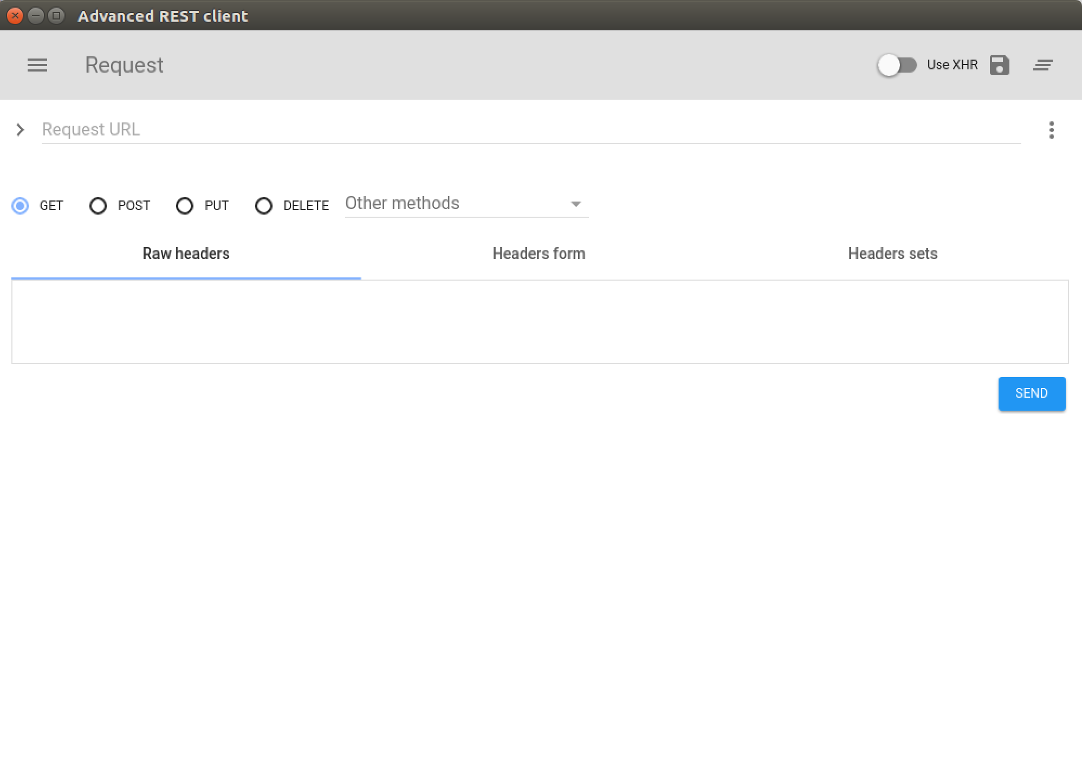You should see a window like this:
3. Type <http://localhost:8080> into the Request URL field and then click Send. You should see:

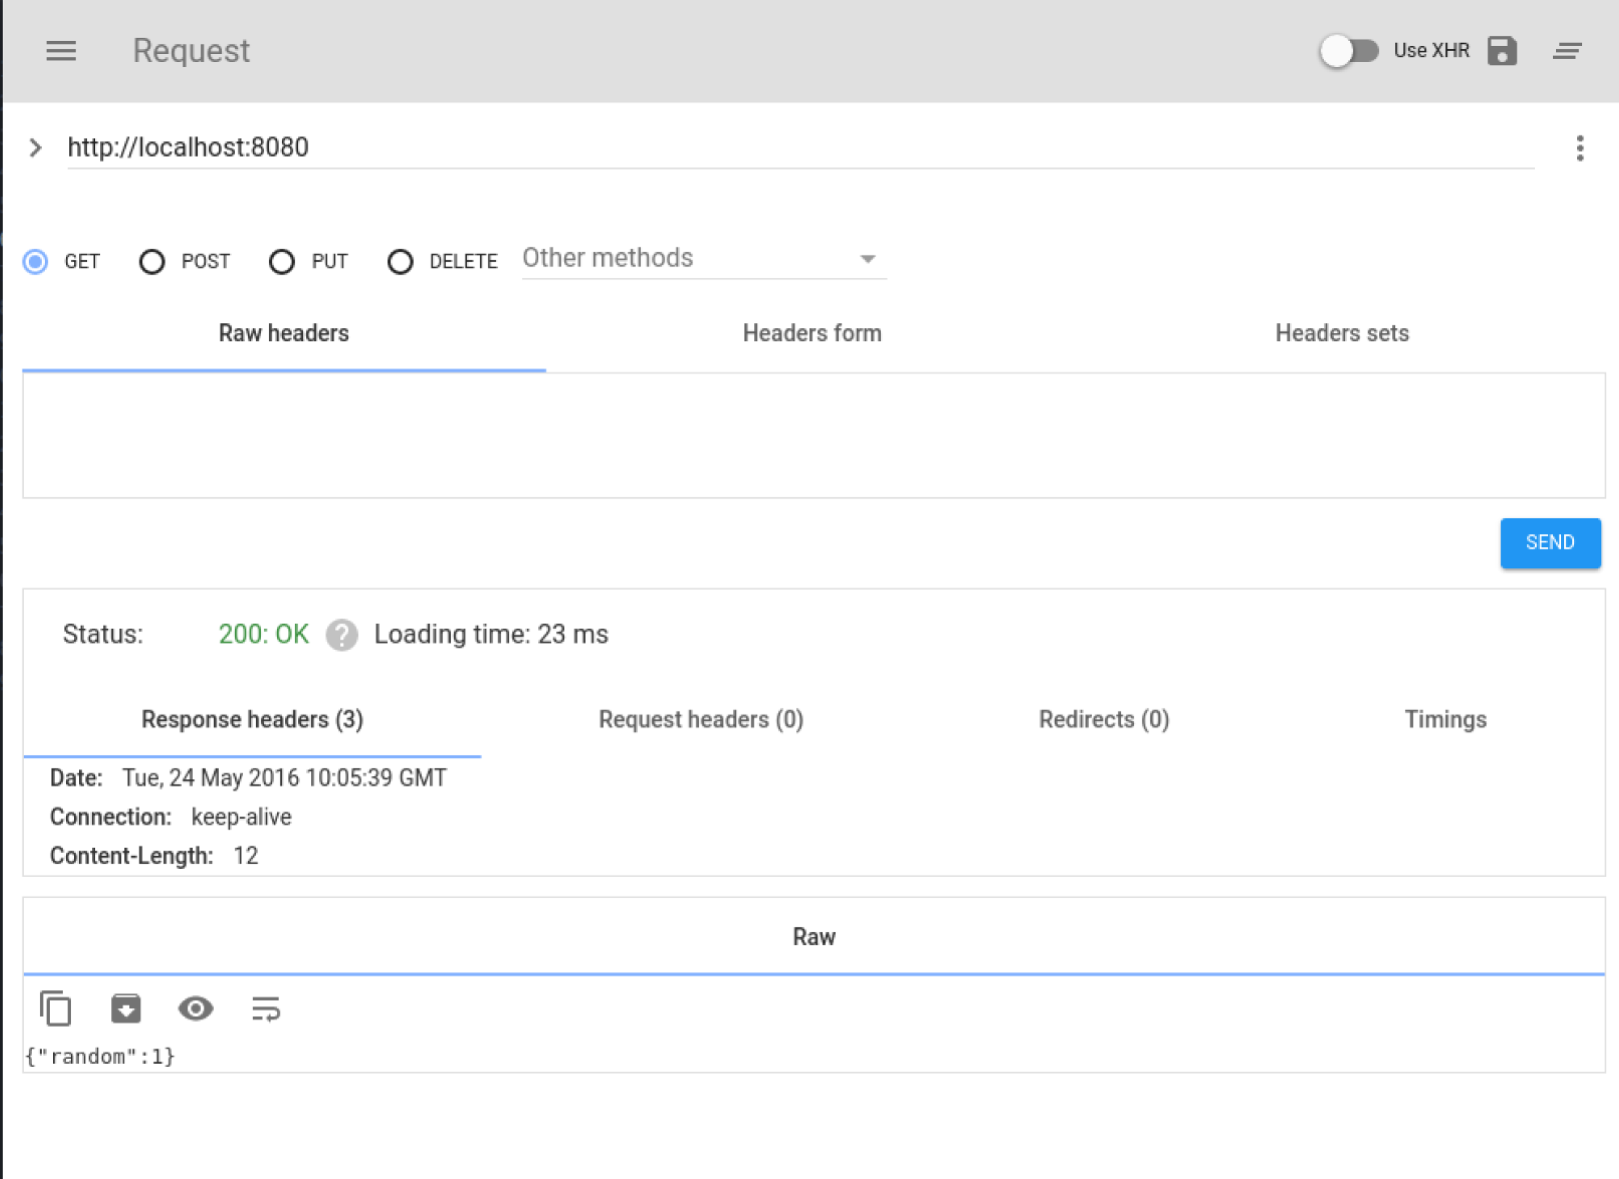

1. *Automated testing of the service*  
   We want this service to meet a set of behavior requirements. To ensure this, we can use a set of tests. There are a number of testing frameworks for SOA services. For this example, we are going to use a JavaScript tool called Frisby (<http://frisbyjs.com/>), which builds on top of another node.js test framework called Jasmine.   
     
   I have written a test script for this service. It is available as a gist on Github. You can download it onto your VM using the following command:  
   cd ~/ex1  
   ex

The test script looks like this:  
The test does an HTTP GET on the URL and then validates the following aspects:  
a. The return code is 200

var frisby = require('frisby');

frisby.create('Test Random Number service')

.get('http://localhost:8080/')

.expectStatus(200)

.expectHeaderContains('Content-Type', 'application/json')

.expectJSONTypes( {

random: Number

}

)

.expectJSON({

random: function(v) { expect(v).toBeGreaterThan(0);expect(v).toBeLessThan(101);}

})

.toss();

b. The Content-Type header is “application/json”

c. The JSON type of the result is a number

d. The JSON contains a tag called random, with a value >0 and <101

1. You can run this test using:  
   jasmine-node .
2. *Does the result match your expectations?*
3. Let’s fix the server so that it passes the test. I’ll leave this up to you, with a hint.   
     
   The hint is that response.setHeader(‘header_name’, ‘header_value’) is the way of setting headers on HTTP responses in nodejs.   
     
   *Hint: you will need to stop and restart the node server once you have edited the code.*
4. Once the tests are passing, this exercise is complete.   
    *Recap:*We have created a simple http server that returns a JSON output. We have tested this service in a number of ways – including via browser, ARC, curl and through a proper automated test.  
     
   In our next exercise we will create a client for this service.