**Exercise 3**

*Using SOAPUI to interact with a sample SOAP Service*

**Prior Knowledge**

XML

**Objectives**

Deploy a ready built service into Tomcat

Call the service using SOAP message

See sample SOAP messages

**Software Requirements**

These are already installed on the VM.

* OpenJDK Java Development Kit 8
* Tomcat 8.035 or later
* SOAPUI 5.0.0 or later

**Step 1. Deploy the service into Tomcat**

The sample service is already coded and available as a WAR file. It was written with Apache CXF and is available in the Downloads directory

~/Downloads/sample-service-1.0.war

Simply copy the WAR file into <tomcat>/webapps/ directory

From the terminal window:

cp ~/Downloads/sample-service-1.0.war ~/servers/tomcat/webapps

Now start Tomcat

*Hint: Since tomcat also runs on port 8080 make sure your other servers that use that port are shut down!*

Rather than use the “daemon” server startup we will use the model that keeps the server running in the open window.

cd ~/servers/tomcat

bin/catalina.sh run

For reference here is the Server Startup approach.

cd <tomcat>

bin/startup.sh [Linux/Mac]

bin\startup.bat [Windows]

Check to see if its running:

Browse <http://localhost:8080/sample-service-1.0/>

You should see a SOAP Web Service listed with a link to the WSDL. Click on this link.

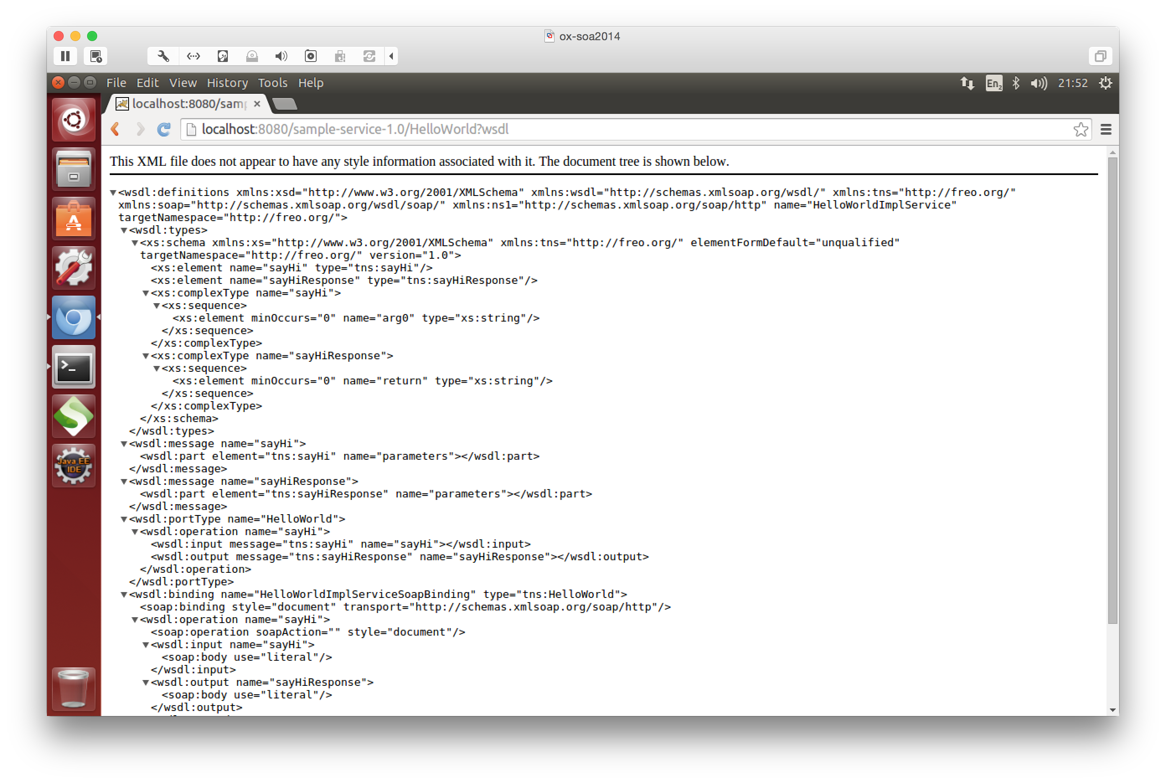Copy the WSDL Link into the Clipboard.

Now start up SOAPUI from the launcher:



You should see a screen like this:

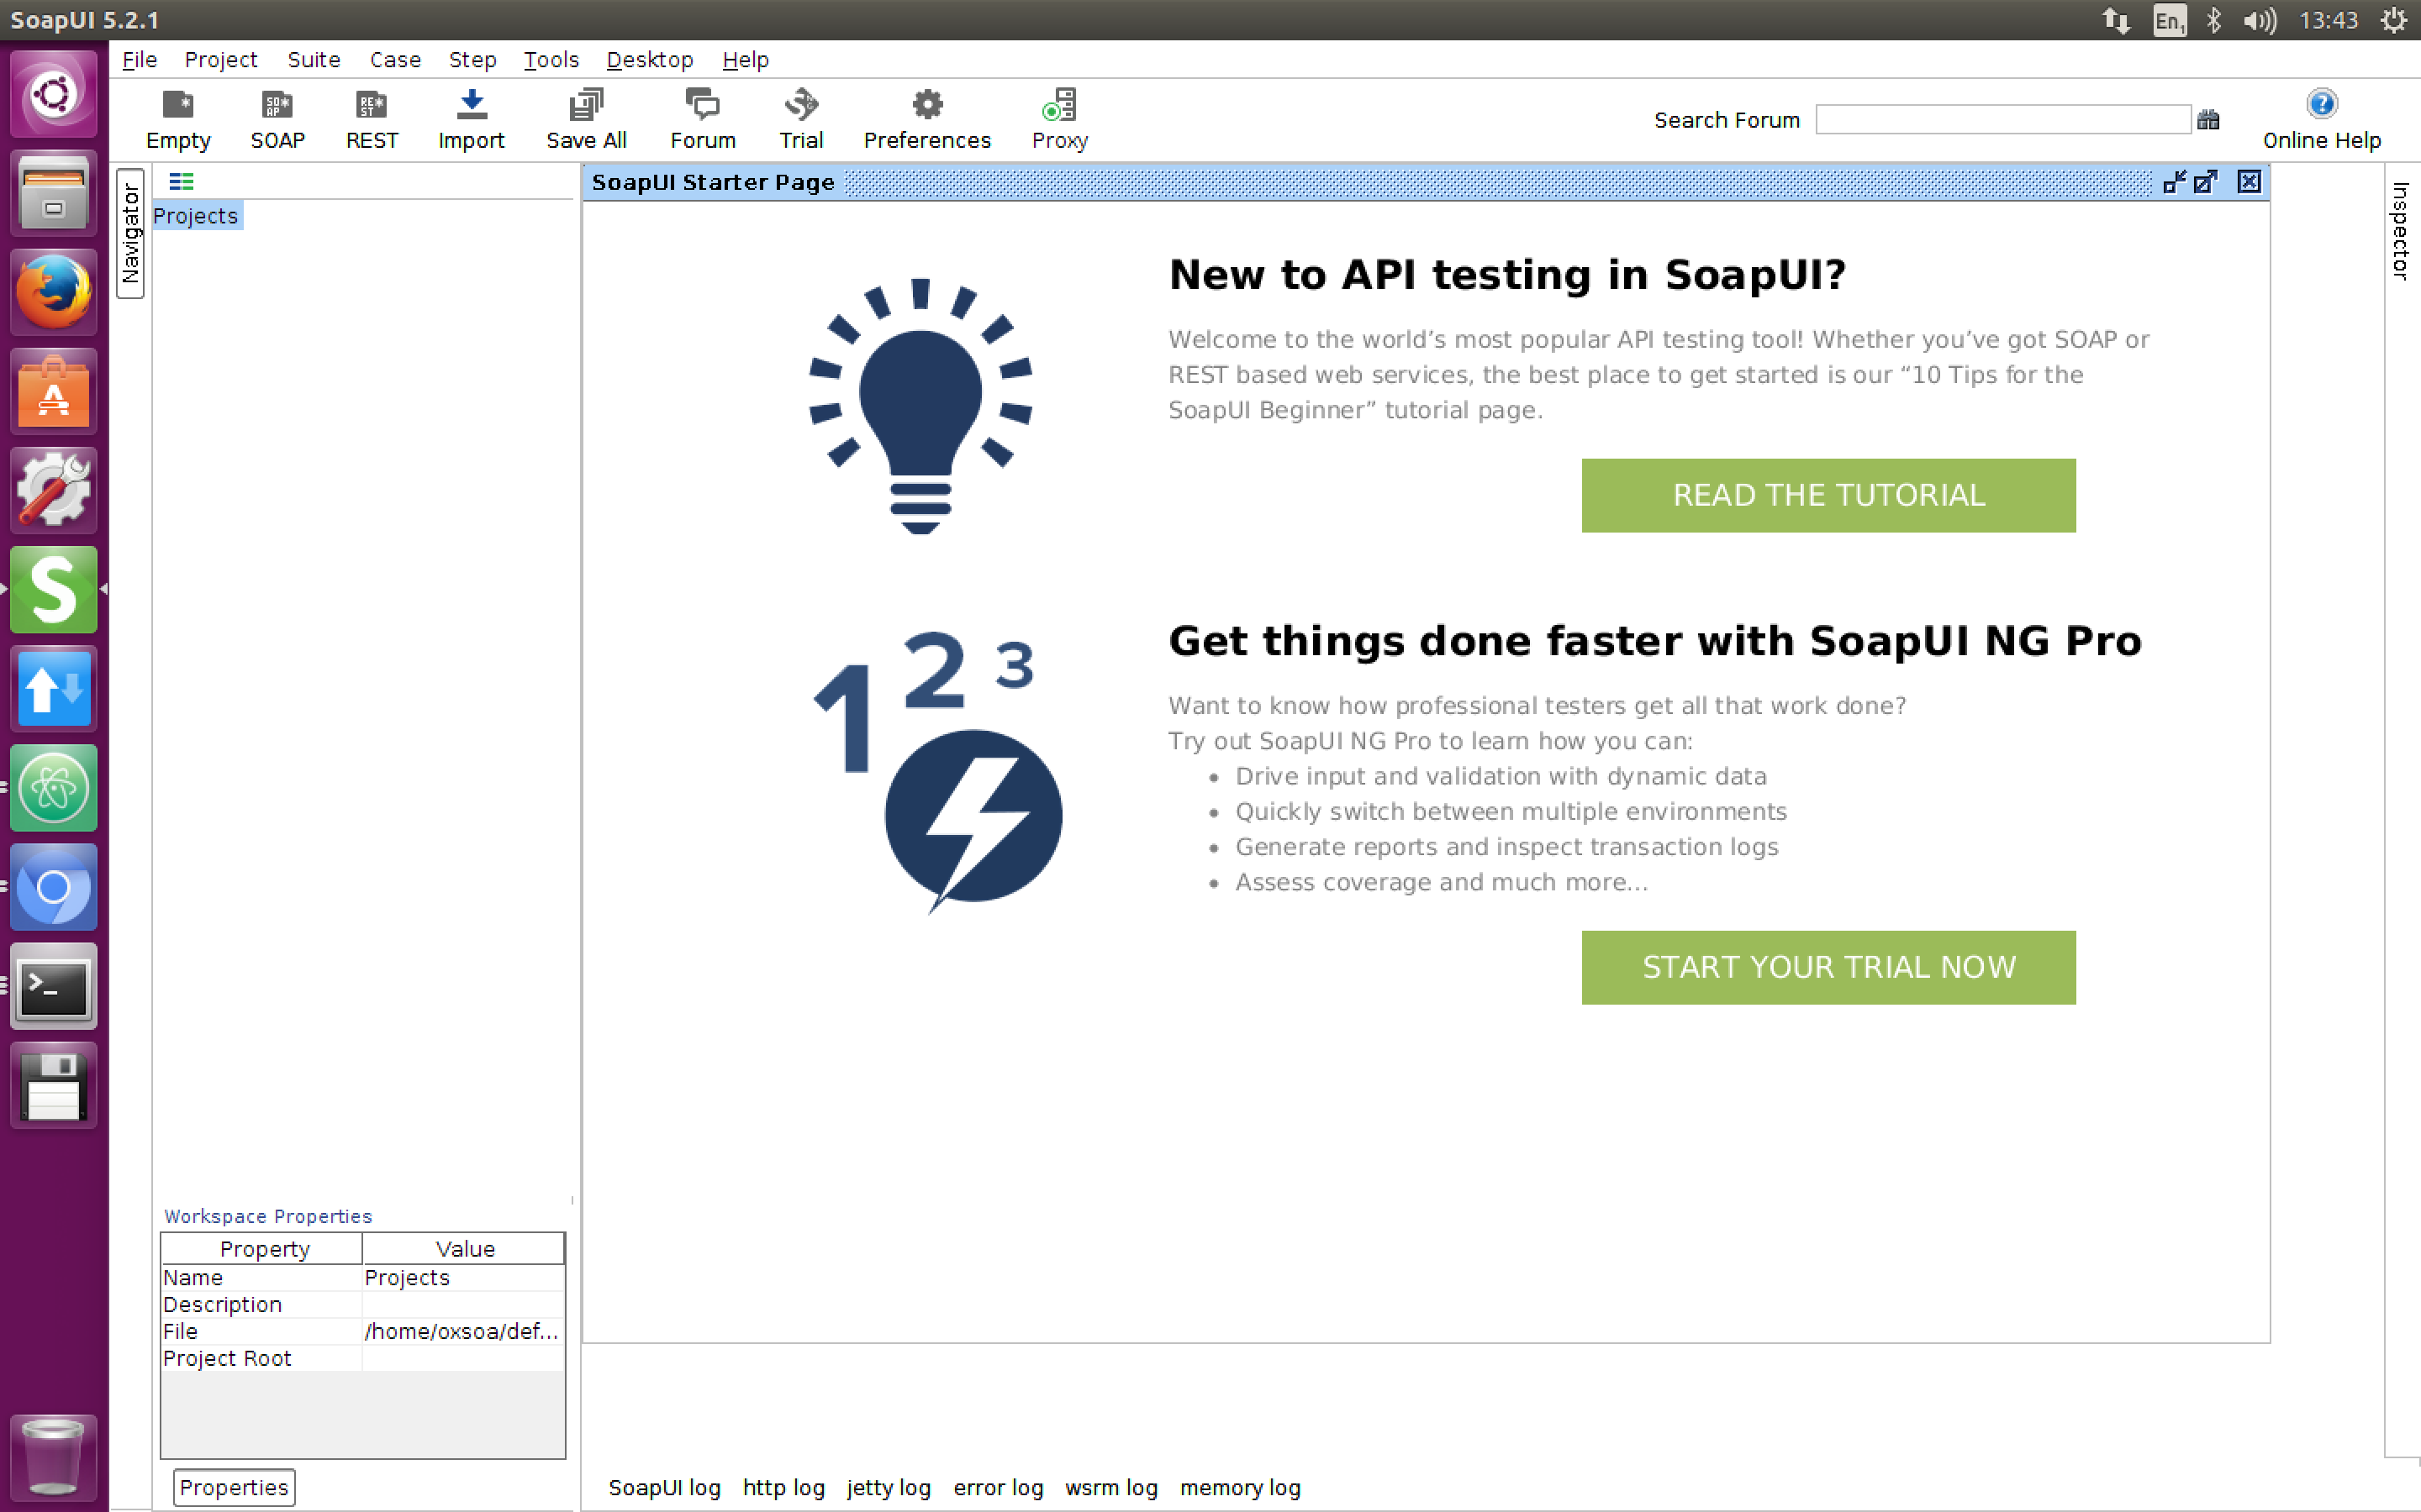

File->New SOAP Project

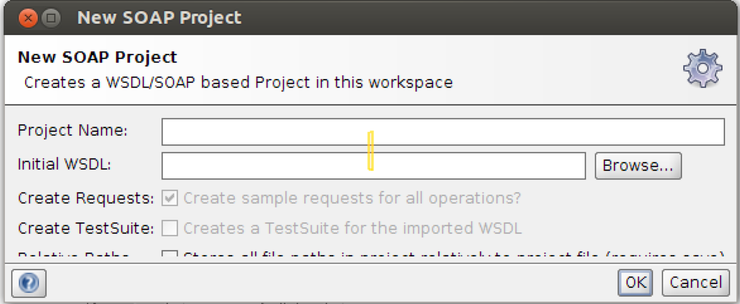

Type in a name for the project (e.g. Sample)

Paste the WSDL URI into the Initial WSDL field

Hit OK

Now open up the Request editor for one of the operations. You can do this by navigating the service tree in the left window until you see a Request object and click on that.

In the XML Payload, change any ‘?’ fields into something useful. Now hit the little green arrow (Run) button.

You should see a response from the service.

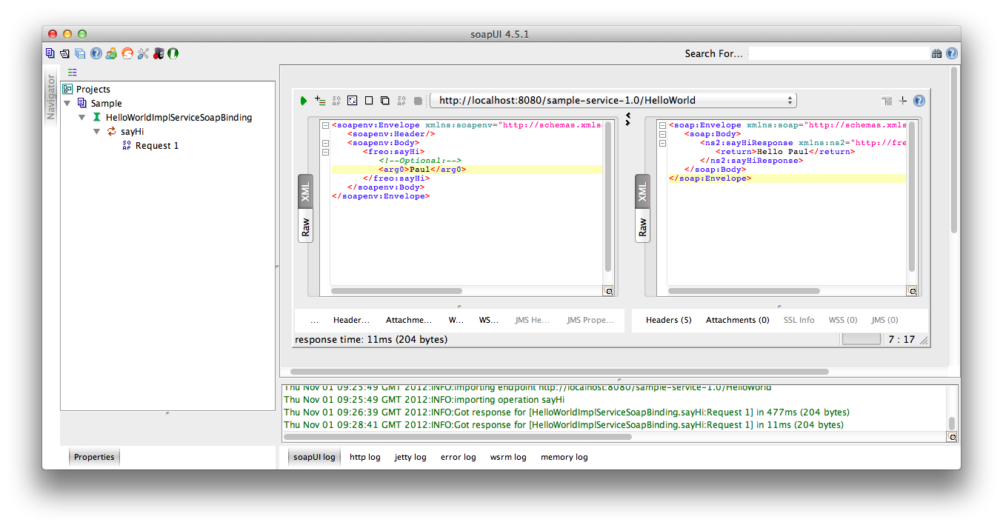

Use some of the SOAP UI capabilities to inspect the HTTP Headers, etc.

Try some other options and see what happens.

Congratulations! That’s all.