**Exercise 5**

*Creating a JAX-WS Client using WSDL2Java*

**Prior Knowledge**

*Basic understanding of SOAP and WSDL*

**Objectives**

*Understand how to create SOAP Web Service Clients in Java*

**Software Requirements**

* Java Development Kit 7
* Tomcat 7.0.69 or later
* Eclipse JEE workbench Luna
* Apache CXF 2.7.18 or later
* Service running from Exercise 4

1. To make a change we are going to use a command-line tool to create a Web Service Client. Later you can also try the wizard in Eclipse.
2. Start up a command-line shell / Terminal
3. I have already setup your environment so you DON'T need to do:  
   export CXF_HOME=~/servers/apache-cxf-2.7.18

export PATH=$PATH:~/servers/apache-cxf-2.7.18/bin

1. Create a directory to store your generated code, e.g.   
   mkdir ~/ex5

cd ~/ex5

1. Start up your service implementation in Tomcat (if it isn’t already running)  
     
   From the directory you want the code in, execute the following command:  
     
   wsdl2java -ant -verbose -client -d . -fe jaxws21 http://localhost:8080/JAXWSSample/services/OrderServiceImplPort?wsdl   
     
   **Put all on one line!**

You should see output like:  
Loading FrontEnd jaxws21 ...

Loading DataBinding jaxb ...

wsdl2java -ant -verbose -client -d . -fe jaxws21 http://localhost:8080/JAXWSSample/services/OrderServiceImplPort?wsdl

wsdl2java - Apache CXF 2.7.18

1. Because we are using JDK 1.8 and the CXF library expects 1.6 or 1.7, we need to do a quick fix. In the same terminal window, type:  
     
   sed -i 's/1.7/1.8/' build.xml
2. Now check it builds. In the directory where the code is generated, there should be an Ant build.xml.   
   Type **ant** in the command line.   
     
   You should see something like:  
   >ant  
   Buildfile: /Users/paul/oxsoa/client/build.xml  
     
   compile:  
    [mkdir] Created dir: /Users/paul/oxsoa/client/build/classes  
    [javac] /Users/paul/oxsoa/client/build.xml:110: warning: 'includeantruntime' was not set, defaulting to build.sysclasspath=last; set to false for repeatable builds  
    [javac] Compiling 14 source files to /Users/paul/oxsoa/client/build/classe  
     
   build:  
     
   BUILD SUCCESSFUL  
   Total time: 3 seconds
3. Now let’s import into Eclipse.
4. Note:
5. I have already done this, so you don’t need to!  
   Go to Preferences, Ant, Runtime, Properties Tab, Add Property with the values:  
   Name: cxf.home  
   Value: /home/oxsoa/servers/apache-cxf-2.7.18

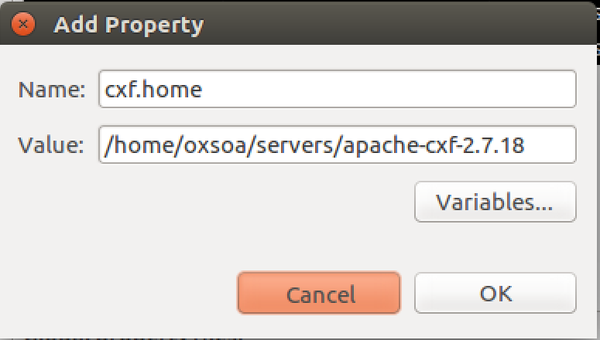

1. Now create a new project using   
   File->New->Other->Java Project from Existing Ant Build File.   
     
   Browse to the build file in your generated code directory.  
     
   Give the project a decent name (e.g. **JAXWSClient**)
2. Take a look at the generated code.
3. Find the class named **OrderService_OrderServiceImplPort_Client** and run it. (**Run As->Java Application**).

***Hint:*** *If you double click on the word Console (or any window title in Eclipse) it maximizes that sub-window. Double click again to return to normal.* **  
*Is the behaviour you are getting expected?*

1. Edit the client to create at least one Order and correctly list all the orders.
2. Congratulations. This exercise is done!
3. *Extension*  
   See if you can get the client to talk via mitmdump and capture the request/response interactions.
4. Before you go, please stop the Tomcat server.