**Exercise 7**

*Making our service into a single JAR microservice with a Redis backend*

**Prior Knowledge**

Exercise 6b

**Objectives**

Looking at deployment models for Services

NoSQL backends

**Software Requirements**

(see separate document for installation of these)

* Java Development Kit 8
* Gradle build system
* Jetty and Jersey
* Eclipse Luna and Buildship
* curl
* Google Chrome/Chromium plus Chrome Advanced REST extension
* Redis

**Overview**

*We have built a reasonable RESTful service, but which can be exported as a WAR and run. It has no real backend as it is based on an in-memory singleton.*

*However, we would like to create a simpler deployment model based on a single JAR, and we would like a reasonable backend database to house the results.*

**Steps**

1. You can do this to your existing POResource project. However, because I’d like us to add *redis* support, I propose that we start from my completed version of Exercise 6.   
   You can checkout this version by doing the following command-line magic.  
     
   mkdir ~/ex7  
   cd ~/ex7  
   git clone <https://github.com/pzfreo/POResourceMS.git>  
   cd POResourceMS
2. We would like to change the build to support creating a single JAR file. We also need to create a new class that supports this.
3. First, lets add some new parts to the build.gradle file.   
   *Hint: You could load the project into Eclipse, but I propose that we get the gradle build improved first, so I would suggest using a Linux editor like Atom, gedit or nano. This means that when we load the project into Eclipse, it will be aware of the new plugins.*  
   In the plugins {} section, add the following additional line:

This is a plugin that mirrors the shadow plugin for maven. This packages all the code required including all dependencies into a single JAR file. The result is a JAR file that has no external dependencies.

plugins {

id 'com.github.johnrengelman.shadow' version '1.2.3'

}

1. Having defined the plugin (using the gradle plugin extension mechanism) we now need to use it:  
   Add the line to the main section of the gradle build (under the other similar lines)  
     
   apply plugin: 'com.github.johnrengelman.shadow'
2. We also need the *application* plugin, which works with shadow to build self-contained executable JARs (see <https://en.wikipedia.org/wiki/JAR_(file_format)#Executable_JAR_files> )  
     
   Add the line:  
   apply plugin: 'application'
3. We need to tell the application plugin the name of our “Main” executable class:  
     
   Add the following line underneath the “apply plugin” lines  
   mainClassName = 'freo.me.rest.Main'
4. Save your changes to the file.
5. Now import the project into Eclipse:  
   **File->Import Gradle->Gradle Project  
   Next>**Browse to the Project root directory: /home/oxsoa/ex7/POResourceMS  
   **Finish**

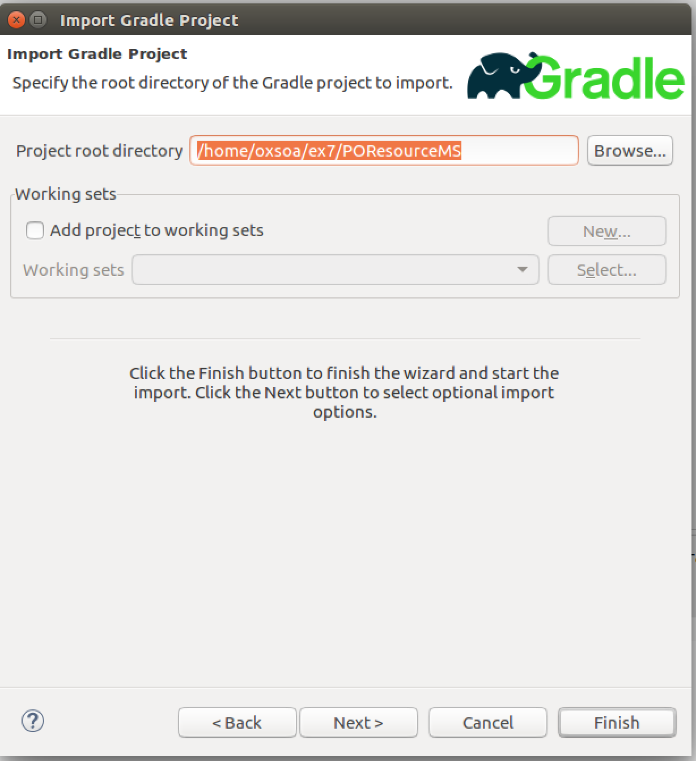

1. Now go to the class called **Main** in the package freo.me.rest.  
   Uncomment it.  
     
   Here is a code listing:

package freo.me.rest;

import java.net.URI;

import javax.ws.rs.core.UriBuilder;

import org.eclipse.jetty.server.Server;

import org.glassfish.jersey.jetty.JettyHttpContainerFactory;

import org.glassfish.jersey.server.ResourceConfig;

public class Main {

public static void main(String[] args) throws Exception {

URI baseUri = UriBuilder.fromUri("http://localhost/")  
 .port(8080).build();

// This is fairly self-explanatory.

// You can define the URL on which the server will listen.

ResourceConfig config =   
 new ResourceConfig(POResource.class);

// This is where we identify that the class   
// POResource is the JAX-RS

// Resource (aka Service) that we want to expose.

Server server = JettyHttpContainerFactory.  
 createServer(baseUri, config);

// Here is where we create the Jetty Server object.

try {

server.start();

// This initiates the startup of the server.

server.join();

// Wait until the server finishes initiation

} finally {

server.destroy();

// Obvious!

}

}

}

The code is available here:  
<http://freo.me/ex7-main>

1. Now you can build this into a shadowJar. You can either use the gradle plugin, or the command line:  
     
   cd ~/ex7/POResourceMS  
   gradle clean shadowJar
2. This creates a file:  
   build/libs/POResourceMS-all.jar
3. Try it out by executing:  
   java –jar build/libs/POResourceMS-all.jar
4. Test it. The URL is <http://localhost:8080/purchase>
5. Extension: Check out the other build targets:  
   gradle runShadow  
   gradle distShadowZip  
   gradle installShadowApp  
   *Hint: execute these with –info to see more of what is happening*
6. *Adding Redis support*  
     
   Redis is a high-performance in-memory datastore which also supports different levels of on-disk persistence. It is a highly featured solution that supports clustering, replication and many other useful capabilities.  
     
   We are going to use it as a sample backend for our Microservice, replacing the existing singleton Java object.   
     
   If you have checked out my version of the service, you will already have a new backend class OrderRedis.java. If not, you can find a copy here:  
   <http://freo.me/OrderRedis>   
   Review the code. I have chosen a simple way of storing the data in redis which is to create three keys for each entry:  
   e078c9ce-c7f4-4a23-9bd3-04e60b3d8a95:json -> { the json }  
   e078c9ce-c7f4-4a23-9bd3-04e60b3d8a95:complete -> true/false  
   e078c9ce-c7f4-4a23-9bd3-04e60b3d8a95:deleted -> true/false

This is probably not the best implementation, but it meant very few changes from the in-memory implementation. Note also that I did not implement paging in the getAllOrders and unlike the singleton version, this will not return all orders but a paged set. This would need fixing in a production system.

You can simply replace the singleton usage of OrderInMemory with an instance of OrderRedis. It is thread safe so you can simply instantiate a single object and call it from the POResource service with impunity.

1. Add the jedis (Java Redis client) dependency to your build.gradle (You can actually just uncomment it).  
     
   Select the Project and Right-click **Gradle->Refresh Gradle Project** to let Eclipse know about the new dependency.
2. Let’s check redis is running before we try to test anything. On the command line type:  
   redis-cli  
     
   If redis is running you will see:  
   127.0.0.1:6379>  
     
   If redis is *not* running you will see:  
   Could not connect to Redis at 127.0.0.1:6379: Connection refused  
   not connected>  
     
   To start redis type:  
   sudo service redis-server start
3. You can do a gradle build to re-run the tests with the redis backend.
4. In a terminal window start the redis-cli and type  
   SCAN 0 MATCH '*:json'   
     
   You should see a response like this:

127.0.0.1:6379> scan 0 MATCH '*:json'

1) "288"

2) 1) "528551f0-810b-4c74-ab89-0d20bde584c1:json"

2) "e685fa1f-cdd4-4ace-87e4-6421c67f54fb:json"

3) "e078c9ce-c7f4-4a23-9bd3-04e60b3d8a95:json"

4) "a235c1f9-da10-4be8-b9c3-29a6ef1d7894:json"

5) "43d90e04-2c1c-40d5-9ab1-ac254ed310a2:json"

1. Build into a shadow JAR and test using java –jar
2. Congratulations the lab is over!