**Exercise 6a**

*Create an embedded Java REST Service using JAX-RS and Jetty*

**Prior Knowledge**

Basic understanding HTTP verbs, REST architecture

Some Java coding skill

**Objectives**

Understand what it takes to create REST services. Interact with a REST service using simple web clients in Chrome, on the command line.

See how Maven can be used.

**Software Requirements**

(see separate document for installation of these)

* Java Development Kit 8
* Gradle build system
* Jetty and Jersey
* Eclipse Neon
* curl
* Google Chrome/Chromium plus Chrome Advanced REST extension

**Overview**

There are many technologies for creating RESTful Web Services in Java. In order to create a simple approach, we are going to use the Java standard for creating REST services, which is called JAX-RS. The “official” Oracle implementation of JAX-RS is Jersey, although there are other implementations such as CXF which we used in Exercises 4 and 5.

Jetty is a lightweight embeddable HTTP server that we will use to make these JAX-RS services available. We will also use a packaging model that creates “Uber JARs” that contain all the dependencies within them.

**Create and test a new Gradle project**

Gradle is a very powerful build tool. It can be seen as a more effective and easier alternative to the Maven build system. Maven is brilliant but incredibly painful!

For those of you who normally use Maven, I have included a sample Maven file for comparison here:

For those of you who have never used Maven, long may that continue!

We are going to use Gradle to build our simple RESTful service project.

We are starting with a basic Gradle build file that does the following:

* Downloads any required dependencies
* Includes Jersey, Jetty, and the bridge between the two.
* Packages the result up as an “uber-jar” that can be run standalone

Steps

1. First start a Unix Terminal window.  
   Now create a directory to store your code in.  
     
   mkdir –p ~/ex6/POResource
2. Change to that directory  
   cd ~/ex6/POResource
3. 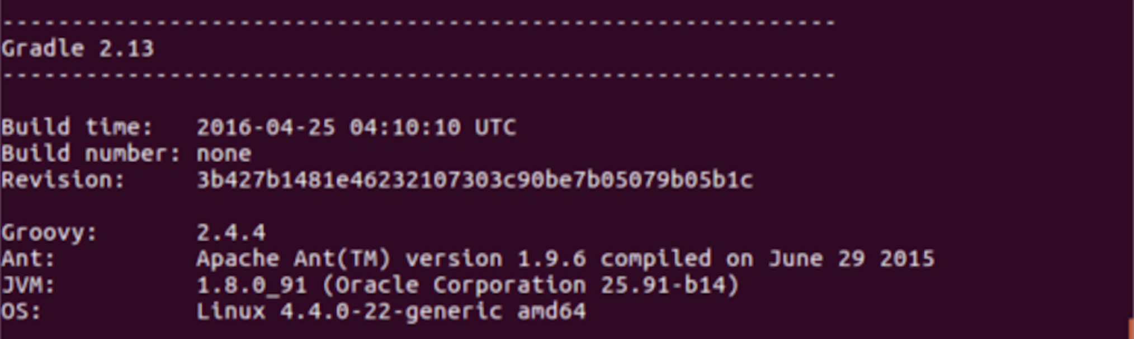Test that you have gradle properly installed. Execute  
   gradle –v  
     
   You should see something similar to this (dependent on your machine, JVM, etc)
4. Grab the prewritten Gradle config from Github and save into ~/ex6/POResource/build.gradle:  
     
   cd ~/ex6/POResource  
   curl -L <http://freo.me/ex6-gradle> -o build.gradle
5. From the ex6/POResource directory, make a directory for your source code.   
   mkdir –p src/main/java
6. Now we can import the project into Eclipse. This will use the Gradle Buildship plugin for Eclipse which is already installed in Eclipse.
7. In Eclipse: **File->Import.. Gradle->Gradle Project**Browse to the ex6/POResource directory and then click **Finish** 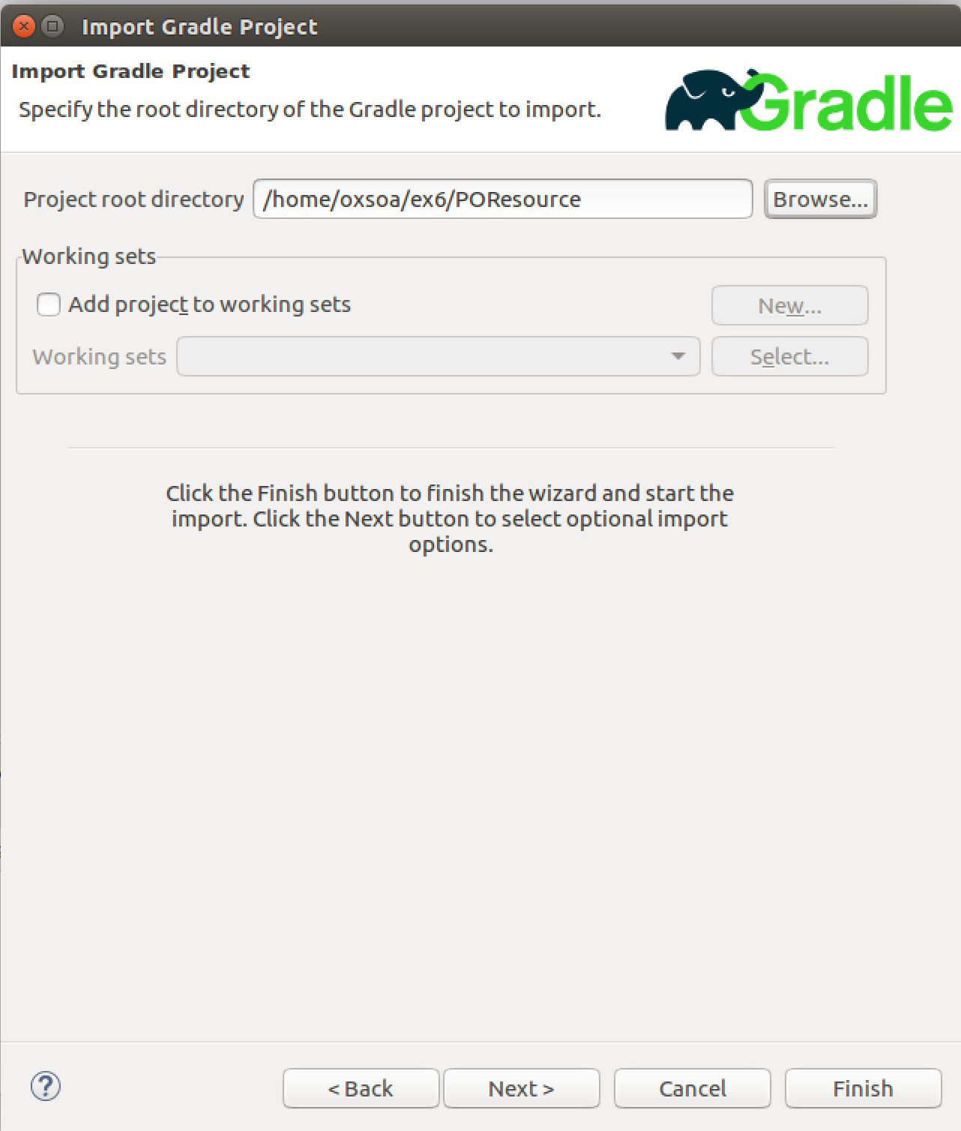  
     
     
   *Note that unlike creating a project directly in Eclipse, where the files are stored in ~/workspace, the Eclipse project will work off of your files here. Just to be clear, if you delete the Eclipse project files, these files will disappear and vice-versa.*
8. We now need to create two classes to implement our first Java service.  
   The first class is called freo.me.rest.Main and this is the class that will configure the system and start up the Jetty server. This class is almost all “boilerplate” just like the pom.xml. In other words you can take this and the pom.xml and re-use them for other projects with very minimal changes.
9. First create a new package in Eclipse under src/main/java:  
   freo.me.rest

The easiest way is to right-click on src/main/java and then choose   
New->Package

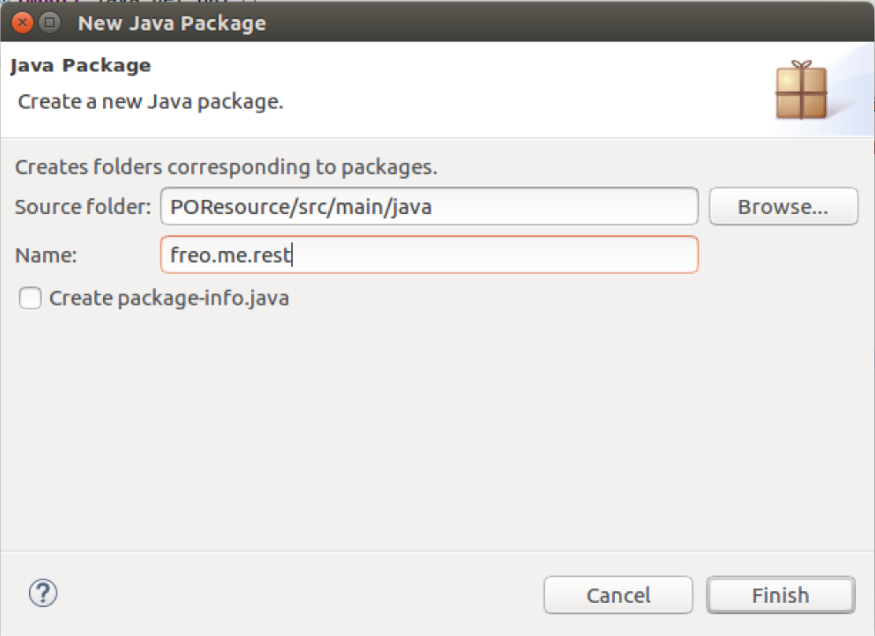

1. Create a Main.java class in that package. Right-click on the Package and choose New->Class. Fill in the name (Main) and Finish: 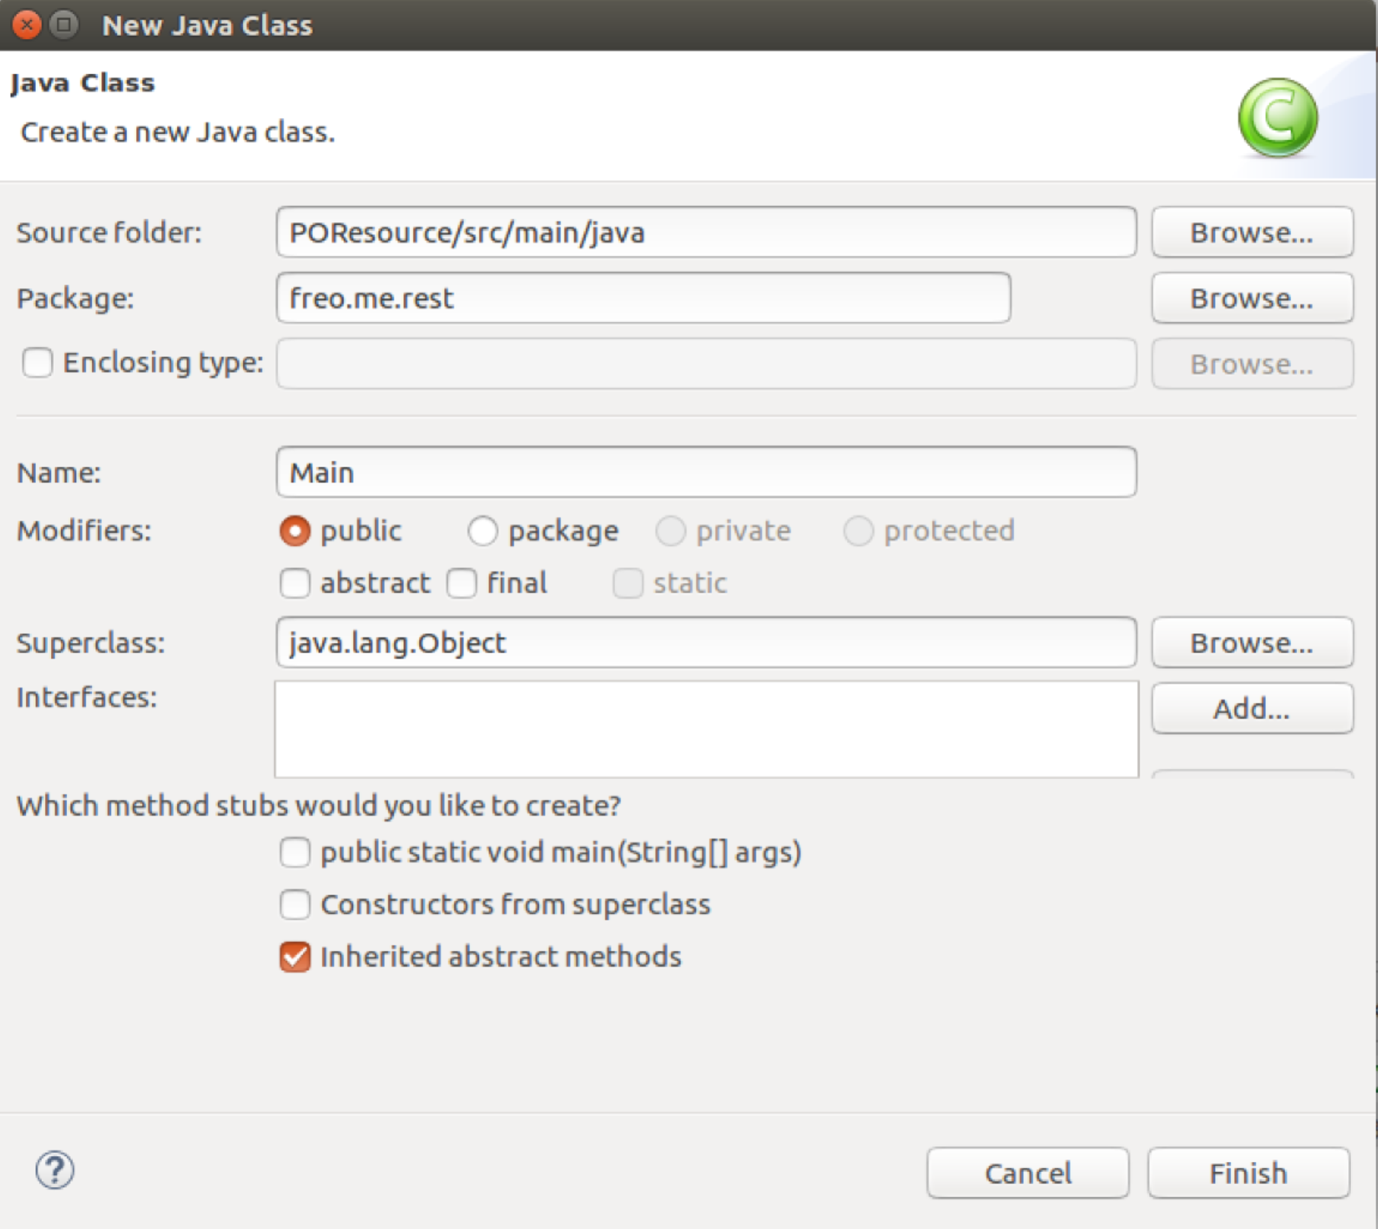
2. Copy and paste the code for Main.java from here:  
   TODO add URL
3. The Main class has the following code:

URI baseUri =

UriBuilder.fromUri("http://localhost/").port(8000).build();  
*This is fairly self-explanatory.*

*You can define the URL on which the server will listen.*ResourceConfig config = new ResourceConfig(POResource.class);  
*This is where we identify that the class POResource is the JAX-RS Resource (aka Service) that we want to expose.*Server server =   
 JettyHttpContainerFactory.createServer(baseUri, config);  
*Here is where we create the Jetty Server object.*

try {

server.start();

*This initiates the startup of the server.*

server.join();  
 *Wait until the server finishes initiation*

} finally {

server.destroy();

*Obvious!*

}

1. You will have noticed that we referenced a class *POResource.class* which is so far absent. Let’s create it. This is where we finally get to use the JAX-RS specification to define an HTTP-based Resource.
2. Here is the code listing for POResource.java. This version has some simple explanations of each part.  
   You should create the class in the same package as Main. Type this in or cut and paste from here:  
   TODO URL

package freo.me.rest;

import javax.ws.rs.GET;

import javax.ws.rs.Path;

import javax.ws.rs.Produces;

import javax.ws.rs.core.MediaType;

// this will be the HTTP URL sub path from the Jetty server’s URI where this   
// resource/service will be available

@Path("purchase")  
public class POResource {

// This method will handle GET requests

@GET  
// Specify the resulting content type

@Produces(MediaType.TEXT_PLAIN)

public String get() {

return "Hello!";

}

}

1. We are now ready to build this. If you look at the bottom pane, you should see a tab called Gradle Tasks. Click on it. 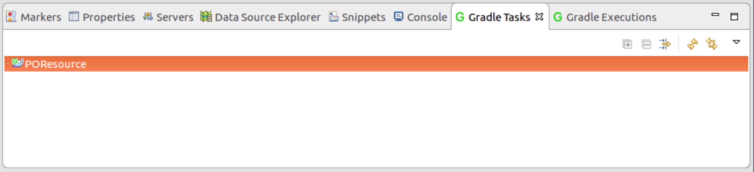
2. Now expand the POResource object and find **shadow/shadowJar**. Click on it. The pane should change to Gradle Executions where you will see:
3. 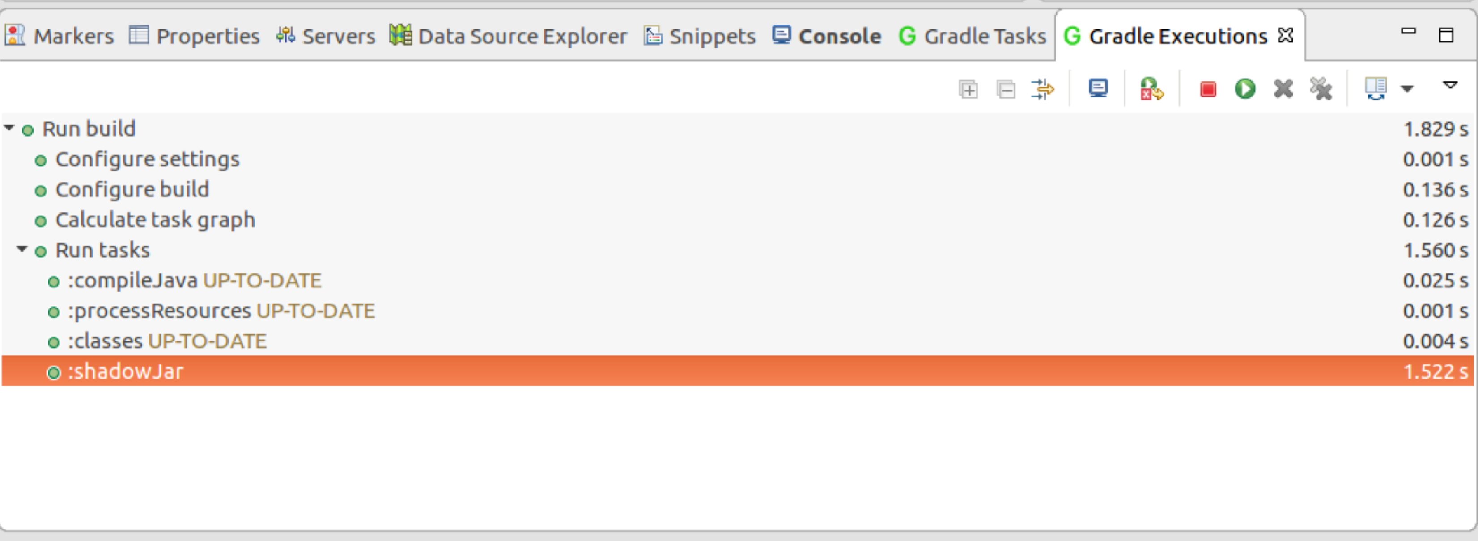You can run this in several ways. The simplest is to go to the **Main.java**, right-click and choose **Run As->Java Application.**   
   The console should display with a log showing that your service is running:  
   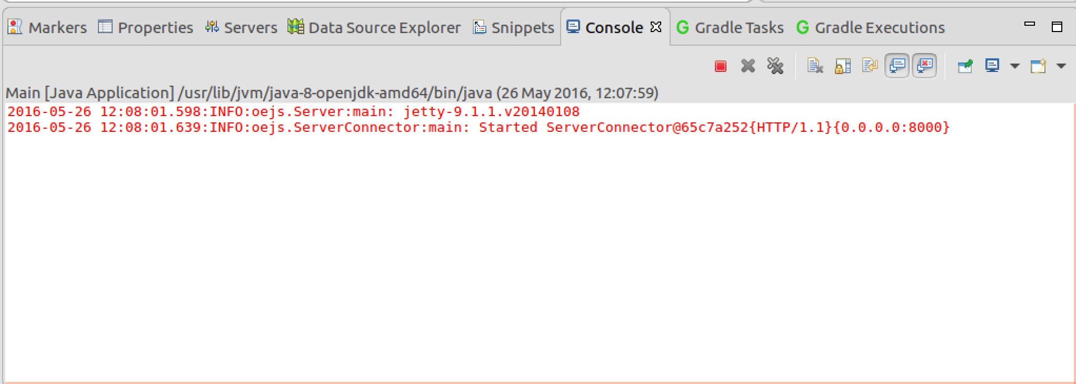
4. Test this by going to the browser and browsing:  
   <http://localhost:8000/purchase>  
     
   You should see:  
   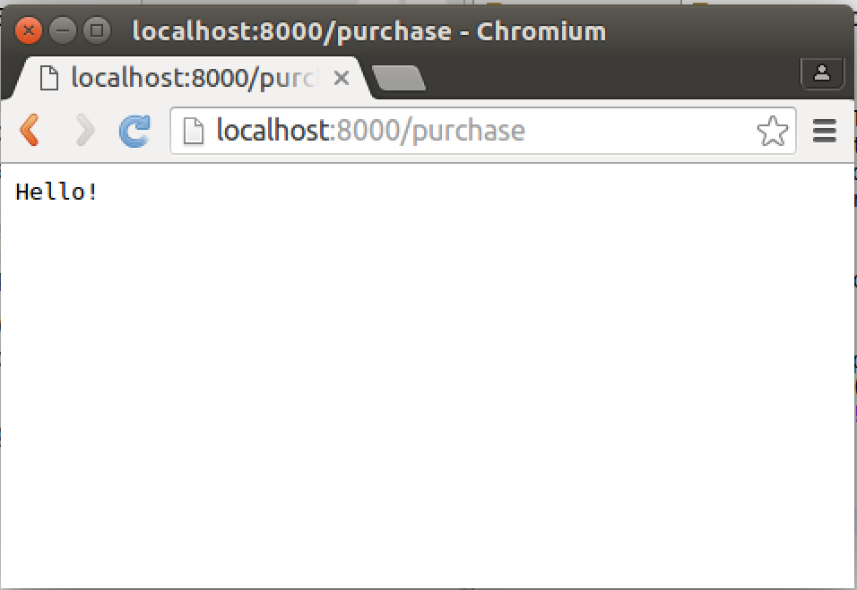
5. You can also run this from the command-line using the Uber Jar.
6. First terminate the existing server by clicking the stop button () in the Console.
7. From the terminal window:  
     
   cd ~/ex6/POResource  
   java -jar build/libs/POResource-all.jar  
     
   You should see:   
   2016-05-26 12:15:20.329:INFO:oejs.Server:main: jetty-9.1.z-SNAPSHOT

2016-05-26 12:15:20.375:INFO:oejs.ServerConnector:main: Started ServerConnector@430ab72d{HTTP/1.1}{0.0.0.0:8000}

1. Test this again with curl or ARC.
2. Recap:  
   We have created a very simple skeleton project (build.gradle, Main.class, directory structure) together with the simplest possible JAX-RS class (POResource.java). This is a great foundation for the next steps. The next steps are to create a proper service / resource that does something useful, and to test it.