**Exercise 1**

*Create a simple JSON HTTP service*

**Prior Knowledge**

Unix Command Line Shell

Some simple JavaScript (node.js)

**Learning Objectives**

Understand the basics of a Web Server

**Software Requirements**

Node.js

Npm

A Text Editor (e.g. Atom)

Creating a node.js program

1. Node.js is an effective framework for writing server-side programs using the JavaScript language. In this exercise we are going to create a simple program that returns a random number between 1 and 100.
2. Make a directory called exercise1. You can do this by starting a terminal window and typing:  
   mkdir ~/exercise1  
   cd ~/exercise1
3. Now we need to create a file and code the server.  
   In the terminal window type:  
   atom simplehttp.js  
     
   *Hint: If you have another text editor on Ubuntu that you prefer, switch to that instead.*
4. You should see an Atom editor window: 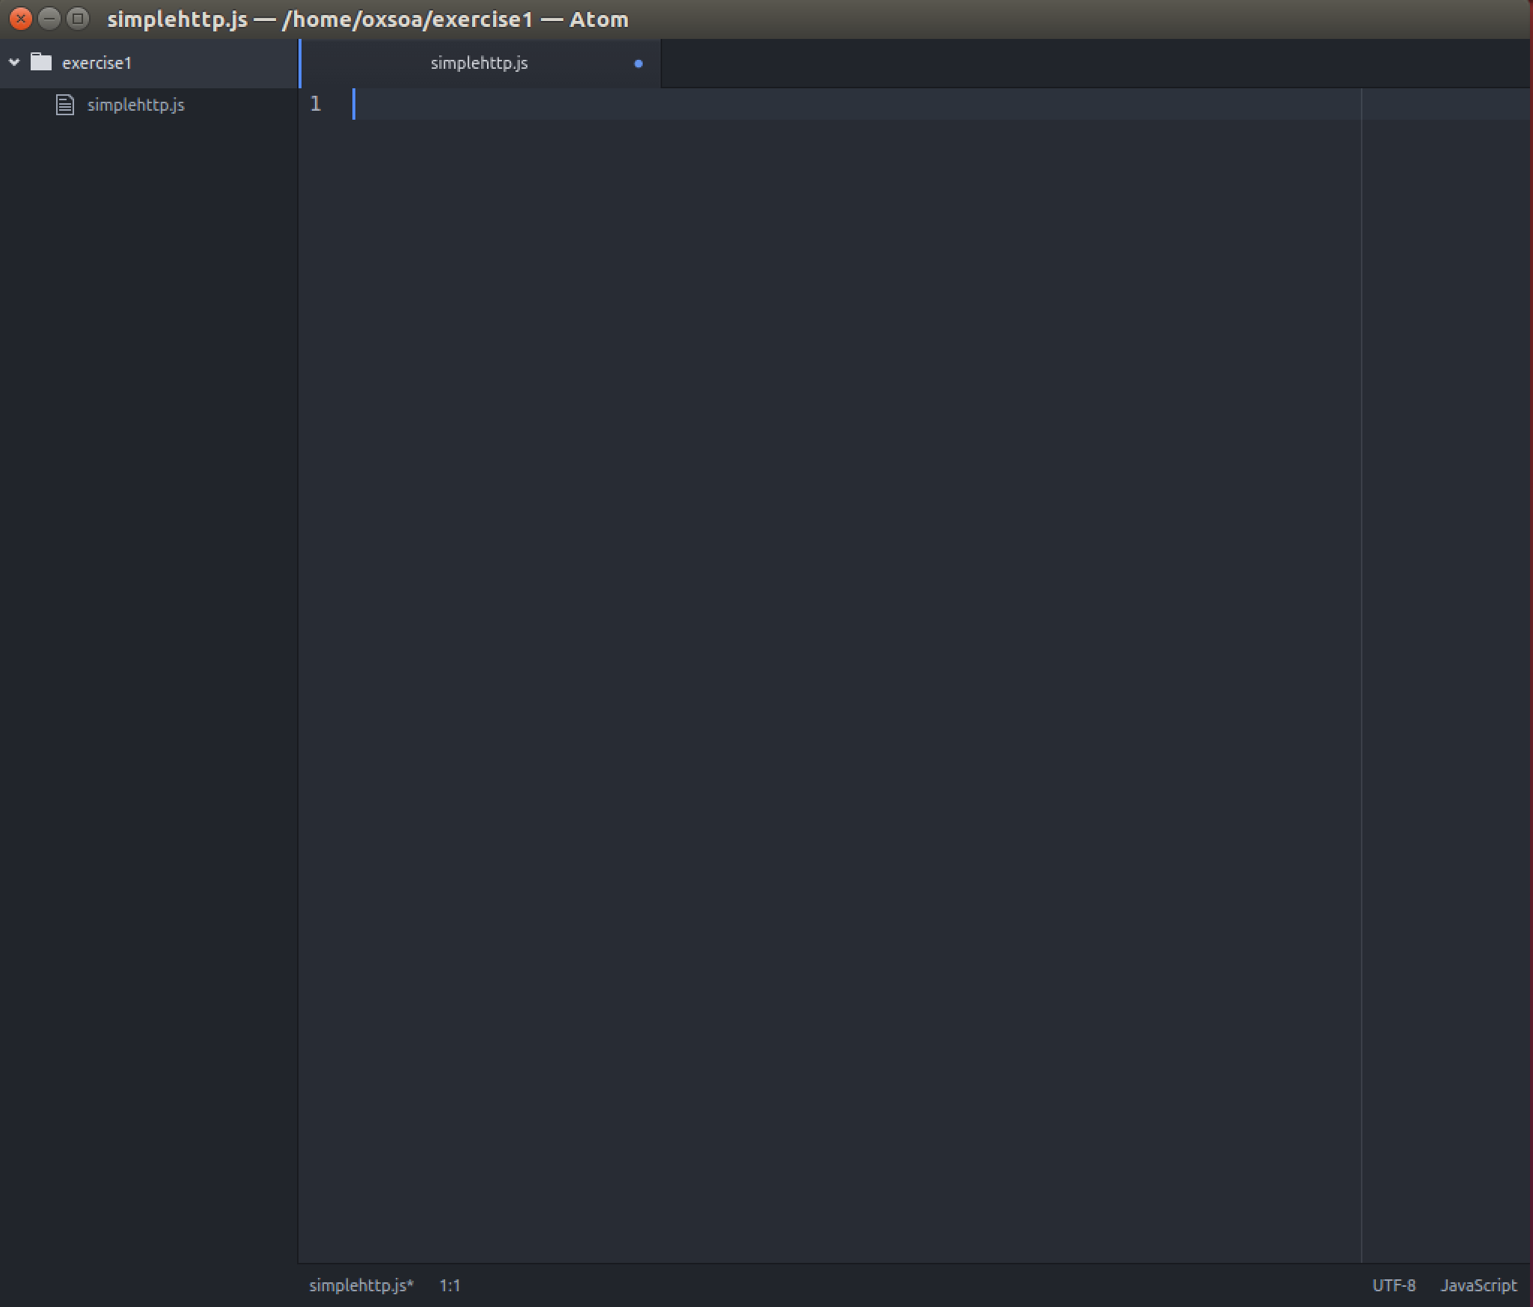
5. Type the following code:

var http = require('http');

function handleRequest(request, response){

var obj = new Object;

obj.random = Math.floor((Math.random() * 100) + 1);

response.end(JSON.stringify(obj));

}

//Create a server

var server = http.createServer(handleRequest);

//Lets start our server

var PORT = 8080

server.listen(PORT, function(){

console.log("Server listening on: http://localhost:%s", PORT);

});