Prompt Influence Explorer Exploring Revision Patterns with Transparent Evidence
Sitong Chang NetID: sc972
Duke Kunshan University
INFOSCI 301: Data Visualization and Information Aesthetics — Autumn 2026
Instructor: Prof. Luyao Zhang

Abstract. Text-to-image creation involves repeated prompt editing, yet a single before-and-after comparison cannot reveal broader revision patterns or clarify the status of every displayed element. Building on Guo et al.’s PrompTHis [5] and my first provenance-focused redesign, I developed Prompt Influence Explorer. The final prototype analyzes a 20,000-record slice of Midjourney Threads [6], yielding 7,307 qualifying consecutive revisions across 3,116 threads and a browser sample of 60 threads and 104 transitions. Coordinated bars, a prompt-change versus caption-change scatterplot, a revision landscape, a semantic edit matrix, and a details-on-demand inspector support overview and close inspection. Evidence controls separate recorded records, deterministic derivations, BLIP-2 captions, regenerated demonstrations, and unavailable evidence. The contribution is an evidence-aware visual analysis workflow that supports pattern exploration without treating association, model interpretation, or historical action as causal truth.

Keywords: provenance; prompt revision; coordinated views; generative AI; responsible visualization

1 Introduction and Research Question
PrompTHis visualizes prompt-edit histories through an Image Variant Graph and supports comparison of prompt-image relationships [5]. My first redesign added a provenance-aware inspector for one three-step thread. The final version retains that close-comparison function but addresses a remaining limitation: one example cannot show how revision strategies vary across many threads.
RQ: How can interactive visualization help creators explore patterns between prompt revisions and image-description changes while preserving the provenance of recorded, derived, regenerated, and AI-interpreted evidence?
This extends my earlier course focus on transparency. Week 1 separated source data from designer-produced ranking values, while Week 2 showed that different questions require different visual idioms. The final design therefore links an overview, filters, selection, and details on demand instead of forcing every question into one comparison view.
The prospective audience is DKU students and novice digital creators who iteratively refine generative-image prompts. This remains a scoped audience hypothesis rather than a validated community-wide need. The project connects narrowly to SDG 4.4 through practice in AI and data literacy: users inspect how claims were produced instead of receiving model-generated explanations as neutral facts.
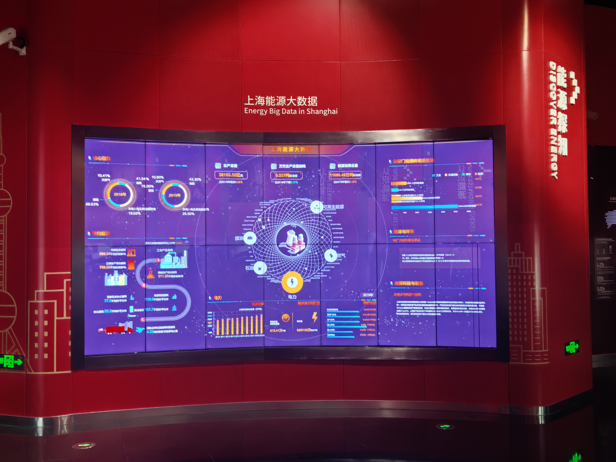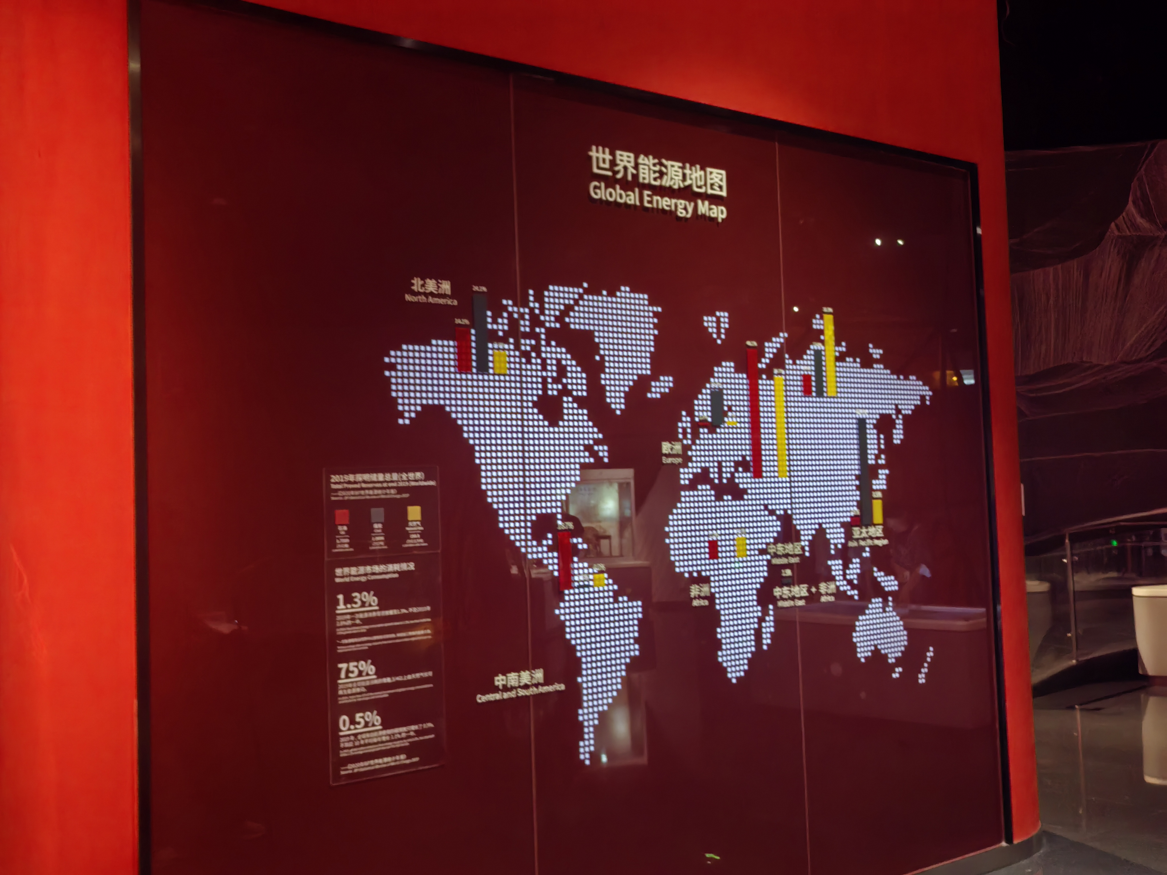
Figure 1. Field evidence and design inspiration. (a) Energy Big Data in Shanghai: dense system overview. (b) Global Energy Map: focused geographic comparison. Shanghai Science and Technology Museum, Sept. 4, 2026.
Both were photographed at the Shanghai Science and Technology Museum on September 4, 2026. I use them as design inspiration, not evidence about visitor comprehension.

2 Critical Evaluation and Governance

2.1 Classic four-level validation
Table 1. Classic four-level validation of PrompTHis
Level | Evidence and design consequence
Domain | PrompTHis targets artists; novice-student provenance comprehension is not its evaluated domain. I therefore retain a scoped student audience.
Data/task | The 20,000-record source slice supports pattern exploration, but creator intention and causal prompt effects remain unavailable.
Idiom | Bars, a scatterplot, a thread landscape, a semantic matrix and an inspector answer comparison, variation, structure and detail questions.
Algorithm | The update uses deterministic token differences and Jaccard distances plus a disclosed keyword heuristic. BLIP-2 caption distance remains model-derived.

2.2 Open science and governance
The complementary source is Midjourney Threads [6]. I analyze the 20,000 records in threads_0.csv. A reproducible script groups records by thread and timestamp, retains English consecutive revisions with prompt-token Jaccard similarity of at least 0.35, and produces 7,307 qualifying transitions across 3,116 threads. The browser uses a deterministic sample of 60 threads and 104 transitions, including thread 2231 as the close-inspection case.
The source includes prompt text, record identifiers, timestamps, generation parameters, upscale labels, historical image URLs, and four BLIP-2 captions per record. The recorded historical image URLs for thread 2231 returned HTTP 404 on September 13, 2026. Regenerated images are therefore labeled demonstrations rather than presented as originals.
The interface distinguishes:
- recorded: prompts, IDs, timestamps, parameters, and upscale actions;
- derived: token differences, edit types, Jaccard distances, and keyword-based semantic focus;
- AI-derived: BLIP-2 captions contained in the source dataset and caption-change distances;
- regenerated: three new comparison images for thread 2231;
- unavailable: historical images, creator intention, and explicit preference.
Upscale is a behavioral trace, not a preference or quality score. Caption change compares model-generated descriptions rather than image pixels, and scatterplot associations are not presented as causal effects.
Design objective: connect aggregate revision patterns to exact source records while keeping computation, model interpretation, demonstration material, and missing evidence visible.

3 Integrated Redesign and Demo
The final redesign places an exploratory overview before the existing Influence Inspector. The coordinated views answer four distinct questions:
- edit-direction bars compare how prompts are revised and also act as filters;
- a scatterplot shows how prompt-token change relates to BLIP-2 caption-token change;
- a thread landscape reveals revision length, sequence, edit direction, and outlying transitions;
- a semantic matrix and inspector show which prompt dimensions changed and expose the exact records.
Search, edit type, upscale action, and minimum-change controls update all views. Selecting a bar, point, thread segment, or matrix cell updates the detailed inspector. Evidence-layer controls allow users to hide derived, AI-caption, or regenerated material while recorded records remain visible.
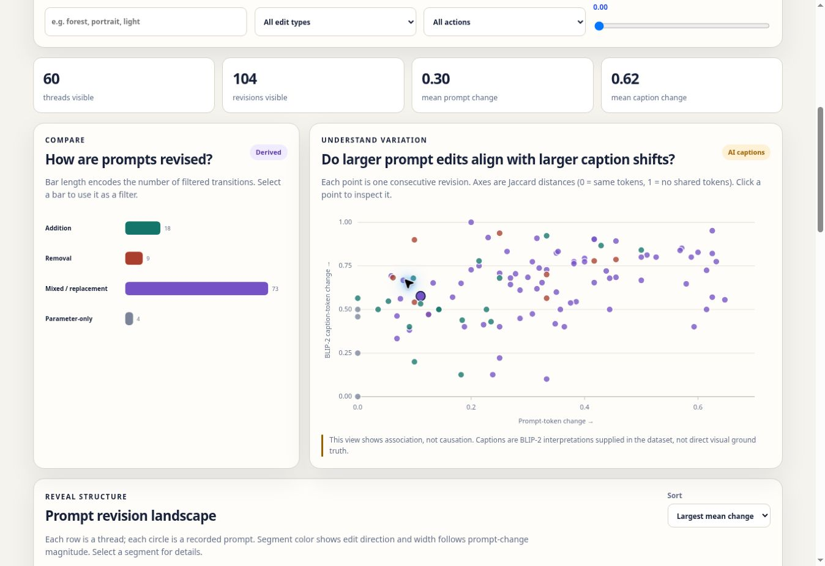
Figure 2. Final multi-thread Explorer. Edit-type bars and the prompt-versus-caption change scatterplot summarize 104 revisions across 60 sampled threads and link to source inspection.
Four human decisions define the final redesign:
- retain Baseline and the inspector so patterns can be checked against exact records;
- add a view only when it answers a comparison, variation, or structure question;
- do not encode upscale or distance measures as quality, preference, or causal influence;
- let users hide interpretive layers while keeping recorded evidence visible.
Static HTML, CSS, JavaScript, and JSON implement the interface; a Python script rebuilds the analysis file.
Website: https://infovis-sc972.vercel.app/
Project: https://github.com/dku-infosci301-Autumn2026/infovis-sc972

4 Evaluation and Findings
The formative evaluation concerns the first one-thread provenance redesign, not the final explorer. Four DKU students completed related inspection tasks using the Image Variant Graph and evidence sections; I recorded time, confidence, behavior, comments, and implications.
Measure | Observed result | Interpretation
Completion and time | 4/4; median 82.5 s | 68–112 s; tasks differed
Confidence | 3, 4, 4, 3 | Median 3.5/5
Initial ambiguity | 4/4 | Provenance, edge, upscale, or AI authority
After cue | 4/4 corrected | Formative; no baseline or final-explorer test
All four completed their tasks in 68–112 seconds (median 82.5), with median confidence 3.5/5. P1 confused a regenerated image with historical output; P2 read graph edges as similarity; P3 inferred preference from upscale; and P4 treated AI interpretation as a causal answer. Each revised the interpretation after checking labels, timestamps, prompt changes, or claim limits.
Cues corrected misunderstanding, but often only after it began. The next revision should place provenance beside images, mark Earlier → Later, pair Observed: upscale with Unknown: reason or preference, and visually subordinate AI interpretation.
The findings are descriptive: tasks differed, the sample is small, and there is no controlled baseline. The final explorer remains untested; BLIP-2 caption distance is a model-derived proxy.

5 Contribution and Next Step

The final contribution is an evidence-aware workflow that links multi-thread pattern exploration to source-level inspection while preserving provenance.

The prototype does not recover historical images, infer intention or preference, treat captions as visual truth, or establish causal prompt effects.

Next, I would compare the explorer with the one-thread interface using matched tasks and a larger art, design, and creative-technology sample, while separately checking AI-caption accuracy and neutrality.

Acknowledgements
I thank the four anonymous student proxies and the peer reviewers who motivated this update. The baseline adapts PrompTHis [5], and analysis data come from Midjourney Threads [6]. I verified source records, calculations, visuals, claims, and evaluation summaries; Appendix B gives the full AI disclosure.

References
[1] Tamara Munzner. 2009. “A Nested Model for Visualization Design and Validation.” IEEE Transactions on Visualization and Computer Graphics 15(6), 921–928.
https://www.cs.ubc.ca/labs/imager/tr/2009/NestedModel/
[2] Mark D. Wilkinson et al. 2016. “The FAIR Guiding Principles for Scientific Data Management and Stewardship.” Scientific Data 3, 160018.
https://doi.org/10.1038/sdata.2016.18
[3] Timnit Gebru, Jamie Morgenstern, Briana Vecchione, Jennifer Wortman Vaughan, Hanna Wallach, Hal Daumé III, and Kate Crawford. 2021. “Datasheets for Datasets.” Communications of the ACM 64(12), 86–92.
https://doi.org/10.1145/3458723
[4] R. Ziman, S. Saharan, G. McGill, and L. Garrison. 2026. “‘It Looks Sexy but It’s Wrong’: Tensions in Creativity and Accuracy Using GenAI for Biomedical Visualization.” IEEE Transactions on Visualization and Computer Graphics 32(1), 320–330.
https://doi.org/10.1109/TVCG.2025.3633883
[5] Y. Guo, H. Shao, C. Liu, K. Xu, and X. Yuan. 2024. “PrompTHis: Visualizing the Process and Influence of Prompt Editing during Text-to-Image Creation.” IEEE Transactions on Visualization and Computer Graphics.
https://arxiv.org/abs/2403.09615
[6] S. Don-Yehiya, L. Choshen, and O. Abend. 2023. “Human Learning by Model Feedback: The Dynamics of Iterative Prompting with Midjourney.” Proceedings of EMNLP 2023.
https://aclanthology.org/2023.emnlp-main.253/
[7] Shachar Don-Yehiya et al. Mid-Journey-to-alignment. GitHub repository.
https://github.com/shachardon/Mid-Journey-to-alignment
[8] United Nations Department of Economic and Social Affairs. “Goal 4: Quality Education — Target 4.4.”
https://sdgs.un.org/goals/goal4
[9] Lee et al. 2024. “Diffusion Explainer.” IEEE VIS 2024 short paper and interactive system.
https://ieeevis.org/year/2024/program/paper_v-short-1224.html

Appendix A Technical Evidence and Cumulative Development

A1 Week 1 and Week 2 Integration Record

Table 3. Week 1 and Week 2 integration record
Earlier component | Earlier evidence | Change and reason | Current location
2056 aspiration, two traditions and transparency principle | Week 1 Zhouzhuang recommendation prototype treated ranking as an inspectable visual argument | Retain and extend. Apply transparency to prompt-revision measures, AI captions and regenerated media | Sec. 1; A1
Exhibition observation and community hypothesis | Week 1 and Week 2 work emphasized scoped audience and community claims | Revise. Keep DKU students and novice creators as a prospective audience; add missing professional voices | Sec. 1; A2
First design, research safeguard and human decisions | Week 1 separated source fields from illustrative values and designer-assigned weights | Strongly retain. Separate recorded, derived, AI-derived, regenerated and unavailable evidence | Sec. 2–3; A3–A4
Field-photo inspirations | Energy Big Data in Shanghai and Global Energy Map, Shanghai Science and Technology Museum | Extend. Combine broad multi-view overview with focused details on demand | Fig. 1; A2
Open-source precedents and SDG target | PrompTHis, Diffusion Explainer and SDG 4.4 | Revise. Use precedents for history inspection and public explanation; limit the SDG claim to AI and data literacy practice | Sec. 1–3; A2
Data contract, tested interaction and failure | Energy Lens emphasized provenance, transformation and missingness | Extend. Make source filtering, derivation rules, AI-caption status and unavailable images inspectable | A3–A4
Four validation levels, data conditions and next test | Week 2 critique used structured task and idiom reasoning | Retain and formalize. Add multi-thread pattern questions while preserving evaluation limits | Table 1; A3; A5

Week 1 artifact
Transparent Zhouzhuang Travel Recommendation Prototype
https://travel-recommendations.my.canva.site/
The Week 1 prototype explored recommendation ranking as an inspectable visual argument rather than a neutral list. Users could reduce the influence assigned to popularity and inspect how the ranking changed.
The methodological lesson retained in the final project is that system-produced, derived, and model-interpreted information should remain distinguishable from documented source records.

Week 2 artifact
Energy Lens v2
https://huggingface.co/spaces/dku-infosci301-Autumn2026/Sitong-W2
Energy Lens separated public energy questions into Place, Magnitude, Mix, and Change. It also made transformation, provenance, and missingness visible.
The final project retains two lessons:
- different analytical questions require coordinated visual forms rather than a single overloaded view;
- derived and AI-interpreted information must remain visibly distinct from source records.

A2 Field Evidence and Design Inspirations

Field Photo 1 — Energy Big Data in Shanghai
Place: Shanghai Science and Technology Museum, Shanghai
Date: September 4, 2026
Photographer: Sitong Chang
Factual caption: A large curved digital display titled “Energy Big Data in Shanghai” presents multiple donut charts, bar charts, numerical indicators, energy relationships, and explanatory text in one coordinated dashboard.
Alt text: Large red exhibition wall containing a multi-screen blue-purple energy dashboard with several charts, numerical values, and a central energy-system diagram.
Observation: The display combines many visual encodings and indicators into one overview.
Inference: A dense system view can communicate broad structure but may not be ideal for every focused analytical question.
Possible task: move between a broad overview of many revision histories and close inspection of one transition.
Design consequence: combine coordinated overview views with a source-level revision inspector.

Field Photo 2 — Global Energy Map
Place: Shanghai Science and Technology Museum, Shanghai
Date: September 4, 2026
Photographer: Sitong Chang
Factual caption: A world map display titled “Global Energy Map” uses vertical colored bars positioned across geographic regions.
Alt text: Dark world map on a red exhibition wall with white geographic outlines and red, yellow, and gray vertical bars positioned across continents.
Observation: Geographic comparison dominates the display.
Inference: A single strong idiom can foreground one question more clearly than a dense dashboard.
Possible task: compare one prompt transition or isolate an outlying revision selected from the overview.
Design consequence: link every selected mark to a focused details-on-demand inspector.
These photographs are treated as evidence of visual forms I observed, not as evidence that visitors were confused or that one display was more effective.

Open-source and research precedents

PrompTHis
Official repository:
https://github.com/Vis4Sense/prompthis
Capability: prompt-edit history exploration and influence analysis.
Design influence: retain graph-based revision history and edge selection as source-level context.
Limitation: the current project does not reproduce the complete system or its influence algorithm.

Diffusion Explainer
Official research page:
https://ieeevis.org/year/2024/program/paper_v-short-1224.html
Capability: combines research explanation, interactive inspection, and an open-source artifact.
Design influence: reinforced the value of linking a research argument, an inspectable public demo, and explicit explanatory boundaries.
Limitation: its main explanatory target is diffusion-model behavior rather than provenance in prompt-edit histories.

Community and SDG
Prospective community: DKU students and novice digital creators who iteratively refine generative-image prompts.
Missing voices: professional creators, art and design students, instructors, non-users, and the original anonymous creators represented in the dataset.
SDG target: SDG 4.4.
Mechanism: provenance controls and linked inspection support practice in distinguishing source records, computation, and model interpretation.
Observable outcome for a future study: users locate a revision pattern, inspect the underlying records, identify evidence provenance, and avoid treating upscale or caption change as objective preference or causal influence.

A3 Data Contract and Governance

Purpose
Support pattern exploration and provenance-aware inspection of real prompt revisions.

Intended community
DKU students and novice digital creators who work with iterative text-to-image prompts.

User action
Filter the revision sample, select a visual mark, compare exact records, and toggle evidence layers.

Supported claim
The interface can expose revision patterns and link them to recorded, derived, AI-derived, regenerated, and unavailable evidence.

Prohibited inference
The prototype does not establish:
- creator intention;
- a causal effect of a specific word or a causal relationship between the two scatterplot measures;
- objective image quality or direct visual distance from BLIP-2 caption change;
- explicit preference from upscale;
- broad community benefit or professional-creator usability.

Table 4. Data conditions and governance decisions
Data condition | Evidence and intended use | Risk and verification
Baseline and first redesign | Attributed simplified PrompTHis graph plus a provenance-aware inspector for thread 2231 | Supports close comparison but not multi-thread pattern discovery
Complementary public data | Midjourney Threads, threads_0.csv: 20,000 records; 7,307 qualifying transitions; 60-thread browser sample | Disclose filtering and sampling; historical images may be unavailable; BLIP-2 captions are model-derived
No suitable open data | Creator intention, direct visual ground truth and explicit preference are absent | Do not infer them; future work should collect creator-authored annotations and evaluate caption accuracy

Selected source records
Step | Record ID | Timestamp | Parameters | Upscaled
1 | 1071138984736084058 | 2023-02-03 18:43:54.761 UTC | --chaos 50 | False
2 | 1071139569849880656 | 2023-02-03 18:46:14.263 UTC | --quality 5 | True
3 | 1071140082511253515 | 2023-02-03 18:48:16.491 UTC | --quality 5 | True

Provenance classes
Class | Example | Treatment
Recorded | prompt, ID, timestamp, parameters, upscale Boolean | copied from source records
Derived | added and removed tokens; edit type; prompt and caption Jaccard distances; semantic-focus heuristic | computed reproducibly and labeled as derived
AI-derived | four BLIP-2 captions per source record and caption-change distance | optional evidence layer; not treated as direct visual truth
Regenerated | three comparison images for thread 2231 | explicitly labeled demonstration material
Unavailable | historical images, creator intention and explicit preference | kept unavailable rather than inferred
The recorded historical Discord image URLs for thread 2231 returned HTTP 404 on September 13, 2026. This missingness remains visible, and regenerated demonstrations appear only for the documented case.

A4 Implementation and Human Design Decisions
Project repository:
https://github.com/dku-infosci301-Autumn2026/infovis-sc972
Live website:
https://infovis-sc972.vercel.app/
Entry file: index.html
Other implementation files:
style.css
script.js
data/analysis.json
data/prototype.json
scripts/build_analysis.py
Runtime: static browser-compatible HTML, CSS, JavaScript, and JSON; Python is used only to rebuild the derived analysis file.
Dependencies at runtime: no framework, package manager, API key, backend, or live AI service.

Reproduction
python -m http.server 8000
Then open:
http://localhost:8000

Working interaction
- Open the site and begin in Redesign Explorer.
- Use search, edit direction, upscale action, or minimum-change controls to narrow the sample.
- Compare the edit bars, prompt-change versus caption-change scatterplot, and thread landscape.
- Select a bar, point, thread segment, or semantic-matrix cell.
- Inspect exact before-and-after prompts, token differences, recorded actions, BLIP-2 captions, and available regenerated demonstrations.
- Toggle derived, AI-derived, and regenerated layers, or switch to Baseline to compare analytical capability.

Three human design decisions

1. Coordinate overview and detail
Reason: aggregate patterns are useful only when users can return to exact source records.

2. Limit every encoding to a supported claim
Reason: prompt distance, caption distance, and upscale record different phenomena and do not measure causal influence or quality.

3. Separate interpretation from evidence
Reason: model captions and regenerated demonstrations should not appear as authoritative historical data.

Accessibility
The implementation includes:
- keyboard-operable controls and chart marks;
- visible focus states and live status updates;
- ARIA labels and pressed states;
- image alt text and textual explanations of visual encodings;
- responsive layouts and readable provenance labels;
- loading, empty-selection, and data-fetch messages.

Failure handling
Historical-image failure is shown explicitly. A zero-result filter produces an empty state, and data-fetch failure produces an error message. No live AI dependency is required.

A5 Evaluation Record

Table 5. Evaluation evidence record
Record | Your evidence
Scope and method | Four DKU student participants completed related inspection tasks with the first one-thread provenance redesign. Tasks differed by participant; measures were completion time, confidence, observed behavior, comments, and design implications.
P1 · 68 s · 4/5 | Read the prompt diff correctly but initially treated a regenerated image as the original output. The Generated demonstration label corrected the error. Comment: “At first I thought these were the original images.” Implication: place stronger provenance beside images.
P2 · 91 s · 3/5 | Understood nodes as prompt versions but first read edges as image similarity. Timestamps and prompt changes clarified chronology. Comment: “I didn’t know whether the line meant time, similarity, or influence.” Implication: add Earlier → Later.
P3 · 74 s · 4/5 | Separated recorded, regenerated, and model-derived evidence, but initially inferred preference from upscale. The claim limit corrected this. Comment: “The data doesn’t actually tell us why they clicked it.” Implication: pair Observed: upscale with Unknown: reason or preference.
P4 · 112 s · 3/5 | Initially treated AI interpretation as the answer to visual causation; the model-derived label prompted reconsideration. Comment: “The AI summary feels convincing because it explains everything in one sentence.” Implication: place AI interpretation after recorded evidence and use a lighter hierarchy.
Limitations and next milestone | Small convenience sample, heterogeneous tasks, no controlled baseline, and no test of the final multi-thread explorer. The next study should use matched tasks, a larger art/design/creative-technology sample, and explicit checks of AI-caption accuracy and neutrality.

Aggregate results
Measure | Result and interpretation
Task completion and time | 4/4; 68, 91, 74, and 112 s; median 82.5 s
Confidence | 4, 3, 4, and 3; median 3.5/5
Initial ambiguity | 4/4, with a different issue for each participant
Correction after cue | 4/4 revised after a label, warning, timestamp, or prompt difference
Scope | First redesign only; no controlled baseline and no final-explorer test

Main formative findings
- P1 showed that image-level provenance labels need to be visible before comparison begins.
- P2 showed that graph edges need an explicit chronological direction cue.
- P3 showed that an observed upscale action must remain separate from inferred preference.
- P4 showed that AI interpretation should be visually subordinate and explicitly presented as a claim to verify.
The evaluation findings are descriptive and formative. They motivate interface changes but do not establish comparative effectiveness or evaluate the final multi-thread explorer.

A6 Feedback and Revision

Table 6. Feedback response and revision record
Comment ID | Evidence-based concern | Response and rationale | Revised location or test
C1 | The interface did not clearly explain why prompt influence matters. | Add a creator workflow and an overview-to-inspection sequence that supports deliberate prompt refinement. | Research question and analysis workflow
C2 | One three-step thread provided too little evidence for pattern analysis. | Analyze a real 20,000-record source slice and expose a 60-thread, 104-transition browser sample. | Data pipeline and coordinated overview
C3 | The evaluation needed a clearer conclusion and a broader future sample. | Visualize the descriptive result, state that it evaluates the first redesign only, and retain professional creators as future work. | Sec. 4; A5
C4 | Regenerated-image production and historical-image absence needed clearer explanation. | Keep demonstrations limited to thread 2231, label them, and show an unavailable-evidence message elsewhere. | Inspector and generation record
C5 | AI summaries may not be consistently accurate or neutral. | Use source-supplied BLIP-2 captions as an optional AI-derived layer and label caption distance as a proxy rather than visual truth. | Evidence controls and scatterplot warning

Appendix B AI Assistance and Human Verification

Table 7. AI assistance and human verification record
Field | Your disclosure
Tool, displayed model/version and date | OpenAI ChatGPT Work and Codex tools, September 2026; OpenAI image generation, September 2026
Purpose and significant prompt or input summary | Assisted with redesign scoping, HTML/CSS/JavaScript/JSON scaffolding, reproducible data-processing code, documentation structure, visual-summary drafting, image generation, evaluation organization and paper revision
Output accepted and where it appears | Interface code, analysis-data builder, regenerated demonstration images, documentation structure, evaluation summary and writing revisions
Output rejected and why | Rejected unsupported visual-causality claims, treatment of upscale as quality or preference, unlabeled generated media, and presentation of AI captions as direct visual truth
Human edits to the argument, visuals, data or code | I selected the research precedents and dataset, defined the research question and provenance classes, preserved source spelling, set the analysis and sampling boundaries, checked calculations and generated visuals, revised claims and approved the final design
Original publications and source records checked | PrompTHis paper and repository; Midjourney Threads paper, repository and CSV records; Munzner; FAIR; Datasheets; SDG 4.4
Data/code tests run and outputs inspected | Data-builder execution, JSON parsing, JavaScript syntax, search and filter linkage, chart selection, evidence-layer toggles, Baseline and Explorer switching, error states, image loading and evaluation-result consistency
Failures corrected and remaining unverified points | Corrected the one-thread depth limitation, image-source ambiguity, overstatement of causal influence and AI-caption authority. Remaining limits: unavailable historical images, unknown creator intention, heuristic semantic categories, model-derived captions and no user evaluation of the final explorer

Student responsibility statement
I designed and verified the submitted work, distinguished source evidence from computation and model interpretation, credited reused resources and specific contributions, and can explain the research question, data-processing choices, visual encodings, interactions, and claim limits. AI assistance was treated as drafting, implementation support, or generated demonstration material rather than independent empirical evidence.
Student name: Sitong Chang
Date: September 20, 2026

