PCBA SPONSORSHIP REQUEST
Hack The Badge
Request for JLCPCB sponsorship of approximately 10 fully assembled PCBA units for MSG CTF
Requester: Aegis Security Team / MSG CTF
Request type: PCB fabrication, component procurement, SMT assembly, and delivery support
Requested quantity: Approximately 10 completed units
Delivery destination: Republic of Korea
Schedule request: Preferably within 7 days; absolute maximum 14 days after production approval
Design status: Circuit and PCB design completed; production files are available for review

Request Summary
Hack The Badge is an interactive cybersecurity badge project operated by the Aegis Security Team for the MSG CTF finals booth. Participants connect to the badge over USB Serial and solve cybersecurity challenges embedded in the badge experience.
We are requesting JLCPCB sponsorship support for approximately 10 fully assembled PCBA units. In this document, completed units means assembled PCBA boards ready for project-side firmware loading and event preparation. This request does not ask JLCPCB to provide an enclosure, retail packaging, or firmware programming unless those services are separately offered and confirmed.
Item | Request / current status
Requested support | PCB fabrication, parts, component procurement, SMT assembly, and delivery support as available from JLCPCB.
Quantity | Approximately 10 completed PCBA units.
Timing | Please confirm whether completion and delivery to South Korea is possible within 7 days if feasible, or within 14 days at the latest.
Design status | Circuit and PCB design are completed. This is a production feasibility and urgent schedule request, not a pre-design review.
Destination | Republic of Korea.

Project Visuals
 | 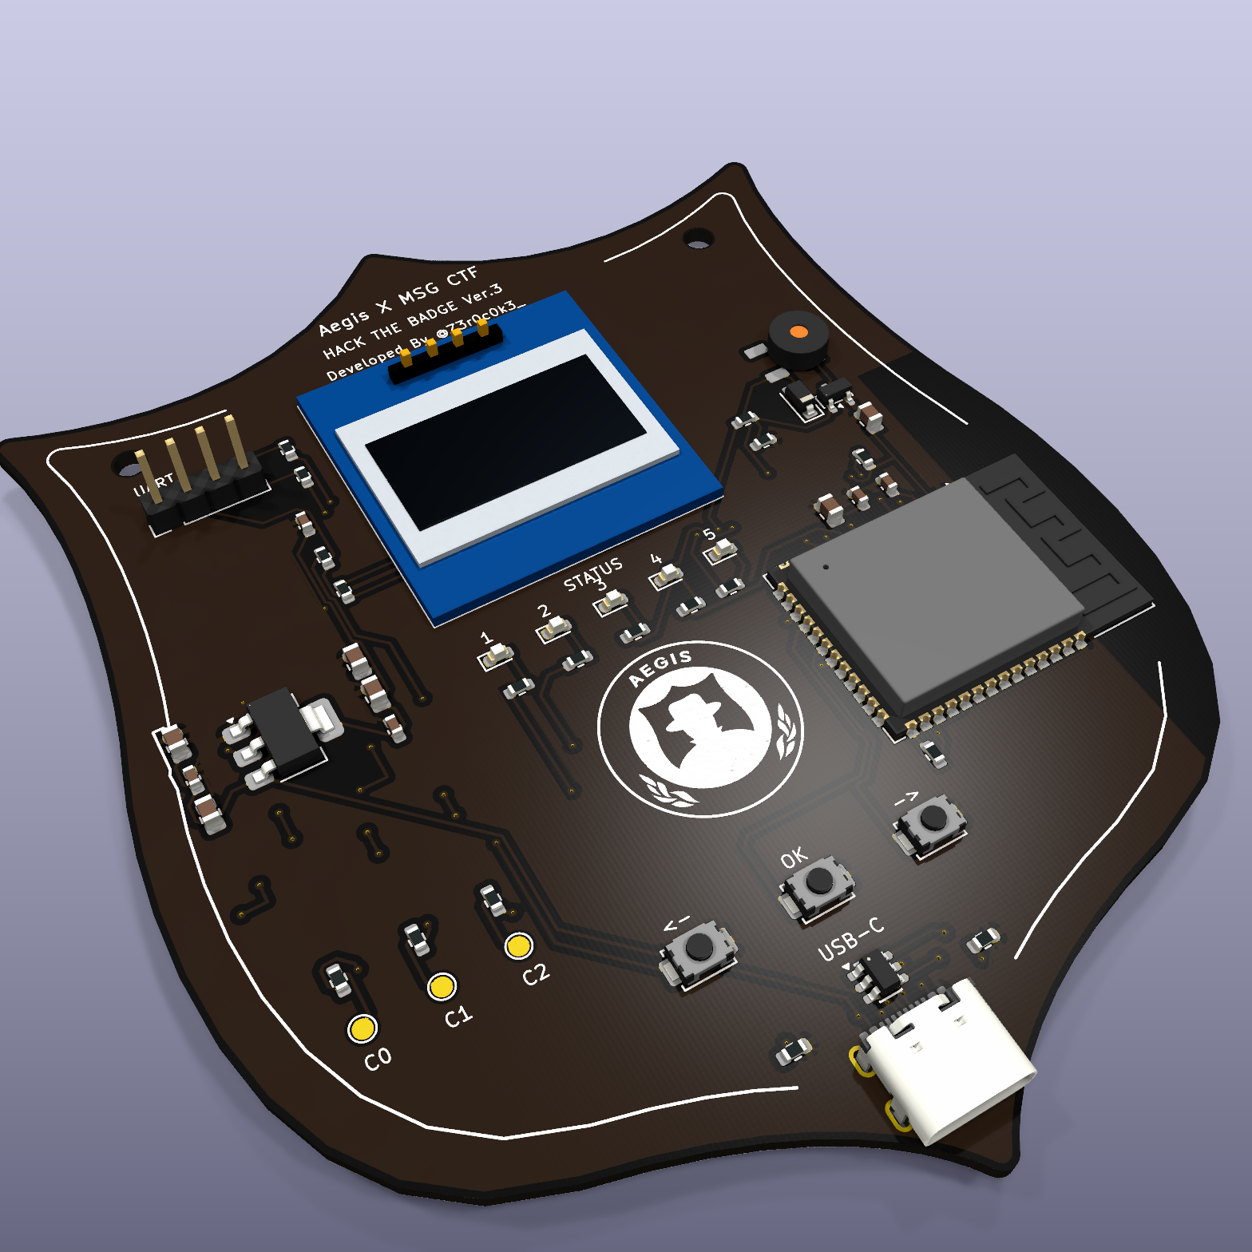
Visual references: Aegis badge artwork and current Hack The Badge PCB render.

Production Files Available For Review
The current project folder includes JLCPCB-oriented manufacturing outputs. These files can be provided for immediate review. The attached manufacturing package is available for immediate review. The requested sponsorship production quantity is approximately 10 units.
File / artifact | Status | Notes
Gerber ZIP | Available for immediate review | JLCPCB fabrication package is present in the project folder.
JLCPCB BOM CSV | Available for immediate review | Current SMT assembly BOM is present; live stock and pricing should be rechecked by JLCPCB.
JLCPCB CPL CSV | Available for immediate review | Current component placement file is present for review.
Manufacturing validation | Available for immediate review | Local validation report is present and records the available package state.
Manual assembly list | Available for immediate review | OLED1 is listed separately in the current package; please confirm whether JLCPCB can support it for completed PCBA units.

Hardware Scope
The badge is based on an ESP32-S3-WROOM class MCU and is designed as a USB-powered interactive CTF device. The main participant interface is USB Serial, with additional intentional challenge pads for UART/GPIO interaction.
Subsystem | Included in the design
Controller | ESP32-S3-WROOM series module
USB and power | USB-C device connector and required power/protection circuitry.
User interface | OLED display, tactile switches, and LEDs.
Challenge interface | UART/GPIO challenge pads and required protection components.
Assembly target | Fully assembled PCBA boards. Please confirm whether OLED sourcing/placement can be included by JLCPCB.

Requested Sponsorship Scope Confirmation
Please confirm which parts of the production and delivery scope JLCPCB may be able to sponsor or discount. Partial sponsorship is still useful if full coverage is not available.
Scope area | Confirmation requested from JLCPCB
PCB fabrication | Can JLCPCB sponsor or discount the PCB fabrication cost for approximately 10 units?
Component cost | Can JLCPCB sponsor or discount the electronic component cost?
Component procurement | Can JLCPCB procure all listed PCBA components, or identify parts requiring substitution/approval?
SMT assembly | Can JLCPCB sponsor or discount SMT assembly for the requested quantity?
OLED / non-SMT handling | Can JLCPCB support the OLED as part of completed PCBA units, or should it remain outside JLCPCB assembly?
Shipping | Can JLCPCB sponsor, discount, or expedite shipping of the completed PCBA units to South Korea?

Urgent Schedule Confirmation
The project is intended for use at the MSG CTF finals booth. Please confirm the fastest realistic schedule after file review and production approval. We are specifically asking whether completed PCBA units can be fabricated, assembled, and shipped to South Korea within the following windows.
Schedule window | Requested confirmation
Preferred | Completion and delivery to South Korea within 7 days if feasible.
Maximum acceptable | Completion and delivery to South Korea within 14 days at the latest.
If not feasible | Please provide the earliest realistic production and delivery schedule and identify the bottleneck.

Review Questions For JLCPCB
- Can JLCPCB support approximately 10 completed PCBA units for this Hack The Badge project?
- Can the available Gerber, BOM, and CPL files be reviewed immediately for production feasibility?
- Which cost areas can JLCPCB sponsor or discount: PCB fabrication, parts, procurement, SMT assembly, or shipping?
- Is the 7-day preferred schedule possible, including shipment to South Korea? If not, is 14 days possible?
- Are there any components that require substitution, stock confirmation, or special handling before production approval?
- Can JLCPCB include the OLED in the completed PCBA scope, or should the OLED remain a separate project-side assembly step?

References
Existing project background: https://github.com/Z3r0c0k3/hacking-box
Attached manufacturing package: Gerber, BOM, CPL, and manufacturing validation files
Primary files for review: hacking_badge_v3_jlcpcb_gerbers.zip, hacking_badge_v3_jlcpcb_bom.csv, hacking_badge_v3_jlcpcb_cpl.csv

