JLCPCB SUPPORT BRIEF
Hack The Badge / Hacking Box V2
Phase 1 hardware requirements based on the existing Arduino Hacking Badge project
Prepared for: JLCPCB fabrication and PCBA support review
Prepared by: Aegis / MSG CTF project team
Date: August 4, 2026
Status: Requirements draft; schematic and PCB layout are out of scope for Phase 1
Reference project: https://github.com/Z3r0c0k3/hacking-box

Executive Summary
Hack The Badge is a CTF booth hardware hacking badge for the Aegis / MSG CTF event. The requested JLCPCB support is focused on reviewing the hardware concept before schematic capture, confirming PCBA feasibility, and identifying manufacturability or component-selection risks early.
This V2 effort is based on the existing Z3r0c0k3/hacking-box Arduino Hacking Badge project. The original project provides a serial shell-style challenge, multiple independent puzzles, LED feedback, and persistent solve state. V2 is intended to preserve the participant-visible challenge flow while moving to a repeatable ESP32-S3-based PCB suitable for a small event run.

Visual Reference

Figure 1. Example Aegis ring artwork rendered from black-white-ring.svg for badge identity reference.
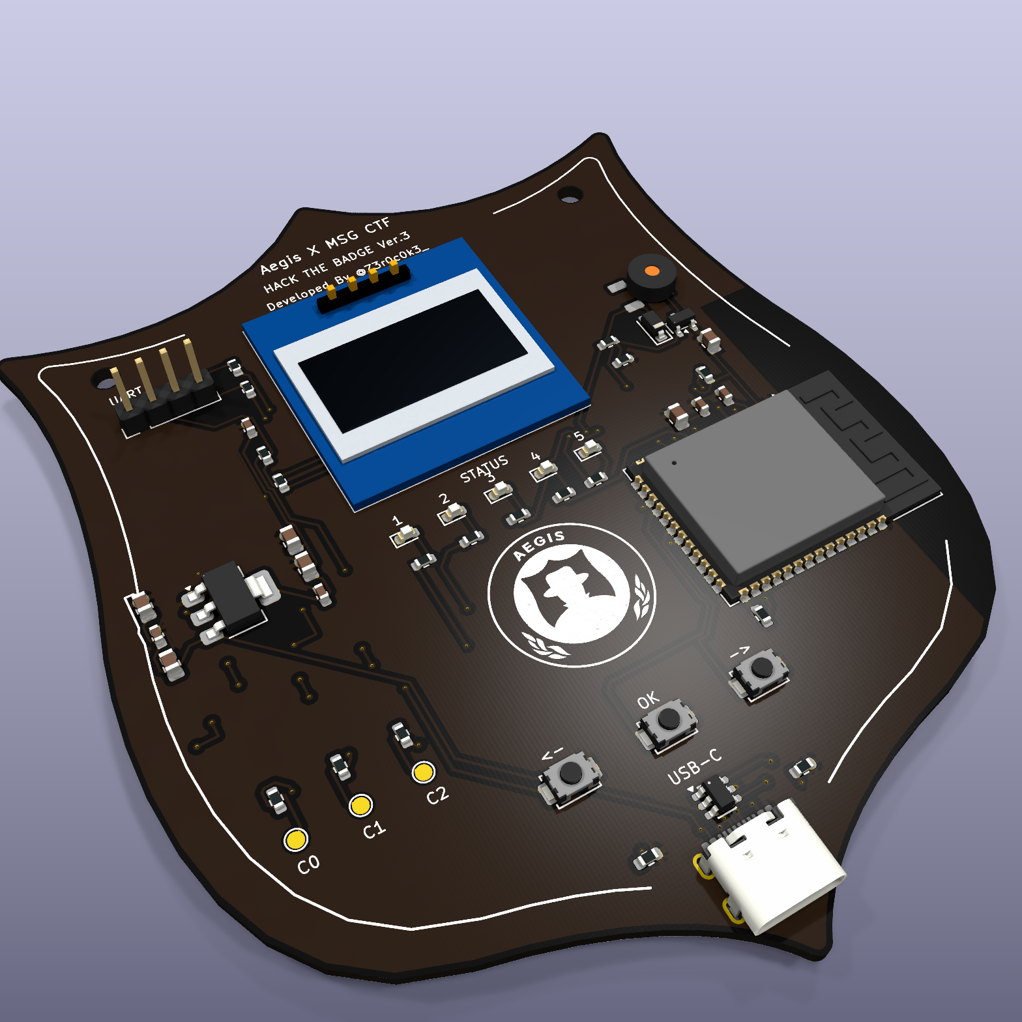
Figure 2. Existing local badge render used as a visual direction reference only; this brief does not release a new PCB design.

Based On The Existing Hacking Box Project
The public reference project is Z3r0c0k3/hacking-box on GitHub. Its README describes an Arduino Hacking Badge that mimics the kind of badge hacking experience distributed at larger CTF finals. The repository contains example, old, and template badge firmware folders, and the README identifies Arduino IDE, C/C++, EEPROM, and PROGMEM as the technical foundation.
- Four independent puzzle slots are described in the reference project.
- Each solved puzzle maps to LED feedback, with additional LED animation when all puzzles are solved.
- A shell-like serial monitor interface lets participants start the game, select problems, check status, reset progress, clear the screen, and exit a problem.
- The README documents 4800 baud serial monitor setup and an Arduino Uno/Nano-style hardware baseline.
- Large challenge text and ASCII art are stored in program memory using PROGMEM, while solve state is persisted using EEPROM.

Support Requested From JLCPCB
- Review the proposed architecture before schematic capture and PCB layout.
- Recommend JLCPCB-available parts for low-volume SMT assembly.
- Advise whether the OLED module should be assembled by JLCPCB or hand-soldered after PCBA.
- Review USB-C, ESD, input protection, exposed UART/GPIO pads, buttons, LEDs, and optional buzzer for PCBA practicality.
- Identify DFM issues related to a badge-shaped PCB outline and decorative silkscreen artwork.
- Help confirm which decisions must be frozen before Gerber, BOM, and CPL generation.

Target Hardware Baseline
Function | Phase 1 baseline | Reason
MCU | ESP32-S3-WROOM module | Native USB, optional Wi-Fi/BLE, more memory, and lower RF risk than a bare chip.
Logic voltage | 3.3 V | Matches ESP32-S3 and modern peripheral modules.
USB | USB-C device port | Power, serial console, firmware upload, and staff recovery.
Display | 0.96 inch 128x64 I2C OLED | Compact logo, status, and challenge text display.
Input | Three tactile switches | Left/OK/right controls, mini-game input, or admin-unlock gesture.
Output | Five status LEDs | Clear challenge progress and solved-state indication.
Audio | Passive buzzer with driver, if approved | Optional audible feedback without directly loading MCU GPIO.
Challenge I/O | UART plus protected GPIO pads | Intentional hardware hacking surface for participants.

Compatibility Requirements
V2 should be treated as a firmware port or rewrite, not as a direct binary-compatible replacement for the Arduino Nano / ATmega328P reference implementation. The participant-visible behavior should remain familiar.
- Preserve the USB Serial shell-style challenge workflow.
- Preserve the puzzle selection model and status commands where practical.
- Map solved-state feedback to multiple LEDs, with room for an all-solved animation.
- Replace EEPROM persistence with ESP32-S3 non-volatile storage while preserving visible behavior.
- Review any V1 dependency on 5 V Arduino electrical behavior before exposing signals on a 3.3 V board.
- Keep staff recovery practical through USB flashing plus EN/reset and BOOT access.

Proposed ESP32-S3 Pin Map
Function | Signal | Behavior | Notes
USB D- | GPIO19 | Native USB | Fixed for ESP32-S3 USB use.
USB D+ | GPIO20 | Native USB | Fixed for ESP32-S3 USB use.
OLED SDA | GPIO4 | 3.3 V I2C | Confirm final OLED pull-ups.
OLED SCL | GPIO5 | 3.3 V I2C | Assume display address 0x3C until confirmed.
Challenge 0 | GPIO6 | 3.3 V through series resistor | Expose only after challenge approval.
Challenge 1 | GPIO7 | 3.3 V through series resistor | Expose only after challenge approval.
Challenge 2 | GPIO8 | 3.3 V through series resistor | Expose only after challenge approval.
Left / OK / Right | GPIO9 / GPIO10 / GPIO12 | Active-low inputs | Use pull-ups and debounce.
Status LEDs | GPIO13-GPIO17 | Active-high outputs | Initialize low at boot.
Buzzer PWM | GPIO18 | MOSFET-driven PWM | Only if buzzer is approved.
Player UART TX/RX | GPIO43 / GPIO44 | 3.3 V through series resistors | Not 5 V tolerant.
Boot / reset | GPIO0 / EN | Staff recovery | Do not use as challenge GPIO.

Open Decisions Before Schematic Capture
ID | Decision needed | Why it matters
O-001 | Confirm exact ESP32-S3-WROOM module variant. | Affects BOM, firmware partitioning, availability, and price.
O-002 | Confirm first-run quantity. | Affects unit price, spare strategy, and assembly options.
O-003 | Decide whether OLED is PCBA-installed or hand-soldered. | Affects BOM/CPL, footprint, and replacement workflow.
O-004 | Approve or remove the buzzer. | Adds feedback but increases board area and firmware work.
O-005 | Finalize challenge pad behavior and labels. | Defines the core hardware hacking experience.
O-006 | Define Wi-Fi/BLE management policy. | Management access must not become an unintended bypass.
O-007 | Decide protection level for USB and exposed GPIO/UART. | Participant handling increases electrical abuse risk.
O-008 | Approve badge shape and silkscreen artwork. | Impacts DFM, branding, and support review.

Questions For JLCPCB Review
- Which ESP32-S3-WROOM module variant is recommended for current PCBA availability and cost?
- Should the OLED module be included in PCBA or handled as manual assembly?
- Are the proposed USB-C receptacle, tactile switches, LEDs, and passive buzzer suitable for single-side SMT assembly?
- Is an input fuse/PTC recommended for a participant-handled USB-powered board?
- Are additional ESD or protection components recommended for exposed UART and challenge pads?
- Are there DFM concerns with a shield-shaped outline and decorative black/white silkscreen artwork?

Phase 1 Scope Boundary
This brief intentionally stops before schematic capture. The next phase should begin only after the open decisions above are approved and the V1 firmware behavior has been reviewed against the proposed ESP32-S3 pin map.
- No new schematic is released by this document.
- No new PCB layout is released by this document.
- No Gerber, BOM, CPL, or production order package is released by this document.
- No firmware port is implemented by this document.

References
Existing project: https://github.com/Z3r0c0k3/hacking-box
Artwork source: black-white-ring.svg, provided Aegis ring artwork source
Local planning documents: docs/hardware-spec.md, docs/decisions.md, docs/pin-map.md

