Changes#1

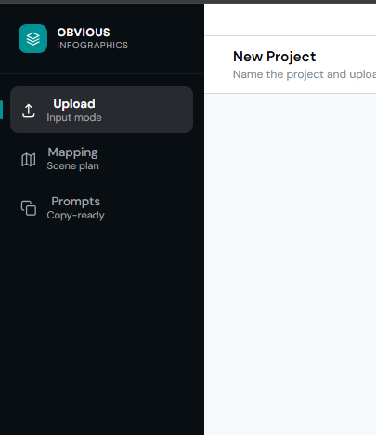
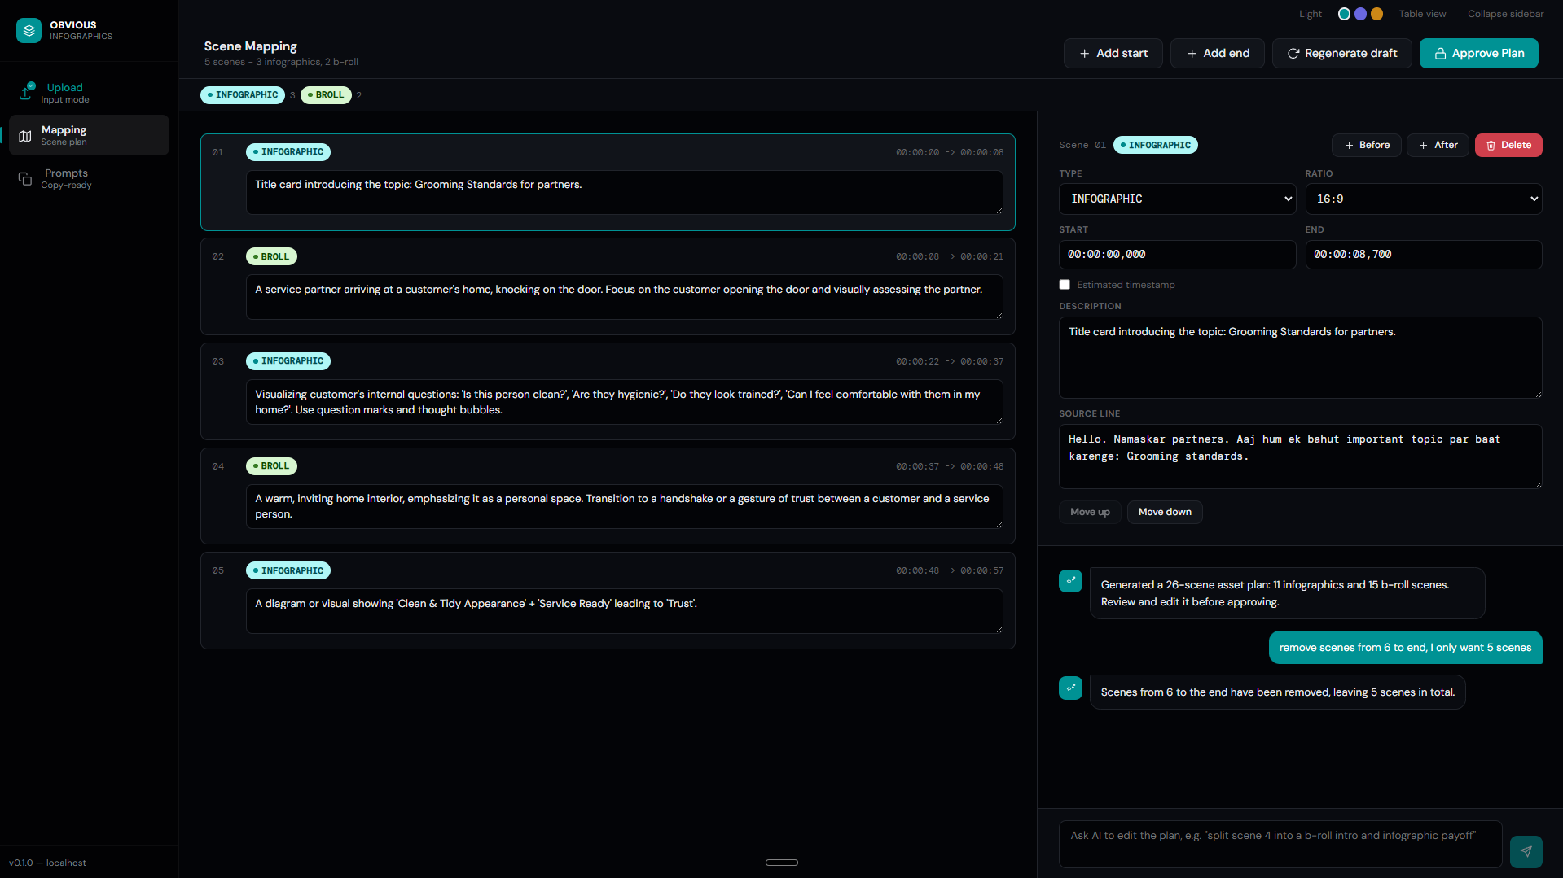
CHANGE #1
Its working great but the issue here is if I'm clicking on the first step tab, i.e., the upload-Input mode tab, it basically throws away everything I've done so far. I don't want that. I want it to keep a session history for every project in which I've done any work, even just scene-mapping also then also keep it's history. And the history has to be like, either delete manually, or auto delete in 30 days, and i want the option to be able to access the history and older projects from the sidebar itself, just like chatgpt or any ai tools. Make the sidebar slightly wider, like about 150% of what it is now, and then after these 3 options, add a little spacing and then add a heading 'Projects' below which all the sessions will be listed by the same name as entered on the 'project name' placeholder on the upload page.
---
CHANGE #2
On the Mapping screen, there are only option to add a scene at the beginning or the end, no option to add a scene in between two scenes.
This does not make sence, fix this thing and make it the best as per the user experience.
Also, when we click on a scene, it's details open in the upper half of the chat section.
This also feels weird because sometimes I want the chat to be in full size now but the ifo box has no option to close or minimize it, sometimes I want the info box to be full but again no options.
Fix this too for the best UX.
---
CHANGE #3
No matter a scene is inforgraphics or video broll, no scene should be of duration more than 5s. Now again it is not necessary that we must have something going at all times. This is the tricky part now. See for example it is okay if a specific line or topic covers 0:12 to 0:30 of the video. Now given this duration covers a single topic in the video, we have to choose smartly. maybe like a 5s broll from 0:13 to 0:18, then a 1-2s breathing space, then an infographics from 0:20 to 0:24 and then another boll or maybe infographic itself from 0:25 to 0:30. This can't be hardcoded you see because this really only can be decided depending upon a video or script. So try to achieve this to whatever level of perfection you can, and I'll decide further action later. But for now one hardcoded rule for scene division: One scene can't be more than 5s in duration. Could be 2s or 3s if the script is tight but can't be more that 5s at any cost. include variety of scene if the topic pushes the duration but not the same scene continues visually.
---
CHANGE #4
other than this, I also want an option to export my final prompts at the end, on clicking it, in a popup i should be able to rename the file, default name should be same project name, i should be able to choose which format to export in, format here meaning wither all prompts stacked like in the scenes list one by one, or infographcs separate and video broll separate. The output can be a simple .txt file for now in which the prompts must in the text file format the prompts nicely, just like at the end screen of the website.

Changes#2

CHANGE #1

