SFMC: Data Extension API Overview
The data extension API in SFMC allows you to insert records directly into a Data Extension via a REST Call.
Approach Details:
In this approach we are leveraging the SFMC Data Extension API to insert records directly into a Data extension via a REST Call. Within AJO, custom actions are configured to trigger through a journey, which then update the respective Data extensions in SFMC.
On the SFMC side, once the data extension is updated with the new records, a journey is set up to run on a schedule basis. This schedule journey processes the ingested records and performs the required actions such as sending an email.
However, the key limitation of this approach is that the journey in SFMC cannot be triggered in real time when the data extension is updated. Instead, it must rely on a pre-defined schedule. As a result, this process introduces a delay and does not provide true real time execution.

Salesforce documentation Reference:
Salesforce: https://developer.salesforce.com/docs/marketing/marketing-cloud/references/mc-data_extension_rows_async?meta=insertRows

API Details for the POC:
POST call
https://{subdomain}.rest.marketingcloudapis.com/data/v1/async/dataextensions/key:{externalKey}/rows
End point details:
https://mcs8hw9n1wf8nz625j-qdzmgxq0y.rest.marketingcloudapis.com/data/v1/async/dataextensions/key:AJO_DE_API/rows

sample Payload
{
"items": [
{
"Reltioid": "ReltioDEAPI3",
"Reltio Email Address": "emailapi3@test.com"
}

]
}

Authentication details :

{
"type": "customAuthorization",
"authorizationType": "Bearer",
"endpoint": "https://{{Subdomain}}.auth.marketingcloudapis.com/v2/token",
"method": "POST",
"headers": {
"Content-Type": "application/json"
},
"body": {
"bodyType": "json",
"bodyParams": {
"grant_type": "client_credentials",
"client_id": "***********************",
"client_secret": "********************"
}
},
"tokenInResponse": "json://access_token"
}

Step 1: Create Custom Action in AJO:
This custom action in AJO holds all the required endpoint details required for SFMC Data extension API. (URL, Authentication, Payload structure, etc.)
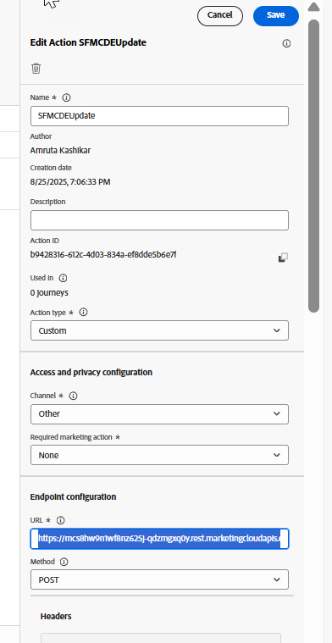

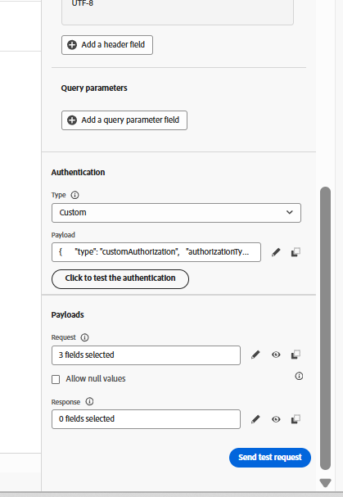
Request Payload
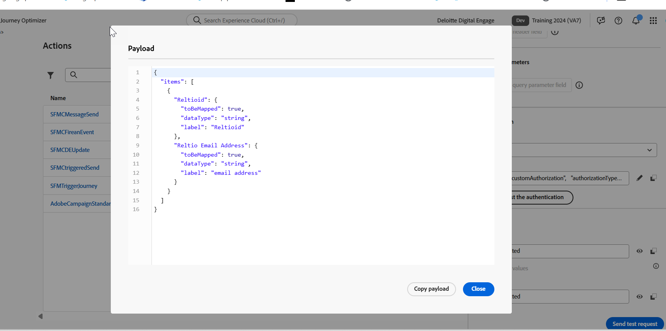
Step 2: Call the custom action from a AJO Journey
Configure an AJO Journey to invoke the custom action whenever the journey reaches the defined step. This action will push records into the SFMC data extension through the REST API
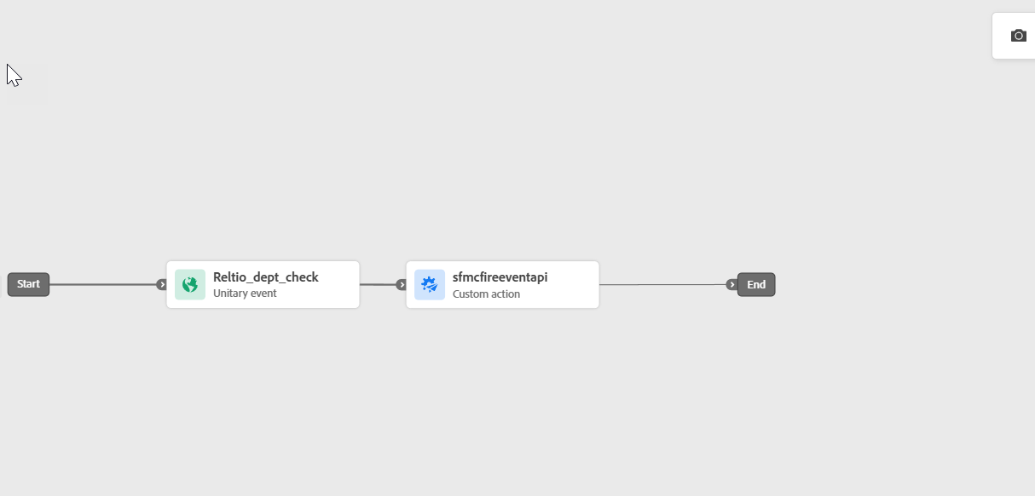

Step 3: Create a Data extension in SFMC
On the SFMC side, create the necessary data extension where the records will be stored after being pushed from AJO
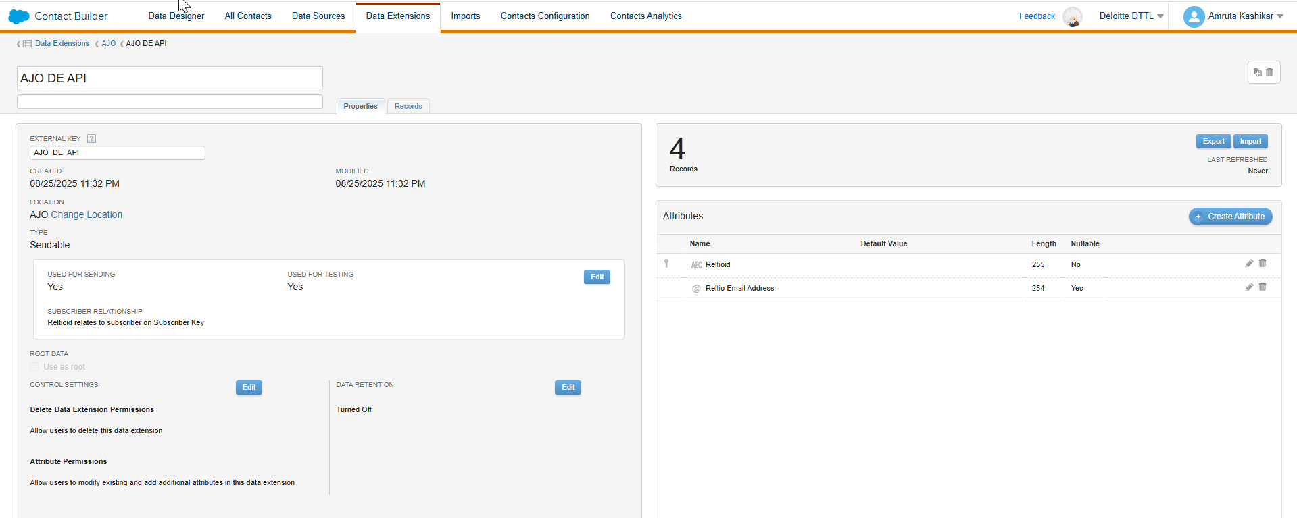

Step 4: Configure a Journey in SFMC
Build a journey in SFMC that uses the data extension as its entry source. Since the journey cannot be triggered automatically when the data extension is updated, this journey must run on a schedule basis.
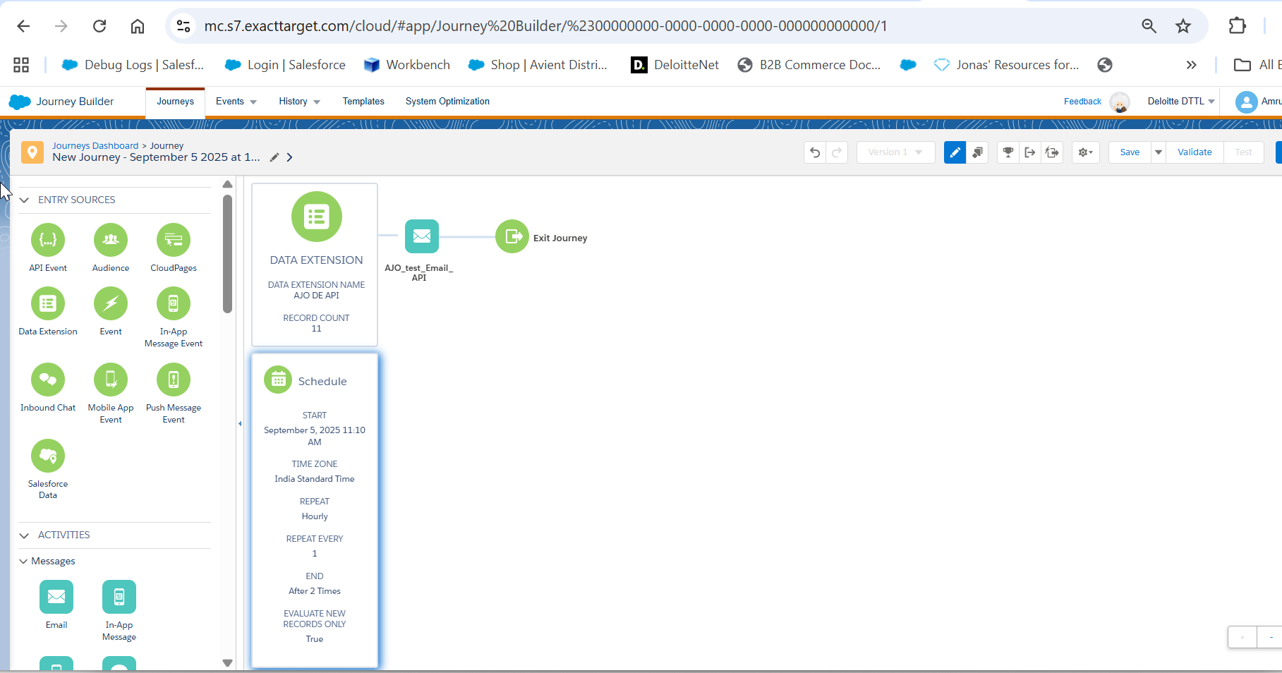

Step 5: Process Records or Triggered an event that will trigger the AJO journey
Once the scheduled journey runs, it will pick up the newly ingested records from the data extension. The journey can then process these records to perform actions such as sending an email.
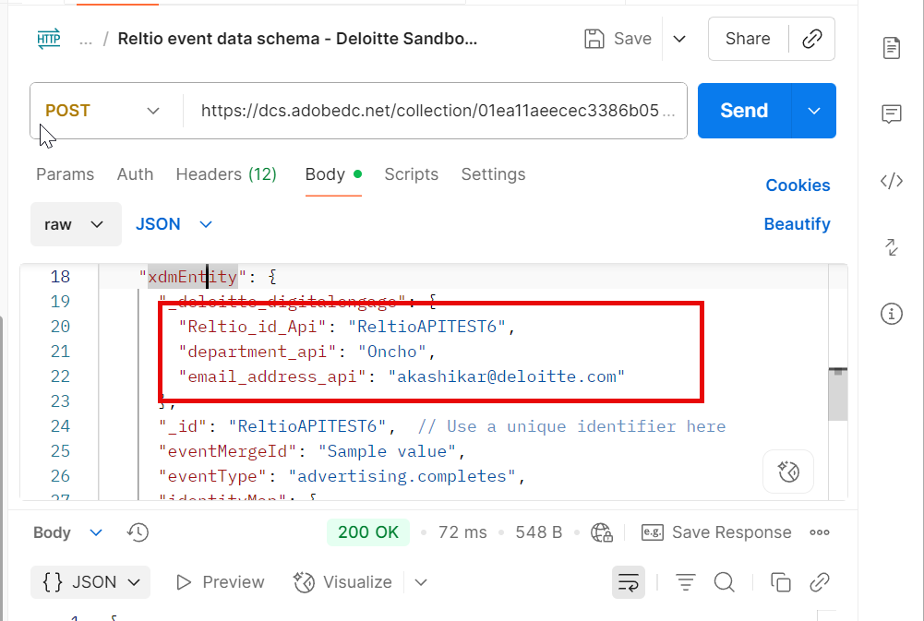

AJO Journey is executed
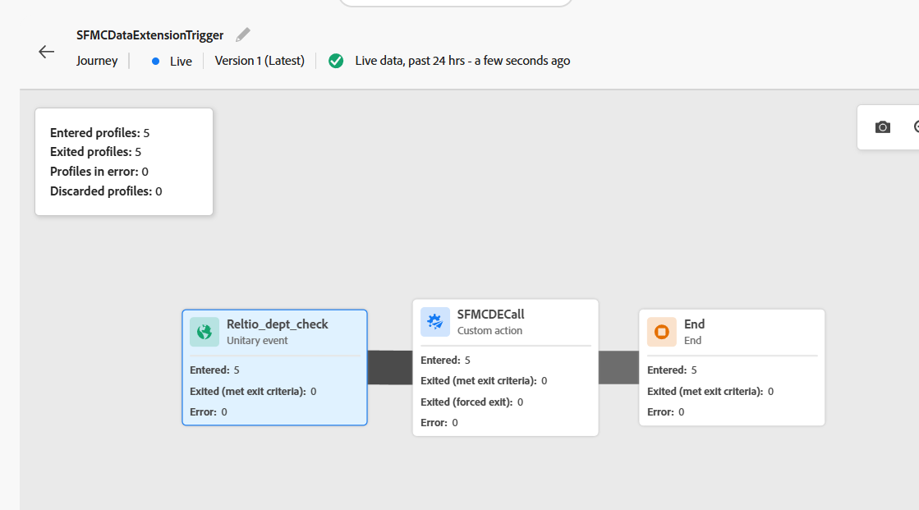

In SFMC, Target Data Extension is updated
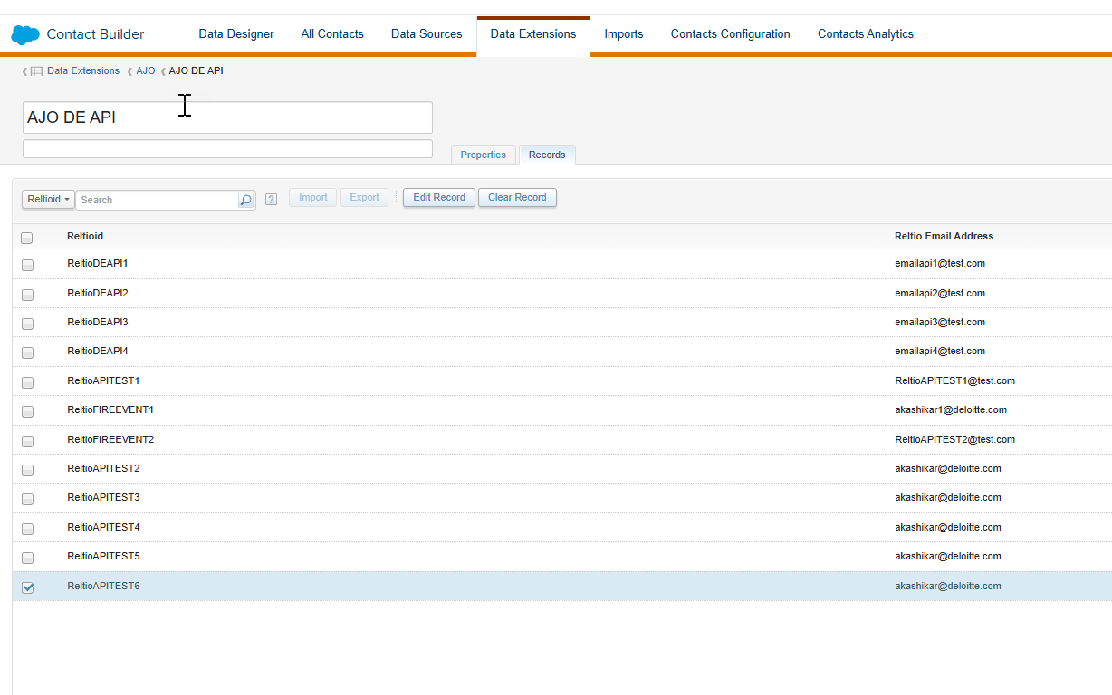

Journey is executed in SFMC
