
INFT3050 – Web programming
Scrum 1.2 Update report: individual reflection and contribution
By: Gay Yu Shen Alex c3552019

In the case of errors when opening the project, a backup of our web page was made at the following repository:
https://github.com/dkwnalex1-del/entertainment-guild-backup.git

1.2 individual report + contribution summary
For this week since the last SCRUM meeting, my team member, Alan, and I had made a fair bit of progress according to our Gantt chart, being right on time in terms of development progress. Being a team of only two people, I believe we have our work cut out for us.
Some notable things made so far was the skeleton of the website and placeholder content made using .css files by me, such that we have a rough idea of what we are going to implement. Seeing as this is an entertainment-related website, we can go either way in its design, from colourful to a more black and white minimalistic professional theme.
My contributions to this project include some other pages aside from the .css file, such as managing the app.css, account,jsx, account.jsx, index.css and the backup repository for our group.
Another notable point was that I’ve asked my member Alan, when setting up our development environment, to assist me with setting up for our development environment. As we started development of the website, I had noticed that changes to our website were reflected slower, and every start up building process for the website and server took extremely long. This slowed down our development significantly.
As a workaround, I looked up alternative ways to speed up the building process, and chanced upon Vite, which is also a way to create a React app. After some testing, I found that it was much faster as compared to Create-react-app, and was a more modern way developers made websites. And as such, I have decided to implement the usage of Vite and integrate it into our development, to improve our efficiency.
As we have completed the skeleton of the website for this Scrum, we plan on slowly developing the website over time and design using frameworks such as Ant Design, which, their homepage can be seen below. We hope to have most features working if possible, and other improvements we discover over time.
We decided on a skeleton as this helps us get started on all pages at once, reducing a lot of cognitive load, optimizing our workflow.
Thus far, I’m happy I got to practice creating and managing my own React app, and hope to progress on my development, as I look forward to creating the ideal end product.
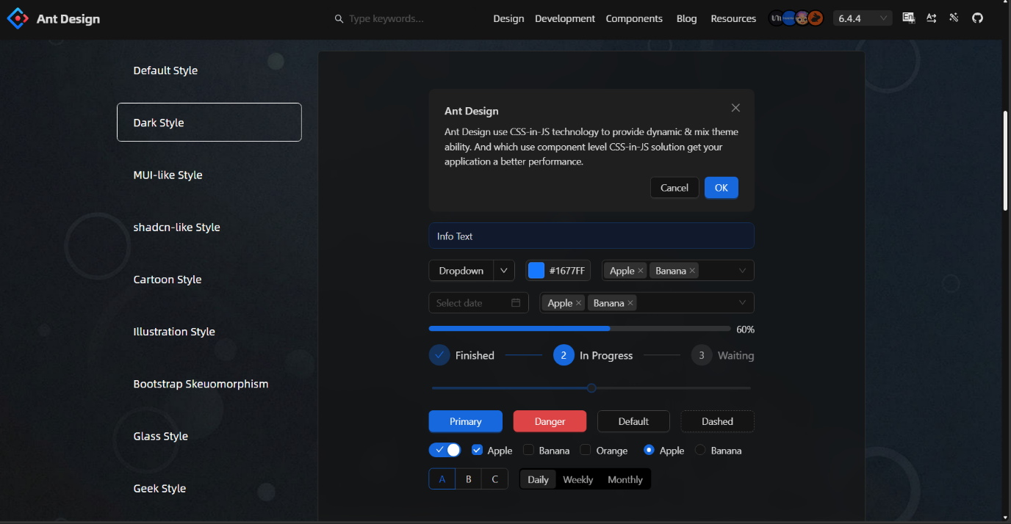

Figure 1.1: Ant design website

