TIDRADIO TD-H9 - User Guide
Firmware 1.0.33- Translation of the official user manual (Ham Version, 71 pages.), modified and supplemented (v5).
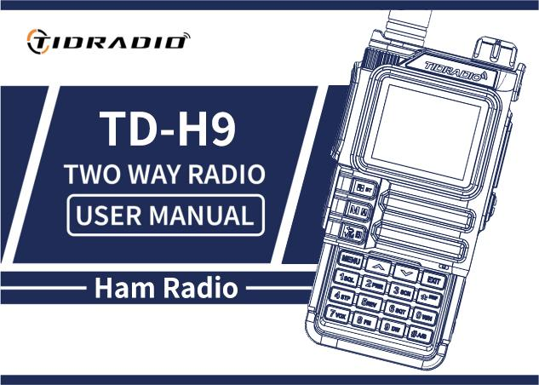
TIDRADIO TD-H9 radio

Relevant references to the manual
. md:|RU | EN
. docx:|RU | EN

Contents
- Preface
  - 1.1 Safety information for amateur radios
  - 1.2 Basic opportunities
  - 1.3 Service (briefly)
- 2. Battery battery
  - Charging.
  - Charger and precautions
  - How to charge
  - 2.5 LED RAM indicator
  - Battery storage
  - Charging via USB-C
- 3. Installation of accessories
- 4. Radio station review
  - Buttons and controls
  - 4.2 LCD display. Badges
  - LED indicators
  - Main control keys
  - Additional key combinations and inclusions
  - 4.6 Digital keyboard
- 5. Basic operations
  - Inclusion
  - 5.2 Loudness
  - 5.3 Choice of channel
  - 5.4 Challenge
  - 5.5 Frequency mode (VFO)
  - Channel mode (MR)
- 6. Additional functions
  - Frequency scanning
  - Scanning of channels
  - Scanning of CTCSS/DCS
  - 6.4 Manual channel programming
  - Emergency Alert (Emergency Alert)
  - 6.6 FM radio
  - 6.7 NOAA weather
  - 6.8 Repiter tone (1000 / 1450 / 1750 / 2100 Hz)
  - 6.9 Call function (Bluetooth calls)
  - 6.10 Audio function (music via radio)
  - 6.11 OD PTT (Odmaster PTT)
  - 6.12 Bluetooth programming
- 7. Work on the menu
  - 7.1 Substantive use
  - 7.2 Short teams (shortcuts)
  - 7.31 Radio Setting (radio settings)
  - 7.32 Program Channel (Channel Programming)
  - 7.33 Analog Set
  - 7.34 Radio Information
  - 7.35 Scan (Scan)
  - 7.36 Bluetooth
  - 7.37 Firmware update
  - 7.38 GNSS (GPS)
  - 7.39 Site Type (Position Type)
  - 7.40 APRS
  - 7.41 Detailed description of APRS functions
  - 7.42 Remote control of APRS repeater
  - 7.43 Retransmission of APRS packets by digipiter
  - 7.44 APRS Worldwide Frequency
  - 7.45 Similar to APRS radio
  - 7.46 SMS
  - 7.47 Spectrum
  - 7.48 Morse
- Annex A. Failure detection and repair
- Annex B: Technical specifications
- Annex C: Table of DCS codes
- Annex D. Table of CTCSS tones
- Annex E. Software
- Annex F. Channels and presets

Preface
Thank you for purchasing the TD-H9 radio. It is a multifunctional amateur (ham) radio station, combining the latest radio technology with a strong mechanical design. The TD-H9 is an ideal and effective solution for professionals who need to keep in touch with the work team (construction sites, buildings, exhibitions, hotels, etc.), as well as for users who need communication for leisure and family.
Important notice.To protect yourself from injuries and damage to property that may occur if misused, read the manual carefully before use. It contains instructions for safe use, as well as information on awareness and control of exposure to radiofrequency energy.

1.1 Safety information for amateur radios
Your portable radio station contains a low-power transmitter. When you press tangents (talk buttons), it emits radio frequency signals. The device is designed to work with a filling factor of not more than 50%. In August 1996, the FCC adopted recommendations on exposure to RF radiation with safety levels for portable wireless devices.
FCC Warning (Part 15.21)The manufacturer is not responsible for any changes or modifications not expressly approved by the party responsible for conformity. Such changes may nullify the user’s right to operate the equipment.
Compliance with the FCC (Part 15)This equipment has been tested and found to comply with the Class B digital device restrictions under Part 15 of the FCC Regulations. These restrictions are intended to provide reasonable protection against harmful interference in living quarters. The equipment generates and can emit radio frequency energy. There is no guarantee that interference will not occur in a particular installation. Check interference is made by turning off and on the device (see the list of measures: change the orientation / location of the antenna, increase the distance between the devices, connect the device to another outlet, contact the seller or specialist).
Warning!Modification of the device for receiving signals of cellular radio phones is prohibited by the FCC rules and federal law.
EU compliance.The product complies with the requirements of Directive 2014/53/EU. NOTE: European users must have a valid amateur license to transmit at frequencies and power levels. Non-compliance may be illegal and may result in prosecution.
Compliance with RF exposure standards.The device conforms to: FCC 47 CFR §§ 1.1307, 1.1310 and 2.1093; ANSI/IEEE C95.1:2005; Canada RSS102 Issue 5 (March 2015); IEEE C95.1:2005 Edition.
Information on RF exposure.Do not allow children to use the radio without adult supervision. Use only a complete or approved antenna; a damaged antenna may cause a slight burn when in contact with the skin. When working head-to-face, keep the radio 1 inch (2.5 cm) away from your face. For wearing on the body, use a complete waist clip.

1.2 Basic opportunities
- Power output: up to 10 W (three levels: high, medium, low).
- Ranges (TX/RX): 136–174 (VHF), 174–245 (SatCom), 240–260, 290–350 (River), 350–400, 400–470 (UHF), 470–520, 520–600 MHz. Reception: 50–76, 65–108 (FM radio), 108–136 (AM/FM, air).
- 199 memory channels.
- 50 CTCSS tones and 105 DCS codes.
- Noise suppressor with 9 levels.
- Frequency step: 0.5 / 2.5 / 5.0 / 6.25 / 10.0 / 12.5 / 25.0 / 50.0 kHz.
- VOX (voice transmission).
- TOT (Transmission Limitation Timer).
- Double observation / double reception / dual-band radio.
- Energy saving.
- The alarm function (Alarm).
- DTMF function, 1750 Hz tone for repeaters.
- Programmable repetitor offset.
- Configurable side key functions (PF1/PF2).
- 1.77-inch color LCD screen, 3 display modes, 18 menu colors.
- Microphone amplification, frequency hopping (FHSS), scrambler.
- Scan function, spectroanalyzer, LED flashlight.
- BCL (Blocking with a busy channel)
- Setting and storing channel names.
- VOICE is the voice-over of the selected function.
- Selection of channel/frequency mode.
- Keyboard lock, Roger Beep.
- Display when enabled, charging and programming via USB-C, Kenwood 2-pin connector.
- Antenna connector on the SMA-Male radio, on the SMA-Female antenna.
- Support for NOAA weather reception (US and Canada).
- GPS, Bluetooth (set up via Odmaster, headsets), APRS.
- CPU 240 MHz, RAM 120 MB, flash 16 MB, Beken BK4819, MK PY32F003.
- Dimensions: 140×53×32 mm, weight 190 g

1.3 Service (briefly)
- Do not open the radio - this will void the warranty.
- Do not store under the sun and in hot places, in dust and dirt.
- Don’t let any moisture get in.
- If you smell or smoke, turn off the power immediately and remove the battery.
- Don’t pass without an antenna.

2. Battery battery
BP-9 7.4V DC Li-ion 2400 mAh 17.76 Wh

Charger: 5V 1A

Charging.
The lithium-ion battery is not charged from the factory – charge it before use. To reach full capacity, the first 2-3 cycles of discharge / charge may not give full capacity.

Charger and precautions
Only use the brand name. Do not close the contacts of the battery, do not throw it into the fire, do not remove the case. Charge at a temperature of 5–40 °C. Turn off the radio before charging. Do not charge a fully charged battery.

How to charge
- Connect the adapter to the socket, then to the DC connector on the back side of the ZU (the indicator flashes orange).
- Install the battery or walkie-talkie in the ZU (the indicator is red - charging is underway).
- Full charging is 2-5 hours; when the green lights up, the charging is completed. Remove the device.
When charging the radioswitched onThe green indicator will not light up - the radio should be turned off.

2.5 LED RAM indicator
Status. | Indicator | Colour
No battery. | Green and red alternately
Regular charging. | Red. | 🔴
Full charge. | Green. | 🟢

Battery storage
- Store at ~80% discharge. In a dry cool place, away from heat and direct sun.

Charging via USB-C
- Turn off the radio.
- Connect the USB-C cable to the battery connector, the second end to the network ROM.
- Full charge of the empty battery is 4 hours; the battery indicator on the screen shows the process.
- It is recommended to charge when the radio is turned off. Remove the radio from charging within 6 hours after charging; do not store it connected to the RAM.

Installation of accessories
- Antenna:Clockwise, roll against the clockwise (behind the base).
- Belt clamping:two screws on the back side above the battery - unscrew, clamp, twist back.
- Battery:The walkie-talkie is off; combine the guides, move up until you click. Removal - the lock button at the bottom of the battery.
- Headset:open the rubber plug and insert the plug into the MIC/SP double connector.

4. Radio station review
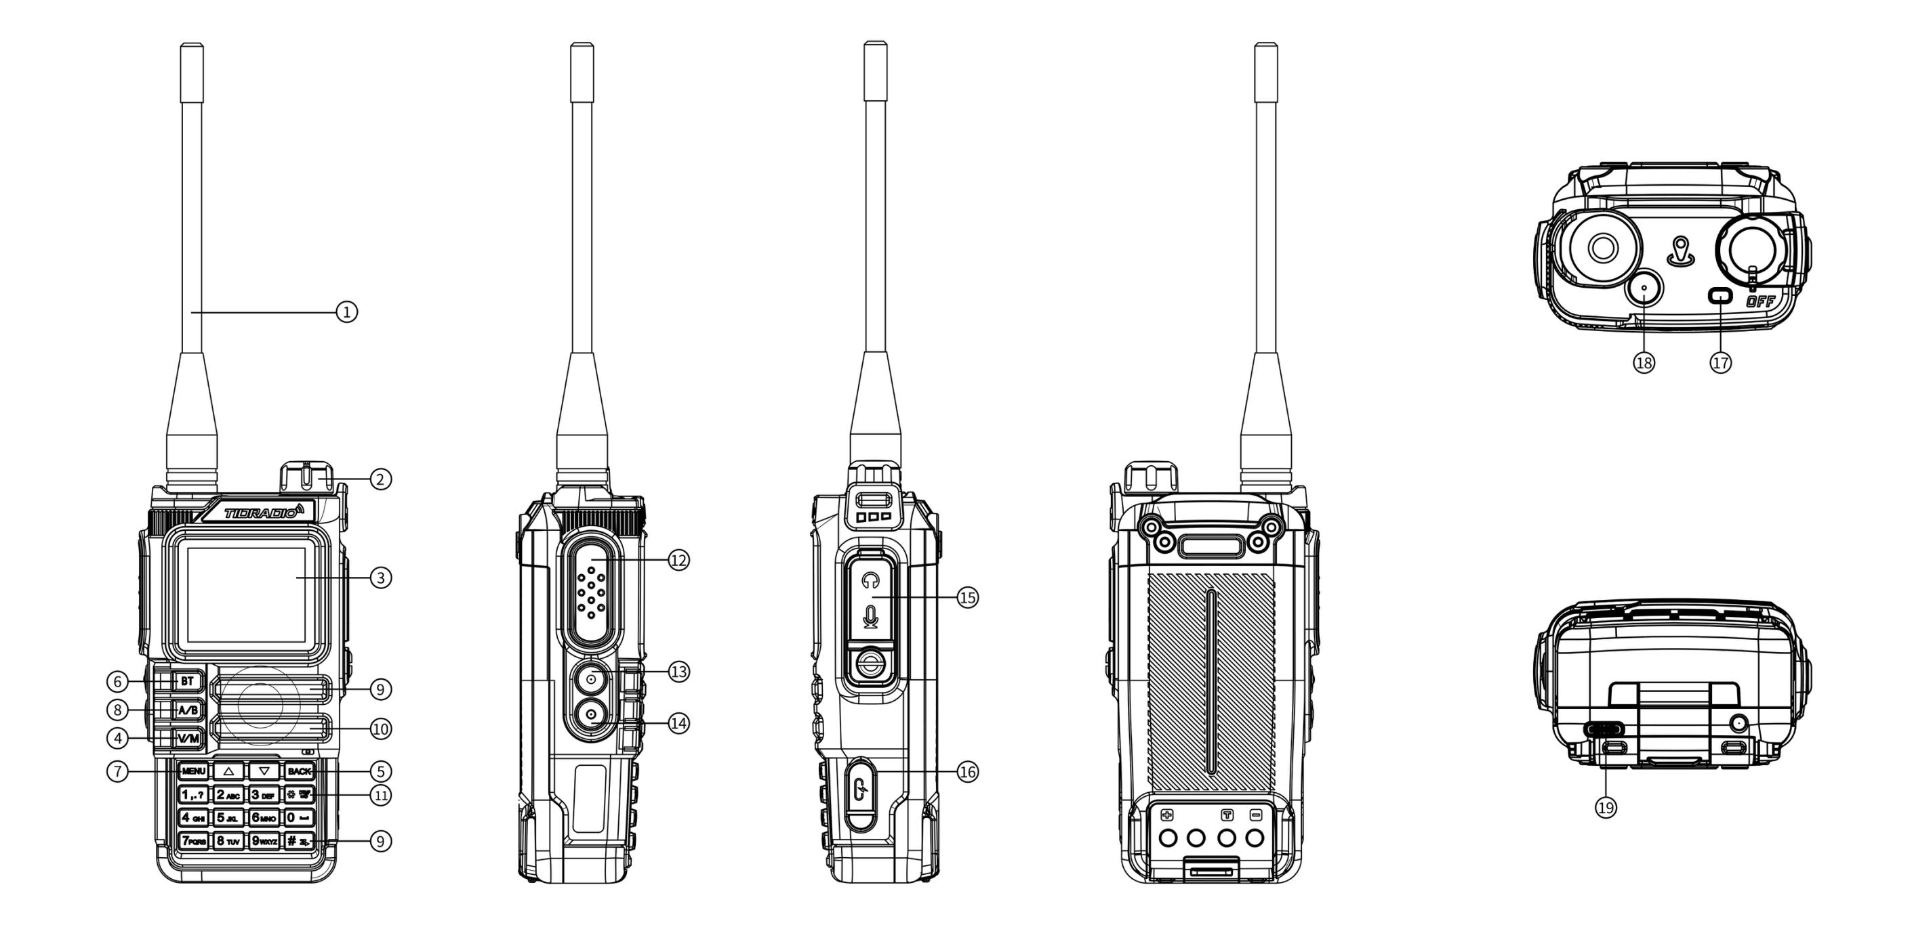
Location of buttons and controls

Buttons and controls
The numbers correspond to the figures in the diagram above.
# | Description
1. | Antenna.
2. | Power handle/volumeTurn on/off and adjust volume.
3. | LCD screen 1.77”.
4. | VFO/MR- switching “Channel mode” / “Frequent mode”.
5. | BACK- back/out.
6. | Bluetooth keyLong press on/off Bluetooth.
7. | MenouA short tap to enter the menu.
8. | A/BSwitching the A/B bands.
9. | Speaker.
10. | Microphone.
11. | DTMF/keyboard lockingLong press on / off the keyboard lock.
12. | PTT- Tangenta: Hold to talk; let go - reception.
13. | PF1 is a customizable side key 1.:
- | - Short press: MENU → Radio Setting → item 27 (options: NONE, FM Radio, Lamp, TONE, Alarm, Weather, PTT2, OD PTT).
- | - Long press: MENU → Radio Setting → item 28 (NONE, FM Radio, Lamp, Cancel Sq, TONE, Alarm, Weather).
14. | PF2 is a customizable side key 2.:
- | - Short press: MENU → Radio Setting → item 29.
- | Long press: MENU → Radio Setting → item 30.
15. | MIC/SP connector- external headset.
16. | USB-C port- programming.
17. | Indicator:Red is transmission; green is reception.
18. | The Weather Orange KeyEntering NOAA weather mode.
19. | USB-C charging connectorbattery.

4.2 LCD display. Badges

Badges in order of table from the manual: | # | Symbol | Description |—|—|—| |1. |Signal strength indicator (4 levels). | |2. || High transmission power /Low transmission power. | |3. || Voice/keyboard sound (not shown if both are off). | |4. |Current tone: DCS orCTCSS. | |5. |Offset “up” (TX above RX) - access to the repeater in VFO mode. | |6. |Offset “down” (TX below RX). | |7. || Dual watch is enabled. | |8. |Keyboard locked; hold onto unlock. | |9. |[S] |Energy saving included. | |10. |[N] | Channel in narrowband mode. | |11. |[W] | Broadband channel. | |12. |Battery level; when dischargedflashing(transfer impossible). | |13. || OD signal. | |14. || OD sign. | |15. ||Bluetooth on, not connected (white icon) | |16. ||Bluetooth connected (blue icon). | |17. || Volume indicator. |

LED indicators
Colour | Indicator | Radio status
🔴 | Always red | Transfer
🟢 | Always green | Reception.

Main control keys
keyboard | Description
BT | Long press: On/off Bluetooth.
Menou | Enter the menu, select an item, confirm the parameter.
▲ | Pressing: step up the channel/frequency; hold more than 2 seconds: fast moving up; in scan mode: moving the scan up.
▼ | Pressing: step down the channel/frequency; hold more than 2 seconds: rapid downward movement; in scan mode: moving the scan down.
VFO/MR | switch between frequency (VFO) and channel (MR) modes. Frequency storage is possible only in VFO mode.
BACK | exit from menus and functions.
A/B | switching between the top (A) and bottom (B) display; the selected one becomes active for reception and transmission. Memory storage works from display A.
Digital keyboard | input of information/choices; when transferring, the digital keys send the corresponding DTMF codes.
# (DTMF/blocking) | Short press: activate the DTMF set; hold more than 2 seconds: lock/unlock the keyboard.

Additional key combinations and inclusions
Combinations with power on (Power On):
Combination | Function
PTT + * + Inclusion | Mode Switching: GMRS/HAM/Normal
PTT + 1 + Inclusion | Firmware through K-cable
PTT + 3 + Inclusion | Firmware via USB
PTT + 7 + Inclusion | APRS Update
PF2 + Inclusion | Wireless Copy (Data Copy Mode between Similar Radio Stations)
Standby keys:
Action. | Function
Retention 0 | Weather.
Retention 1 | Frequency detector
Retention 3 | Scanner.
Retention 5 | On/off Reverse mode on channels with frequency shift of reception-transmission
Retention 7 | Spectroanalyzer
Retention 8 | Firmware via USB
Retention * | Locking the keyboard (Keylock)
Holding # | Change of DTMF Group (1.8)
Holding Back | Switching between modes: radio/GNSS
Quick access from the main menu:
Action. | Function
Menu, 1 | Squelch Level - The noise level
Menu, 2. | Power - transmission power
Menu, 3 | Scan Mode - Scan Mode
Menu, 4 | Freq Step - the step of setting the frequency
Menu, 5. | Backlight - setting up the display backlight
Menu, 6 | Voice prompt - voice confirmation of commands
Menu, 7. | VOX
Menu, 8 | Broadcast Radio - FM radio stations
Menu, 9 | Dual Watch (TDR) - Double listening mode
Menu, 0 | Bandwidth - bandwidth

Headset mode (Bluetooth calls):
Action. | Function
1 | Answering the phone
Retention 4 | Call me back.
3/PTT | Hang up.
Column mode (Bluetooth-audio):
Action. | Function
1 | Previous music track
2 | Losing/pausing
3 | The next music track

4.6 Digital keyboard
With these keys, you can enter information or select the settings on the radio.
In Transfer Mode (TX), press the digital keys to send the corresponding DTMF code.
Press.to activate the tone dial function (DTMF).
Press and holdMore than 2 seconds allows you to lock or unlock the keyboard.

5. Basic operations

inclusion
Turn the power/volume handle clockwise before clicking. After ~1 sec, a double beep, a message/savers display, then a frequency or channel. When the voice prompts are turned on, a mode will be announced. Turn off - counterclockwise to click.

5.2 Loudness
Turn the handle clockwise.

5.3 Choice of channel
Two modes:VFO (frequency)- for experimentation and rapid programming in the field;MR (channel)For everyday use of pre-programmed channels. Switching keys / or encoder.

5.4 Challenge
- Channel mode:Select a channel, hold [PTT] and speak (red indicator). Reception - automatically when releasing PTT (green indicator).
- Frequency mode:Press [V/M], enter frequency (within range), hold [PTT].
- Keep the microphone 2.5-5 cm away from your mouth.

5.5 Frequency mode (VFO)
Moving in frequency with keys ках / ках (with a step specified in the settings) or direct frequency input from the digital keyboard with an accuracy of kilohertz.
Example: 432,56250 MHz input on display A: 1. In standby mode, switch to frequency mode (VFO). 2. Enter on the keyboard: [4] [3] [2] [5] [6] [2] [5] [0].
In VFO mode, the VFO icon is displayed. Transmission on prohibited frequencies is illegal; listening is generally permitted. Check the requirements with the local regulator.

Channel mode (MR)
Depends on the programmed channels. Navigation - keys / or encoder. In MR mode, the channel number CH-XXX is displayed.

6. Additional functions

Frequency scanning
- In frequency mode, hold the key.[3 SCAN]more than 2 seconds - the scan will begin with a given step.
- Stop-key[V/M].
- Settings: MENU → Scan → No. 1.

Scanning of channels
- Hold it in channel mode.[3 SCAN]more than 2 seconds.
- The direction is the ./. keys.
- Stop–[V/M].

Scanning of CTCSS/DCS
Standby: MENU → Scan → “SEEK DCS” – the choice of CTCSS or DCS scanning. The function is not available in channel mode; scanning will begin only when a signal is detected.

6.4 Manual channel programming
199 memory channels, each storing: frequency of reception, group signal (tones), channel width, ANI/PTT-ID, six-character channel name. Conservation: MENU → Program Channel → item 12 (Memory CHL).
Modes:VFO is frequency; MR is channel. To save, switch to VFO with VFO/MR keys.
Example 1. Channel 31 with CTCSS tone 123.0 Hz (RX 432.55000 MHz):1. Press [VFO/MR] - VFO mode. 2. [Menu] → Program Channel → [1] [3] [Menu] – delete previous channel data (e.g. 31) → OK. 3. [Back] → [2] [Menu] → ALTER → CTCSS → 123.0 [Menu] [Back] — select the TX tone. 4. Enter the RX frequency (43255000). 5. [Menu] → Program Channel → [1] [2] – Enter channel number (31) → [Back] – RX added. 6. Press [VFO/MR] - Return to MR mode.
Example 2. Frequency scanning (channel 31 recording):1. Press [V/M] - MR mode (CH-XXX icon). 2. Hold on.[3 SCAN]- scanning. 3. At 432.55,000 MHz, press [PTT] – stop.

Emergency Alert (Emergency Alert)
Assign the Alarm function to the side key [PF1] or [PF2] in advance, then press this key – the radio will emit a loud signal and the flashlight will blink. The exit is press [PTT].Attention:Use only in a real emergency.

6.6 FM radio
When you turn on the listening mode FM-radio bluetooth module is turned off.
Assign the FM Radio function to [PF1]/[PF2] in advance. The range is 87-108 MHz. 1. Press [PF1]/[PF2] to turn on the radio (or menu, then 8). 2. The choice of frequency - keys . / . or input. 3. Pressing again is the exit.
Note: when the signal disappears, the radio automatically returns to FM mode; when the call is switched to reception mode (configured through the menu - FM Interrupt).

6.7 NOAA weather
11 NOAA channels. Key: orangeweather. 1. Press the orange key to enter NOAA mode. 2. Channel selection - ./► 3. Pressing again is the exit.
Channels: Wx-01…Wx-11 (162.5500; 162,400; 162,475; 162,425; 162,450; 162,500; 162,525; 161,650; 161,775; 161,750; 162,000 MHz). Only reception, transmission is impossible.

6.8 Repiter tone (1000 / 1450 / 1750 / 2100 Hz)
Assign the TONE function to [PF1]/[PF2] in advance and select the tone frequency at 24 Radio Setting. Press [PF1]/[PF2] and the repeater tone will be sent. It works even with a locked keyboard.

6.9 Call function (Bluetooth calls)
- Turn on Bluetooth: MENU → Bluetooth → BT ON/OFF (or long press MENU).
- Connect the phone (name: MENU → Bluetooth → BT Name – TD-H9xxxx).
- Incoming call - a short press of the key1- answer.
- In standby mode, long keystroke4- call me back.
- During the conversation, a short press3orPTT- complete.

6.10 Audio function (music via radio)
- Turn on Bluetooth, plug in your phone.
- keyboard1- previous track;3- next track;2Long / short press - pause / playback.

6.11 OD PTT (Odmaster PTT)
- Turn on Bluetooth (MENU → Bluetooth → BT ON/OFF or long press [MENU]).
- Put the phone on.
- Once connected, the PF1 side key automatically becomes the OD PTT and returns the previous function after disabling.
- Make sure you have Receiver mode (MENU → Bluetooth → BT Mode).
- Set OD PTT: OD (OD only) or OD+Analog (OD and similar radios at the same frequency).
- Open the Odmaster app and join the group.
- Press OD PTT for conversation.
Step-by-step illustrations of OD PTT setup and operation (pages from the manual):
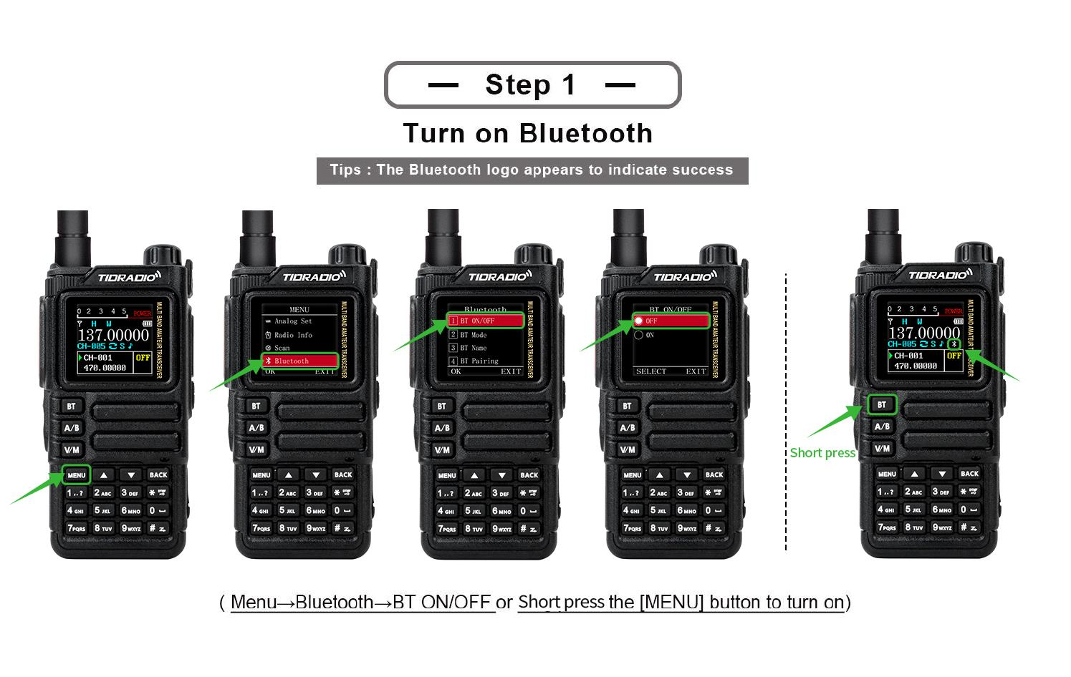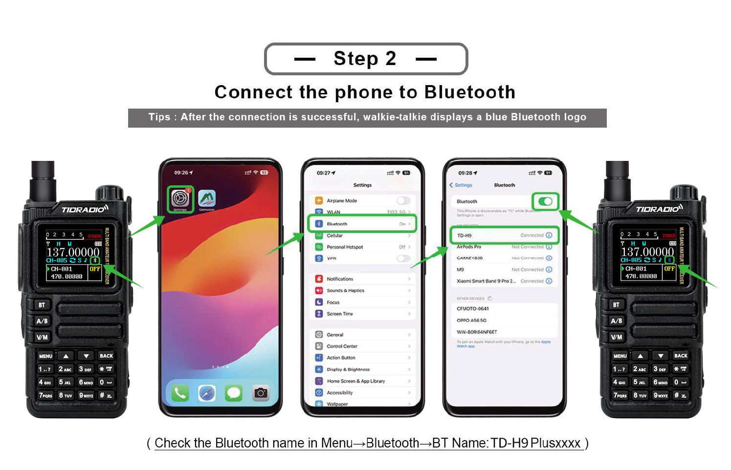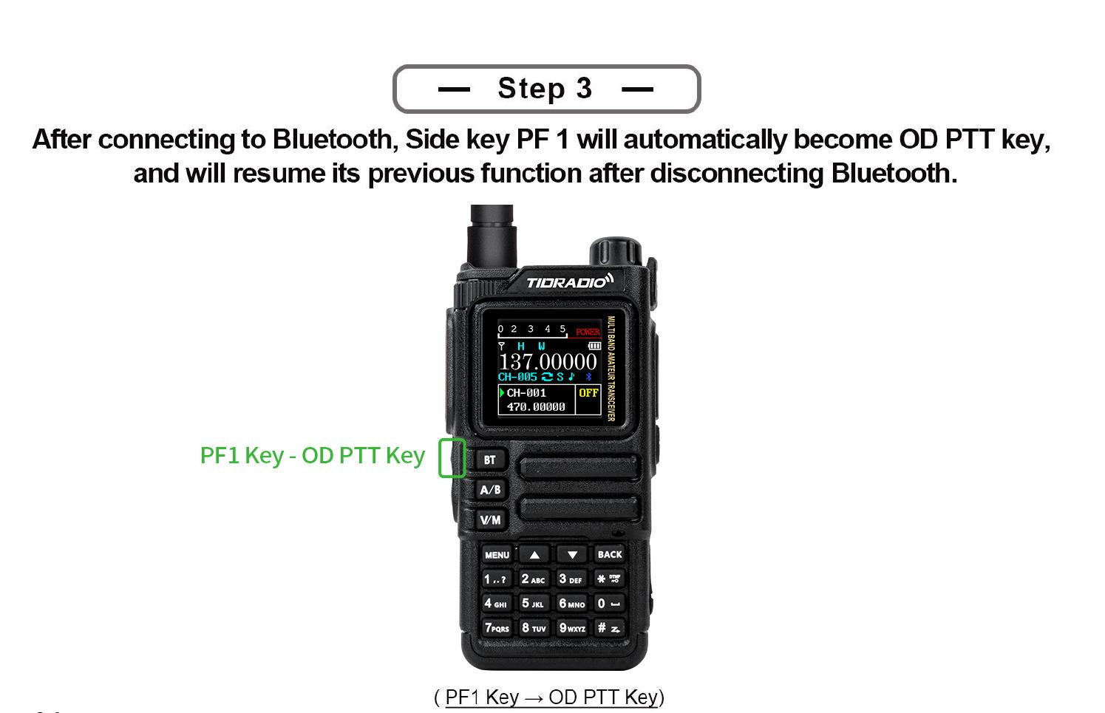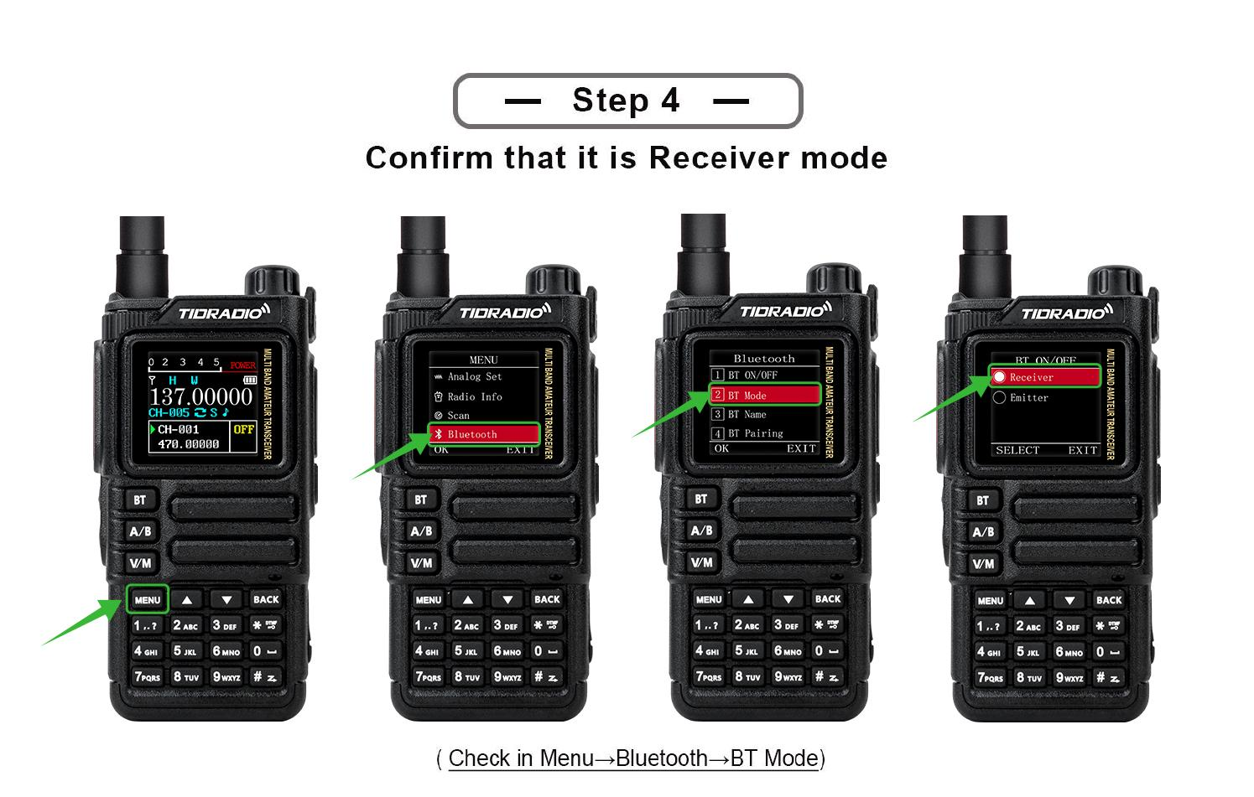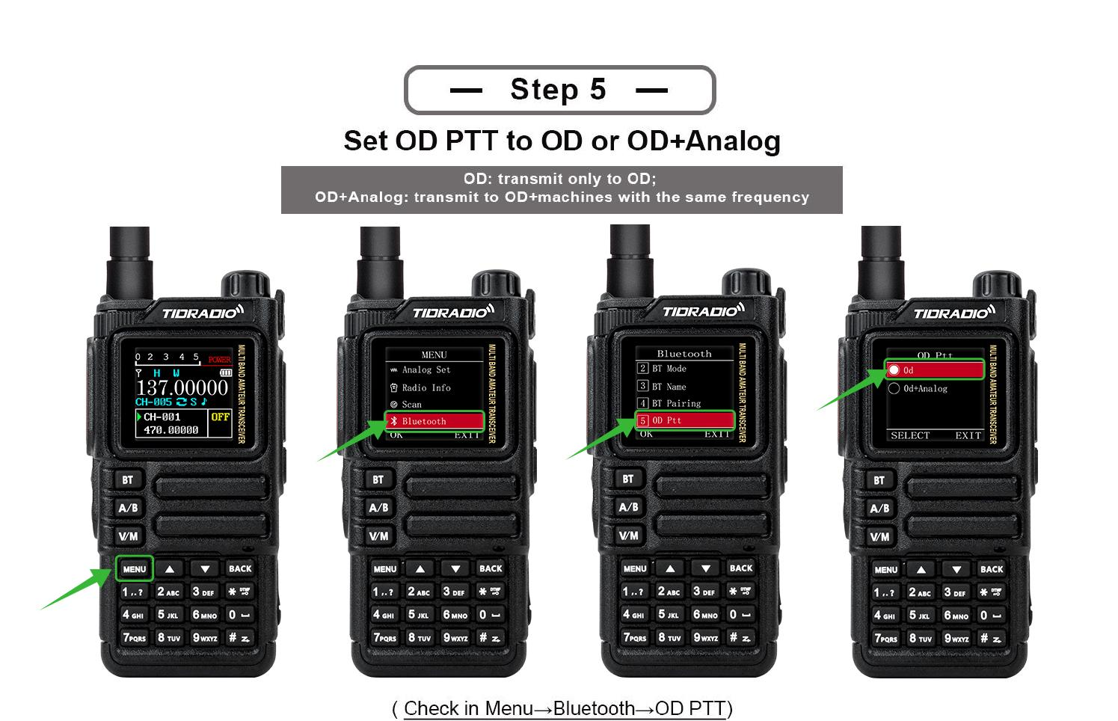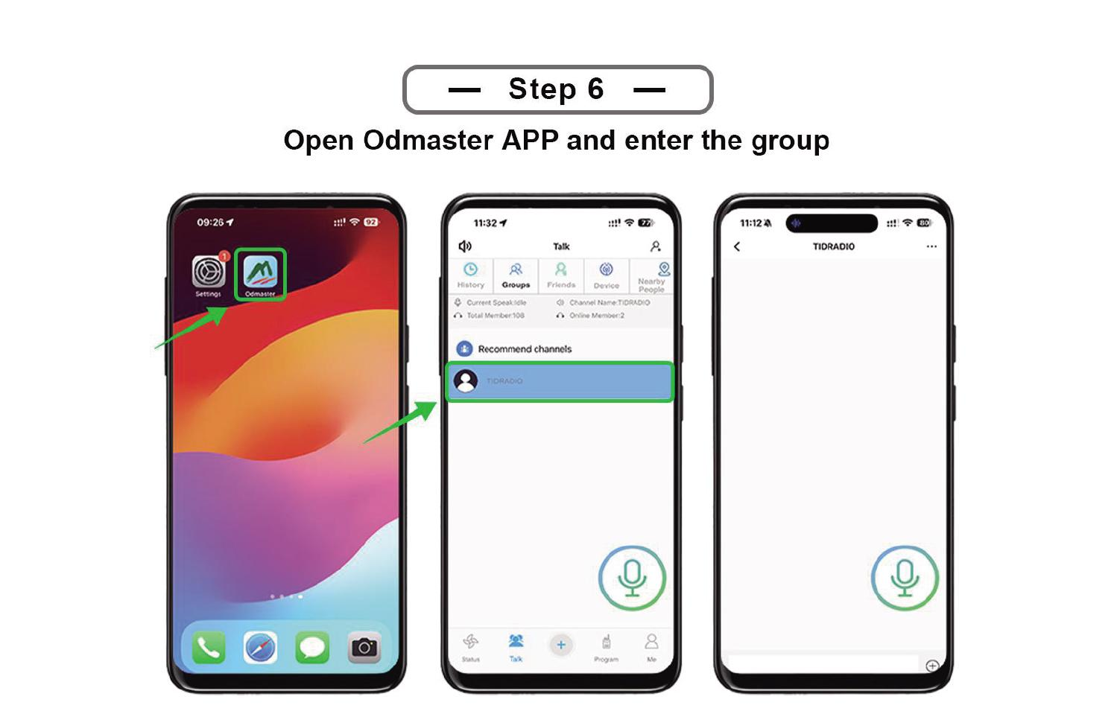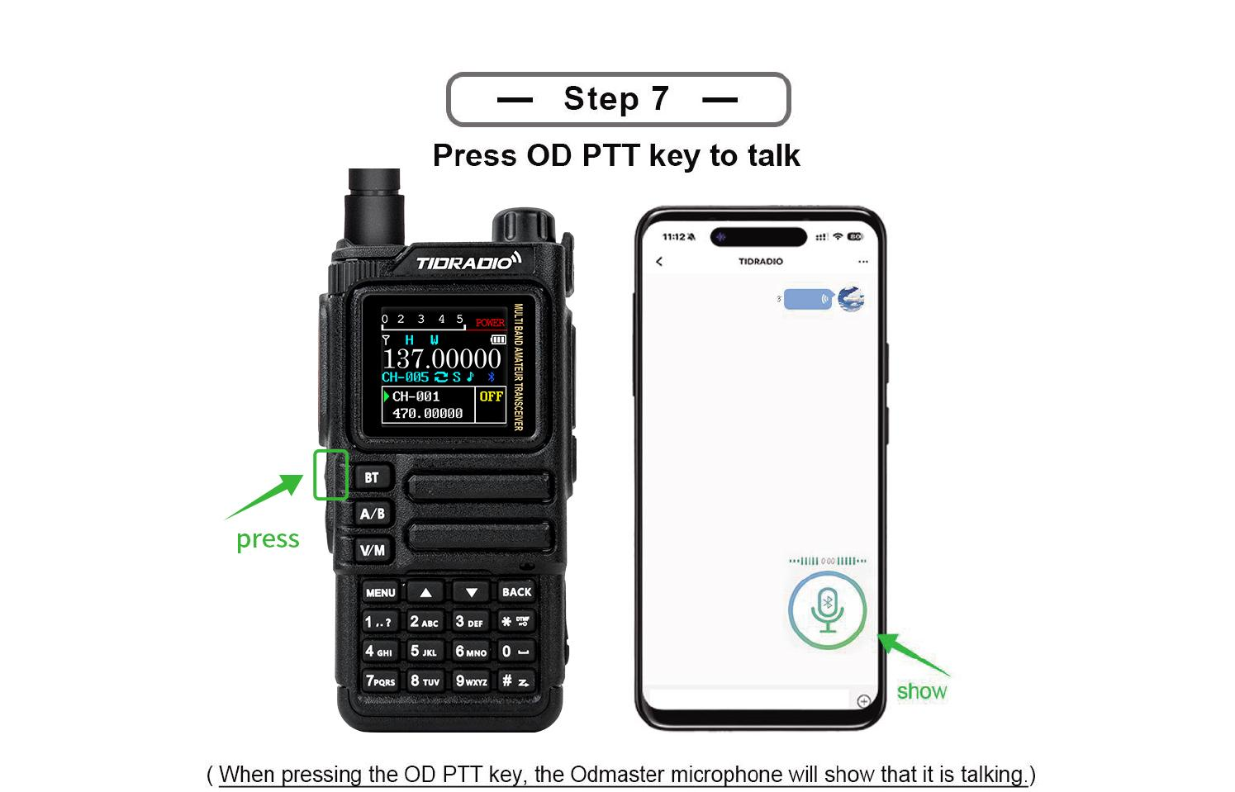

6.12 Bluetooth programming
(Section with step-by-step illustrations; see the original manual - programming walkie-talkie via Bluetooth connection to the software.) Connect the radio over Bluetooth and use programming software.
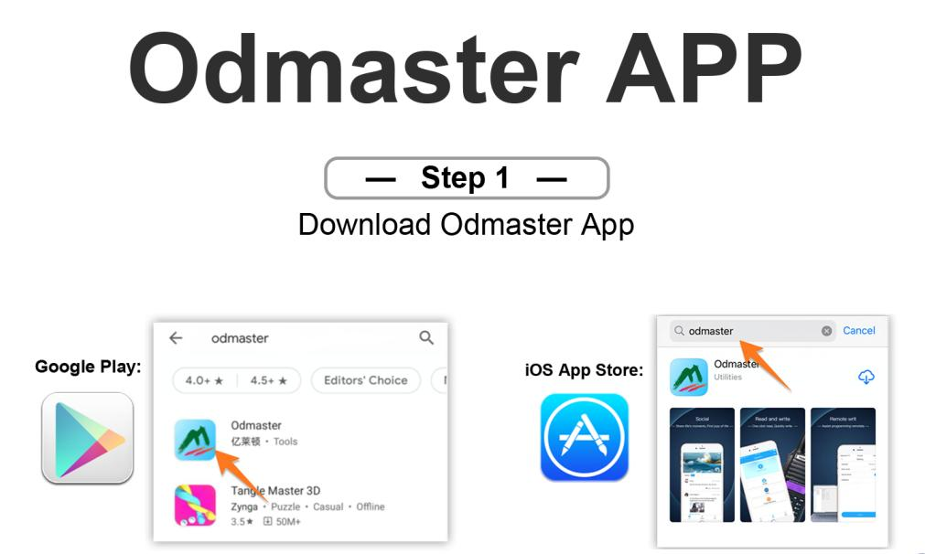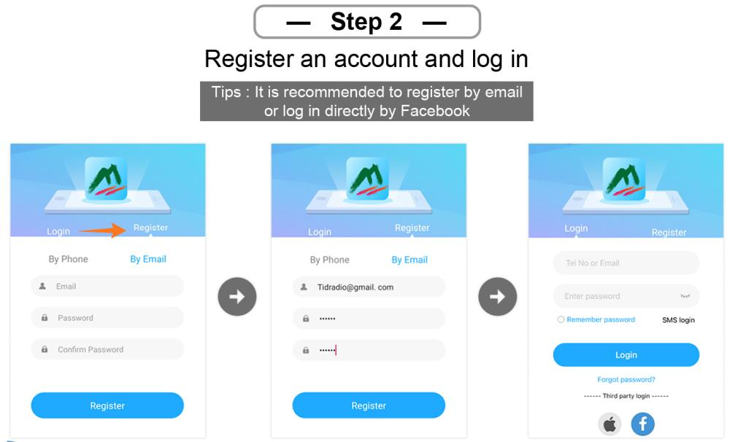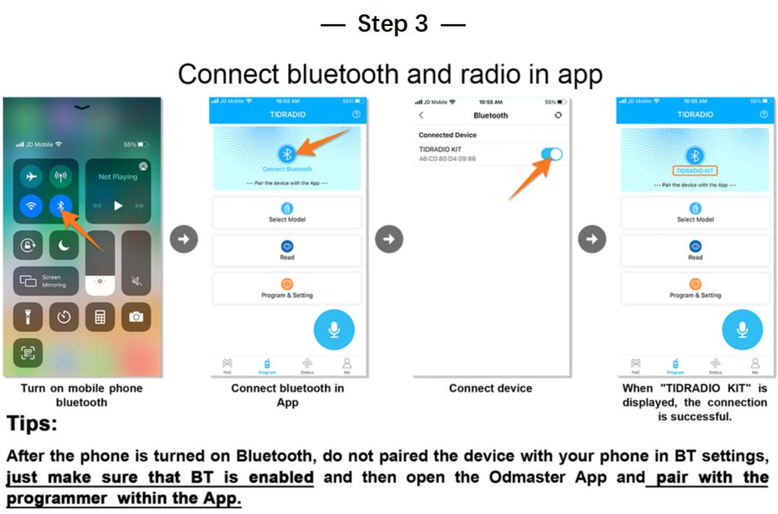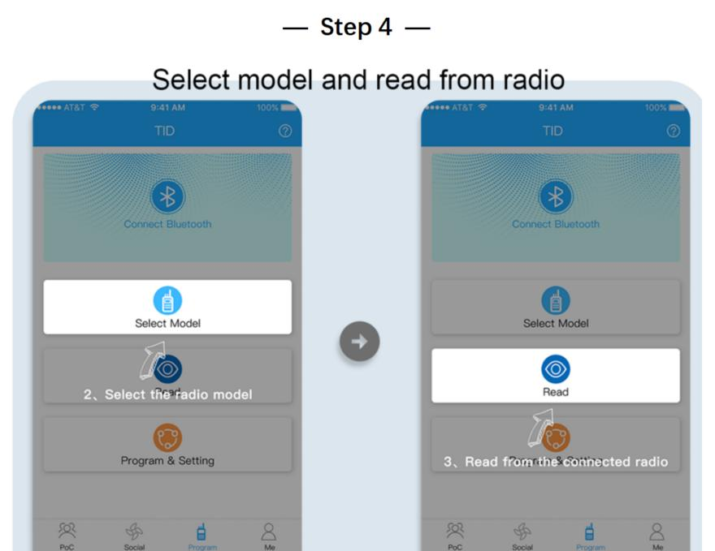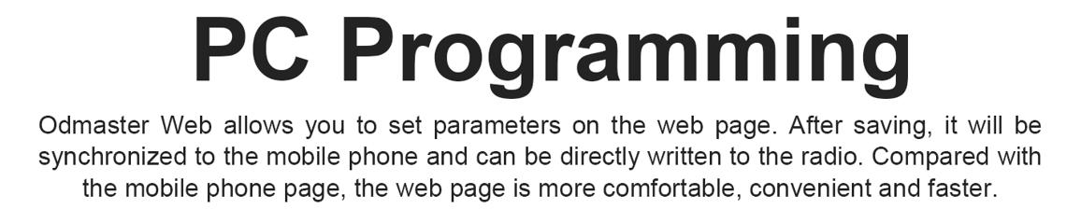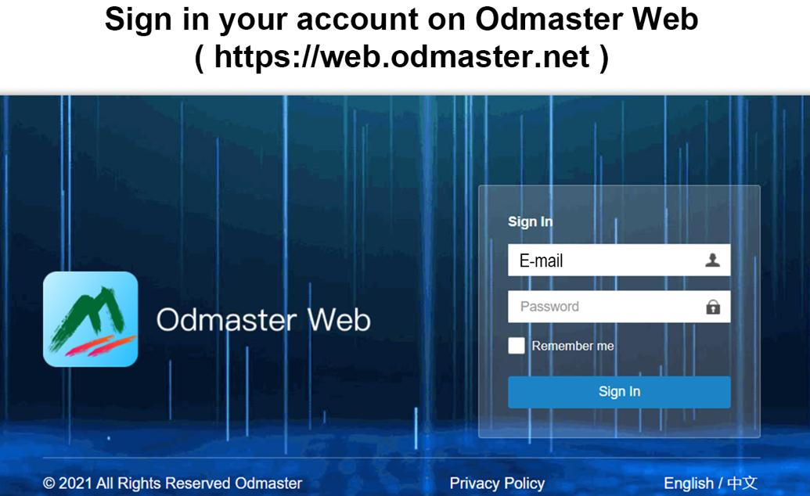

7. Work on the menu
Channel mode is not available: CTCSS/DCS tones, channel width, PTT-ID, BCL, channel name editing.

7.1 Substantive use
- Click [MENU] - Enter the menu.
- м/м - moving to points.
- [MENU] - item selection.
- ./. is the choice of parameter.
- [MENU] - confirm and return to the menu; [BACK] - cancel and exit the menu.
- [BACK] - exit the menu at any time.

7.2 Short teams (shortcuts)
- Press [MENU].
- Enter the item number with a digital keyboard.
- [MENU] Enter the point.
- Parameter: ./. or numerical shortcode.
- [MENU] - save; [BACK] - cancel.
- [BACK] Exit.

7.31 Radio Setting (radio settings)
№ | Function | Description
1 | Squelch LV | The noise reduction level is 1–9 (1 lowest, 9 highest). Default 4.
2 | Step Freq | Frequency step: 0.5/2.5/5.0/6.25/10.0/12.5/25.0/50.0 kHz. The channel mode doesn’t change.
3 | VOX Level | Voice activation level: Off, 1-5.
4 | VOX Delay | VOX delay: 1.0/2.0/3.0 s.
5 | TOTT | Transmission restriction timer: off/30/60/90/120/150/180/210 s.
6 | Roger Beep. | Sound signal when releasing PTT.
7 | Beep. | Keyboard sound.
8 | Power Save | Energy saving: Off, 1:1 / 1:2 / 1:3 / 1:4 (work: sleep).
9 | Keypad Lock | Automatic keyboard locking
10 | Dual Watch | Listen to both channels (TDR) A and B
11 | Voice | Voice confirmation of commands
12 | Backlight | Timeout duration of screen illumination
13 | Brightness | Screen brightness (Recommended setting: 5, with other values when transmitting and the screen is turned on, a squeak is transmitted to the air)
14 | Pwr On Disp | Welcome screen when enabled (Voltage/Message/Picture)
15 | display | Display mode radio - Single (single channel), Dual and Classic (dual channel)
16 | ANI-Edit | DTMF radio identifier
17 | Disp Type-A | Display information about the programmed channel A (Freq + Number / Name + Number)
18 | Disp Type-B | Display information about the programmed channel B (Freq + Number / Name + Number)
19 | DTMF DISE | DTMF signals during transmission: OFF/ON.
20 | PTT Delay | Delayed transmission when releasing PTT
21 | Language language | English/Chinese (English/Chinese)
22 | Alarm Mode | On Site (local signal only, flashing flash) / TX Alarm (sound 10 s, pause 2 s, cycle).
23 | Side Tone (Tail) | Tail suppression: ON/OFF (method specified by CPS).
24 | Tone Burst (TBST) | Repiter tone: 1000/1450/1750/2100 Hz. Sending - side key (TONE).
25 | Talk to me. | OFF: “failed to activate relay”; ON: TX = RX, on the
26 | FM Interrupt | OFF: in FM mode, the call does not interrupt; ON: when calling, the FM is interrupted by 5 seconds.
27 | PF1 S Press | Short press PF1: NONE, FM Radio, Lamp, TONE, Alarm, Weather, PTT2, OD PTT.
28 | PF1 L Press | Long press PF1: NONE, FM Radio, Lamp, Cancel Sq, TONE, Alarm, Weather.
29 | PF2 S Press | Short press PF2: similar to paragraph 27.
30 | PF2 L Press | Long press PF2: similar to paragraph 28.
31 | Top S Press | Short press of the top button: similar to paragraph 27.
32 | Top L Press | Long press of the top button: similar to paragraph 28.
33 | Factory R | Reset: VFO (frequency settings only), CHL (channels only), FULL (all).
34 | Breath Led. | The frequency of LED flashing in standby mode.
35 | MIC GAIN | Microphone amplification: 0-9.
36 | DTMF Speed | DTMF speed (default 110 ms).
37 | DCD | OFF: DTMF off. ON: Enable DTMF call/group call.
38 | D-HOLD | DTMF Auto Reset Time: 5–60 s.
39 | D-RSP | Answer DTMF: NULL / RING / REPLY / BOTH.
40 | 200T X | ON: Open the 220-260 MHz band in VFO mode.
41 | 350T X | ON: Open the 350-390 MHz band in VFO mode.
42 | 500T X | ON: Open the top of UHF (up to 520 MHz) in VFO mode.
43 | Menu Color | The color of the current menu item.

7.32 Program Channel (Channel Programming)
№ | Function | Description
1 | RX Sub-audio | Reception tone: CTCSS (67.0–254.1), DCS (D023N–D754N), Reverse DCS (D023I–D754I).
2 | TX Sub-audio | Tone of transmission: similar.
3 | bandwidth | Wide (25 kHz) / Narrow (12.5 kHz).
4 | TX Power | Low / Middle / High.
5 | Busy Lock. | BCL: OFF - Transmission is allowed with a busy channel; ON is prohibited.
6 | Call code. | 8 groups of alarm codes (edited from PC).
7 | PTT-ID | Sending ANI-ID: OFF / BOT (when PTT is pressed) / EOT (when released) / BOTH.
8 | Scan Add | ON is involved in the scan; OFF is not involved.
9 | Scramble. | Scrambling voice (the same for both).
10 | Offset | TX/RX offset: 0.000–99.998 MHz.
11 | SET-D | Offset direction: OFF / Positive / Negative.
12 | Memory CHL | Save the channel (save the specified parameters before recording).
13 | Delete CHL | Canal removal.
14 | Hopping | Frequency hopping: ON/OFF (group interference protection).
15 | CH-Name | Name of channel
16 | Modulation | Modulation (AM/FM)

7.33 Analog Set
№ | Function | Description
1 | Frequency Calibration | Calibration: UHF/VHF range.
2 | AM Volume Level | AM volume level: 1-5.

7.34 Radio Information
№ | Function
1 | Versions Info
2 | APRS Info
3 | User Manual

7.35 Scan (Scan)
№ | Function | Description
1 | Scan Mode | TO/(CO)/SE (by default CO).
2 | SEEK DCS | Frequency scanning with DCS/CTCSS/R-DCS. Unavailable in channel mode.
3 | Hang time. | Retention time when the signal is detected: step 0.5 s, by default 1 s.
4 | Scan Freq | Quick frequency search with one touch: 1) long press of key 1 - input; 2) е / е - channel selection for saving; 3) on the screen frequency and DCS during transmission; 4) wait for completion; 5) [Menu] - confirm / save, key * - reshoot.
5 | Freq Ranger | Scanning frequency range
6 | Spectrum. | Spectroanalyzer

7.36 Bluetooth
In mode.ReceiverThe radio can act as a bluetooth column for sound/music playback.
In mode.EmitterThe radio is connected to external devices: headsets, microphones, PTT.
№ | Function | Description
1 | BT ON/OFF | On/off Bluetooth.
2 | BT Mode | Receiver (radio - receiver, connects to the phone; name TD-H9 XXXX, do not connect to the suffix BLE) / Emitter (radio - source; mating through paragraph 4). Compatible accessories: Bluetooth PTT, MIC, headset.
3 | BT Name | Name: TD-H9xxx.
4 | BT Pairing | Pairable (device search: PTT, MIC, headset) / Paired (conjugated list: PTT, MIC, headset).
5 | OD PTT | OD (Odmaster only) / OD + Analog (simultaneously with analog transmission).
6 | OD Mode | Local Mode (radio sound; default) / Forward Mode (sending to other walkie-talkie/platforms) / Full Mode (both).
7 | BT Int MIC | Bluetooth microphone amplification switch: OFF/ON.
8 | BT Int Spk | Bluetooth speaker amplification switch: OFF/ON.
9 | BT MIC Gain | BT microphone amplification: 1-5.
10 | BT Spk Gain | BT dynamic amplification: 1-5.
11 | BT Pin Code | PIN pairing: 0000 / 000000 / 123456.
12 | BT Reset | …

Features of Bluetooth
A radio station can hold only one bluetooth connection. To interact with a smartphone or PC, you need to select BT Mode: Receiver mode. To connect the headset - BT Mode - Emitter.

When working withTID-MICThere is a significant delay in order.1~2. 5seconds when pressing the tangent on the transmission and about1~1. 5Seconds when receiving the signal. When pressing the tangent, the audio bluetooth channel opens first, only after that the radio frequency path for transmission opens and the red indicator lights up. That should be taken into account.

When working withTID-PTTslackTID-MICforms0.2~1Seconds, so the radio opens faster. When connecting TID-PTT to a smartphoneODmasterworks with the deviceTID-PTTxxxxxx-A(speed)38400baud), when pairing through the Bluetooth menu of the android, it is not recommended to mate with this device -ODMasterMaybe you can’t see him. Instead, there is a device. TID-PTTxxxxxxx-B.
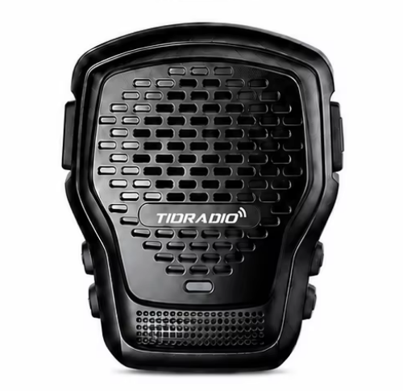
QL2
When working withQL-2…

7.37 Firmware update
- Enter:web.odmaster.net.
- Remote Control Program: Upgrade Firmware
- Follow the steps on the screen.
Either.
- Open up.
- Download the drivers and the current version of the firmware
- Follow the instructions in the archive
Important: Update APRS firmware erases all settings. Callsign, APRS configuration, channel frequencies, digipeater paths - everything disappears!
There are two ways to connect a walkie-talkie to a computer for programming and firmware updates. The first is a USB-C data port on the side of the case, next to the K-1 tangent connectors. The second is the CH340 programming cable, which connects to the same K-1 connectors and connects to the computer via USB-A.

7.38 GNSS (GPS)
№ | Function | Description
1 | GPS ON/OFF | On/off GPS.
2 | GPS Information | Antenna, longitude, latitude, date, time, altitude, course, speed, satellites.
3 | Position | (D) / DM / DMS – Deg, Deg.min, Deg.min.s.
4 | Time zone | Time zone UTC-12…UTC+12 (default +3).
5 | Speed Unit | Speed units: (Kmph) / Knot / Mpt.
6 | Distance Unit | Distance units: (Km)/Sea/Mile.
7 | Altitude Unit | Height units: (M)/Ft.
8 | Fixed Latitude | Fixed latitude (example 44° 35’ 04” - а/а selection, [#] confirmation).
9 | Fixed Longitude | Fixed longitude (example 40° 06’ 38).
10 | Fixed Altitude | Fixed height (default 0).

7.39 Site Type (Position Type)
- Fix Coordinates- fixed coordinates.
- GPS Coordinates- GPS coordinates.
Fixed coordinates are transmitted in case of activation of the beacon transmission mode via APRS, if the appropriate setting is enabled. GPS coordinates - when the location was determined.
If the radio station is stationary, you can turn off GPS and the station will send the specified coordinates (menu items 7.38.8 Fixed Latitude, 7.38.9 Fixed Longitude and 7.38.10 Fixed Altitude).

7.40 APRS
When working with APRS, it is advisable to completely turn off the energy saving mode so as not to miss the start of the package.
№ | Function | Description
1 | APRS Switch | On/off APRS.
2 | Beacon Set | Lighthouse setting:
2. 1st | .. | Call SignAmateur radio call sign (up to 6 characters, capital Latin + digits; итель/итель character selection, confirm - input, back - deletion, # - save)
2. 2. | .. | SSID(0-15, default 11)
2. 3 | .. | SSID Symbol (/or\accordingtable
2. 4. | .. | Custom InformationCommentary on the APRS package, up to 60 ASCII characters
2. 5 | .. | Icon Settings- the reference book viewed according totable. Use it to find the desired character, then enter the code into the SSID Symbol.
2. 6 | .. | MIC Start(On/Off)
2. 7 | .. | MIC Type(MO: Off Duty / M1: En Route / M2: In Service / M3: Returning / M4: Committed / M5: Special / M6: Priority / M7: Emergency)
2. 8. | .. | Route 1: Use the а/а button to select the symbol. Press the confirmation button to select it. If you make a mistake, press the return button to delete.
2. 9. | .. | Route 1 Count: (0-9)
2. 10 | .. | Route 2: Use the а/а button to select the symbol. Press the confirmation button to select it. If you make a mistake, press the return button to delete.
2. 11. | .. | Route 2 Count: (0-9)
2. 12. | .. | Report VoltageSend information about the battery (on default)
2. 13 | .. | Report SatsSend satellite information (on default)
2. 14. | .. | Report MileageSend mileage information (OFF default)
3 | Beacon Type | Setting up beacon transmission:
3. 1st | .. | PTT Linkage(Beacon at each PTT press/release; OFF default)
3. 2. | .. | Timed Beacon- send information at a given frequency (on default)
3. 3 | .. | Timing.- the interval in seconds, for example 0090 = every 90 seconds (input digits + [#]).
4 | Relay Set | Settings of APRS-repiter mode:
4. 1st | .. | DIGI Forward CHTo which channel to relay packets (A/(B)/AB)
4. 2. | .. | DIGI1 Enable(OFF default)
4. 3 | .. | DIGI1 Name(default WIDE1), up to 6 ASCII characters: capital letters and numbers
4. 4. | .. | DIGI2 Enable(OFF default)
4. 5 | .. | DIGI2 Name(default WIDE2), up to 6 ASCII characters: capital letters and numbers
4. 6 | .. | Wait Before ForwardingDelay before retransmission (0-9c). In the presence of several repeaters allows you to divide the transmission time and avoid collisions of beacons in the air
4. 7 | .. | Remote PasswordRemote Repetitor Control Password via KISS (TNC) (default 123456)
5 | Advanced Set | Advanced reception/transmission settings:
5. 1st | .. | APRS RX CHOn which channel to receive APRS (OFF/A/(B))
5. 2. | .. | APRS TX CHOn which channel to transmit APRS (OFF/A/(B))
5. 3 | .. | PTT PriorityPriority for simultaneous voice/APRS (Talk/APRS)
- | .. | RX Decode ToneAudible signal with successful reception and decoding of APRS (on default)
- | .. | TX Tone- audible signal when transmitting APRS (by default OFF)
5. 4. | .. | Beacon Auto Popup(on default) - display the screen with information about the received beacon
6 | Beacon List | List of beacons: up to 100 accepted; control/removal.
7 | APRS Reset | Reset APRS to factory settings.

7.41 Detailed description of APRS functions
# | Topeka | Description
1 | APRS Channels | A/B channels can be assigned to APRS or voice; modes are supported:
. | .. | - reception + transmission to A
. | .. | Receiving A/transmitting B (cross-repeater)
. | .. | - Just take A.
. | .. | - simultaneous transmission A and B
. | .. | - reception + transmission to B
. | .. | - reception B / transmission A (cross-repiter)
. | .. | - Only B.
. | .. | Work is supported offline (without the Internet and cellular communication) - radios determine each other’s positions directly.
2 | Bluetooth | Support for KISS TNC over Bluetooth; data can be parsed and displayed or uploaded to the network via Odmaster.
3 | APRS Relay (DIGI) | Full DIGI relay with customizable names; on/off remotely.
4 | MIC-E | Beacons are compressed and transmitted in MIC-E format - shorter airtime, fewer collisions, higher probability of successful decoding.
5 | PTT Delay | Customizable delay between pressing PTT and starting transmission (useful with a slow noise suppressor of a remote station).
6 | APRS Digital Relay | Two repeater names: by default, WIDE1 and WIDE2 (up to 6 characters, numbers or capital letters). Rule: when receiving a valid beacon containing the repeater name and the transition counter > 1, the radio sends the packet once, reducing the counter by 1. At 0 the packet is not sent. Each transition is a complete cycle of reception → decode → recoding → transfer. The counter limits infinite propagation.Details…
7 | Deleted password | By default.123456(6 digits).
8 | Fixed station | In the Fix Coordinates type, given coordinates are used to calculate the distance/pelling.
9 | Maps/view tracks | …
. | Odmaster: | - https://web.odmaster.net/login.
. | APRS.fi. | - https://aprs.fi/
. | APRS.to. | - https://aprs.to/
. | APRS Map Info | - https://aprs-map.info/
PTT Linkage and Timed Beacon transmissions cannot be enabled at the same time. If both are included, the Timed Beacon does not work.
The bandwidth for APRS should be Wide!

7.42 Remote control of APRS repeater
You can send a control packet from any other radio station or smartphone connected to the transceiver as a standard APRS Message addressed to the call sign of your radio station (for example, N0CALL-9). A combination of [password][command] (e.g., 123456A1) is entered in the message text. If the radio station successfully receives and decodes the package, it will change the operating mode of the built-in digipiter.
The password should strictly consist of 6 digits. For the tracker to execute the command, the message must contain your password and then the command itself (without spaces).
Available remote commands: |Team |What’s going on | |—|—| |A1|Insert repeater 1 (DIGI 1 - activation of digipiter function)| |A0| Turn off repeater 1 (DIGI 1)| |B1|Insert repeater 2 (DIGI 2)| |B0| Turn off repeater 2 (DIGI 2)| |R0|Reset the current settings and restart the device with parameters from non-volatile memory EEPROM|

7.43 Retransmission of APRS packets by digipiter
APRS relayIt is a process: reception → decoding → recoding → sending. With each relay, the signal quality remains the best, unlike traditional analog voice relays.
Due to the fact that the lighthouse contains a specified number of relays, endless relaying does not occur.
In the digipiter mode, the radio station, when receiving an APRS packet, searches for the name of the installed digipiter in its PATH, and if it finds it, then sends this packet further to the air, decrementing the SSID per unit, but only if the SSID is greater than zero.

7.44 APRS Worldwide Frequency
The frequency | Description
144.3900 MHz | North America: United States, Canada, Chili
144.3900 MHz | Indonesia, Singapore, Malaysia
144.3900 MHz | Thailand (https://www.qsl.net/rast/text/2mbandplan.htm)
144.3900 MHz | Mexico, Dominican Republic, Puerto Rico, Trinidad & Tobago, Columbia
144.8000 MHz | Europe, UK, Ireland, Iceland,Russia
144.8000 MHz | South Africa, Azores, Costa Rica, Israel, Lebanon, Senegal
145.1750 MHz | Australia, Tasmania
144.5750 MHz | New Zealand
144.9300 MHz | Argentina, Uruguay, Paraguay
144.6600 MHz | Japan
144.6400 MHz | China, Hong Kong, Taiwan
144.6200 MHz | South Korea
145.5250 MHz | Thailand (OLD)
145.5700 MHz | Brazil
433.8000 MHz | Europe (Primary)
432.5 MHz | Europe (Secondary)
439.1000 MHz | Australia
430.5125 MHz | Netherlands
432.5750 MHz | New Zealand
Do not use the above frequencies for voice transmission.
http://aprs.qrz.ru/freq.php
https://www.sigidwiki.com/wiki/Automatic Packet Reporting System (APRS)
https://aprs.fi/

7.45 Similar to APRS radio
Significant disadvantages of APRS implementation on H9: * Inability to assign beacon sending by pressing the side key (Send Beacon) Ability to silence the sound on the APRS channel (Mute A/B) *Not able to work with APRSDroid, only ODMaster
A similarly functional APRS radio stationLanchonlh HG-UV98: *HG-UV98 * lanchonlh hg-uv98 ru manual
The HG-UV98 has better bandwidth filters than the H9. The H9 has better APRS selectivity.
For the correct interaction withLanchonlh HG-UV98need to adjustAPRS RX LevelUV98.

7.46 SMS
When working with SMS, you need to turn off Dual Watch (TDR) mode and it is desirable to remove the power saving mode.
The radio station allows you to send and transmit short messages between similar stations:TD-H9and TD-H3+.
Send and receive messages via APRS.
In RF mode, messaging is only possible betweenTD-H9and TD-H3+. The recipient is indicated by Radio Info (Radio Info -> Radio ID). Radio ID is configured via CPS on your computer (DTMF Code -> DTMF Settings -> Local ID).
In the APRS mode, messaging is carried out by APRS-packets Message (:). The receiver and sender on the pop-up screen is displayed correctly. On the incoming SMS view screen, the sender is indicated as the recipient.
Item | Name | Description
1 | SMS ON/OFF | On/off SMS reception mode
2 | Send SMS | Sending a message to the recipient. Amateur radio call sign with SSID suffix is indicated as the recipient of the message.
3 | Inbox | Incoming communications
4 | Outbox | Outgoing communications
5 | Draft | Communication templates
6 | SMS Mode | SMS mode (RF/R)APRS)
7 | RX Filter | Message filter
8 | Statisctics | Message statistics (memory use)

7.47 Spectrum
The radio station allows you to view the radio frequency spectrum.
Management | Description
Retention 7 | Enter spectrum analyzer mode
Menou | Entrance to the text menu of spectrometer settings
BACK/EXIT | Quick exit from spectrum analyzer mode
PF1 | Exclusion of frequency from scanning (Perhaps you need to reset to spectrum mode, or reset peak values)0)
PF2 | Including frequency in the scan
# | Automatic transition of the cursor to the peak of the strongest signal
2/8 (retention) | Change of the RSSI threshold (Threshold)
/ | Frequency navigation (cursor movement)
* | On/off cursor
PTT | Monitor Mode (MONI) – Instantly opens the noise suppressor to listen to the frequency under the cursor
0-9 | Manual central frequency input

menu:
Item | Name | Description
1 | Modulation | Modulation change
2 | Step Freq | Changing the step of the scanning frequency grid 0.1/0.5/1.0/2.5/5.0/6.25/10.0/12.5/25.0/50/100 kHz
3 | Threshold | RSSI threshold (minimum signal strength in decibels (dBm))
4 | Cursor | On/off cursor
5 | bandwidth | Channel width setting (W/N)
6 | Reset | Resetting spectrometer settings and cleaning cut frequencies

7.48 Morse
The radio can transmit and receive Morse code. Adjustable TX speed, RX threshold and tone frequency.
Item | Name | Description
1 | Morse On/Off | Morse regimen
2 | Key TXX | Manual transmission mode
3 | Edit TX | Entering the transmission text with sending
4 | RX Code | Morse code acceptance mode
5 | TXX Speed | Transmission speed for automatic 5/8/12/18 mode
6 | RX Threshold | RSSI threshold (minimum signal strength in decibels (dBm))
During Morsea transmission, CTCSS or DCS subtones are not transmitted.

Annex A. Failure detection and repair
Problem. | Analysis | Decision
Not included. | Incorrectly installed battery / discharged / poor contact | Reinstall battery; charge or replace; clean contacts
Weak/intermittent voice when receiving | Low volume / antenna weakened or installed incorrectly / clogged speaker | Increase volume; turn off and reinstall the antenna; clean the speaker
No connection to the group. | Frequency or signals do not match / too far | Check frequencies and signals; get closer
Other voices/noise heard | Interference on frequency / in analog mode no alarm | Change the frequency or raise the noise suppressor; adjust the alarm
No one heard (noise) | Large obstacles / open terrain / electromagnetic interference | Go to an open flat area, restart the radio; move away from sources of interference
Continuous transmission | VOX enabled or headset not inserted until the end | Turn off VOX; check the headset

Annex B: Technical specifications
Parameter | Meaning.
Frequency range (Amateur, RX & TX) | 136–173.99 and 400–519.99 MHz (TX/RX also 174–245, 240–260, 290–350, 350–400, 470–520, 520–600 MHz; RX 50–76, 65–108 (FM radio), 108–136 (AM/FM air), 220–260, 350–390 MHz
Memory channels | 199
RF power output | up to 10 W (3 levels: high, medium, low)
Working voltage | DC 7.4 V ± 10%
Battery capacity | 2400 mAh (Li-Ion)
Frequency stability | ± 2.5 ppm
Operating temperature | -20 °C to +50 °C
Mode of work | simplex
Impedance antenna | 50 ohm
antenna connector | On the SMA-Male radio, on the SMA-Female antenna
Headset jack | K-Plug (Kenwood 2-pin)
Display. | 1.77” color LCD, 3 display modes, 18 menu colors
GPS | Built-in GPS/GNSS
Bluetooth | Built-in (for customization through Odmaster, headsets)
APRS | Built-in support (KISS TNC, DIGI, MIC-E)
Spectroanalyzer | Built-in
CPU/RAM/Flash | 240 MHz / 120 MB / 16 MB
Radiochip/MK | Beken BK4819 / PY32F003
FM modulation | 11K0F3E@ 12.5 kHz (Narrow band) /16K0F3E@ 25 kHz (Wide band)
Power of the adjacent channel | 60 dB @ 12.5 kHz
Transmission current | ≤ 1500 mA
Sensitivity of the receiver | 0.25 μV (12 dB SINAD)
Selectivity on the adjacent channel | ≥ 55 dB @ 12.5 kHz
Suppression of intermodulation | ≥ 55 dB @ 12.5 kHz
Parasite radiation | ≤ -57 dB @ 12.5 kHz
Sound output | 1 Watt @ 16 Ohm
Reception current. | ≤ 380 mA
Sound distortion | ≤ 5%
Dimensions (without antenna) | 140 x 53 x 32 mm
Weight. | 190

Annex C: Table of DCS codes
№ | Code. | № | Code. | № | Code.
1 | D023N | 2 | D025N | 3 | D026N
4 | D031N | 5 | D032N | 6 | D036N
7 | D043N | 8 | D047N | 9 | D051N
10 | D053N | 11 | D054N | 12 | D065N
13 | D071N | 14 | D072N | 15 | D073N
16 | D074N | 17 | D114N | 18 | D115N
19 | D116N | 20 | D122N | 21 | D125N
22 | D131N | 23 | D132N | 24 | D134N
25 | D143N | 26 | D145N | 27 | D152N
28 | D155N | 29 | D156N | 30 | D162N
31 | D165N | 32 | D172N | 33 | D174N
34 | D205N | 35 | D212N | 36 | D223N
37 | D225N | 38 | D226N | 39 | D243N
40 | D244N | 41 | D245N | 42 | D246N
43 | D251N | 44 | D252N | 45 | D255N
46 | D261N | 47 | D263N | 48 | D265N
49 | D266N | 50 | D271N | 51 | D274N
52 | D306N | 53 | D311N | 54 | D315N
55 | D325N | 56 | D331N | 57 | D332N
58 | D343N | 59 | D346N | 60 | D351N
61 | D356N | 62 | D364N | 63 | D365N
64 | D371N | 65 | D411N | 66 | D412N
67 | D413N | 68 | D423N | 69 | D431N
70 | D432N | 71 | D445N | 72 | D446N
73 | D452N | 74 | D454N | 75 | D455N
76 | D462N | 77 | D464N | 78 | D465N
79 | D466N | 80 | D503N | 81 | D506N
82 | D516N | 83 | D523N | 84 | D526N
85 | D532N | 86 | D546N | 87 | D565N
88 | D606N | 89 | D612N | 90 | D624N
91 | D627N | 92 | D631N | 93 | D632N
94 | D645N | 95 | D654N | 96 | D662N
97 | D664N | 98 | D703N | 99 | D712N
100 | D723N | 101 | D731N | 102 | D732N
103 | D734N | 104 | D743N | 105 | D754N
106 | D023I | 107 | D025I | 108 | D026I
109 | D031I | 110 | D032I | 111 | D036I
112 | D043I | 113 | D047I | 114 | D051I
115 | D053I | 116 | D054I | 117 | D065I
118 | D071I | 119 | D072I | 120 | D073I
121 | D074I | 122 | D114I | 123 | D115I
124 | D116I | 125 | D122I | 126 | D125I
127 | D131I | 128 | D132I | 129 | D134I
130 | D143I | 131 | D145I | 132 | D152I
133 | D155I | 134 | D156I | 135 | D162I
136 | D165I | 137 | D172I | 138 | D174I
139 | D205I | 140 | D212I | 141 | D223I
142 | D225I | 143 | D226I | 144 | D243I
145 | D244I | 146 | D245I | 147 | D246I
148 | D251I | 149 | D252I | 150 | D255I
151 | D261I | 152 | D263I | 153 | D265I
154 | D266I | 155 | D271I | 156 | D274I
157 | D306I | 158 | D311I | 159 | D315I
160 | D325I | 161 | D331I | 162 | D332I
163 | D343I | 164 | D346I | 165 | D351I
166 | D356I | 167 | D364I | 168 | D365I
169 | D371I | 170 | D411I | 171 | D412I
172 | D413I | 173 | D423I | 174 | D431I
175 | D432I | 176 | D445I | 177 | D446I
178 | D452I | 179 | D454I | 180 | D455I
181 | D462I | 182 | D464I | 183 | D465I
184 | D466I | 185 | D503I | 186 | D506I
187 | D516I | 188 | D523I | 189 | D526I
190 | D532I | 191 | D546I | 192 | D565I
193 | D606I | 194 | D612I | 195 | D624I
196 | D627I | 197 | D631I | 198 | D632I
199 | D645I | 200 | D654I | 201 | D662I
202 | D664I | 203 | D703I | 204 | D712I
205 | D723I | 206 | D731I | 207 | D732I
208 | D734I | 209 | D743I | 210 | D754I

Annex D. Table of CTCSS tones
№ | Hz | № | Hz | № | Hz | № | Hz | № | Hz
1 | 67.0 | 2 | 69.3 | 3 | 71.9 | 4 | 74.4 | 5 | 77.0
6 | 79.7 | 7 | 82.5 | 8 | 85.4 | 9 | 88.5 | 10 | 91.5
11 | 94.8 | 12 | 97.4 | 13 | 100.0 | 14 | 103.5 | 15 | 107.2
16 | 110.9 | 17 | 114.8 | 18 | 118.8 | 19 | 123.0 | 20 | 127.3
21 | 131.8 | 22 | 136.5 | 23 | 141.3 | 24 | 146.2 | 25 | 151.4
26 | 156.7 | 27 | 159.8 | 28 | 162,2 | 29 | 165.5.5 | 30 | 167.9
31 | 171.3 | 32 | 173.8 | 33 | 177.3 | 34 | 179.9 | 35 | 183.5
36 | 186.2 | 37 | 189.9 | 38 | 192.8 | 39 | 196.6.6 | 40 | 199.5
41 | 203.5 | 42 | 206.5 | 43 | 210.7 | 44 | 218.1 | 45 | 225.7
46 | 229.1 | 47 | 233.6 | 48 | 241.8 | 49 | 250.3 | 50 | 254.1

Annex E. Software
soft | Reference
Drivers.
Setting up a PC radio | TIDRadioCPS
Setting up the radio on Android | Odmaster
Alternative APRSDroid | APRSDroid 9M2PJU Mod
Android javAPRSSrvr IGate | javAPRSSrvr IGate
Software and firmware
Online channel editor | TD Editor
APRS software for PC | Desktop BLE-TCP Bridge Software
APRS software for Android | Android BLE-TCP Bridge Software
Other software (APRS) | github.com/dkxce
Description of the .td format | DISAMS

Annex F. Channels and presets

Translated from the official manual TIDRADIO TD-H9 (Ham Version).
Official website: https://tidradio.com/.
Legal information and full illustrations in the original manual.

