Preliminary GABRIEL v9 Report
Peer-Community Comparability in Massachusetts Municipal Wage-Setting Documents
Descriptive evidence from a 32-row public-source causal corpus

Prepared for internal discussion | June 25, 2026

Core takeaway
GABRIEL v9 finds a real comparability signal, but it is concentrated in safety-side arbitration and award-style documents. Ordinary CBAs, including most safety and non-safety CBAs, contain much less explicit peer-community comparability language. The current evidence keeps H1 plausible but underidentified.

Executive summary
- The v9 corpus contains 32 causal rows across 9 Massachusetts cities, with 12 healthy matched safety rows (9 exact-cycle and 3 overlap-cycle).
- The pooled safety/non-safety comparison shows a higher mean comparability score for safety rows. But the split is heavily shaped by source type: arbitration-award rows score much higher than ordinary CBA rows.
- When arbitration-award rows are excluded, the safety/non-safety gap becomes much smaller. This suggests that the public corpus is measuring both wage-setting mechanisms and document-production differences.
- The best current interpretation is descriptive rather than causal: explicit peer-community wage comparability is highly visible in safety-side arbitration/award documents, while ordinary CBAs often record the wage outcome without explaining the bargaining logic.
- The next high-value empirical task is to find non-safety reasoning documents or proxy materials - especially public meeting packets, bargaining exhibits, factfinding-like documents, or settlement memos - in Newton, Somerville, and Boston.
Measure | Value
Causal corpus rows | 32
Cities | 9
Safety rows | 15
Non-safety rows | 17
CBA rows | 29
Arbitration-award rows | 3
Healthy matched safety rows | 12
Exact-cycle matched safety rows | 9
Overlap-cycle matched safety rows | 3
Unmatched safety rows | 3

1. Corpus and research question
The working hypothesis is that police and fire wages rise faster because police/fire wage-setting relies more heavily on peer-community comparability. In this report, comparability means explicit reference to what comparable municipalities, surrounding communities, or peer public employers pay for similar work.
The report is a measurement memo, not a causal estimate. The corpus is public-source and document-based. It measures explicit comparability language that appears in contracts, awards, and award-like documents; it does not observe all bargaining arguments that may have occurred off-document.
Group | N | Mean | Median | Max
Overall | 32 | 10.41 | 5.0 | 88
Safety rows | 15 | 16.80 | 5.0 | 88
Non-safety rows | 17 | 4.76 | 5.0 | 10
CBA rows | 29 | 5.52 | 5.0 | 25
Arbitration-award rows | 3 | 57.67 | 85.0 | 88

2. GABRIEL v9 measurement approach
GABRIEL v9 scores one attribute: comparability_emphasis. It builds on the v8 pipeline: full-text input, verbatim quote verification, bounded retry for failed excerpts, and relevance filtering. v9 also explicitly filters generic health-insurance "comparable plan" language, because that phrase can be verbatim without being peer-wage comparability.
Counted as comparability: peer communities, surrounding municipalities, external public-employer wage comparisons, pay/salary/compensation comparisons, and clearly compensation-related longevity or detail-rate comparisons.
Not counted as comparability: generic health-insurance comparable-plan language, CPI/COLA alone, internal step schedules, boilerplate arbitration clauses, or vague market language without external wage comparison.

3. Main descriptive result: source type drives much of the signal
The pooled safety/non-safety split shows a large gap. Safety rows average 16.80 while non-safety rows average 4.76. On its own, that looks favorable to H1. But source type is the central caveat: arbitration-award rows average 57.67, while CBA rows average 5.52.
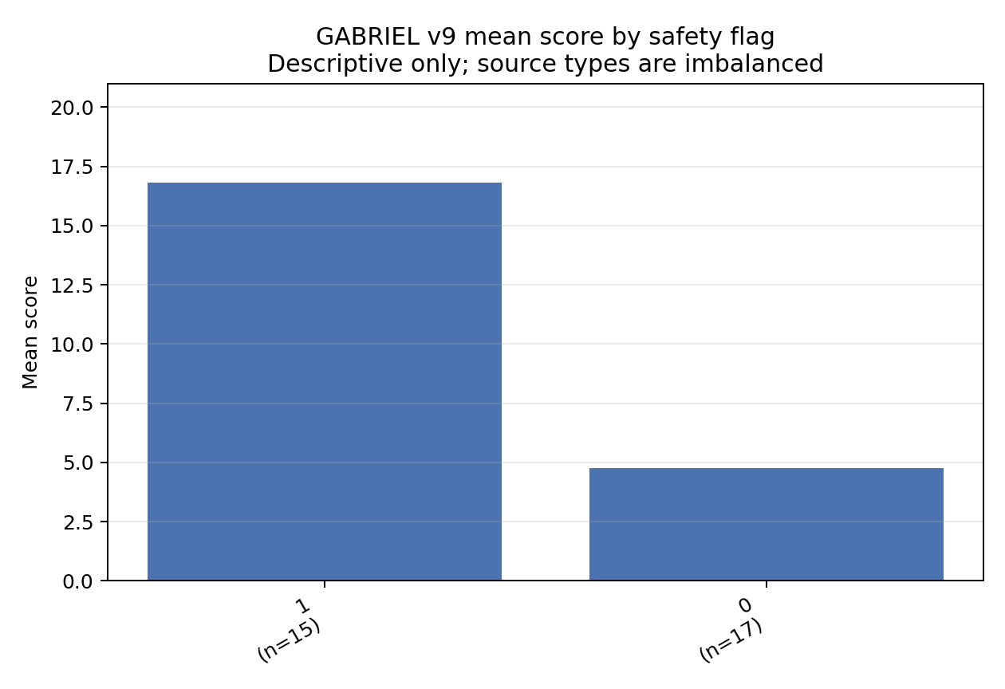
Figure 1. Pooled mean GABRIEL v9 score by safety flag. Descriptive only; source types are imbalanced.
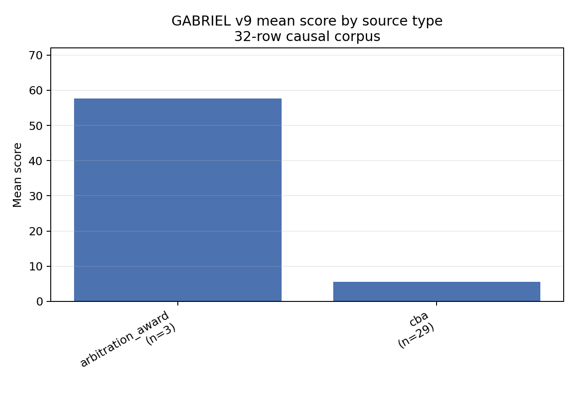
Figure 2. Mean GABRIEL v9 score by source type. Award-style sources contain much more explicit reasoning.
The top-document plot makes the pattern clear. The two highest-scoring documents are Somerville police arbitration awards. A single Arlington fire CBA is the highest-scoring ordinary CBA, based on outside-detail rate language, but most CBAs score far lower.
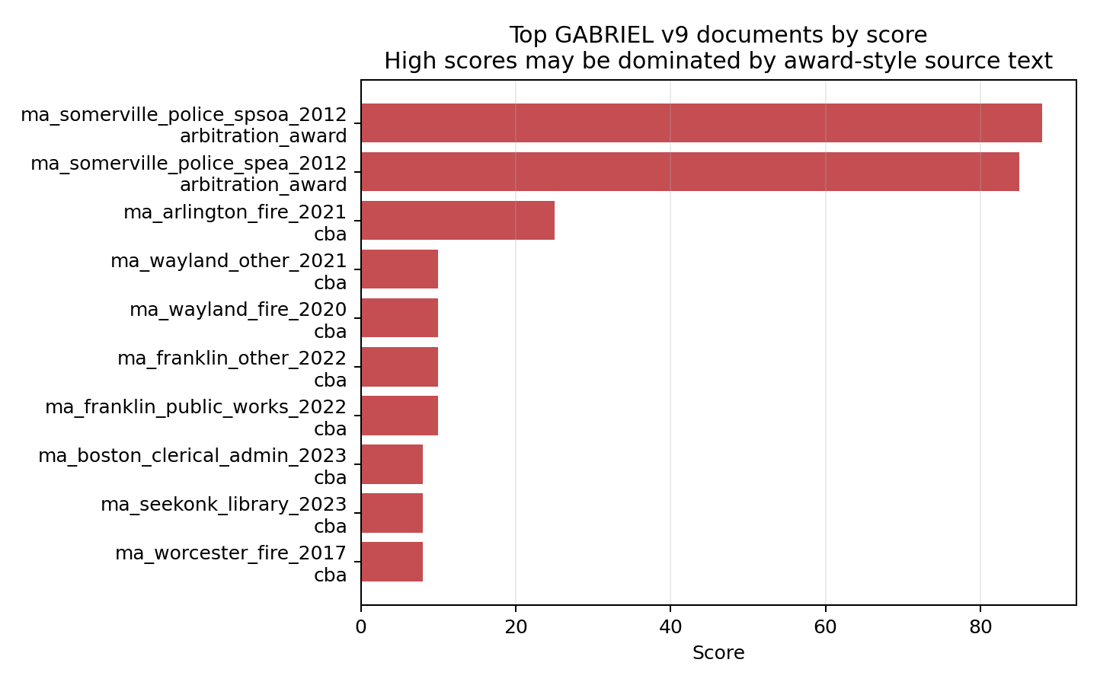
Figure 3. Top GABRIEL v9 documents by score. The largest scores are concentrated in award-style safety documents.

4. Distribution and CBA-only sensitivity
The all-row distribution has a low-score mass and two high-score outliers. Once arbitration-award rows are excluded, the distribution is compressed near the bottom of the scale. This is the cleanest visual evidence that the pooled safety/non-safety gap should not be read as a pure occupation effect.
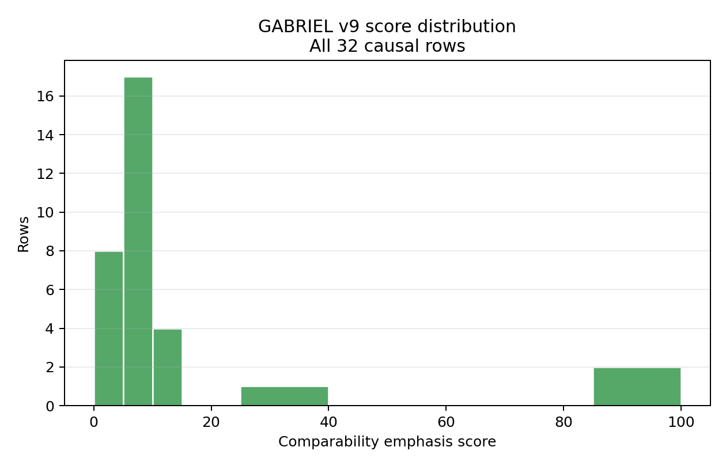
Figure 4. Score distribution across all 32 causal rows.
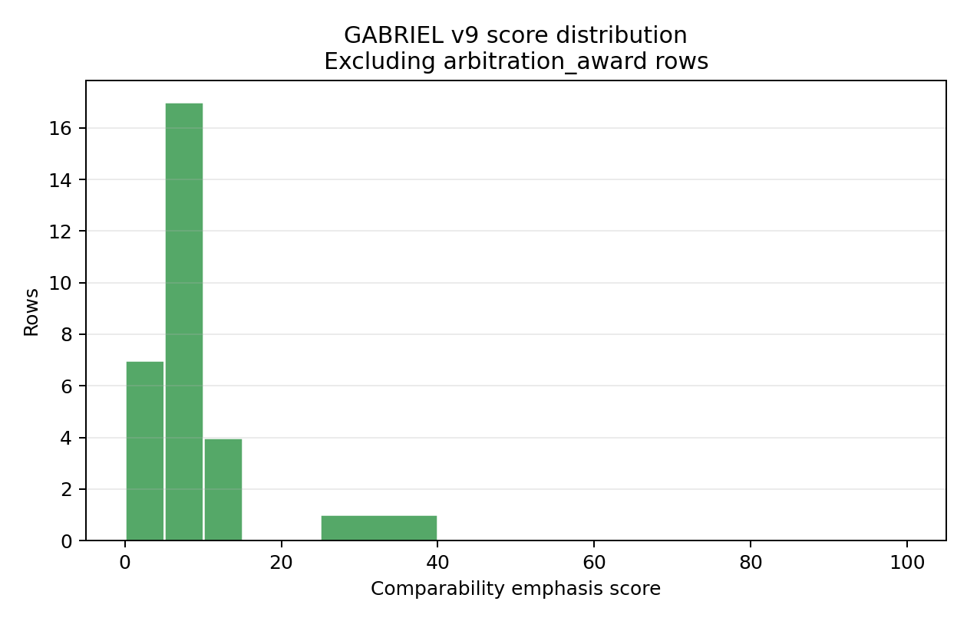
Figure 5. Score distribution after excluding arbitration-award rows.
The CBA-only safety/non-safety comparison is more modest. Safety CBAs still score somewhat higher than non-safety CBAs, but the difference is small relative to the award-vs-CBA gap. This keeps H1 alive, but it shifts the interpretation: the public CBA corpus alone does not yet show strong, widespread explicit comparability reasoning.
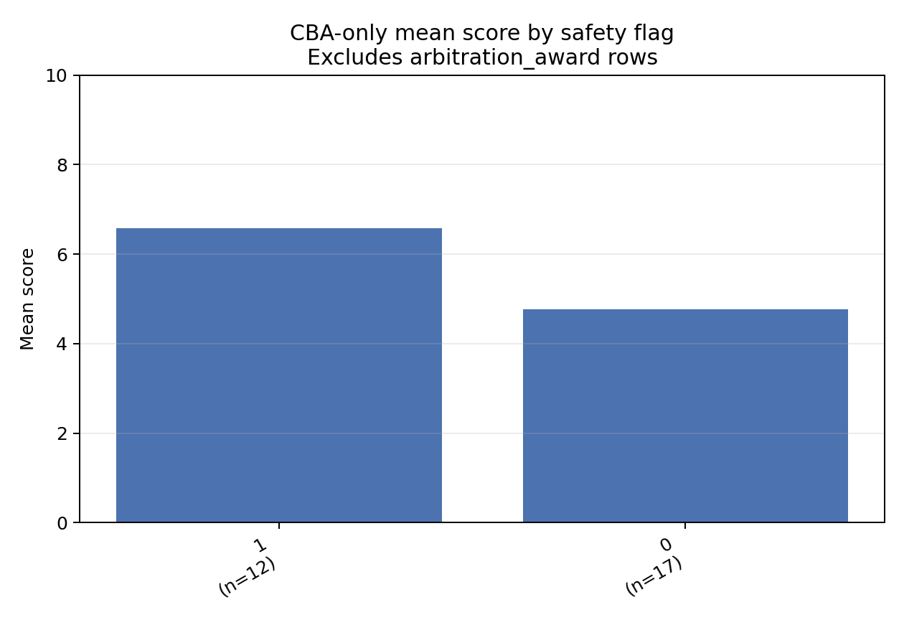
Figure 6. CBA-only mean score by safety flag. The safety/non-safety gap shrinks after excluding awards.

5. City, occupation, and match-tier views
City-level results are dominated by Somerville because the corpus includes two high-scoring Somerville police arbitration awards. Franklin, Wayland, and Seekonk substantially improve matched coverage, but their ordinary CBA scores are mostly low.
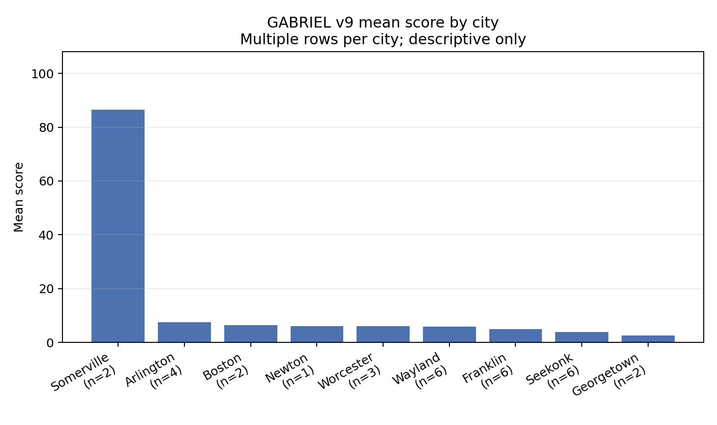
Figure 7. Mean score by city. Somerville is the clear outlier because of police arbitration awards.
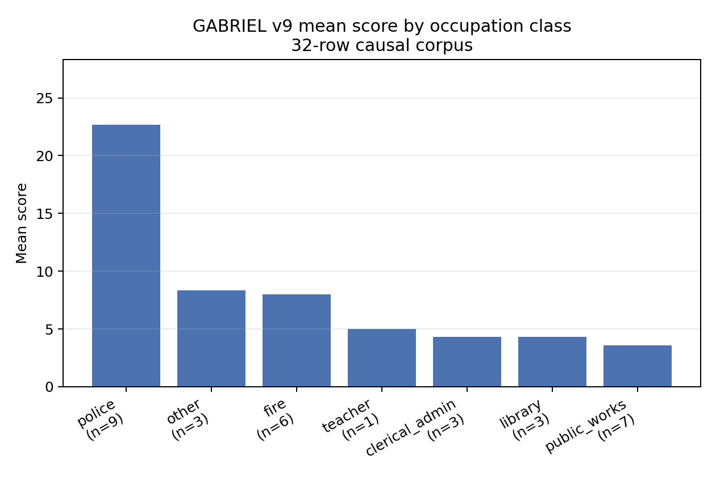
Figure 8. Mean score by occupation class. Police scores are highest, but source type is a major confounder.
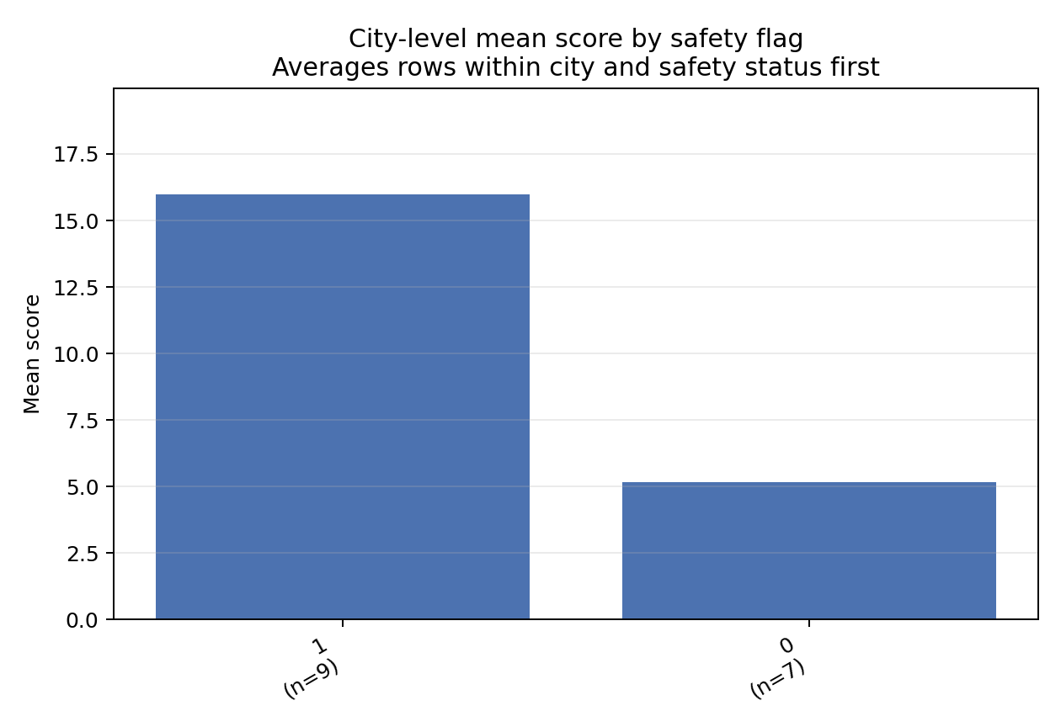
Figure 9. City-level mean score by safety flag. This averages within city and safety status before comparing groups.
The match-tier plot compares exact-cycle and overlap-cycle safety rows. Exact-cycle safety rows score slightly higher on average, but both groups are small. Match tier is useful for reporting discipline, but it does not resolve the source-type issue.
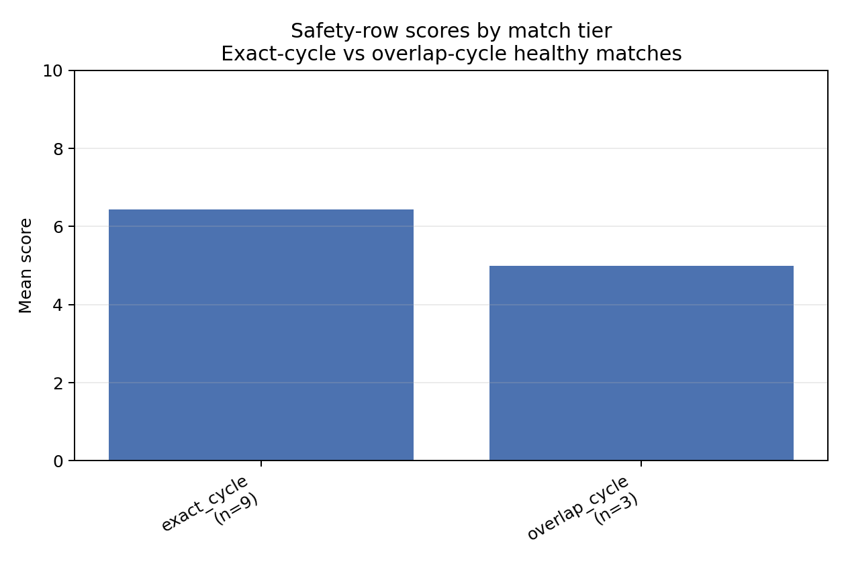
Figure 10. Safety-row scores by match tier.

6. Row-level summary and quote audit
The table below lists the highest-scoring documents. The key point is not just that police rows score high; it is that the highest scores occur in arbitration-award documents that explain reasoning in a way ordinary CBAs usually do not.
Document | City | Occupation | Safety | Source type | Score | Relevant excerpts
ma_somerville_police_spsoa_2012 | Somerville | police | safety | arbitration_award | 88 | 5
ma_somerville_police_spea_2012 | Somerville | police | safety | arbitration_award | 85 | 4
ma_arlington_fire_2021 | Arlington | fire | safety | cba | 25 | 1
ma_franklin_public_works_2022 | Franklin | public_works | non-safety | cba | 10 | 0
ma_franklin_other_2022 | Franklin | other | non-safety | cba | 10 | 0
ma_wayland_fire_2020 | Wayland | fire | safety | cba | 10 | 0
ma_wayland_other_2021 | Wayland | other | non-safety | cba | 10 | 0

GABRIEL v9 identified 10 verified relevant supporting excerpts and 3 verbatim but irrelevant or ambiguous excerpts. To avoid overquoting, the table below gives only short cue phrases. The full quote audit remains in the CSV output.
Document | City | Source type | Score | Relevant excerpts | Short cue phrases
ma_arlington_fire_2021 | Arlington | cba | 25 | 1 | "outside detail rate"
ma_somerville_police_spea_2012 | Somerville | arbitration_award | 85 | 4 | "comparable communities", "surrounding communities"
ma_somerville_police_spsoa_2012 | Somerville | arbitration_award | 88 | 5 | "comparable communities", "wages and benefits"

7. Interpretation
Headline interpretation
The report supports a cautious descriptive conclusion: explicit peer-community wage comparability is highly visible in safety-side arbitration and award-style documents, but much less visible in ordinary CBAs. H1 remains plausible, but the current public-source evidence cannot yet distinguish a police/fire occupation effect from a source-type or document-production effect.

The current evidence strengthens the project in two ways. First, it shows that the GABRIEL pipeline can recover substantively meaningful comparability language when that language is present in the document. Second, it clarifies the main identification problem: non-safety reasoning documents comparable to the Somerville and Wayland safety-side award material remain scarce in the public-source corpus.
The report also cautions against treating CBA silence as evidence that comparability did not matter. CBAs and MOAs often record final wage terms without spelling out the arguments that led to those terms. Arbitration awards, JLMC awards, factfinding reports, and some public meeting packets are more likely to record the reasoning layer.

8. Recommended next steps
- Prioritize mechanism-source search over broad ingestion. Newton, Somerville, and Boston remain the highest-value targets for public school committee packets, bargaining exhibits, settlement memos, or factfinding-like documents.
- Use v10 to test one additional institutional attribute after quote review. The leading candidate is arbitration_or_impasse_backstop, because v9 suggests source type and dispute-resolution institutions are central.
- Continue official-portal ingestion selectively. More public CBAs help robustness, but new CBA rows are less valuable than non-safety reasoning documents unless they add new cities or clean exact-cycle matches.
- Keep PRRs deferred unless the PI changes preference. The public-only path is still productive, but it should be presented as source-limited.
- Prepare a PI-facing short memo from this report. The message should be high-level: the measurement pipeline works, the first descriptive pattern is real, and the next bottleneck is non-safety reasoning evidence.

Appendix A. Summary tables

A1. Source-type summary
Source type | Rows | Mean | Median | Max | Rows > 0 | Rows with verified relevant excerpts
arbitration_award | 3 | 57.67 | 85 | 88 | 2 | 2
cba | 29 | 5.52 | 5 | 25 | 22 | 1

A2. Safety summary
Safety status | Rows | Mean | Median | Max | Rows > 0 | Rows with verified relevant excerpts
non-safety | 17 | 4.76 | 5 | 10 | 12 | 0
safety | 15 | 16.80 | 5 | 88 | 12 | 3

A3. Occupation summary
Occupation | Rows | Mean | Median | Max | Rows > 0 | Rows with verified relevant excerpts
clerical_admin | 3 | 4.33 | 5 | 8 | 2 | 0
fire | 6 | 8 | 6.50 | 25 | 4 | 1
library | 3 | 4.33 | 5 | 8 | 2 | 0
other | 3 | 8.33 | 10 | 10 | 3 | 0
police | 9 | 22.67 | 5 | 88 | 8 | 2
public_works | 7 | 3.57 | 5 | 10 | 4 | 0
teacher | 1 | 5 | 5 | 5 | 1 | 0

A4. City summary
City | Rows | Mean | Median | Max | Rows > 0 | Rows with verified relevant excerpts
Arlington | 4 | 7.50 | 2.50 | 25 | 2 | 1
Boston | 2 | 6.50 | 6.50 | 8 | 2 | 0
Franklin | 6 | 5 | 5 | 10 | 4 | 0
Georgetown | 2 | 2.50 | 2.50 | 5 | 1 | 0
Newton | 1 | 6 | 6 | 6 | 1 | 0
Seekonk | 6 | 3.83 | 5 | 8 | 4 | 0
Somerville | 2 | 86.50 | 86.50 | 88 | 2 | 2
Wayland | 6 | 5.83 | 5 | 10 | 5 | 0
Worcester | 3 | 6 | 5 | 8 | 3 | 0

