Preliminary GABRIEL v9 Report
Peer-Community Comparability in Massachusetts Municipal Wage-Setting Documents
Descriptive evidence from a 32-row public-source causal corpus

Prepared for internal discussion | June 25, 2026

Core takeaway
GABRIEL v9 finds a real comparability signal, but it is concentrated in safety-side arbitration and award-style documents. Ordinary Collective Bargaining Agreements (CBAs), including most safety and non-safety CBAs, contain much less explicit peer-community comparability language. The current evidence keeps H1 plausible but underidentified.

Executive summary
- The v9 corpus contains 32 causal rows across 9 Massachusetts cities, with 12 healthy matched safety rows (9 exact-cycle and 3 overlap-cycle).
- The pooled safety/non-safety comparison shows a higher mean comparability score for safety rows. But the split is heavily shaped by source type: arbitration and award-style rows score much higher than ordinary CBA rows.
- When arbitration-award rows are excluded, the safety/non-safety gap becomes much smaller. This suggests that the public corpus is measuring both wage-setting mechanisms and document-production differences.
- The best current interpretation is descriptive rather than causal: explicit peer-community wage comparability is highly visible in safety-side arbitration and award-style documents, while ordinary CBAs often record the wage outcome without explaining the bargaining logic.
- The next high-value empirical task is to find non-safety reasoning documents or proxy materials - especially public meeting packets, bargaining exhibits, factfinding-like documents, or settlement memoranda - in Newton, Somerville, and Boston.
Measure | Value
Causal corpus rows | 32
Cities | 9
Safety rows | 15
Non-safety rows | 17
Collective Bargaining Agreement (CBA) rows | 29
Arbitration / award-style rows | 3
Healthy matched safety rows | 12
Exact-cycle matched safety rows | 9
Overlap-cycle matched safety rows | 3
Unmatched safety rows | 3

1. Corpus and research question
The working hypothesis is that police and fire wages rise faster because police/fire wage-setting relies more heavily on peer-community comparability. In this report, comparability means explicit reference to what comparable municipalities, surrounding communities, or peer public employers pay for similar work.
The report is a measurement memo, not a causal estimate. The corpus is public-source and document-based. It measures explicit comparability language that appears in Collective Bargaining Agreements (CBAs), Memoranda of Agreement (MOAs), arbitration awards, and award-like documents. It does not observe all bargaining arguments that may have occurred off-document.
Group | N | Mean | Median | Max
Overall | 32 | 10.41 | 5.0 | 88
Safety rows | 15 | 16.80 | 5.0 | 88
Non-safety rows | 17 | 4.76 | 5.0 | 10
CBA rows | 29 | 5.52 | 5.0 | 25
Arbitration / award-style rows | 3 | 57.67 | 85.0 | 88

2. GABRIEL v9 measurement approach
GABRIEL v9 scores one attribute: comparability_emphasis. It builds on the v8 pipeline: full-text input, verbatim quote verification, bounded retry for failed excerpts, and relevance filtering. v9 also explicitly filters generic health-insurance "comparable plan" language, because that phrase can be verbatim without being peer-wage comparability.
Counted as comparability: peer communities, surrounding municipalities, external public-employer wage comparisons, pay/salary/compensation comparisons, and clearly compensation-related longevity or detail-rate comparisons.
Not counted as comparability: generic health-insurance comparable-plan language, CPI/COLA alone, internal step schedules, boilerplate arbitration clauses, or vague market language without external wage comparison. CPI/COLA refers to Consumer Price Index or cost-of-living adjustment language.

3. Main descriptive result: source type drives much of the signal
The pooled safety/non-safety split shows a large gap. Safety rows average 16.80 while non-safety rows average 4.76. On its own, that looks favorable to H1. But source type is the central caveat: arbitration and award-style rows average 57.67, while CBA rows average 5.52. The Joint Labor-Management Committee (JLMC) is the Massachusetts public-safety impasse/arbitration body; JLMC-type records are closer to reasoning documents than ordinary CBAs.
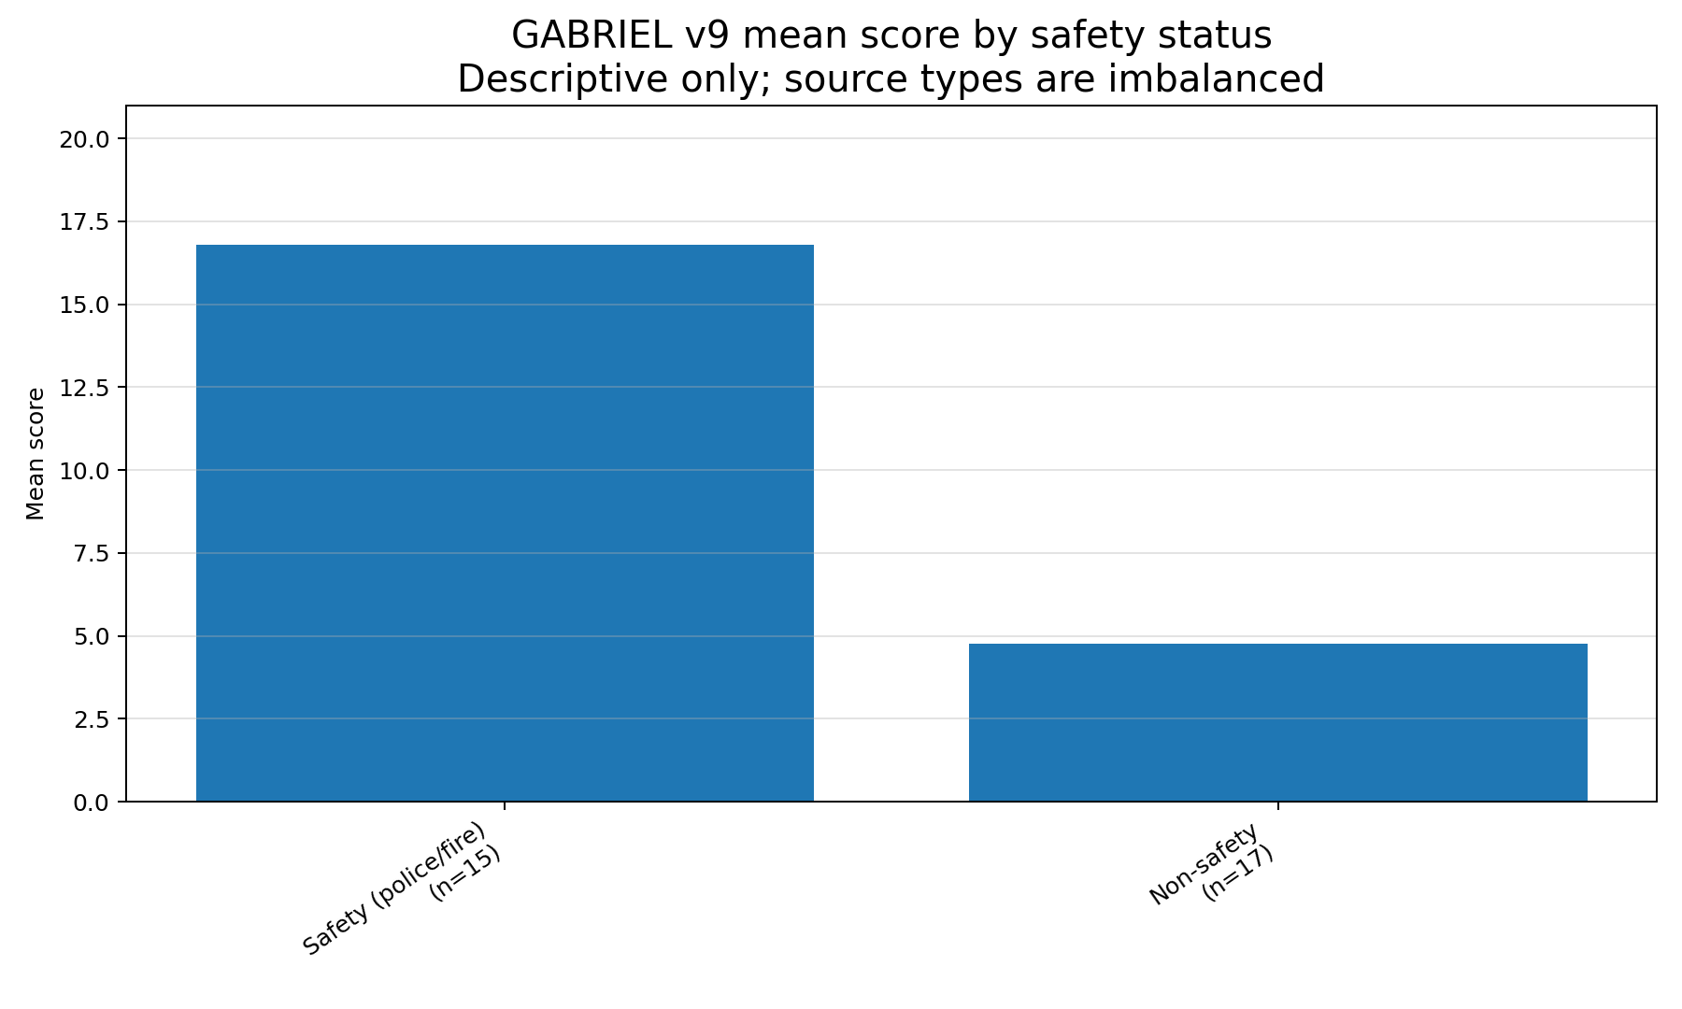
Figure 1. Pooled mean GABRIEL v9 score by safety status. Descriptive only; source types are imbalanced.
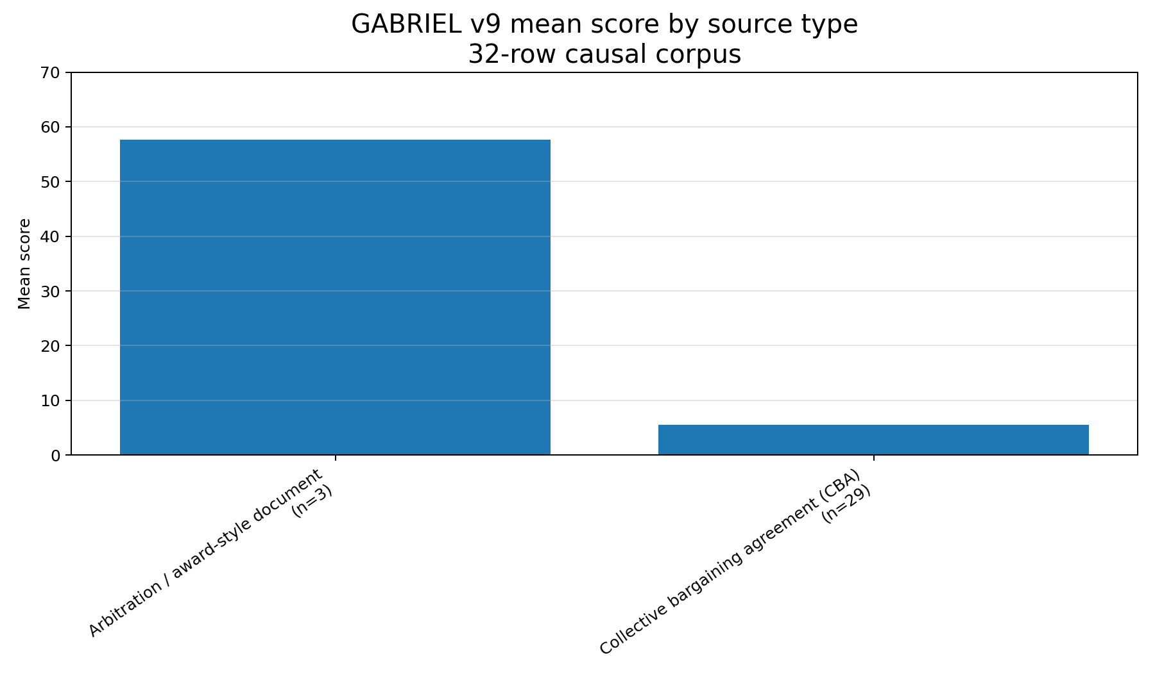
Figure 2. Mean GABRIEL v9 score by source type. Award-style sources contain much more explicit reasoning.
The top-document plot makes the pattern clear. The two highest-scoring documents are Somerville police arbitration awards. A single Arlington fire CBA is the highest-scoring ordinary CBA, based on outside-detail rate language, but most CBAs score far lower.
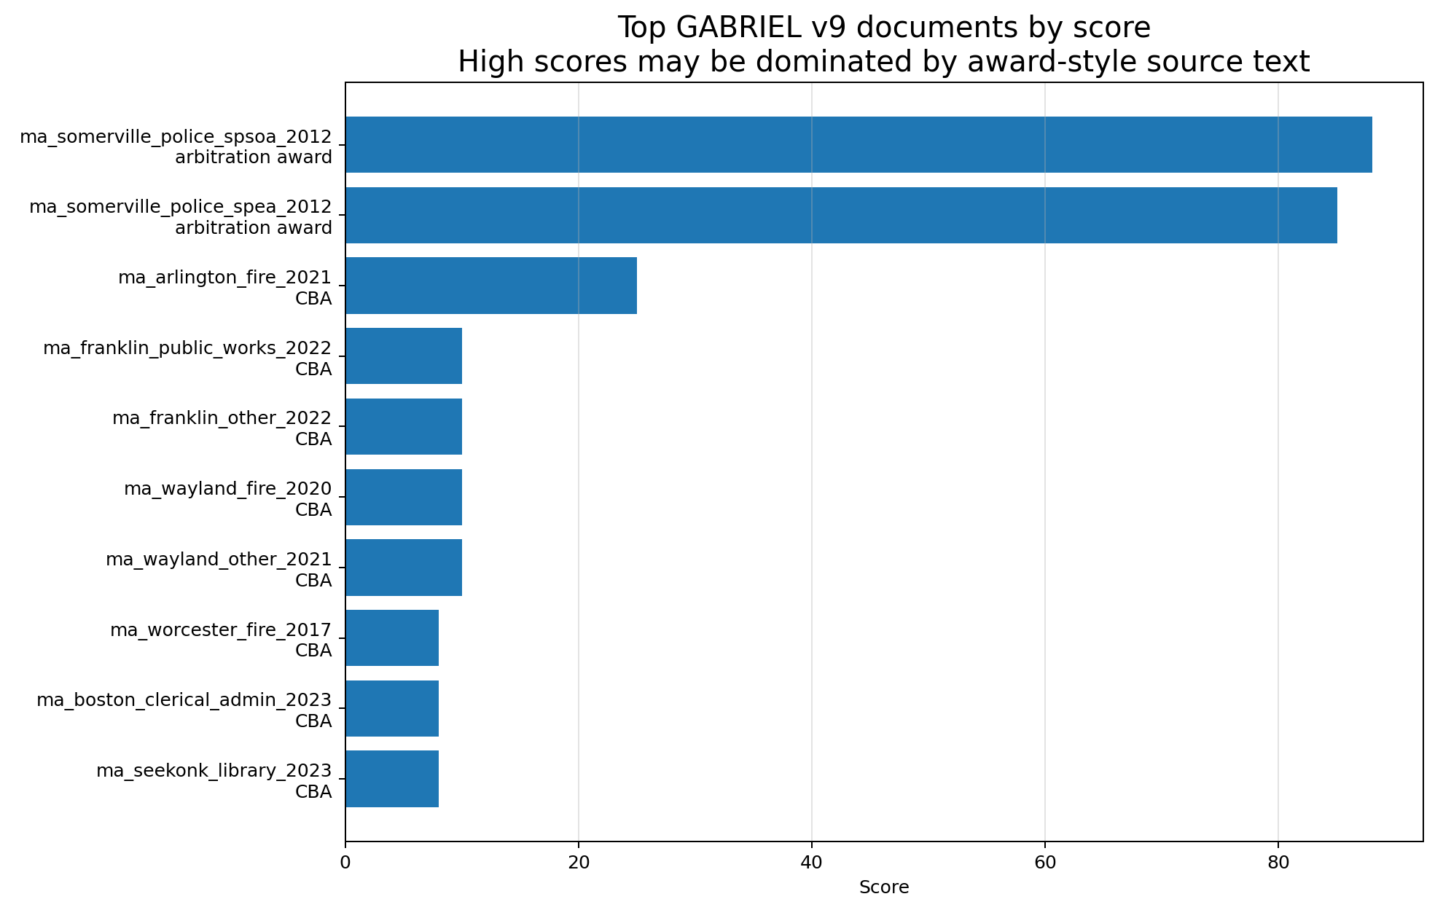
Figure 3. Top GABRIEL v9 documents by score. The largest scores are concentrated in award-style safety documents.

4. Distribution and CBA-only sensitivity
The all-row distribution has a low-score mass and two high-score outliers. Once arbitration-award rows are excluded, the distribution is compressed near the bottom of the scale. This is the cleanest visual evidence that the pooled safety/non-safety gap should not be read as a pure occupation effect.
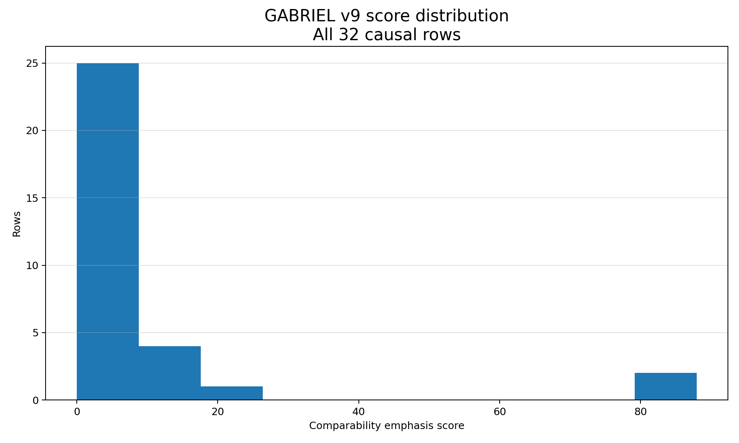
Figure 4. Score distribution across all 32 causal rows.
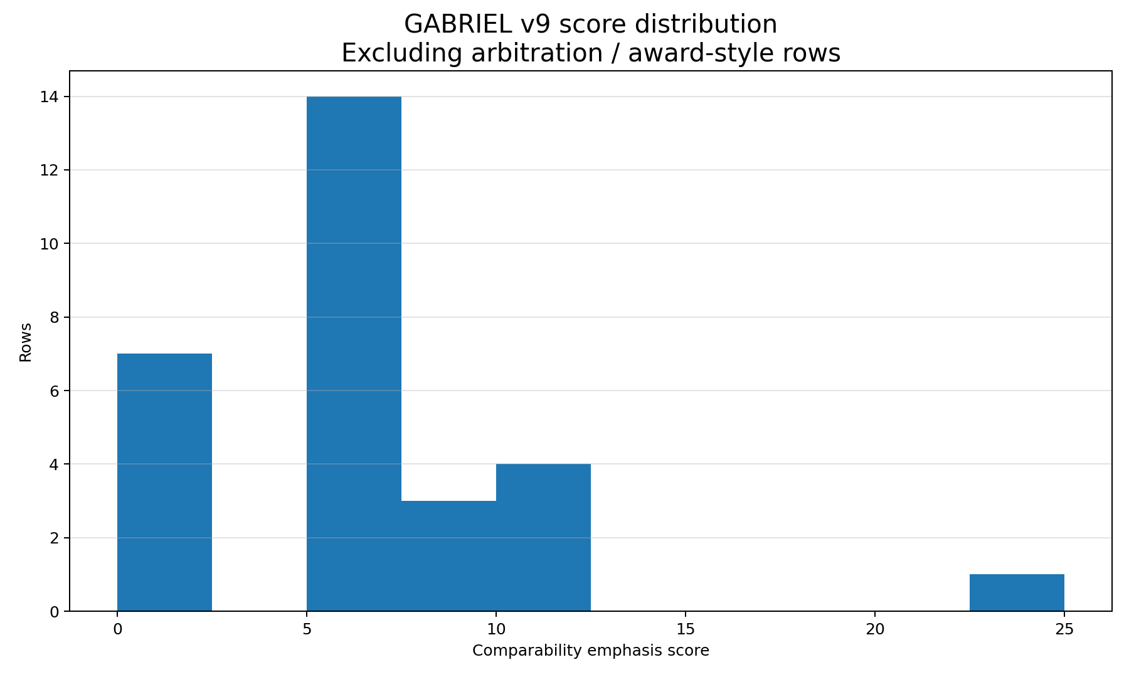
Figure 5. Score distribution after excluding arbitration and award-style rows.
The CBA-only safety/non-safety comparison is more modest. Safety CBAs still score somewhat higher than non-safety CBAs, but the difference is small relative to the award-vs-CBA gap. This keeps H1 alive, but it shifts the interpretation: the public CBA corpus alone does not yet show strong, widespread explicit comparability reasoning.
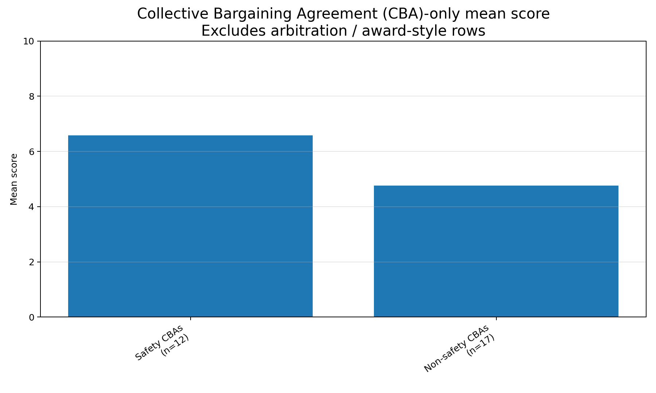
Figure 6. CBA-only mean score by safety status. The safety/non-safety gap shrinks after excluding awards.

5. City, occupation, and match-tier views
City-level results are dominated by Somerville because the corpus includes two high-scoring Somerville police arbitration awards. Franklin, Wayland, and Seekonk substantially improve matched coverage, but their ordinary CBA scores are mostly low.
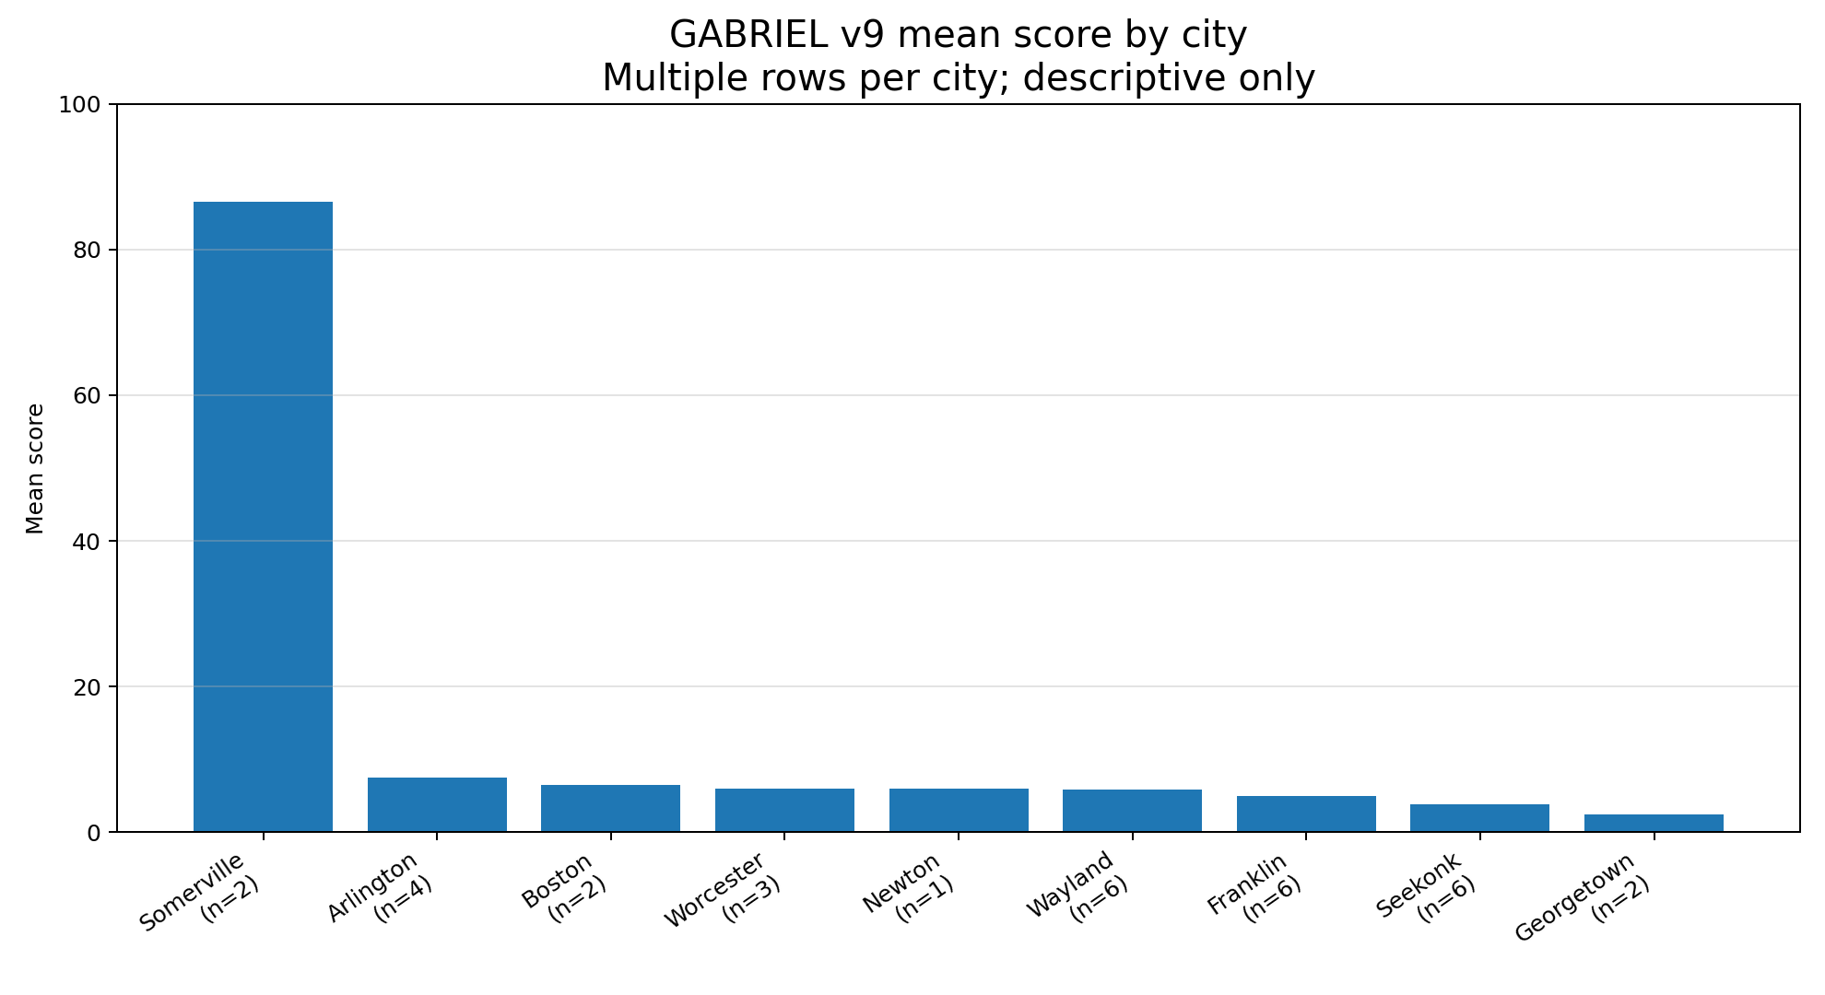
Figure 7. Mean score by city. Somerville is the clear outlier because of police arbitration awards.
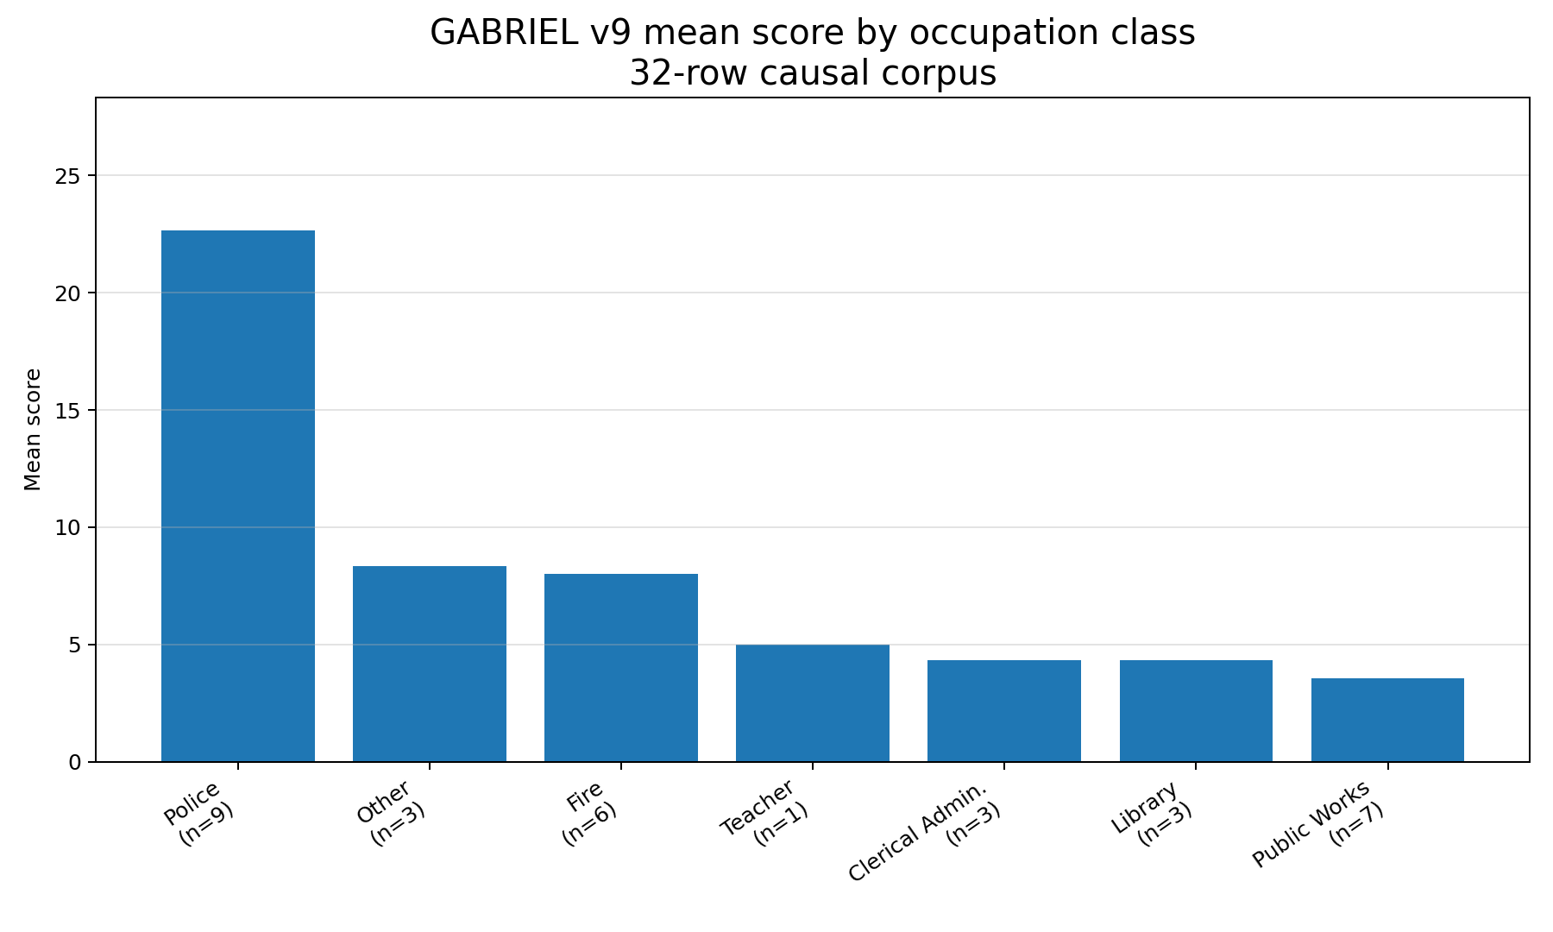
Figure 8. Mean score by occupation class. Police scores are highest, but source type is a major confounder.
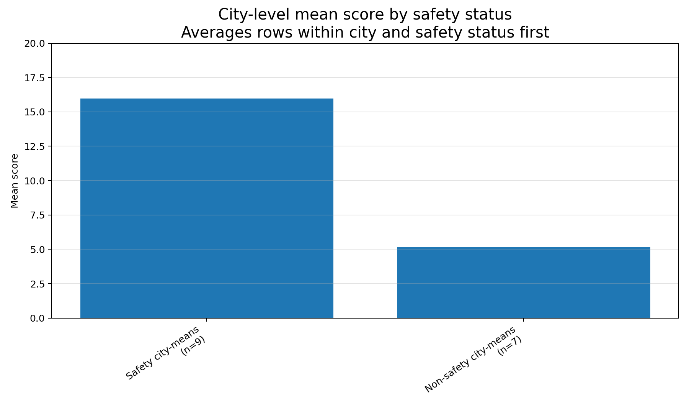
Figure 9. City-level mean score by safety status. This averages within city and safety status before comparing groups.
The match-tier plot compares exact-cycle and overlap-cycle safety rows. Exact-cycle safety rows score slightly higher on average, but both groups are small. Match tier is useful for reporting discipline, but it does not resolve the source-type issue.
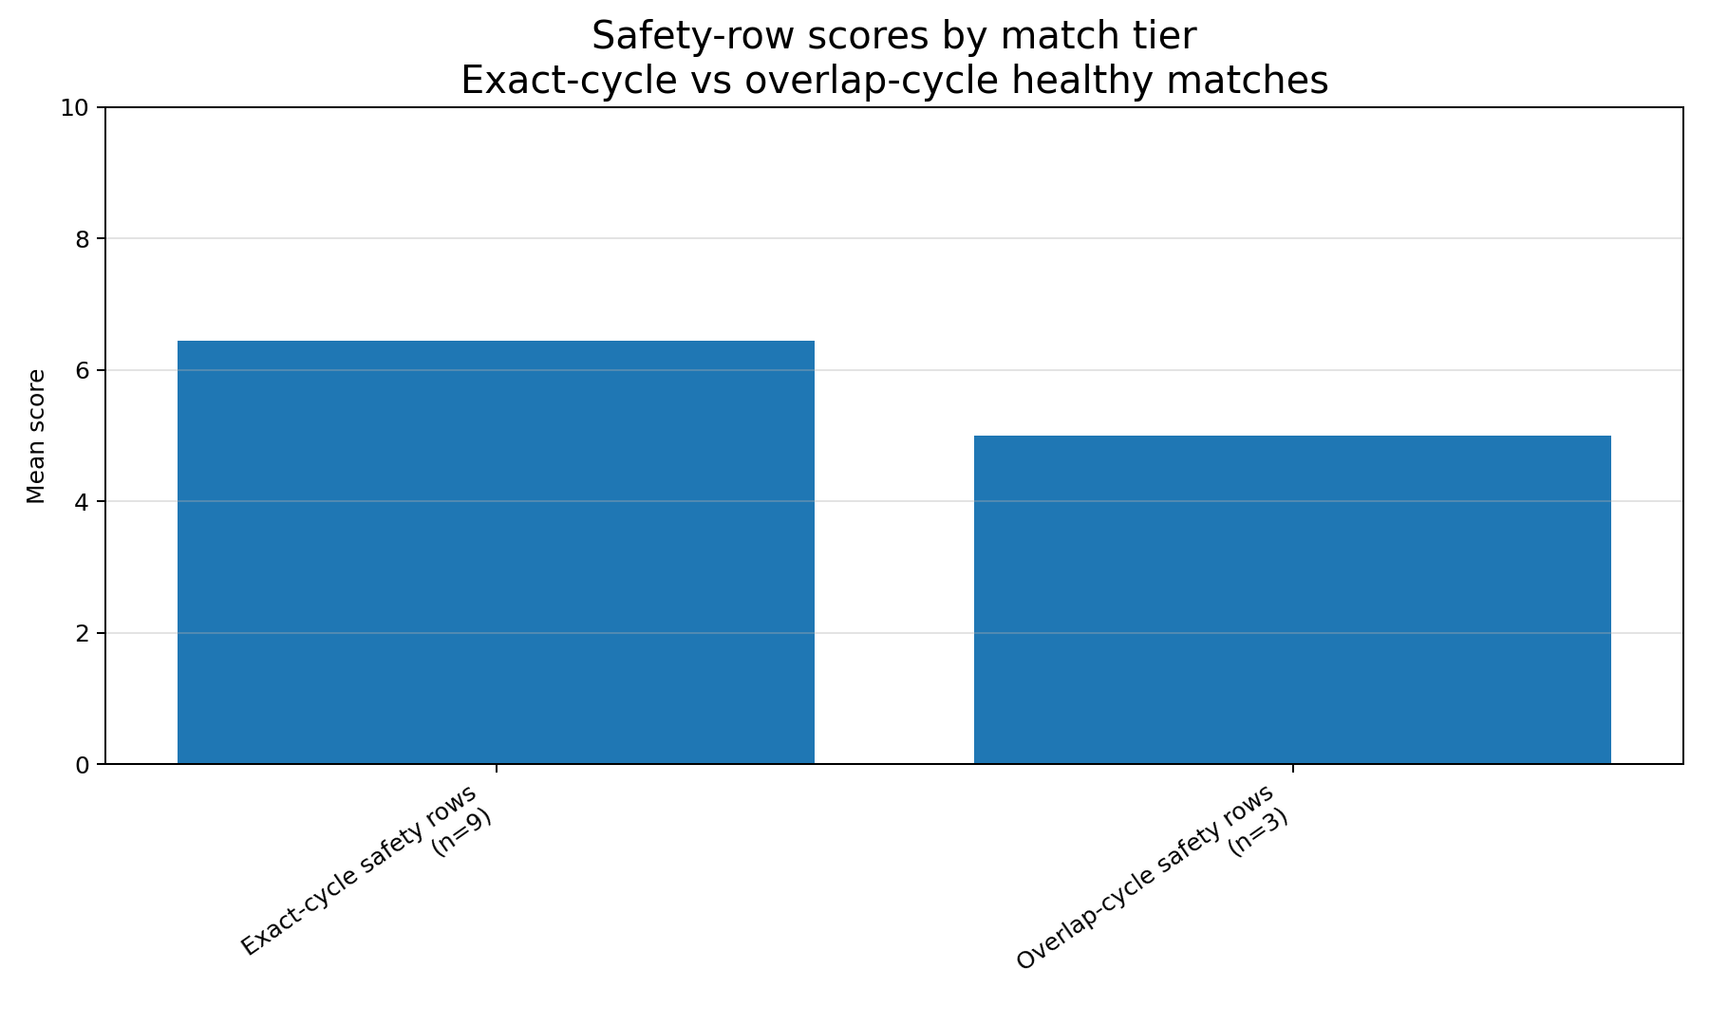
Figure 10. Safety-row scores by match tier.

6. Row-level summary and quote audit
The table below lists the highest-scoring documents. The key point is not just that police rows score high; it is that the highest scores occur in arbitration-award documents that explain reasoning in a way ordinary CBAs usually do not.
Document | City | Occupation | Safety status | Source type | Score | Relevant excerpts
ma_somerville_police_spsoa_2012 | Somerville | Police | safety | arbitration award | 88 | 5
ma_somerville_police_spea_2012 | Somerville | Police | safety | arbitration award | 85 | 4
ma_arlington_fire_2021 | Arlington | Fire | safety | CBA | 25 | 1
ma_franklin_public_works_2022 | Franklin | Public Works | non-safety | CBA | 10 | 0
ma_franklin_other_2022 | Franklin | Other | non-safety | CBA | 10 | 0
ma_wayland_fire_2020 | Wayland | Fire | safety | CBA | 10 | 0
ma_wayland_other_2021 | Wayland | Other | non-safety | CBA | 10 | 0

GABRIEL v9 identified 10 verified relevant supporting excerpts and 3 verbatim but irrelevant or ambiguous excerpts. Below are the pulled excerpts from the quote-audit file. In a larger corpus, repeated or highly similar excerpts should be sampled rather than reproduced one-by-one; at this stage, showing the full pulled excerpts helps explain what GABRIEL counted and what it rejected.
Document | City | Occupation | Safety status | Source type | Score | Quote classification | Estimated page
ma_somerville_police_spsoa_2012 | Somerville | Police | safety | arbitration award | 88 | Verified relevant support | 52
ma_somerville_police_spsoa_2012 | Somerville | Police | safety | arbitration award | 88 | Verified relevant support | 55
ma_somerville_police_spsoa_2012 | Somerville | Police | safety | arbitration award | 88 | Verified relevant support | 56
ma_somerville_police_spsoa_2012 | Somerville | Police | safety | arbitration award | 88 | Verified relevant support | 62
ma_somerville_police_spsoa_2012 | Somerville | Police | safety | arbitration award | 88 | Verified relevant support | 54
ma_somerville_police_spsoa_2012 | Somerville | Police | safety | arbitration award | 88 | Flagged: verbatim but not wage-comparability | 58
ma_somerville_police_spsoa_2012 | Somerville | Police | safety | arbitration award | 88 | Flagged: verbatim but not wage-comparability | 71
ma_somerville_police_spea_2012 | Somerville | Police | safety | arbitration award | 85 | Verified relevant support | 58
ma_somerville_police_spea_2012 | Somerville | Police | safety | arbitration award | 85 | Verified relevant support | 60
ma_somerville_police_spea_2012 | Somerville | Police | safety | arbitration award | 85 | Verified relevant support | 76
ma_somerville_police_spea_2012 | Somerville | Police | safety | arbitration award | 85 | Verified relevant support | 75
ma_somerville_police_spea_2012 | Somerville | Police | safety | arbitration award | 85 | Flagged: verbatim but not wage-comparability | 53
ma_arlington_fire_2021 | Arlington | Fire | safety | CBA | 25 | Verified relevant support | 20

ma_somerville_police_spsoa_2012 (Somerville; Police; Arbitration / award-style document)
Verified relevant support - estimated page 52
"The City argues that the wages and benefits of Somerville Superior Officers compare well with their counterparts in other comparable communities, and that Somerville Superior Officers rank at the top in terms of total compensation. The City states that this is due, not only to a high base salary, but also the generous benefits that are provided to the Superior Officers."
Verified relevant support - estimated page 55
"In the Police Arbitration Award the Panel decided to review a listing of comparable communities that was utilized by the Collins Center for Public Management at the University of Massachusetts, when conducting a classification and compensation study for the City’s non- union positions. Those communities chosen in the Collins Center classification study were Arlington, Brookline, Cambridge, Lowell, Malden, Melrose, Newton, Quincy, and Waltham."
Verified relevant support - estimated page 56
"The evidence further demonstrates that the overall compensation (including wages and benefits) provided to Somerville Police Superiors, although not the same, is comparable to what is provided to police superiors in these other communities. In fact the total compensation for Somerville Police Superiors is above the average provided in the comparable communities."
Verified relevant support - estimated page 62
"The chart below shows longevity payments for comparable communities. Community 5 YRS 10 YRS 15 YRS 20 YRS 25 YRS 30 YRS"
Verified relevant support - estimated page 54
"Specifically, the Union asserts that the proper benchmark, as provided by the arbitration law, is wages and benefits paid to comparable employees, which means it is more appropriate to look at wages and benefits provided to other superior police officers not civilian employees working in the City."
Flagged: verbatim but not wage-comparability - estimated page 58
"The Panel Awards wage increases for the six-year period as follows: FY 2013 – 2.5% FY 2014 – 2% FY 2015 – 2% FY 2016 – 2% FY 2017 – 2.5% FY 2018 – 2.5%"
Flagged: verbatim but not wage-comparability - estimated page 71
"Discussion Patrol Officers now receive a higher weekend differential rate than Superior Officers. It is appropriate and reasonable that Superior Officers receive the same weekend differential. Accordingly, the weekend differential rates for Superior Officers should be increased to $7.00 for day differential and $6.50 for the weekend night differential. This increase shall be effective June 30, 2018."

ma_somerville_police_spea_2012 (Somerville; Police; Arbitration / award-style document)
Verified relevant support - estimated page 58
"The Union argues that its list of comparables is smaller and more appropriate. Specifically, the Union contends that Boston should be considered as comparable due to its close proximity, its population density, and the fact that it is faced with similar urban policing concerns. The Union argues that a review of its comparable communities shows that wages and benefits of Somerville Patrol Officers lag behind what is provided in these other communities."
Verified relevant support - estimated page 60
"The wage adjustments in surrounding communities for the relevant time period show that the wage increases proposed by the City are in line with the wage increases agreed to in these surrounding communities. Moreover, the evidence also demonstrates that the overall compensation (including wages and benefits) provided to Somerville Police, although not the same, is comparable to what is provided to police officers in these other communities."
Verified relevant support - estimated page 76
"The chart below shows longevity payments for comparable communities."
Verified relevant support - estimated page 75
"There is insufficient justification to grant the Union’s proposal. It is true that other Police Departments in the list of comparable communities provide additional financial recognition for the hazards of being a police officer. This is also the current situation for Somerville Police Officers who receive an annual Weapons of Mass Destruction stipend, and also a separate payment for weapons qualification; both stipends pertain to the unique duties and responsibilities of being a police officer."
Flagged: verbatim but not wage-comparability - estimated page 53
"In reaching the conclusions in the present award, the Arbitration Panel has considered the criteria set forth in the statute including the municipality's ability to pay, wages and benefits of comparable towns, and the cost of living."

ma_arlington_fire_2021 (Arlington; Fire; Collective bargaining agreement (CBA))
Verified relevant support - estimated page 20
"f) Any outside detail assignment outside the borders of the Town of Arlington shall be paid at that city’s or Town’s outside detail rate consistent with current practice at the time this provision is agreed to. Any rules governing such outside details will be determined by the city or town in which the detail is performed."

7. Interpretation
Headline interpretation
The report supports a cautious descriptive conclusion: explicit peer-community wage comparability is highly visible in safety-side arbitration and award-style documents, but much less visible in ordinary CBAs. H1 remains plausible, but the current public-source evidence cannot yet distinguish a police/fire occupation effect from a source-type or document-production effect.

The current evidence strengthens the project in two ways. First, it shows that the GABRIEL pipeline can recover substantively meaningful comparability language when that language is present in the document. Second, it clarifies the main identification problem: non-safety reasoning documents comparable to the Somerville and Wayland safety-side award material remain scarce in the public-source corpus.
The report also cautions against treating CBA or MOA silence as evidence that comparability did not matter. CBAs and MOAs often record final wage terms without spelling out the arguments that led to those terms. Arbitration awards, Joint Labor-Management Committee (JLMC) awards, factfinding reports, and some public meeting packets are more likely to record the reasoning layer.

8. Recommended next steps
- Prioritize mechanism-source search over broad ingestion. Newton, Somerville, and Boston remain the highest-value targets for public school committee packets, bargaining exhibits, settlement memoranda, or factfinding-like documents.
- Use v10 to test one additional institutional attribute after quote review. The leading candidate is arbitration_or_impasse_backstop, because v9 suggests source type and dispute-resolution institutions are central.
- Continue official-portal ingestion selectively. More public CBAs help robustness, but new CBA rows are less valuable than non-safety reasoning documents unless they add new cities or clean exact-cycle matches.
- Keep public-records requests (PRRs) deferred unless the principal investigator changes preference. The public-only path is still productive, but it should be presented as source-limited.
- Prepare a PI-facing short memo from this report. The message should be high-level: the measurement pipeline works, the first descriptive pattern is real, and the next bottleneck is non-safety reasoning evidence.

Appendix A. Summary tables

A1. Source-type summary
Source type | Rows | Mean | Median | Max | Rows > 0 | Rows with verified relevant excerpts
Arbitration / award-style document | 3 | 57.67 | 85 | 88 | 2 | 2
Collective bargaining agreement (CBA) | 29 | 5.52 | 5 | 25 | 22 | 1

A2. Safety summary
Safety status | Rows | Mean | Median | Max | Rows > 0 | Rows with verified relevant excerpts
Non-safety | 17 | 4.76 | 5 | 10 | 12 | 0
Safety (police/fire) | 15 | 16.80 | 5 | 88 | 12 | 3

A3. Occupation summary
Occupation | Rows | Mean | Median | Max | Rows > 0 | Rows with verified relevant excerpts
Clerical Admin. | 3 | 4.33 | 5 | 8 | 2 | 0
Fire | 6 | 8 | 6.50 | 25 | 4 | 1
Library | 3 | 4.33 | 5 | 8 | 2 | 0
Other | 3 | 8.33 | 10 | 10 | 3 | 0
Police | 9 | 22.67 | 5 | 88 | 8 | 2
Public Works | 7 | 3.57 | 5 | 10 | 4 | 0
Teacher | 1 | 5 | 5 | 5 | 1 | 0

A4. City summary
City | Rows | Mean | Median | Max | Rows > 0 | Rows with verified relevant excerpts
Arlington | 4 | 7.50 | 2.50 | 25 | 2 | 1
Boston | 2 | 6.50 | 6.50 | 8 | 2 | 0
Franklin | 6 | 5 | 5 | 10 | 4 | 0
Georgetown | 2 | 2.50 | 2.50 | 5 | 1 | 0
Newton | 1 | 6 | 6 | 6 | 1 | 0
Seekonk | 6 | 3.83 | 5 | 8 | 4 | 0
Somerville | 2 | 86.50 | 86.50 | 88 | 2 | 2
Wayland | 6 | 5.83 | 5 | 10 | 5 | 0
Worcester | 3 | 6 | 5 | 8 | 3 | 0

