Here is an example Output of the program.

Validate User Input

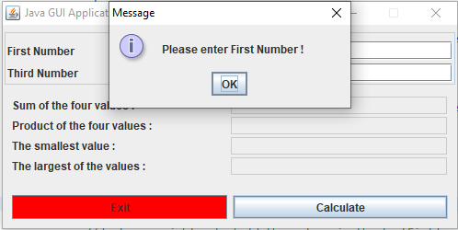

Results after entering 4 integers

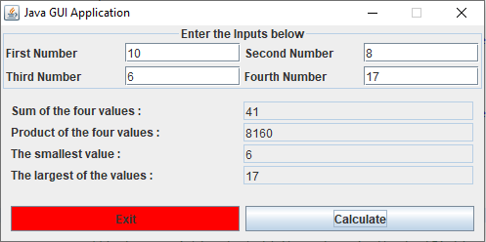

Cancel button exits the application