# 配置hibernate

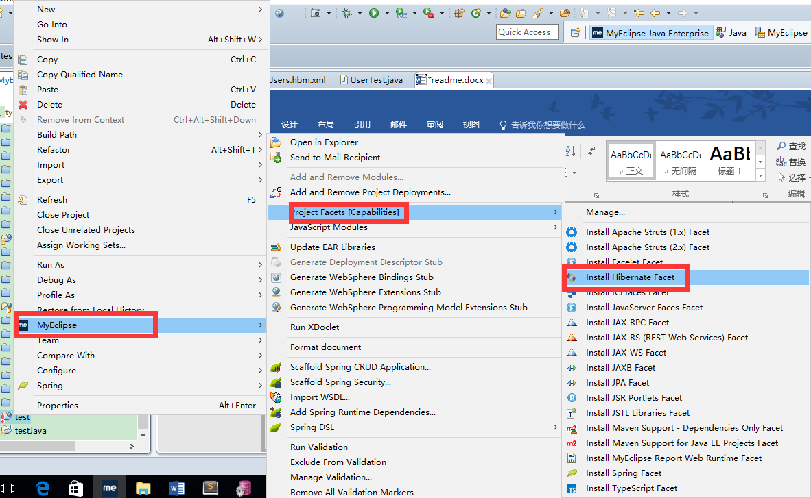

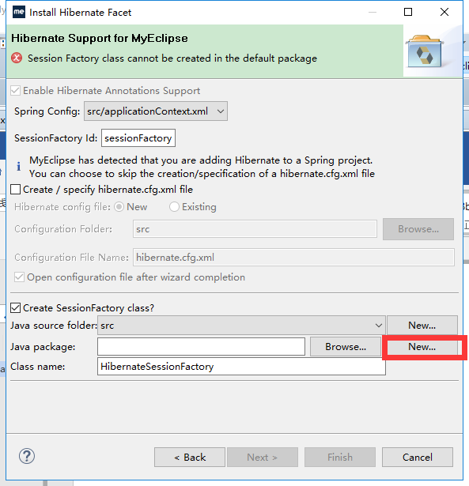

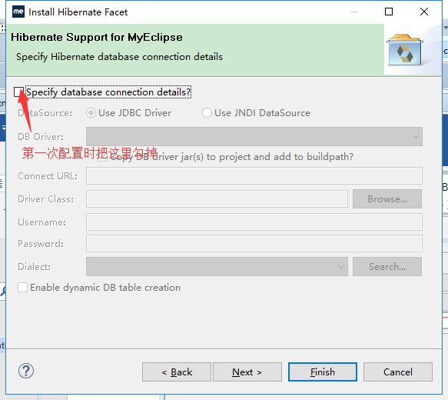

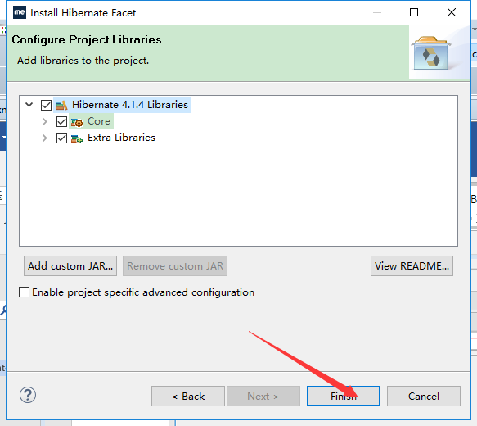

第一次配置要配置通用数据库

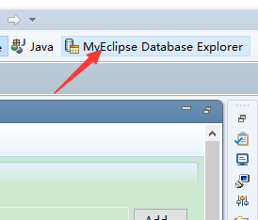

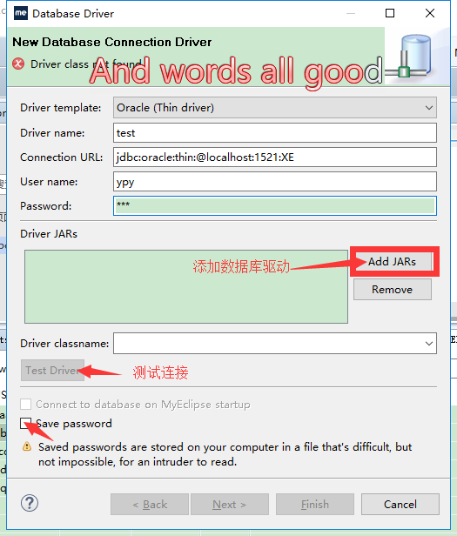

配置完数据库后与项目进行连接

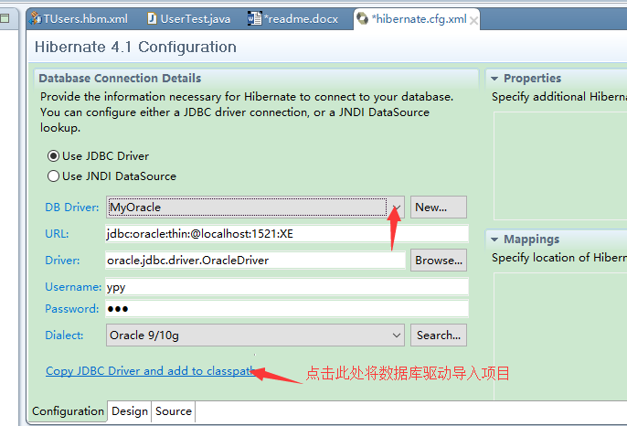

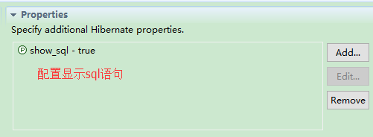

配置自动生成pojo

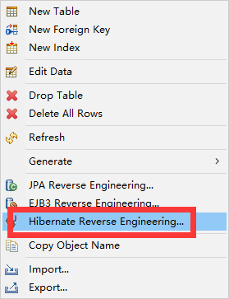

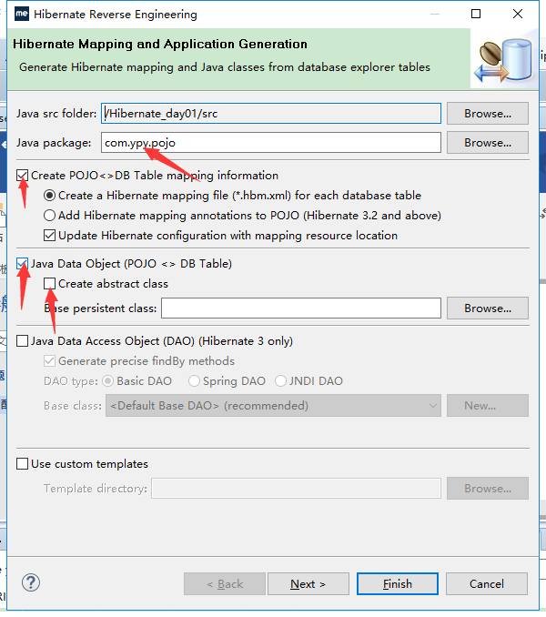

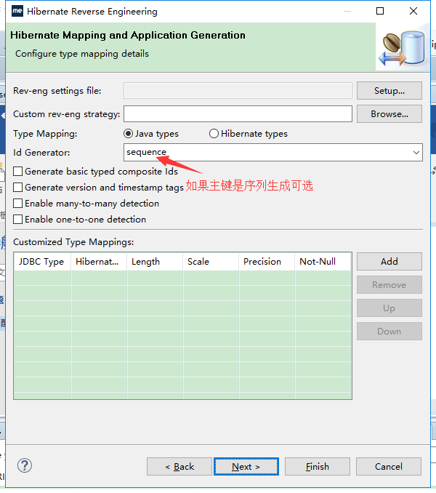

配置完再生成的映射文件中

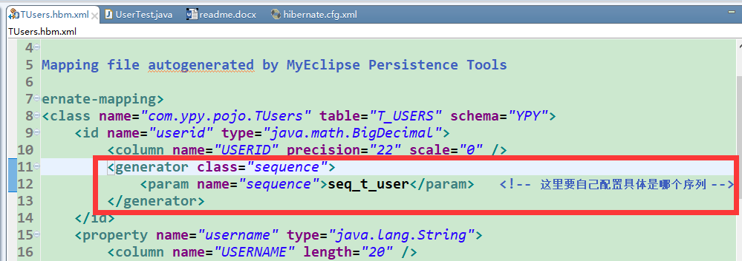

配置测试类：

**package** com.ypy.tets;

**import** org.hibernate.Session;

**import** org.hibernate.SessionFactory;

**import** org.hibernate.Transaction;

**import** org.hibernate.cfg.Configuration;

**import** org.hibernate.service.ServiceRegistry;

**import** org.hibernate.service.ServiceRegistryBuilder;

**import** org.junit.Test;

**import** com.ypy.pojo.TUsers;

**public** **class** UserTest {

@Test

**public** **void** test() {

TUsers user = **new** TUsers();

user.setUsername("hibernate测试");

//1.读取配置文件

Configuration cfg = **new** Configuration().configure("hibernate.cfg.xml");

//2.获取sessionFactory对象

ServiceRegistry serviceRegistry = **new** ServiceRegistryBuilder().applySettings(cfg.getProperties()).buildServiceRegistry();

SessionFactory factory = cfg.buildSessionFactory(serviceRegistry);

//3.获取session对象

Session session = factory.openSession();

//4.获取事务管理器

Transaction transaction = session.beginTransaction();

**try** {

session.save(user);

transaction.commit(); //进行事务提交

} **catch** (Exception e) {

transaction.rollback(); //出错后事务回滚

}

session.close();

}

}

注：使用hibernate 表必须有主键