Filename: fir.vhd
Dependencies: none
Actual version: 1.0

Interface definition:

Generic Name | Type | Description
fir_order | natural | filter order
fir_coeff | fir_coeff_t | signed Q26 format

Port Name | Type | Description
clk | Input (std_logic) | system clock
stb | Input (std_logic) | input data strobe
d | Input (signed) | data input in Q26
q | Output (signed) | data output in Q26
rdy | Output (std_logic) | output data strobe

design structure:
0
1
x
+
IN
OUT
COEFF

Design test:

test enviroment: ghdl + matlab

test discription:
It will be tested for amplitude and phase errors.
The filter will be applied to two different channels. One stimulated with a sinus wave and the other stimulated with the orthogonal cosine wave. The two output signals forms a complex signal which will be analysed. In addition each channel consists of two different waves. One wave in the passband and one in the stopband of the filter.

DUT
X(t)
Y(t)

I channel:
Q channel:
with
filter characteristic:

The complex output signal consists of one signal with a positive frequency on the position +10kHz. The signal with the positive frequency +20kHz should be suppressed. In the FFT plot there must no image frequencies.

The result of the MATLAB reference implementation(firf.m in directory test):
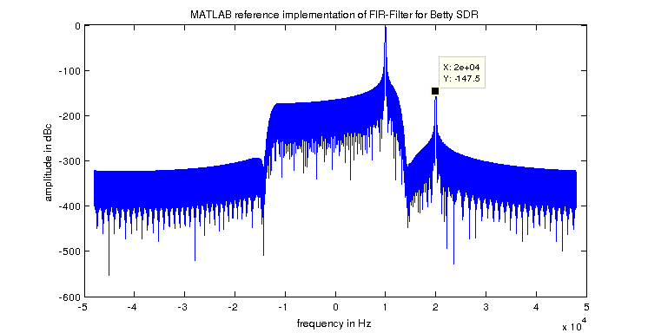

An example of 5% amplitude error:
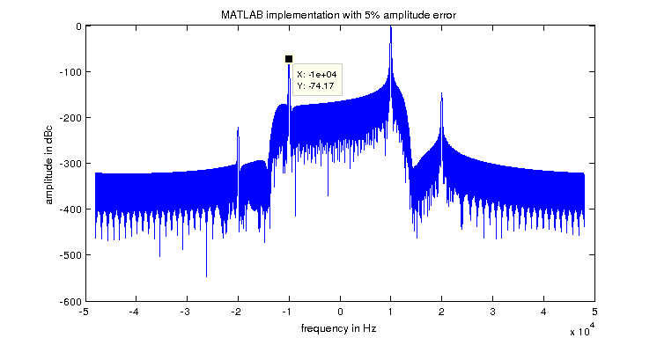
The result of the VHDL implementation:

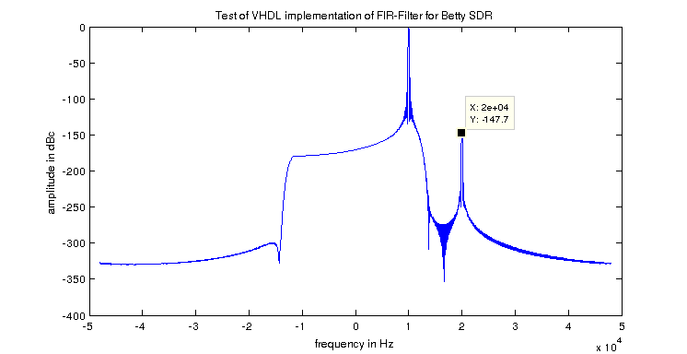

Test result:

The spectrum of the output signal of the VHDL implementation shows no image frequency and has a perfect suppression of the signal in the stopband.
The Test is passed by the VHDL implementation.

