Geospatial Data in R – Workshop Prep

Open the following web page in a web browser

https://github.com/dlab-geo/r-geospatial-workshop

Click the green **Download** link and download the workshop files as a zip file

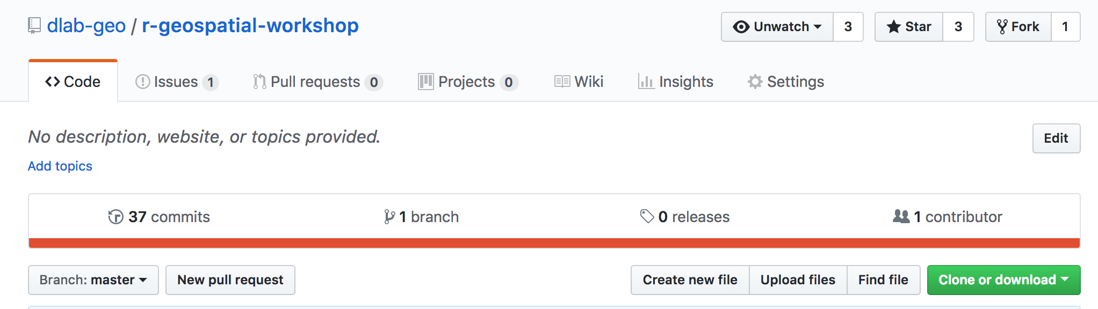

Unzip the zip file and make a note of the folder in which it is located

Open **RStudio** and then open a new script

Set your RStudio working directory to the folder in which your unzipped files are located



Install required libraries by typing or copying the following lines of code in RStudio. Only install the libraries that you don’t already have installed.

install.packages(

c("sp","rgdal","tmap","classInt","RColorBrewer",

"ggplot2","leaflet", "ggmap"), dependencies=TRUE

)

You only need to install a library once, but you need to load the library every time you start a new RStudio session in which you use it. So, load those libraries now:

Follow along by opening the file **r-geospatial-workshop-pt1.html** in a browser window

Just double-click on it to open it in a browser

**Slides:** r-geospatial-workshop-pt1.html

Or

**Tutorial:** r-geospatial-workshop-pt1-tutorial.html

Check to make sure that you can copy and paste from the above html file into your RStudio script

If you cannot, open the following script file so that you can copy and paste from it if you don’t want to type out the commands we use today

**Raw Code:** scripts/r-geospatial-workshop-pt1.R