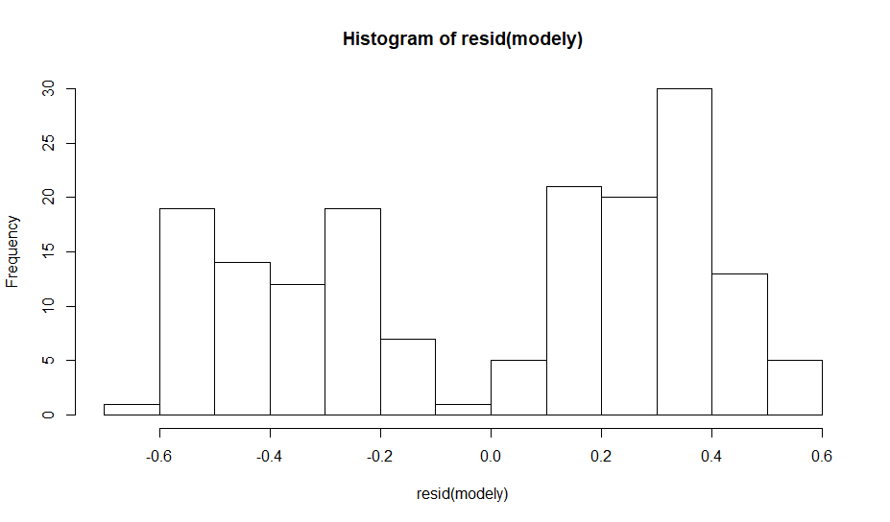

-not normal

modely<-lm((Ammo)~SoilMoisture+Ca2012,data = structural)

> hist(resid(modely))

Without treatment:

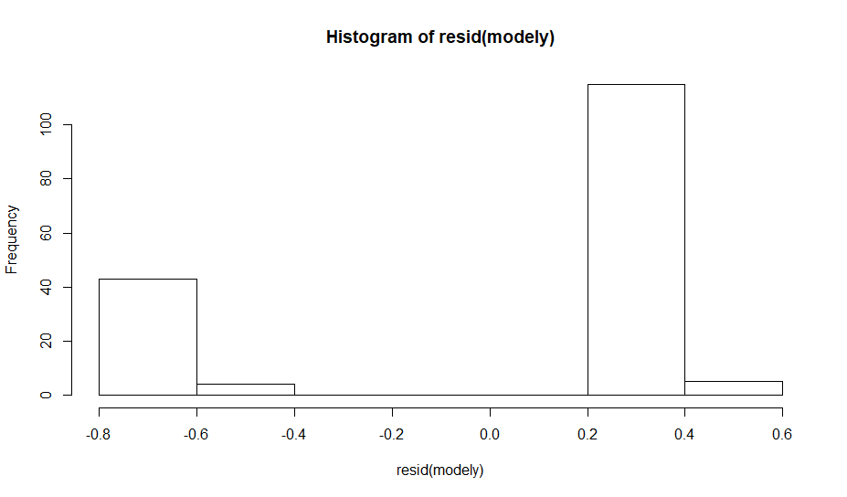

Linked plots:

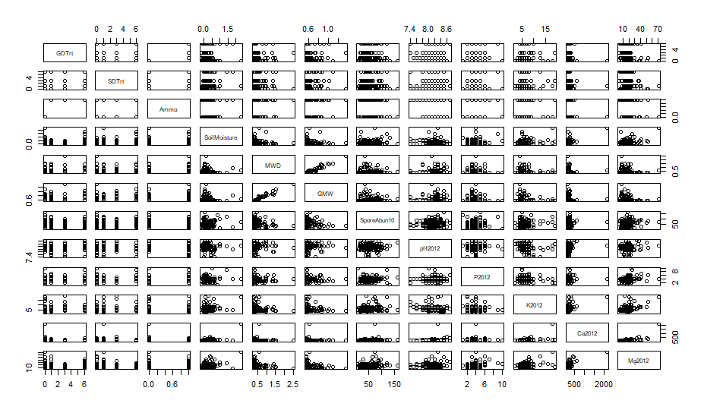

-without GDtrt,SDTrt, and Ammo:

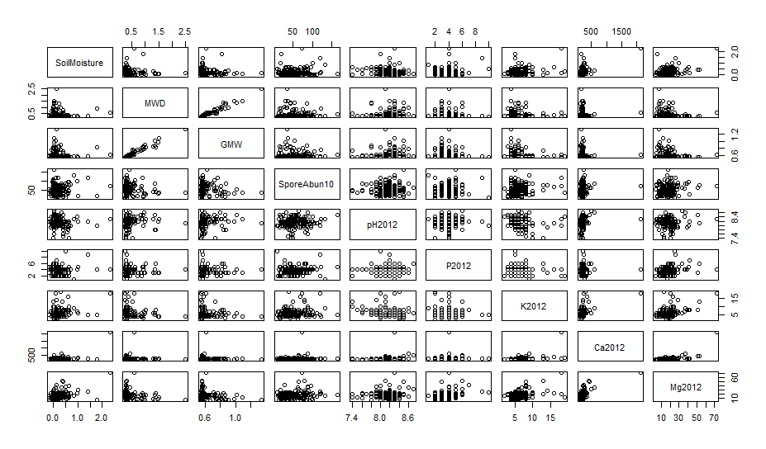

-MWD,GMW have linear increasing association.

-MWD and Mg2012 have inverse relationship.

-GMW AND MG2012 decreasing.

\*\* after getting rid pf two outliers from calcium: #71 ,56 and 22

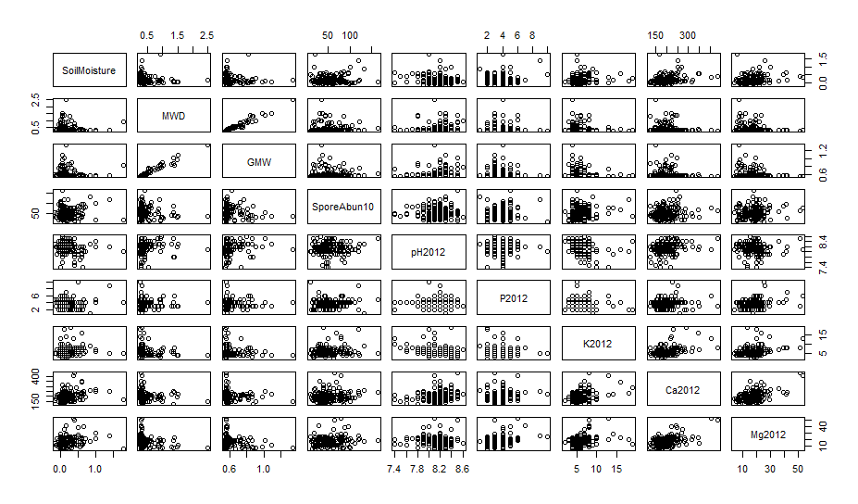

->modely<-lm((Ammo)~SoilMoisture+Ca2012+GDTrt,data = datawithout71)

anova(modely)

hist(resid(modely))

* 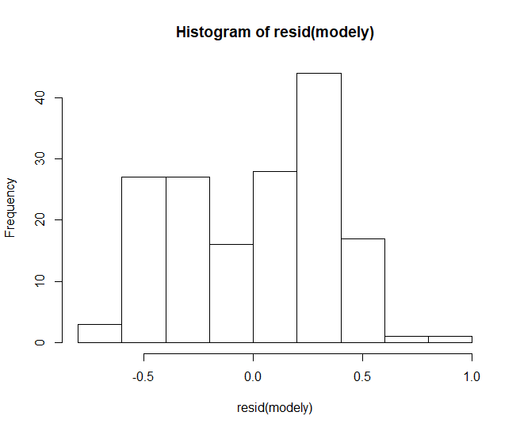
* Looks slightly normal
* Qqnorm(resid(modely))

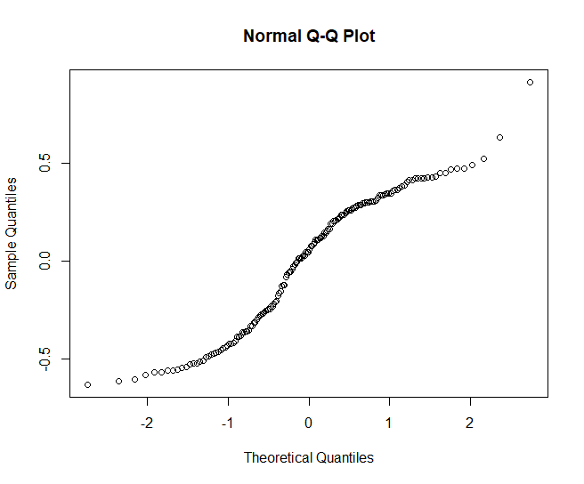

> shapiro.test(resid(modely))

Shapiro-Wilk normality test

data: resid(modely)

W = 0.9449, p-value = 5.25e-06

Covariance matrix:

> research.m = data.matrix(datawithout71[c(10,11,12,22,23,24,25,26)])

> cov(research.m)

SoilMoisture MWD GMW pH2012 P2012 K2012 Ca2012 Mg2012

SoilMoisture 0.067829856 -0.004495105 -0.001349663 -0.007359115 0.016050271 0.09245008 3.889187 0.35860479

MWD -0.004495105 0.090016037 0.032774870 0.007646399 -0.006119580 -0.10090981 -1.012185 -0.57975691

GMW -0.001349663 0.032774870 0.012492680 0.003238589 -0.004386212 -0.03990418 -0.350132 -0.22202464

pH2012 -0.007359115 0.007646399 0.003238589 0.045692054 -0.004399222 -0.12852013 2.251863 -0.09335628

P2012 0.016050271 -0.006119580 -0.004386212 -0.004399222 1.446356427 -0.16115517 2.080952 2.98009876

K2012 0.092450083 -0.100909805 -0.039904176 -0.128520126 -0.161155170 5.82088882 50.849170 5.47688164

Ca2012 3.889186884 -1.012185255 -0.350132036 2.251862936 2.080951668 50.84916953 2319.062846 190.14843633

Mg2012 0.358604787 -0.579756914 -0.222024637 -0.093356277 2.980098758 5.47688164 190.148436 57.18868772

> cor(research.m)

SoilMoisture MWD GMW pH2012 P2012 K2012 Ca2012 Mg2012

SoilMoisture 1.00000000 -0.05752670 -0.04636466 -0.13218885 0.05124297 0.14713033 0.31009310 0.18207511

MWD -0.05752670 1.00000000 0.97735702 0.11922756 -0.01695993 -0.13940514 -0.07005575 -0.25552355

GMW -0.04636466 0.97735702 1.00000000 0.13555256 -0.03263053 -0.14797757 -0.06505007 -0.26267473

pH2012 -0.13218885 0.11922756 0.13555256 1.00000000 -0.01711267 -0.24920465 0.21875871 -0.05775214

P2012 0.05124297 -0.01695993 -0.03263053 -0.01711267 1.00000000 -0.05554077 0.03593090 0.32767094

K2012 0.14713033 -0.13940514 -0.14797757 -0.24920465 -0.05554077 1.00000000 0.43765607 0.30018130

Ca2012 0.31009310 -0.07005575 -0.06505007 0.21875871 0.03593090 0.43765607 1.00000000 0.52213335

Mg2012 0.18207511 -0.25552355 -0.26267473 -0.05775214 0.32767094 0.30018130 0.52213335 1.00000000

* GMW and MWD strong positive