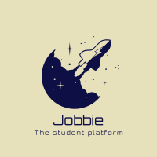

Jobbie

Project plan

Dimitar L. | S-ESE6-CMK | 20.03.2022

# Version History

|  |  |  |  |  |
| --- | --- | --- | --- | --- |
| **Version** | **Date** | **Author** | **Changes** | **State** |
| 1.0 | 15.03.2022 | Dimitar Lalev | Start | In progress |
| 1.1 | 17.03.2022 | Dimitar Lalev | Added Repository | In progress |
| 2.0 | 08.05.2022 | Dimitar Lalev | Decision making | In progress |

# Distribution

|  |  |  |
| --- | --- | --- |
| **Version** | **Date** | **Receivers** |
| 1.0 | 20.03.2022 | Fontys |
| 2.0 | 08.05.2022 | Fontys |
|  |  |  |

Table of Contents

Version History 1

Distribution 1

Introduction 3

Project assignment 3

context 3

Goal of the project 3

Functionality description 4

Scope and preconditions 6

Strategy 6

Research questions and methodology 6

Project organization 8

stakeholders and team members 8

Communication 8

Activities and time plan 8

Time plan and milestones 8

Risk 9

Risk and mitigation 9

Glossary 10

Repository 10

# Introduction

This project plan is made as part of my studies for Fontys University of Applied Science and the document is going to show my plan for the individual project and will describe my goals and achievements of the sprints. This plan will also include the phases of the individual project and for each phase what deliverables can add value to the project.

The goals that I want to reach with this plan are to make the main purpose and goal clear for me and my teachers.

# Project assignment

## context

The project is related to creating an enterprise software and practicing my software development skills and to demonstrate that I am capable of creating enterprise software on my own.

We were given the opportunity to define our own cases for the individual project in consultation with the teachers. Examples like Netflix, Spotify, YouTube, Facebook and Twitter were given.

When defining the individual project case, I started with reading all learning outcomes. Also thought about how I wanted to demonstrate the learning outcomes via the individual project. Furthermore, I included the challenges that I want to take up in my project and also will define them by defining non-functional requirements. The individual project should be fully functional and thoroughly tested.

We were given also a default case, which I changed a bit and used as my base.

## Goal of the project

The reason for choosing this type of project is that I wanted to make something different and at the same time to be able to cover all of the learning outcomes. The focus is on creating an enterprise software on my own and cover the requirements.

The goal of the platform is to exchange text-based messages of at most 100 characters and to find a job for students as an optional case. The functionalities are described further in the document. The perfect case scenario is to cover the requirements for the default case Kwetter and add some additional functions like creating, publishing and reading a job.

## Functionality description

|  |  |  |
| --- | --- | --- |
| **Function** | **Description** |  |
| Profile picture profile name | Profile picture and name of the user |  |
| Profile details | User details: description about the user, location – City, Country, website description is limited to 160 characters |  |
| Own posts | 10 most recent posts by this user |  |
| Followers | Other users following this user.  By clicking followers, a list of followers appears instead of jobs and posts table. |  |
| Following | Other users followed by this user.  After clicking one of the links in Following, information of the user is opened in new tab. |  |
| Jobs accepted | Other user can see the jobs that you have accepted and done.  By clicking jobs accepted in your jobs , a list of jobs appears. | Optional |
| Jobs published | Other user can see the jobs that you have published and done.  By clicking jobs accepted in your jobs , a list of jobs appears. | Optional |
| Stars | Users can add a stars to the job of another user. A user can give at most five stars and least 1 star to each job accepted. | Optional |
| Search | Search within all jobs available. Results will be shown in the timeline tab. |  |
| What’s happening? | Textbox to enter your post or job with a maximum of 140 characters. The job/post will be shown immediately under 'Your posts. |  |
| Timeline | Timeline of jobs published from the user and from other users. |  |
| @Mentions | Posts mentioning the user appear in this tab. It is possible to mention another user by adding @username in the post. |  |
| Following/ followers | After clicking on either the following or followers link, the profile page appears. |  |
| Trends | Clicking on one of the trends results in list of jobs in the timeline tab. These jobs are at most one week old and contain a hashtag followed by the selected trend. |  |
| Jobs available | After clicking on the jobs available window, all the available jobs are listed and you can accept the job by clicking it. |  |
| Logout | After clicking logout the profile page appears. It is then possible to login as a different user. |  |
| Login | After clicking login and providing credentials, the starting page appears filled with tweets and other information for the user that is logged in. |  |
| Register | After clicking register, the user provides name, location, bio up to 160 characters and profile picture. |  |

Registration:

Create a registration form for new users.

Moderation:

Create a page for users with the role of moderator. Moderators can see a list of users and their roles. They can remove users who spread insulting posts or jobs or use swear words. In addition, moderators can change the role of other users to moderator.

Administration:

An administrator can add or remove accounts of other users and may change the roles of other users.

## Scope and preconditions

|  |  |
| --- | --- |
| **Inside scope** | **Outside scope** |
| Research about enterprise software and how to achieve the goals |  |
| Implementing the enterprise software |  |
| Relevant to the project articles and planning the phases |  |

## Strategy

The strategy for the semester is to work on the individual project on Mondays, since we do not have any lessons then. The idea is to meet with the technical teachers on Fridays and receive feedback on what needs to be added or removed and what could be improved. It is nice that we are able to meet the teachers in person to ask questions and receive feedback directly.

The process is not mandatory to be tracked by the teachers, but is recommended to have meetings with them to know if I need to catch up or I am going fine with the flow. I am planning to use the scrum strategy, because I start with planning the upcoming weeks first. This is done in the first week of the sprint, where I can ask questions and focus on what tasks needs to be done and what I am expected to deliver. In the beginning of the sprints I need to make sure that I have proper planning for the sprint and what are my goals for the sprint. In other words I need to set expectations for the final result.

During the second and third week of the sprint I will be working on the goals that I set in the first week of the sprint. The work will be done in those two phases. There will be tasks that require more time than one sprint. But they will be divided into smaller ones.

My final deadline is in week 16 and is when I need to deliver everything.

## Research questions and methodology

Main research question is bolded and the sub questions are below:

* **How to cover all learning outcomes and what are the challenges of creating an enterprise software?**
* What are the best practices for creating an enterprise software?
  + Field method:
    - Document analysis
    - Problem analysis
    - Task analysis
  + Lab method:
    - Security test
    - Unit test
* What tools, techniques am I going to use for developing enterprise software?
  + Library method:
    - Community research
    - Best, good and bad practices
* How to integrate security by design in enterprise software?
  + Library method:
    - Community research
    - Best, good and bad practices
  + Field method:
    - Document analysis
    - Task analysis
* Is there any example on the open-market for enterprise software and can I use it to improve my enterprise software?
  + Library method:
    - Community research
    - Best, good and bad practices
* Strengths and weaknesses of the enterprise software ?
  + Library method
    - Literature study
    - Community research
  + Field method:
    - Document analysis
* How to handle such a big data?
  + Library method:
    - Community research
    - Best, good and bad practices
* How to divide services into microservices?
  + Library method:
    - Community research
    - Best, good and bad practices

# Project organization

## stakeholders and team members

|  |  |  |  |
| --- | --- | --- | --- |
| **Name** | **Abbreviation** | **Role and functions** | **Availability** |
| Pu,Xuemei | X. Pu | Technical teacher | Friday |
| Snoeren, Jacco | J. Snoeren | Technical teacher | Friday |
| Li, Li | L. Li | Tutor | Tuesday, Friday |

## Communication

The meetings will Li Li will take place online on Tuesdays, but on Fridays all of the teachers are available and meetings face to face are possible. In my opinion it is good to have at least one meeting during the sprint.

# Activities and time plan

The phases of the project are not determined and the time span will be divided into sprints with end date 19 of June 2022 as it is the last delivery for the individual project.

## Time plan and milestones

|  |  |  |  |
| --- | --- | --- | --- |
| **Phasing** | **Effort** | **Start date** | **End date** |
| Sprint 1 |  | 21.02.2022 | 20.03.2022 |
| Sprint 2 |  | 21.03.2022 | 10.04.2022 |
| Sprint 3 |  | 11.04.2022 | 01.05.2022 |
| Sprint 4 |  | 02.05.2022 | 29.05.2022 |
| Sprint 5 |  | 30.05.2022 | 19.06.2022 |
| Final delivery of documents and code |  | 21.03.2022 | 19.06.2022 |

# Risk

## Risk and mitigation

|  |  |  |  |
| --- | --- | --- | --- |
| **Risk** | **Impact** | **Probability** | **Prevention activities** |
| No feedback from teachers | High | Low | Try to reach teachers every sprint for feedback |
| Illness and absence | Medium | Medium | Follow the government guidelines |
| Lockdown | Low | Low | This is something that is not in our control and we cannot prevent this, but online work is possible |
| Not having enough time | High | Medium | Plan everything carefully |

# Decision making

## Migration to .net

Since my laptop refuses to run Java and I am trying for way too long now, I will move everything to .Net, because this is also what I find easier now when I worked with it in the group project. I was not able to fix the Java compiler error and this took me long time. I have improvements on the frontend and the services still remain the same. Everything can be checked in the repositories. 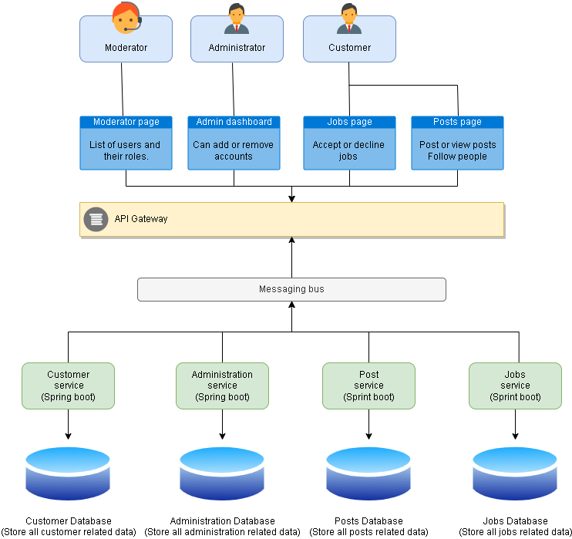

The architecture diagram above still remains the same, only Spring boot is removed from it now. I will continue improving it.

# Glossary

|  |  |
| --- | --- |
| **Word** | **Explanation** |
| Enterprise software | Enterprise software, also known as enterprise application software (EAS), is computer software used to satisfy the needs of an organization rather than individual users. Such organizations include businesses, schools, interest-based user groups, clubs, charities, and governments. |
| Sprint | Sprints are time-boxed periods of one week to one month, during which a product owner, scrum master, and scrum team work to complete a specific product addition |

# Repository

This is the repository where I will store everything.