|  |
| --- |
| My Windows 10 PC |
| Vulnerability Report |
| Monday, June 07, 2021 |

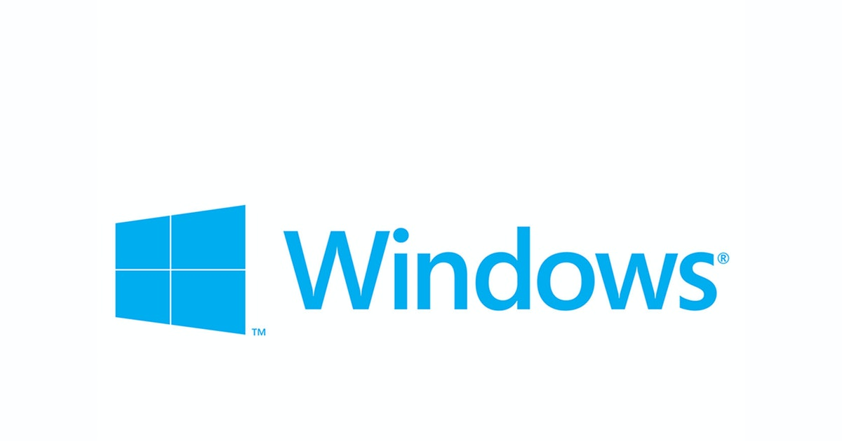

modifications history

| **Version** | **Date** | **Author** | **Description** |
| --- | --- | --- | --- |
| 1.0 | 06/07/2021 | D.Lalitha | Initial Version |
|  |  |  |  |
|  |  |  |  |
|  |  |  |  |

Table of Contents

1. General Information 4

1.1 Scope 4

1.2 Organisation 4

2. Executive Summary 5

3. Technical Details 6

3.1 title 6

4. Vulnerabilities summary 8

# General Information

## Scope

My Windows 10 PC has mandated us to perform security tests on the following scope:

* Exploiting Vulnerabilities in My Windows 10 PC

## Organisation

The testing activities were performed between 06/07/2021 and 06/07/2021.

# Executive Summary

# Vulnerabilities summary

Following vulnerabilities have been discovered:

|  |  |  |  |
| --- | --- | --- | --- |
| **Risk** | **ID** | **Vulnerability** | **Affected Scope** |
| Medium | VULN-001 | .NET Framework Denial of Service Vulnerability | .Net Framework 4.8 |

# Technical Details

## .NET Framework Denial of Service Vulnerability

|  |  |  |  |  |  |
| --- | --- | --- | --- | --- | --- |
| CVSS Severity | Medium | | CVSSv3 Score | | 6.8 |
| **CVSSv3 criterias** | Attack Vector : | **Local** | Scope : | **Unchanged** | |
| Attack Complexity : | **Low** | Confidentiality : | **Low** | |
| Required Privileges : | **None** | Integrity : | **None** | |
| User Interaction : | **None** | Availability : | **High** | |
| **Affected scope** | .Net Framework 4.8 | | | | |
| **Description** | Windows Exploit Suggester 0.98 ( https://github.com/bitsadmin/wesng/ )  [+] Parsing systeminfo output  [+] Operating System  - Name: Windows 10 Version 20H2 for x64-based Systems  - Generation: 10  - Build: 19043  - Version: 20H2  - Architecture: x64-based  - Installed hotfixes (11): KB4601554, KB4562830, KB4570334, KB4577586, KB4580325, KB4586864, KB4589212, KB4598481, KB5000736, KB5003173, KB5003242  [+] Loading definitions  - Creation date of definitions: 20210530  [+] Determining missing patches  [+] Found vulnerabilities  Date: 20210216  CVE: CVE-2021-24111  KB: KB4601050  **Title: .NET Framework Denial of Service Vulnerability**  **Affected product: Microsoft .NET Framework 4.8 on Windows 10 Version 20H2 for x64-based Systems**  **Affected component: Issuing CNA**  **Severity: Important**  **Impact: Denial of Service**  Exploit: n/a  Date: 20210216  CVE: CVE-2021-24111  KB: KB4601050  **Title: .NET Framework Denial of Service Vulnerability**  **Affected product: Microsoft .NET Framework 4.8 on Windows 10 Version 20H2 for x64-based Systems**  **Affected component: Issuing CNA**  **Severity: Important**  **Impact: Denial of Service**  **Exploit: n/a**  [+] Missing patches: 1  - KB4601050: patches 2 vulnerabilities  [+] KB with the most recent release date  - ID: KB4601050  - Release date: 20210216  [+] Done. Displaying 2 of the 2 vulnerabilities found.  image  Image 1 – Screenshot (138).png | | | | |
| **Observation** | As, we have used Windows Exploit Suggester to check the vulnerabilities of my Windows 10 machine, We have found these Vulnerabilities  we can observe that this can lead to DOS (Denial of Service) of .Net framework 4.8. | | | | |
| **Test details**  I have Installed the recommended KB4601050 update & successfully patched the DOS .Net framework4.8 vulnerability  image  Image 1 – Patched.JPG | | | | | |
| **Remediation** | [+] Missing patches: 1  - **KB4601050: patches 2 vulnerabilities**  [+] KB with the most recent release date  - **ID: KB4601050**  - Release date: 20210216  We can install This KB4601050 & KB4601554(replaced update of KB4601050) updates. This will fix/patch these vulnerabilities in our respective machine.  image  Image 1 – Screenshot (139).png | | | | |
| **References** | Windows Update | | | | |