Image Quality Classification For Diagnosing Retinal Fundus Diseases

¹Minwoo Lee, ²Seungmin Rho, ¹Yunyoung Nam

¹Department of Computer Science, Soonchunhyang University

Asan, South Korea
²Department of Software, Sejong University, 209 Neungdong-ro, Gwangjin-gu, Seoul 05006, South Korea.

[e-mail: dlalsdn229@gmail.com, smrho@sejong.edu, ynam@sch.ac.kr]
*Corresponding author: Yunyoung Nam

Abstract

This paper presents a classification of the retinal image set into available and not available to obtain only available images using the python environment. Classification processing begins with a large category of classification. The classification of the large category is decided fundus images using feature extraction. Features used include the retinal vascular and optic disc. After selecting the fundus image we classify the not available images. The retinal image-set contains normal images and not available images that reflected or blackout. we use Python Opencv that is an image processing library. In blackout images classifying, we have weighted the pixel luminance so we can figure out a partial blackout. On the other hand, in reflected images classifying, the area where light reflection occurs is divided into 4parts and classified by comparing with adjacent pixels.

Keywords: Blackout image, Reflected image, Classification,

1. Introduction
There are many types of fundus diseases, including diabetic retinopathy, glaucoma, and age-related macular degeneration. These diseases can weaken or even cause loss of sight in many people. We usually use machine learning to diagnose these fundus diseases[1]. we need a lot of learning data to use machine learning. The learning data can be to includes data that does not need to be entered. It can be adversely affect learning model creation if the learning data include not available images. So we have to classify available or not available images. we are classified through image processing because these cannot be classified manually. Through the feature extraction, the images classified as the fundus image is filtered out of the blackout image and the not available image that is the light reflection[2].
2. Methods
2.1. Histogram analysis for blackout image classification.
Blackout images are divided into a partial blackout and fully blackout images. The partial blackout image is an image in which a blackout occurs in a part of the fundus region. On the other hand, a full blackout image is an image in which all parts of the fundus image are blacked out.

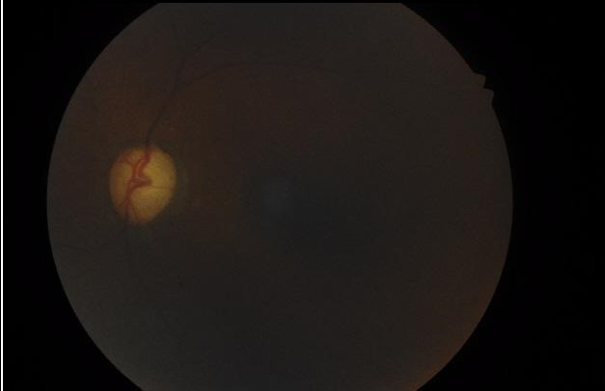
Fig. 1 Blackout images

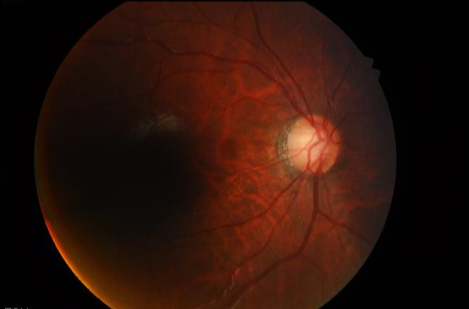
Fig. 1.1 partial blackout images.

Fig. 1, Fig. 1.1 shows the types of blackout images. We analyzed the histograms of the images to classify such images[3]. We analyze the histogram then we can see that the 0 and 1 values are very high. However, since this is a black background outside the fundus image, the histogram value is 0 or 1 except that. As shown in Fig. 2, Except for the 0 and 1 values, most fully black images have histogram values less than 50. Therefore, we set the threshold at 50, if the histogram value of image is less than or equal 50 so mean this image is full black else not full black, Fig. 3 Histogram of fully blackout image’, the partial black image cannot be classified because of the value range from under threshold to the upper threshold. Also, if there are value more than the threshold, they may be not classified

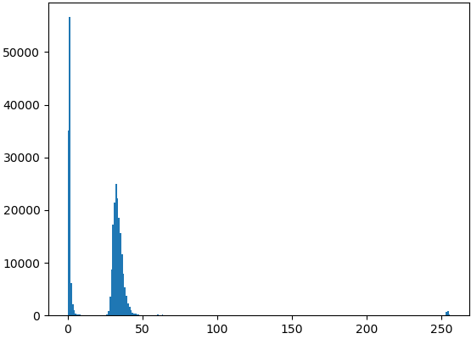
Fig. 2 Histogram of fully blackout image.

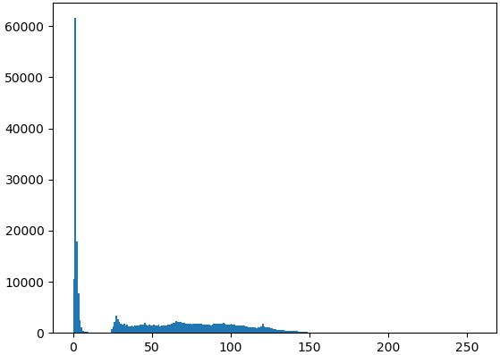
Fig. 3 Histogram of partial blackout image.

We weighted histogram values to solve this problem. Therefore, the lower the histogram value, the more influential it is. If the histogram is 2-15 the weight is 1000, 16-23 is 100, and 24-30 is 10. As a result, the lower is the luminance value, the higher score evaluated, so the partial blackout images can be classified.
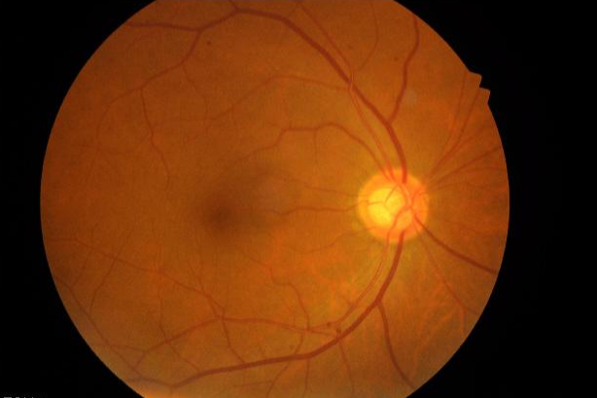
Fig. 4 Normal image.

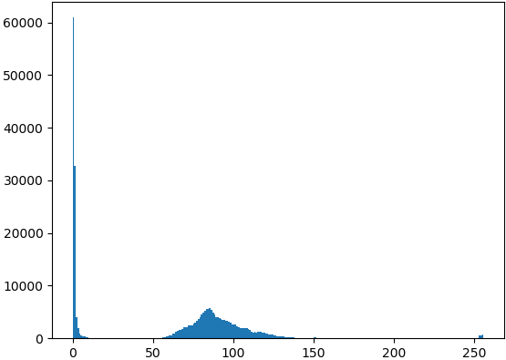
Fig. 5 Histogram of Normal image.

Fig. 5 shows the histogram distribution of the normal image. Normal images(Fig. 4) have a high distribution at luminance values above 50. Even If less than 50 histogram values are detected in an image, it is unlikely to be classified as a blackout image because there is no weight in the remaining values below 50. This is the reason why the weight is applied.

2.2. Masking for reflected image classification.

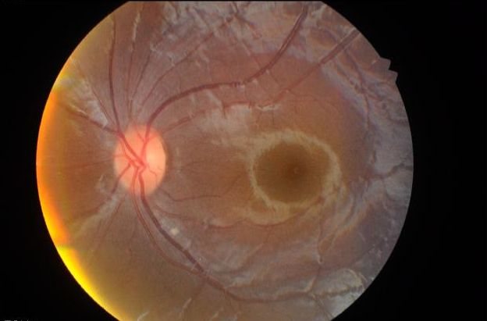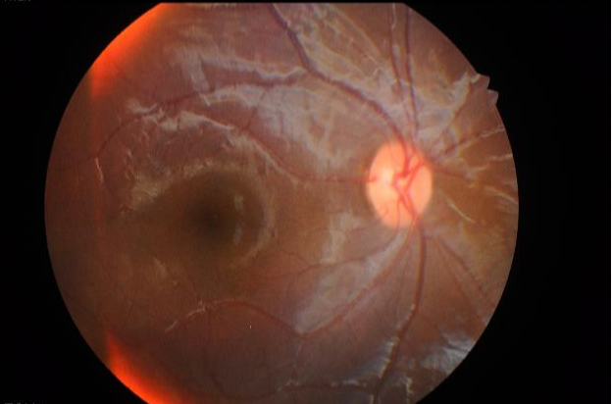
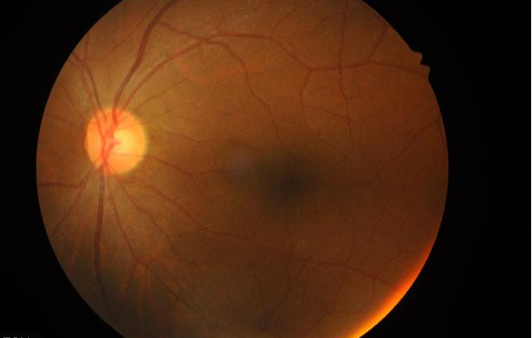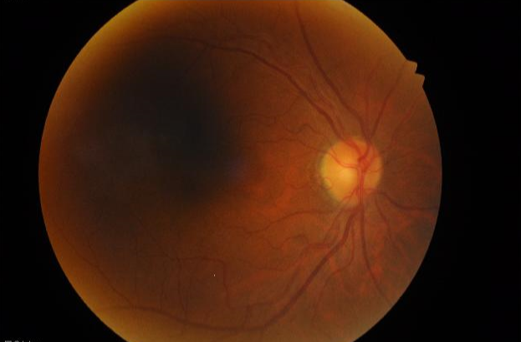
Fig. 6 reflected images.

Fig. 6 shows an image that light reflection occurs at the outer part of the fundus. Some light reflection images may be used, but they cannot be used if the light reflection is severe.

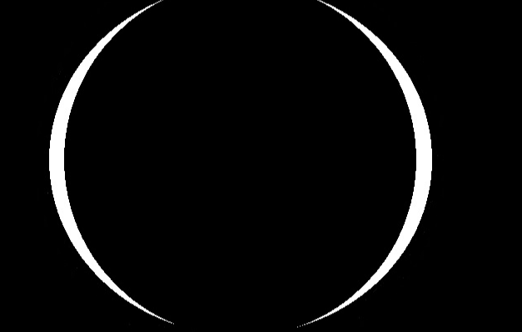
Fig. 7 Fundus outer area detection mask.

Fig. 7 is used for light reflection image detection. In Fig. 7, the Left one is a mask that detects the outer of the fundus, and the other is an area next to the light reflection area. We are classified as light reflected images if the difference in brightness between these two areas is dynamic. Light reflections, like blackouts, can occur on all sides of the fundus and may occur partially. Thus, the masked region of interest was divided into 4 areas. The difference of luminance was checked in each area, and if there was a difference of luminance in only one zone, it was classified as a light reflection image. In order to ensure the distinction of luminance difference, a correction factor C was defined and applied. The correction factor ignores slight luminance changes and allows them to be classified only in dramatic luminance changes.
3. Result
Image Quality Classification is classified Retinal Fundus image in three groups fully blackout image, luminance, and normal image. The result separate good quality of the image and can be using it for Diagnosing Retinal Fundus Diseases. Image classification consists of blackout classifying and reflection classifying. Each image must pass both of these steps to be classified as a normal image. The test used an image-set of 211 images. The image-set is a mixture of normal images, blackout images, and reflected images. In fact, the order of these two steps is not important.

Table 1. Result
Table 1 |  | Predicted class
 |  | P | N
Actual class | T | 131 | 3
Actual class | F | 4 | 73

Table 1 shows the results for 144 normal images, 77 not available images, and 211 total images. In the case of TN, all three images are classified by the reflection image classifier, not the blackout classifier. We checked and found that there was a very fine light reflection, but not enough to be classified as a not available image. On the other hand, in the case of FP, three images were classified in the reflection classifier and the other in the blackout classifier. Misclassified images in the reflection classifier don’t have a dramatic change of luminance. These have a very slow change of luminance. Finally, This table showed an accuracy of 96.6%, a precision of 97.0%, and a recall of 97.7%.
4. Conclusions
We will get better quality data when gathering training datasets for machine learning training. We can expect a better effect on the training model generation if we get good quality data. Of course, there are still kinds of images that need to be classified. For instance, an image that is out of focus, an uncleared feature, and so on. However, blacked out or reflected images can be classified with high probability.
References
- Chander, Sharang M. S, Shanmukh Reddy Manne “Diagnostic Quality Assessment of Ocular Fundus Photographs: Efficacy of Structure-Preserving ScatNet Features” IEEE 2019 41st.
- Raghav Singh, Sanjeev Dubey, Utkarsh Mittal “Quantification of Retinal Tissue Damage” Cluster Innovation Centre (2017) :19-20.
- Jun Zhang, Jinglu Hu, “Image Segmentation Based on 2D Otsu Method with Histogram Analysis” IEEE (2008).

