The Classification of retinal images for diagnosis of diabetic retinopathy

**Minwoo Lee**1**,** **Seungmin Rho**2\***, Yunyoung Nam**1**, Eenjun Hwang**3

1Department of Computer Science Engineering, Soonchunhyang University,

Asan, South Korea

[e-mail: dlalsdn229@gmail.com, ynam@sch.ac.kr]

2Department of Software, Sejong University, Seoul, South Korea

[e-mail: korea.smrho@gmail.com]

3School of Electrical Engineering, Korea University, Seoul, Korea

[ehwang04@korea.ac.kr]

*\*Corresponding author: Seungmin Rho*

***Abstract***

This paper represents a classification method of retinal images to determine whether useable images or useless images using Python OpenCV. Image processing is conducted by data density procedure and optic disc extraction. Through data density procedure, we determine whether retinal vascular extracted from retinal vascular images are useful for training sets. In another hand, optic disc extraction step can determine whether images are useful or not, nevertheless data density procedure cannot extract retinal vascular. Those two steps can achieve the higher accuracy that a single step.

**Keywords:** Retinal Image, Data density, Optic disc Extraction.

**1. Introduction**

Diabetic retinopathy is complications of the major of diabetes and occurs in the capillaries of the eye. The Diabetic retinopathy became major cause of many people blinded. The retina is photographed to diagnose diabetic retinopathy. The doctor will determine whether the retinal image is useable or useless. Focusing on supporting the doctor’s decision by classifying images as useable or useless using image processing.

**2. Image Classification Processing**

**2.1 Find images that Retinal vascular not extracted.**

The feature of [1,2]retinal vascular images is the radiation pattern spreading around the center optic disc. Thus, the outline of the image is less important than the center. Masking by 20% of the total lateral size from the center of the retinal vascular image to the left and right and 20% of the vertical total size up and down. Data density is calculated in the masked area.

data density = Number of pixels represented by retinal vascular / Width of the masked area

Image is divided into primarily useable and useless according to data density.

하늘, 나무, 실외, 조류이(가) 표시된 사진

매우 높은 신뢰도로 생성된 설명

**Fig 1.** Density = 0.0252

하늘, 실외, 나무이(가) 표시된 사진

매우 높은 신뢰도로 생성된 설명

**Fig 2.** Density = 0.0266

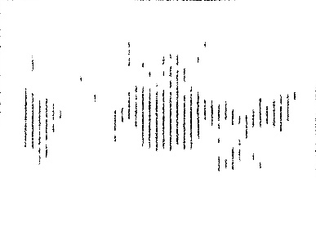

**Fig 3.** Density = 0.0245

Fig 1, Fig 2 are appearance of retinal vascular according to data density. In images with a data density of about 0.02, it can be seen that although the retina vascular were visible, the area was narrow and deformed.

Fig 3. is an image that is extracted noise in the form of a vertical line not retinal vascular. For this image, data density can has various value according to number of vertical lines. To solve this problem, the presence or absence of the optic disc in the retinal image is determined.

**2.2. Determining presence or absence of optic disc.**

Optic disc is located in center and it has luminance higher than others. Using this, we can find the presence of optic disc by extracting pixels above a specific luminance.

Extracting optic disc consist of [3]3 steps.

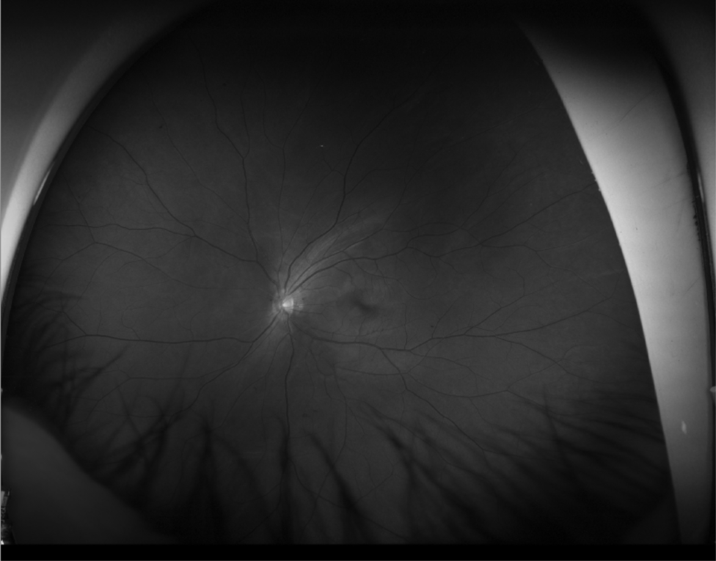

**Fig 4.** Gray scaling

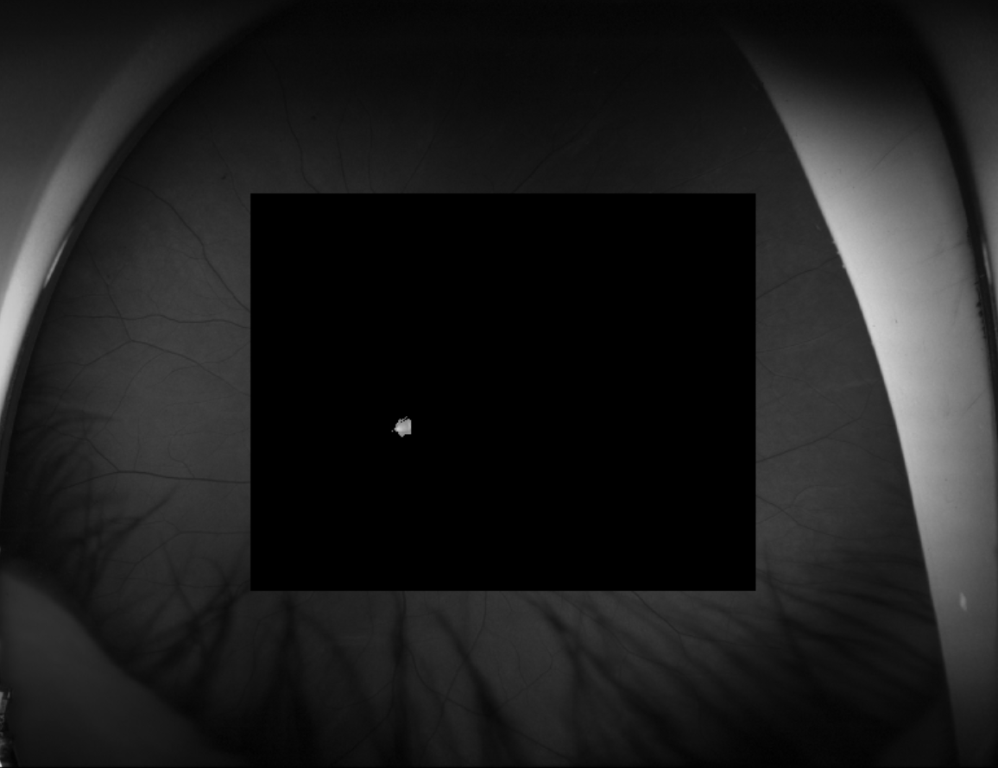

**Fig 5.** Image masking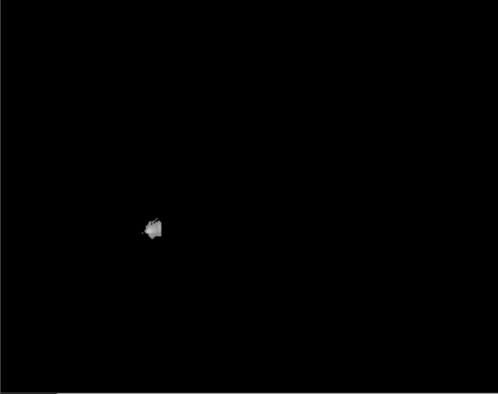

**Fig 6.** Extracting optic disc

First, gray scaling step performs all pixels are able to have luminance between 0 and 255. The higher the pixel luminance, the more white the color. The lower the pixel luminance, the more black.

Second, image masking step trims the pixel area we need. By doing so, we can reduce the number of variables that occur in areas we do not need.

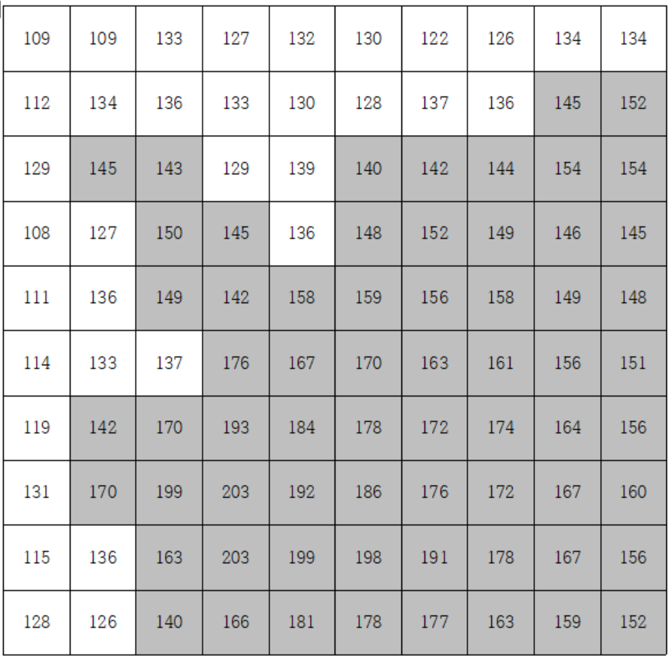

**Fig 7.** Luminace of optic disc

Fig 7 shows the luminance of some areas near the optic disc. As a result, the luminance of the optic disc area was 140 or more, and the luminance of the optic disc area and the non optic disc area were clearly different from each other.

**3. Final image classification method.**

Finally, Image is determined according to data density step and presence of optic disc.

**Table 1.** Result

|  |  |  |  |  |
| --- | --- | --- | --- | --- |
| **Table 1** | | | **Actual class** | |
| **T** | **F** |
| **Predicted**  **class** | **Data**  **density** | **Pos** | **103** | **19** |
| **Neg** | **1** | **86** |
| **Optic**  **disc** | **Pos** | **100** | **24** |
| **Neg** | **4** | **81** |
| **Both** | **Pos** | **100** | **15** |
| **Neg** | **4** | **90** |

Table 1 shows the results for 104 useable images, 105 useless images and 209 total images. Each image is categorized as an image that can useable image that are represented true for both data density procedure and optic disc extraction and others are categorized as useless images.

In the case where the images are classified in correctly, the useable images are divided into the case of being classified as useless and the case where the useless image is classified as being useable. The latter case is more dangerous, because the former can be resolved by retinal re-imaging immediately, but in the latter case, a situation may arise in which the patient is scheduled to be photographed again. Thus, focused on dropping the false negative value even if the false positive value is raised.

If both the data density and the optic disc detection process are performed, the image as shown in Fig. 3 is properly classified and the false negative values ​​of both are dropped. Finally, it showed an accuracy of 90.9%, a precision of 96%, and a recall of 86.9%.

**4. Conclusions**

Doctor will be able to make more efficient decisions in processing and classifying retinal images. However, there are images that have not been solved yet. If we use an algorithm that uses feature of radial retinal vascular instead of data density, we think that a better result will be obtained.

**References**

1. Raghav Singh, Sanjeev Dubey, Utkarsh Mittal*“Quantification of Retinal Tissue Damage”* Cluster Innovation Centre (2017) :19-20
2. Sanjeev Dubey retina-features

<https://github.com/getsanjeev/retina-features>

1. Sansjang Python OpenCV Category

https://blog.naver.com/PostList.nhn?blogId=samsjang&from=postList&categoryNo=66