**2조 CheForest팀**

**팀원:** **이민중(팀장), 최유준, 강승태, 박예성, 허장호, 하윤주, 이진수**

**요구사항** **정의서**

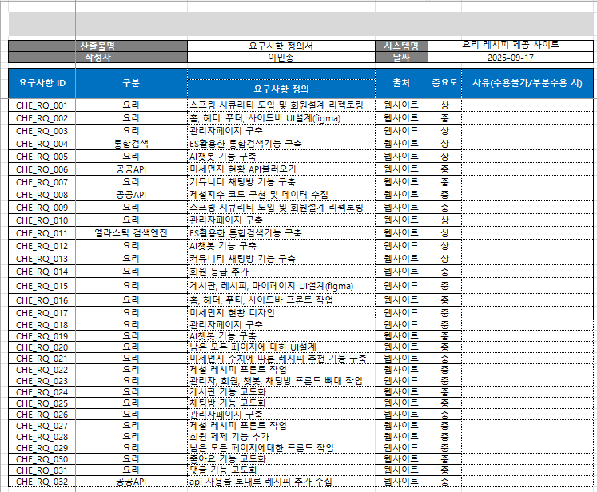

* **WBS**:  
  <https://drive.google.com/drive/folders/1ennjna5BOyB6pdQsCUOHpVN_onpC0A98?usp=sharing>

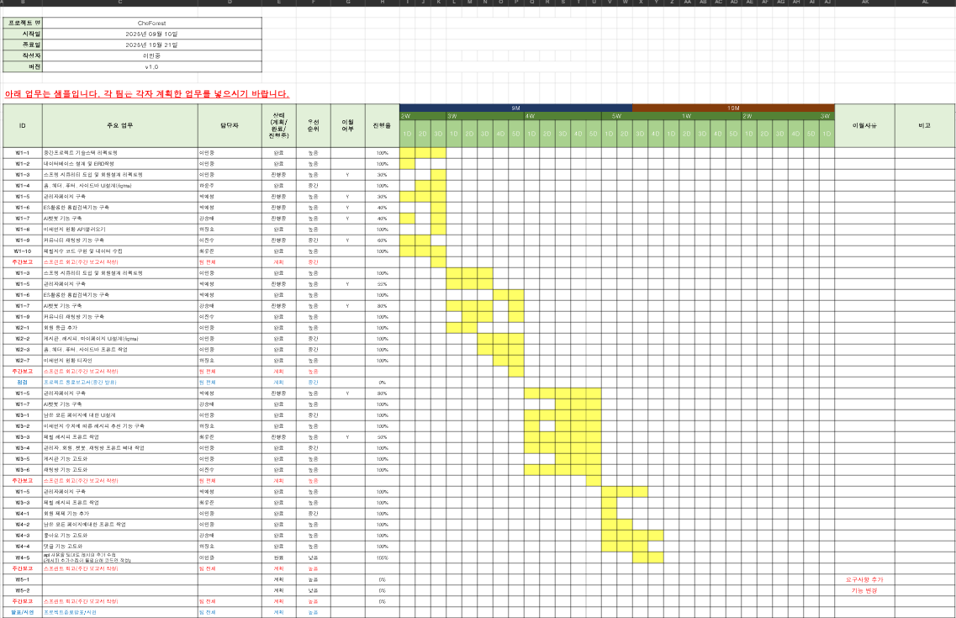

* **ERD** **CLOUD**:  
  <https://www.erdcloud.com/d/C7yn9utzWsBD9BMGP>

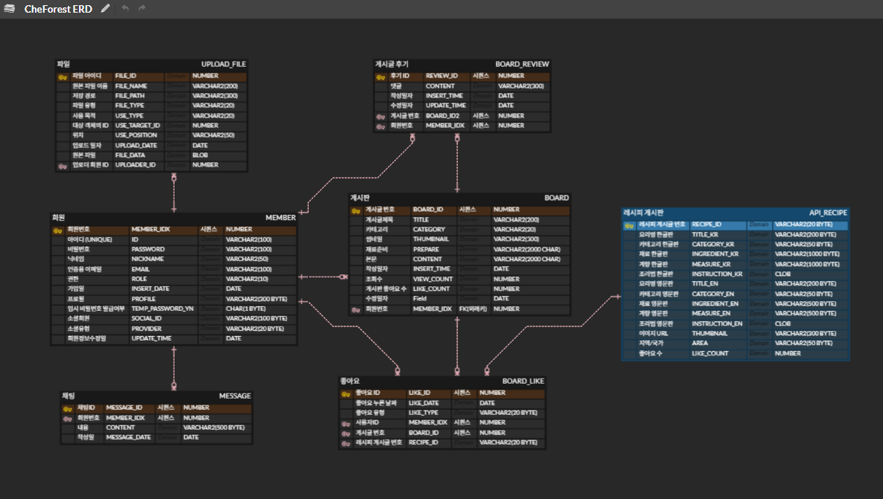

* **FIGMA**<https://www.figma.com/make/HPd1HywXhVsBdiJ4rndOgp/CheForest-%EC%9A%94%EB%A6%AC-%EB%A0%88%EC%8B%9C%ED%94%BC-%EC%82%AC%EC%9D%B4%ED%8A%B8-%ED%99%88%ED%8E%98%EC%9D%B4%EC%A7%80?node-id=0-1&p=f&t=VwZMFg9LsL1P6R87-0&fullscreen=1>

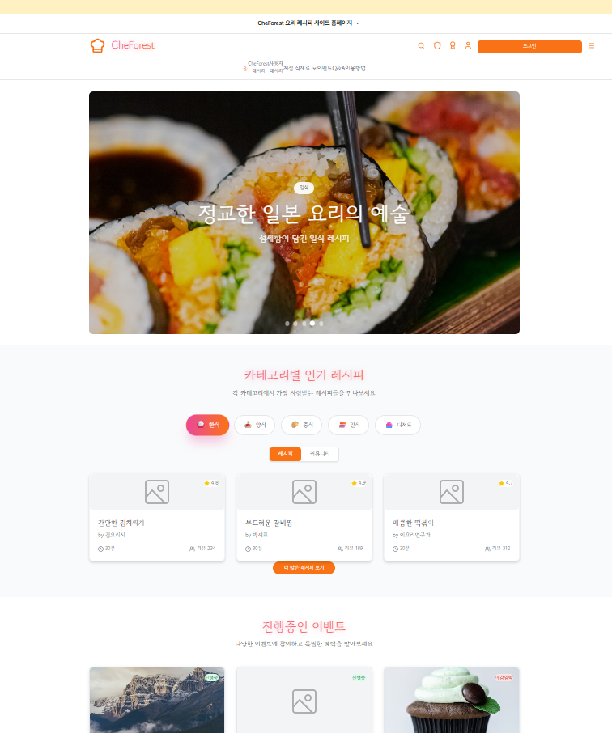

* **GITHUB:**  
  <https://github.com/dlalswnd34/Final_Project>