Tab 1

Personal Project: Website UI & Functional Testing

Type: Manual Testing | Platform: Web (Chrome Desktop)
Tools Used: Google Docs (Bug Report), Google Sheets (Test Cases), Screenshots

Objective:
To evaluate the user interface and visual presentation of a live website from a user perspective, identifying UI, content, and design-related issues that impact professionalism and usability.

Bug Reports:

🐞 Bug 1: Broken .png Image on Anti-aging Solutions page

Severity: Minor

Steps to Reproduce: Open homepage > Services >Aesthetic Services>Anti-aging Solutions>Observe icon

Expected Result: Image should display properly

Actual Result: Shows missing icon placeholder

Screenshot: 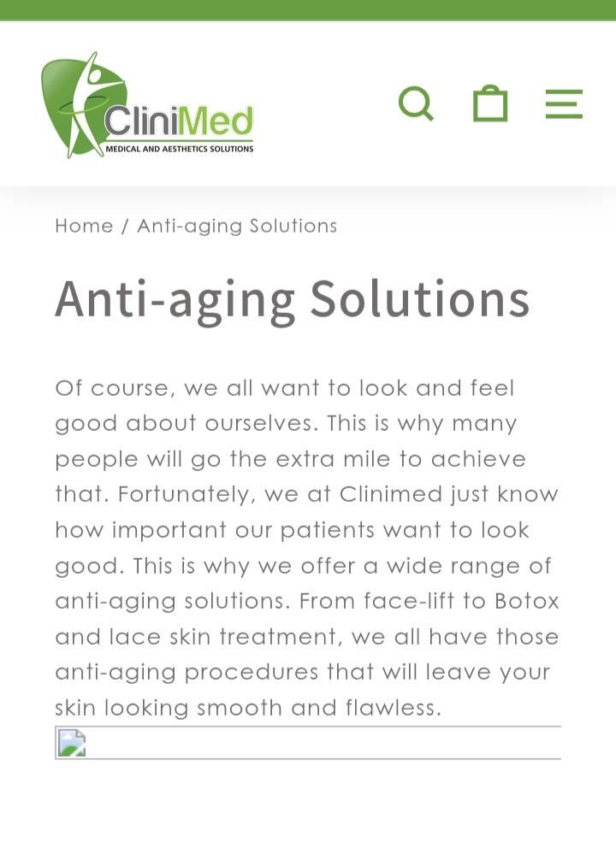

🐞 Bug 2: Spelling Error on Services Page
- Severity: Medium
- Steps to Reproduce: Navigate to Services >Iv Drip Services> scroll down to “Skin Glow”
- Expected Result: No spelling errors
- Actual Result: heingredientlps
- Screenshot: 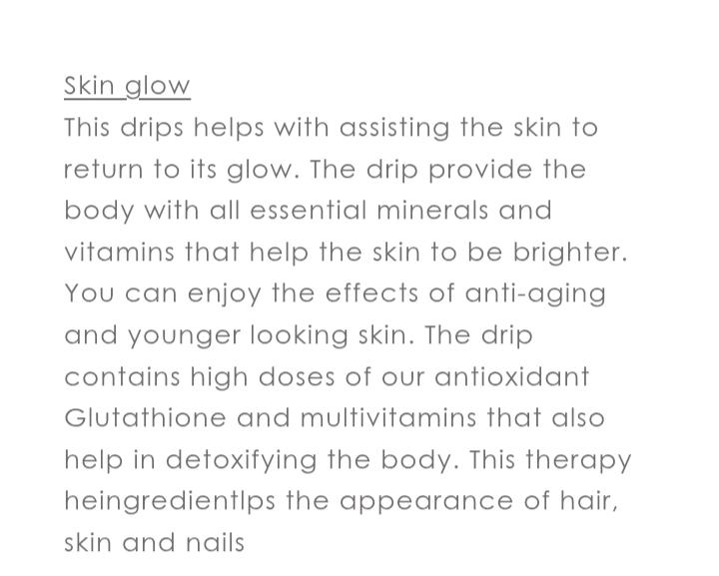

🐞 Bug 3: Heading Misalignment
- Severity: Medium
- Steps: Home > Shop Now> Acne
- Actual Result: Heading “ How to get rid of acne” the text “acne” is partially cut off with only the top part visible
- Screenshot:

🐞 Bug 4: Case Sensitivity Issue
- Severity: Minor
- Observed On: Home> Shop Now> Acne
- Actual Result: Sentences start with “these” and “the”
- Screenshot:

Outcome & Skills Gained:
- Identified 4+ UI/content issues on a live website
- Practiced manual bug reporting with screenshots and structured detail
- Strengthened visual attention to detail and user experience sensitivity
- Simulated client-facing testing for a professional service provider
Disclaimer:
This project was conducted independently for educational purposes.

