University of Washington Bothell
Electrical Engineering Program

BEE 341 Discrete-Time Linear Systems

Lab 2: Introduction to Image Processing

- Purpose:
The purpose of this lab is to introduce you to some basic concepts in image processing. You will learn how to read and display an image in MATLAB. You will perform:
- Simple edge detection of an image provided as well as of an image of your own.
- You will scale an image to create its thumbnail version.

- Background:

Digital images is made up of many pixels (picture elements). When the pixels are placed close to each other, such as in an image viewed on a computer display or in a printed paper, the image appears to be continuous. The number of pixels per inch (ppi) defines the resolution of the image which varies with an application. Some monitors can only display 72 pixels per inch (ppi). For publishing, 200–1200 ppi is often required. Laser printers are usually capable of 300- 600 ppi.

A black and white image is represented by a two-dimensional array of a size that is equal to the size of the pixels of the image. The location in the matrix corresponds to the location of a pixel in the image. For example, X[1,1] (usually) identifies the pixel located in the upper left corner, as shown in figure 1. The values of the matrix represent the brightness (intensity) of the corresponding pixel. The pixel brightness values are commonly represented by an 8-bit gray scale image which takes any value from 0 to 255. Usually black is encoded by a value of 0 and white by a value of 255.

A color image is stored in a three-dimensional array, where the first plane in the 3rd dimension represents the red pixel intensities, the second plane represents the green pixel intensities, and the third plane represents the blue pixel intensities. True color has 24 bits of resolution (8 bits for each of the red, green, and blue planes).

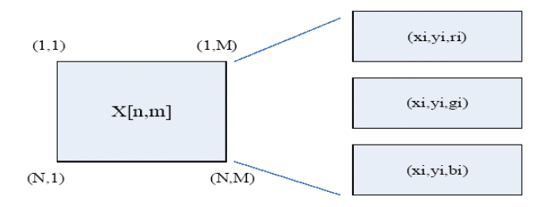
Figure 1. Pixel locations and file format; (x_{i,} y_{i,} ri) represents red pixel intensity at location (xi,yi), (xi ,yi, g_{i} ) and (xi ,yi, b_{i} ) are green and blue pixel intensities, respectively.
In this lab, you will use the MATLAB Image Processing Toolbox. To learn more about the functions included in it, type help images.

Assignment 1. Edge Detection

In this assignment, you will perform edge detection on your image. (Edge detection is often used as a first step in more complicated image processing operations.). Edge detection can be implemented by convolving the image by a specific two dimensional matrix (mask). The most common used edge detection convolution masks are the Sobel convolution kernels which are matrices that perform a row and a column gradients.

The following mask is the Sobel vertical edge detection mask, h₁[n,m], which in MATLAB notation is given by,

>> h1 = [-1 0 1; -2 0 2; -1 0 1];
This mask is designed to respond maximally to edges running vertically relative to the pixel grid. To perform vertical edge detection an image x is convolved by h₁ as follows,

>> M1 = conv2(x,h1);
Where conv2( ) is a MATLAB function to perform a two-dimensional convolution.

The Sobel horizontal edge detection convolution kernel which is designed to respond maximally to edges running horizontally relative to pixel grid is given by:

h2 = [1 2 1; 0 0 0; -1 –2 -1]

Before performing edge detection, you should save the file DailyShow.jpg on your computer. On the MATLAB command enter

>> x = imread(‘DailyShow’, ‘jpeg’)

to read your JPEG image. To display the image use the command

>> imshow(x ).

Since we will be working with gray scale images in this lab, your next step is to convert your input image to an 8-bit gray scale format using the command:
>> x = rgb2gray(x )

Tasks of Assignment 1:

  - Check its size using the size( ) command. Write the size of the image.

  - Include in your report the gray scale image and add title to the image.

  - Apply the Sobel Vertical masks (by convolving the image by the vertical detection kernel) on the image. Assume M1 is the result of convolving the grayscale image with h1 (i.e. M1 is the row gradient of the grayscale image). Plot the magnitude of M1 ( |M1|). Also turn in you MATLAB code used to perform the vertical edge detection.

  - Repeat procedure 1.3 using the Sobel horizontal mask. Assume M2 is the result of convolving the grayscale image with h2. Plot the magnitude of M2 ( |M2|). Also turn in you MATLAB code used to perform the horizontal edge detection.

  - We can find edge detection across vertical and horizontal grids by displaying the overall gradient which is computed by M = (|M1|²+|M2|²)^0.5. Plot the magnitude of M ( |M|). Also turn in you MATLAB code used to perform the overall edge detection.

Note: The data type of the values obtained from convolution and data type of the image are different. As a result, the image displayed would look different from the expected edge-detected image. The problem can be fixed by changing the data type of the convolved values to the data type that the imshow function takes as follows:
>> y = rgb2gray(x);
>> class_y = class(y); % determines the data type of the image.
Now when displaying the edge-image of |M1|, for example, we can cast |M1| using class_y as follows:
>>imshow(cast(abs(M1), class_y));

[Optional]
You may notice lots of dark areas in these edge images. To save the toner (or cartridge) of your printer, you can try to figure out a way to reverse the grayscale of your edge images before printing them out. That is, you do a transformation to map the original darkest area to the brightest one, and the original brightest area (e.g. edge) to the darkest one.

Assignment 2. Image Scaling
In this section, you will investigate scaling of images in the spatial domain. You will scale the image x[n,m] in both the vertical and horizontal directions using the same scaling factor S. An example where you want to use such scaling would be creating thumbnail-sized pictures for a web page. In this assignment, you will write two different of resizing function, to scale the original gray scale image by a factor of S=3 and 4. Note that you are not allowed to use MATLAB resizing functions.

  - In the first task, perform a simple scaling by keeping one pixel out of S × S square of pixels, i.e. keep one out of S² pixel. Since this is a 2D scaling, you can keep the center pixel in each square of S2 pixels, when S is an odd number and one of the 4 center pixels when S is even. Plot the two scaled images by adding the scaling factor and the method of scaling in the title.

  - Next, you are going to perform a more advanced scaling operation. Instead of keeping the center pixel in each square of S2 pixels, keep the average value of all of the pixels in this square. Plot your scaled images by adding titles.
  - Compare the two scaled versions of the original picture (i.e. picking one out of S2 pixels versus picking the average of each block with S2 pixels). Which one is the better thumbnail image?

Assignment 3. Flipping Images

3.1. Guess how the following images look like when compared to an arbitrary original image x[n,m] where N and M are represent the total number of rows and columns of the image.

- Xx[N-n+1, m]
- X [n, M-m+1]
- X [ N - n+1, M - m+1]
where 1 ≤ n ≤ N , 1 ≤ m ≤ M

3.2. Using the DailyShow.jpg as the original image (i.e. x[n,m]), verify your guesses by displaying the images of (i) (ii) (iii). Turn-in the plots in your report. The functions fliplr( ) and flipud( ) may be helpful to perform the operations.

Assignment 4. Interpolating Images

When an image is scaled up to a larger size, there is a question of what to do with the new spaces in between the original pixels. Taking a 1-dimensional signal [0,2,4,6,4,2,0] for example,
suppose now we want to expand it by a factor of 2, then you can think of two common Ways:

(i) Simply double each sample – value replication; and
(ii) Make the new samples half way between the previous samples – 2 tap linear interpolation.
The original signal and the up-scaled signals from the two methods are shown below.

4.1. Now, write a MATLAB function that can expand the input image (DailyShow.jpg) with dimension NxM to a 2Nx2M image using linear interpolation. Plot the 2Nx2M. Also, include your MATLAB function for the interpolation.
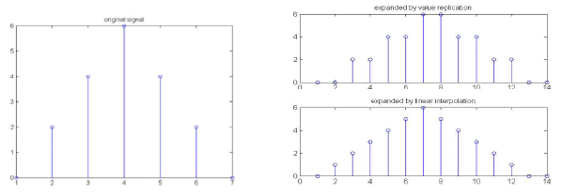

Hint: You can directly use interp2( ) provided by MATLAB. Figure 2 shows the concept of “bilinear interpolation” that is used to deal with a 2-dimensional signal. Also, you can type help interp2 to see more information.

Figure 2. Enlarging the image by a factor of 2 using bilinear interpolation.
