Date practical was performed: 28 September 2025
Date report was handed in: 13 October 2025
Solar powered washing machine
Washing machine controlled by a Micro-controller
Lubabalo Dlangamandla

Declaration Signature: ______________________

Abstract
This project is focused on the design and evaluation of a solar-powered washing machine that is controlled by a micro-controller Arduino Uno. The main objective was to create a system that operates using renewable energy, removing the need for the electrical grid power while maintaining full washing functionality. The washing machine performs all major cycles which are filling, washing, rinsing, draining, and spinning while it adjusts the operations based on the amount of solar power available. An infrared receiver then detects power levels from the solar system, in which this allows the machine to manage energy usage automatically and prevent overloading during low sunlight conditions. Both simulated and physical versions of the system were developed, and they were used to verify the washing machine operations. The simulation of the circuit was built using Tinkercad, and on Tinkercad the simulation was built using LEDs to represent the stepper motor, while the physical circuit used the actual stepper motor, DC motor, and infrared sensor. Doing the testing showed that the system paused during low sunlight and resumed automatically when power returned, confirming its liability to adapt to fluctuating renewable energy supply. This project demonstrates a practical, low-cost approach to applying renewable energy in household appliances that are mostly used in our daily lives. It reduces dependence on grid electricity and supports sustainable energy use, especially in off-grid or energy-limited environments.

Terms of reference
This report outlines the design, simulation, implementation, and evaluation of a solar-powered washing machine micro-controller developed for the Embedded Systems 3 (ESS370S) Final Integrated Summative Assessment (FISA). The system is built around an Arduino Uno micro-controller and in which it aims to demonstrate:
- Autonomous control of all washing cycles (fill, wash, rinse, drain, spin) using embedded logic.
- Intelligent power management based on real-time solar energy availability.
- Reliable operation under fluctuating sunlight conditions using infrared-based power level detection.
- Practical application of embedded systems in sustainable household automation.
The scope includes both simulated and physical circuit designs, performance testing under variable irradiance, and quantitative analysis of energy efficiency. All design decisions, calculations, and corrections are documented to validate the system’s functionality and alignment with renewable energy goals.

Table of contents
Table of Contents

Abstract 1
Terms of reference 2
Table of contents 2
List of Illustrations 3
Glossary of terms 3
Introduction 3
Subject 4
Background 4
Problem statement 4
Objectives 5
Methodology 5
Project and Data Design 6
Simulated Circuit Diagram 6
Physical Circuit Diagram 6
Calculations 7
Water level Calculations 8
Photo of Simulated Circuit 8
Photo of Physical Circuit 9
Program code 11
Findings 22
Explanation of findings 23
Simulation Serial Monitor 23
Physical Serial Monitor 24
Quantitative Analysis 24
Rectifications based on findings 25
Conclusion 25
Scope and Limitations 26
Recommendation 26
Appendices 26
References 26

List of Illustrations
Figure 1: Schematic representation of the simulated washing machine controller circuit……………………………..4
Figure 2: Schematic of the physical circuit……………………………………………….. ………………….…………….5
Figure 3: Simulation Circuit Design…………………………………………..………………………………………………7
Figure 4: Physical Circuit Design …………………………………………………………………………………………….8
Figure 5: Serial Monitor showing system initialization…………………………………….……………………………….17
Figure 6: Serial Monitor during the “fill” stage……………………………………………………………………………….17
Figure 7: Serial Monitor during the “washing” and “fill” cycle……………………………………..……………………….18
Figure 8: Serial Monitor during draining……………………………………….……………………………………………..18
Figure 9: Serial Monitor during the spin and completion cycle……………….……………………………………………19
Figure 10: Physical circuit Serial Monitor (1 of 2)……………………………………………………………………………19
Figure 11: Physical circuit Serial Monitor (2 of 2)……………………………………………………………………………20
Figure 12: Graph showing the relationship between solar voltage and washing cycle time……………………..……..21

Glossary of terms
TERMS | DESCRIPTION
ADC | Analog-to-Digital Converter – converts analog signals (e.g., voltage) into digital values that can be read by the micro-controller
DC | Direct Current, a type of electrical current that flows in one direction, used in most low-voltage electronics
IR | Infrared – a type of wireless communication used in remote controls and sensors
NPN Transistor | A transistor that is used to switch electronic signals and power
IRemote.hpp | A C++ library used in Arduino to code infrared signals from remotes
UNO (Arduino Uno) | A micro-controller board that is used for embedding systems together
Tinkercad | Online simulation platform used for designing and testing electronic circuits
PV Panel | Photovoltaic Panel – converts sunlight into electrical energy inside a solar panel
LED | Light Emitting Diode – it is used in the circuit simulation to represent motor activities
L298N | A dual H-bridge motor driver module that is used to control DC and stepper motors.
NEC Protocol | A common infrared communication protocol which is used in remote controls.
Serial Monitor | A debugging tool that is found in Arduino IDE, which displays real-time output from the micro-controller
EMF | Electromotive Force – it is the voltage generated by a source like a battery or solar panel that drives current on a circuit
NPN Transistor | A type of transistor used to switch electronic signals and power

Introduction

Subject
The subject of this project is about designing and developing a solar-powered washing machine controller that can adapt to various power levels from the solar panel output. This project is about building an embedded system that monitors solar panel energy availability and control the washing machine operations so that the washing machine can run reliably even when the output of the solar power fluctuates.

Background
Modern day life depends heavily on reliable electricity, however in many rural areas power supply is often or completely absent. The absence of power supply can reduce quality of life, economic productivity and the access to hygiene and health services. The use of solar systems can improve access to reliable electricity even for homes in off-grid areas. The project is about a solar powered washing machine controller that can adapt to various stages of the solar panel output. (Pakula & Stamminger, 2023)
The existing projects that are like this project are the solar-powered water-recycling washing machine whereby the solar energy and water recycling is integrated to reduce energy and water use. The other existing project is the LaudReCycle which deals with optimizing water reuse and solar power for laundry treatment which shows that high self-sufficient fractions are possible under real sunlight conditions with the use of solar panel.
As the solar panel output vary due to the time of day which may cause fluctuations, batteries are then needed to smooth out the fluctuations by storing energy and make use of them when the energy from the solar is insufficient. The challenge with using batteries would be that they are costly. (Nalina, et al., 2023)
The use of this project will really help to improve energy access, reduce reliance on fossil fuel generators, enable sustainable living and help in reducing the carbon emission. Using this washing machine system will lead to having fewer disruptions to everyday tasks like laundry in places with unstable electricity like the rural areas. The core idea of this project can also be scaled up and adapted to other appliances. This project can also help in reducing the cost of using electricity. (Persson & Ronnelid, 2007)

Problem statement

Objectives
To solve the problem, start by defining the problem in which the washing machine uses a solar panel for power, and the solar has a varying output power. Conduct research to come up with a solution for the problem and to understand the problem even more. Design an Arduino controller that will control the washing machine operations considering the varying output power of the solar panel. Build the electric circuit for the controller on tinkercad for the washing machine. Build the physical circuit of the washing machine. The system must allow the washing machine to function even when the solar panels output power varies. Do the testing on the circuit for bugs and troubleshoot to be able to detect any defects and fix them.

Methodology
- Step 1: Define the engineering challenge and investigate on how to design a controller.
- Step 2: Conduct research on the types of washing machines, solar power variability and Arduino controllers. Analyse requirements for hardware and software the circuit will need.
- Step 3: Choose components that include Arduino, inferred sensors, motor drive component for software and hardware, water sensor component, water pump component, and valve indicator.
- Step 4: Develop a block diagram showing all components and interactions. Define the cycle scheduling for washing and create schematic diagrams and wiring layouts.
- Step 5: Assemble solar panel, sensors, Arduino, water pump, valve indicator and motor drive on a breadboard. Ensuring safe voltage and current limits are maintained for the components.
- Step 6: Write an Arduino code to monitor input power, run cycles only if there is sufficient power and delay cycles based on the power variations.
- Step 7: Test the controller under various sola panel power levels and simulate different sunlight conditions using the inferred sensor which acts as the solar. Record the behaviour of the controller, response time and the execution of the cycles.
- Step 8: Evaluate the performance of the controller by checking if the washing machine completed the cycles without interruptions, use of available power efficiently and if the switching logic was effective and stable. Identifying delay issues from the controller or the washing machine as it performs the cycles.
- Step 9: Do improvements and optimizations by adjusting the Arduino code and retest after the improvements made.
- Step 10: Writing the final report, submit the report and demonstrate the working prototype.

Project and Data Design

Simulated Circuit Diagram
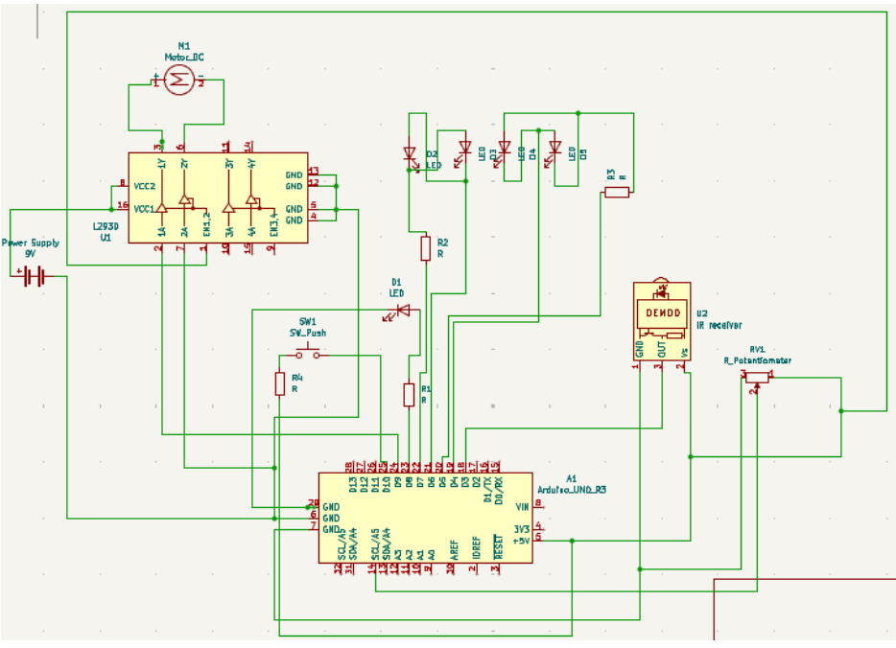
Figure 1: Schematic of a simulated circuit

Physical Circuit Diagram
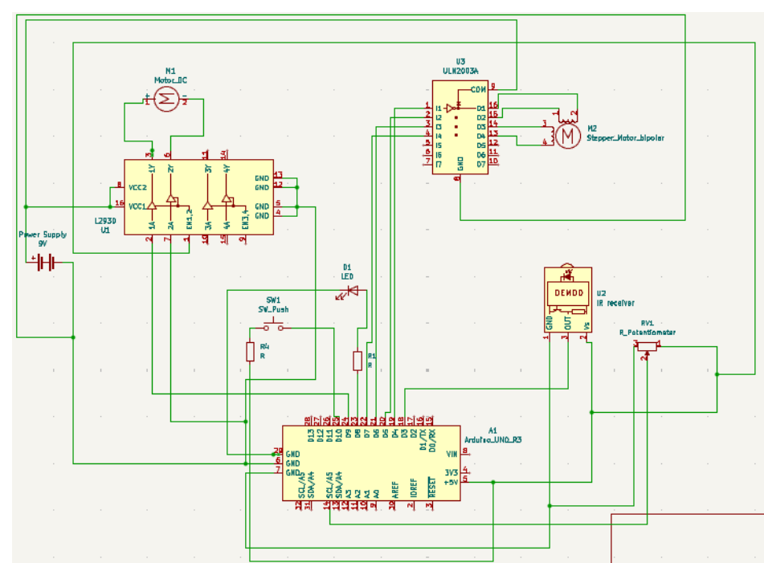
Figure 2: Schematic of the physical circuit
The simulated circuit shows the control system of a solar-powered washing machine that is using an Arduino Uno as a micro-controller. Four LEDs with 1 kΩ resistors connected to pins D4–D7 represents the drum motor, the LED on pin D8 indicates the water valve. A push button on pin D10 acts as the start or pause control for the washing machine, and an IR sensor on pin D3 receives power level signals from the solar system. The potentiometer on pin A5 simulates the water level sensor. A DC motor is driven through an NPN transistor with a 1 kΩ base resistor, and a diode protects the circuit from back EMF. This setup allows the Arduino to control all washing cycles automatically and test power management before building the physical prototype.

Physical Circuit Diagram

The physical circuit represents the real implementation of the solar-powered washing machine system using an Arduino Uno as the main controller. The setup includes a stepper motor connected through a motor driver module to handle the drum’s bidirectional rotation, and a DC motor controlled via an NPN transistor, diode, and 1 kΩ resistor for draining operations. The transistor works as a switch to handle the motor’s higher current, while the diode prevents damage from back EMF. A valve indicator LED with a 1 kΩ resistor on pin D8 shows when water is filling. The IR sensor connected to pin D3 receives signals indicating available solar power, while the potentiometer on pin A5 detects the water level. A push button on pin D10 serves as the start or pause control. The circuit is powered by a regulated +5V supply, ensuring stable operation of all components during the washing cycles.

Calculations

Water level Calculations
The water level sensor since it is connected to the Arduino’s 10-bit analog-to-digital converter, it produces values between 0 – 1023. To convert these readings using percentages, the usage of the following calculation was applied:
Water Level (%) = $\frac{ADC Reading}{100}⋅1023$
During the fulfilling process, the program continuously read the analog input and compare the calculated percentage against the threshold of 80% and 10%. For example:
$$Water Level = \frac{80}{100}⋅1023$$
$$Water Level = 818.4$$
The water level becomes open till the water level is reached, and then when the value is reached the cycles proceed.
During the draining process, the same conversion is used, but the program now was checking whether the water level had fallen below 10%. For example:
$$Water Level = \frac{10}{100}⋅1023$$
$$Water Level = 102.3$$
In the case above, the pump was kept running until it reached the calculated value. Once the threshold is reached, the program will stop the pump and move on to the next stage of the cycle
By applying the two above thresholds, the controller could reliably determine the two situations of whether the drum is full enough for washing and that if whether the drum was empty for spinning.
Photo of Simulated Circuit
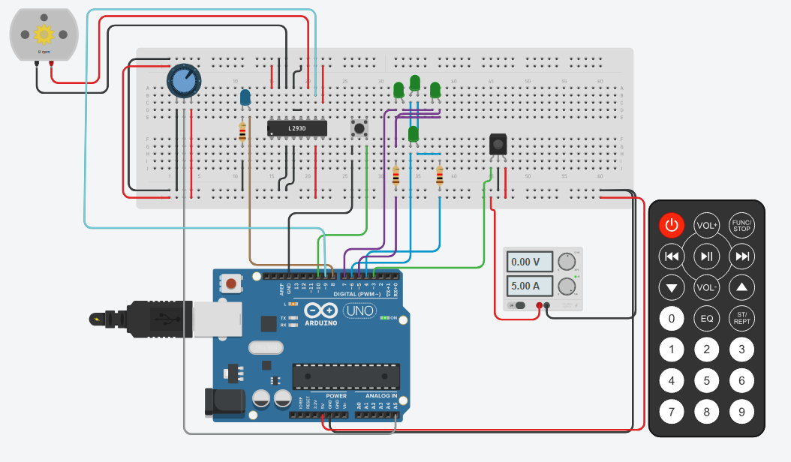
Figure 3: Simulated circuit
The simulated washing machine controller above was developed using Tinkercad to validate the embedded logic before hardware implementation. LEDs were used to emulate the drum motor on Page | 8 and the valve operations, while a potentiometer simulated the water level sensor. The Arduino Uno received infrared signals to determine available solar power and execute all washing cycles— fill, wash, rinse, drain, and spin—based on real-time energy input emitating the solar. The simulation confirmed that the system could pause during low power and resume automatically, demonstrating effective energy-aware control logic in a virtual environment
Photo of Physical Circuit
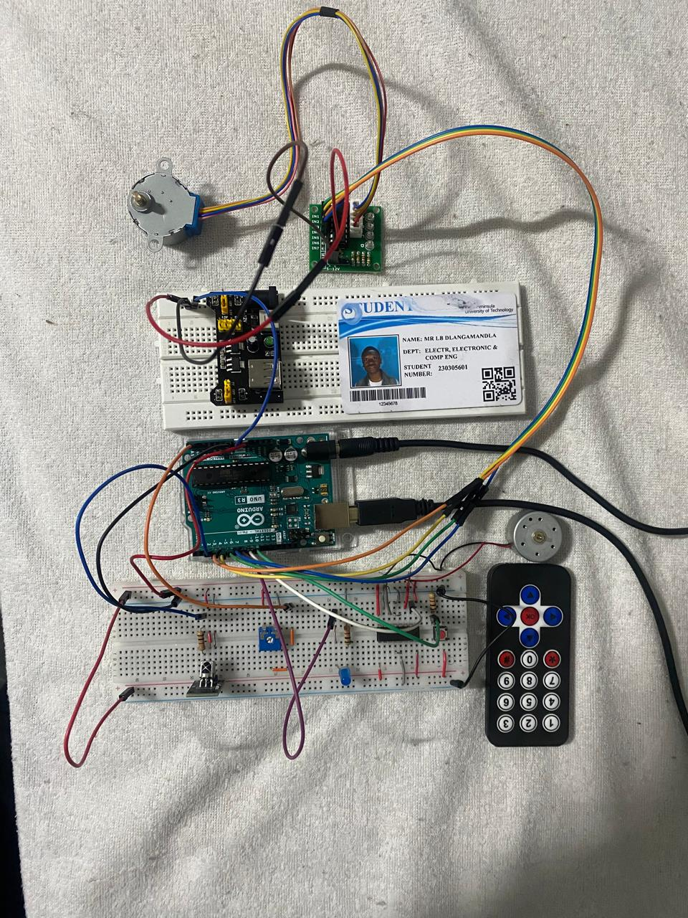
Figure 4: Physical Circuit
The physical prototype was assembled on a breadboard using an Arduino Uno, IR receiver, stepper motor, DC pump, solenoid valve, and analog water-level sensor. The power was supplied via an Infrared communication and a breadboard power supply. The IR remote transmits power levels into the Arduino, which manages each washing cycle accordingly. The key enhancements include a transistor-based motor switch and diode protection which stabilizes the current flow. Real-time testing showed the system reliably paused under low sunlight and resumed when power returned, validating the embedded control and energy management under real-world conditions
Program code
#include <IRremote.hpp>

// --- Pin mapping ---
const int led1 = 4;
const int led2 = 5;
const int led3 = 6;
const int led4 = 7;
const int inValve = 8; // Inlet valve (Blue LED)
const int pumpPin = 9; // Drain pump motor
const int startButton = 10; // Start button
const int waterLevel = A5; // Potentiometer simulating water level
const int IR_RECEIVE_PIN = 3; // Infrared remote sensor pin

int powerLevel = 0; // 0–3 received from IR

// -------------------- Setup --------------------
void setup() {
pinMode(led1, OUTPUT);
pinMode(led2, OUTPUT);
pinMode(led3, OUTPUT);
pinMode(led4, OUTPUT);
pinMode(inValve, OUTPUT);
pinMode(pumpPin, OUTPUT);
pinMode(startButton, INPUT_PULLUP);
Serial.begin(9600);
Serial.println("Washing machine ready. Press Start...");

IrReceiver.begin(IR_RECEIVE_PIN, ENABLE_LED_FEEDBACK);
}

// -------------------- Loop --------------------
void loop() {
checkPower(); // Continuously check for IR signals

// Wait for the Start button to be pressed
if (digitalRead(startButton) == LOW) {
Serial.println("\n===================================");
Serial.println("Start button pressed. Program running...");
Serial.println("===================================");
delay(1000);

// --- Main program sequence ---

// --- Stage 1: Initial Fill & Wash ---
waitForPower(2); // Wait for at least power level 2 to start washing

fillDrum("for Wash");
wash_rinse("washing");
draining("after Wash");

// --- Stage 2: Fill & Rinse ---
waitForPower(2);
fillDrum("for Rinse");
wash_rinse("rinsing");
draining("after Rinse");

// --- Stage 3: Spin ---
waitForPower(3);
spinCycle();

Serial.println("\n===================================");
Serial.println("Program finished. Ready for next cycle.");
Serial.println("===================================");

while(digitalRead(startButton) == LOW) {
// Wait for button to be released
}
}
}

// -------------------- Functions --------------------

// Fill drum with water until it reaches 80%
void fillDrum(String stage) {
Serial.print("\nFilling water ");
Serial.println(stage);

digitalWrite(inValve, HIGH); // Open the valve (LED ON)

while (map(analogRead(waterLevel), 0, 1023, 0, 100) < 80) {
int currentLevel = map(analogRead(waterLevel), 0, 1023, 0, 100);
Serial.print("\nCurrent Level: " + String(currentLevel) + "%\r");
delay(1000);
}

digitalWrite(inValve, LOW); // Close the valve
Serial.println("\nFilling complete (80%).");
delay(2000);
}

// Drain drum until it is empty (<= 10%)
void draining(String stage) {
Serial.print("\nDraining water ");
Serial.println(stage);

digitalWrite(pumpPin, HIGH); // Turn pump motor ON

while (map(analogRead(waterLevel), 0, 1023, 0, 100) > 10) {
int currentLevel = map(analogRead(waterLevel), 0, 1023, 0, 100);
Serial.print("\nCurrent Level: " + String(currentLevel) + "%\r");
delay(100);
}

digitalWrite(pumpPin, LOW); // Turn pump motor OFF
Serial.println("\nDraining complete (<=10%).");
delay(2000);
}

// Wash/Rinse cycle
void wash_rinse(String cycleName) {
Serial.print("\nCycle: ");
Serial.println(cycleName);

// 3 full rotations CW
rotateDrumCW(3, 200);
delay(1000);

// 3 full rotations CCW
rotateDrumCCW(3, 200);
delay(1000);
}

//Spin Cycle
void spinCycle() {
Serial.println("\nSpin cycle: high speed...");

digitalWrite(pumpPin, HIGH);
rotateDrumCW(20, 50); // 20 full rotations at high speed
digitalWrite(pumpPin, LOW);

Serial.println("Spin complete.");
}

// --- Utility Functions ---

void checkPower() {
if (IrReceiver.decode()) {
unsigned long command = IrReceiver.decodedIRData.command;
if (command == 12) powerLevel = 0; // Button "0"
if (command == 16) powerLevel = 1; // Button "1"
if (command == 17) powerLevel = 2; // Button "2"
if (command == 18) powerLevel = 3; // Button "3"
Serial.print("Power Level updated to: ");
Serial.println(powerLevel);
IrReceiver.resume();
}
}

void waitForPower(int requiredLevel) {
if (powerLevel >= requiredLevel)
return;

Serial.println("-----------------------------------");
Serial.print("Waiting for power level >= ");
Serial.print(requiredLevel);
Serial.print(" (Current: ");
Serial.print(powerLevel);
Serial.println(")");
Serial.println("-----------------------------------");

while (powerLevel < requiredLevel) {
checkPower();
digitalWrite(led1, LOW);
delay(200);
}
Serial.println("Sufficient power received. Resuming program...");
}

// --- Stepper Motor Emulation ---
// Two LEDs ON per step to simulate magnetic overlap like a real stepper

void rotateDrumCW(int rotations, int stepDelay) {
Serial.println("\n[Drum Rotation: CLOCKWISE]");
for (int r = 0; r < rotations; r++) {
digitalWrite(led1, HIGH);
digitalWrite(led2, HIGH);
digitalWrite(led3, LOW);
digitalWrite(led4, LOW);
delay(stepDelay);
digitalWrite(led1, LOW);
delay(stepDelay);

digitalWrite(led2, HIGH);
digitalWrite(led3, HIGH);
digitalWrite(led4, LOW);
digitalWrite(led1, LOW);
delay(stepDelay);
digitalWrite(led2, LOW);
delay(stepDelay);

digitalWrite(led3, HIGH);
digitalWrite(led4, HIGH);
digitalWrite(led1, LOW);
digitalWrite(led2, LOW);
delay(stepDelay);
digitalWrite(led3, LOW);
delay(stepDelay);

digitalWrite(led4, HIGH);
digitalWrite(led1, HIGH);
digitalWrite(led2, LOW);
digitalWrite(led3, LOW);
delay(stepDelay);
digitalWrite(led4, LOW);
delay(stepDelay);
}

// Turn off all LEDs at the end of rotation
digitalWrite(led1, LOW);
digitalWrite(led2, LOW);
digitalWrite(led3, LOW);
digitalWrite(led4, LOW);
Serial.println("[CW Rotation Complete]");
}

void rotateDrumCCW(int rotations, int stepDelay) {
Serial.println("\n[Drum Rotation: COUNTERCLOCKWISE]");
for (int r = 0; r < rotations; r++) {
digitalWrite(led4, HIGH);
digitalWrite(led1, HIGH);
digitalWrite(led2, LOW);
digitalWrite(led3, LOW);
delay(stepDelay);
digitalWrite(led1, LOW);
delay(stepDelay);

digitalWrite(led3, HIGH);
digitalWrite(led4, HIGH);
digitalWrite(led1, LOW);
digitalWrite(led2, LOW);
delay(stepDelay);
digitalWrite(led4, LOW);
delay(stepDelay);

digitalWrite(led2, HIGH);
digitalWrite(led3, HIGH);
digitalWrite(led1, LOW);
digitalWrite(led4, LOW);
delay(stepDelay);
digitalWrite(led3, LOW);
delay(stepDelay);

digitalWrite(led1, HIGH);
digitalWrite(led2, HIGH);
digitalWrite(led3, LOW);
digitalWrite(led4, LOW);
delay(stepDelay);
digitalWrite(led2, LOW);
delay(stepDelay);
}

// Turn off all LEDs at the end of rotation
digitalWrite(led1, LOW);
digitalWrite(led2, LOW);
digitalWrite(led3, LOW);
digitalWrite(led4, LOW);
Serial.println("[CCW Rotation Complete]");
}

Findings

Explanation of findings
On the simulation circuit everything was working except for the LEDs and the DC motor since the DC motor was not supposed to use power from Arduino but only from the power supply, whenever I would try to connect to the Arduino pin with the positive terminal connected to the power supply the Arduino would burn. The LEDs were not working correctly due to not being able to turn on one LED to indicate the direction of the direct drive and the LEDs were just moving in 2 pairs only. Everything else worked correctly because the potentiometer could detect whenever water was above 80% or less than 10% and stop until conditions are met, the inferred sensor which was representing the solar panel was able to change into different level of power.
On the physical circuit the stepper motor was not working at all and the DC motor kept on causing error on the Arduino, and the L293D was not working correctly due to the wiring on the breadboard. Everything else was working well, the inferred sensor could detect the inputs from the remote, and the potentiometer could also detect water levels as well. The valve LED was working correctly as well, and the breadboard power supply was supplying sufficient power.

Simulation Serial Monitor
The system correctly follows the programmed washing stages which are Fill, Wash, Rinse, Drain, and Spin using LEDs to represent the motor movement. Each stage is timed to complete within one minute as per the project requirement. The Serial Monitor output now confirms that the Arduino successfully transitions between stages and displays the current operation on-screen.
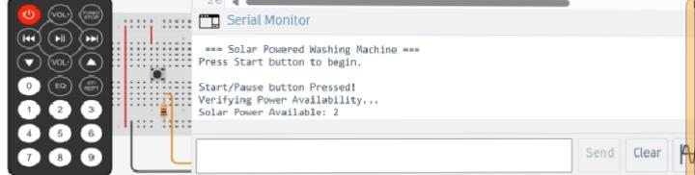
Figure 5: Serial monitor showing system initialization
This output confirms that the Arduino successfully initialized and is waiting for the start button. When the start button is pressed, it verifies the solar power before beginning the washing cycle. The IR signal correctly sent a “power level 2,” indicating sufficient energy to start the machine.
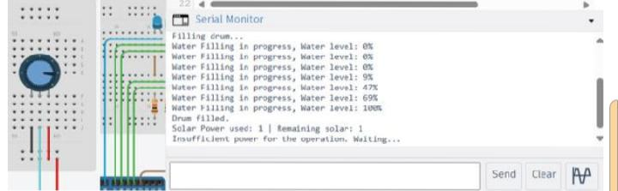
Figure 6: Serial monitor during the fill stage
During the filling process, the analog input from the simulated water sensor (potentiometer) increases gradually until it reaches 80%. The system correctly stopped filling when the water level successfully reached 80%. This proves that the water level logic and water level calculation conversion formula that was calculated above worked properly in the simulation.
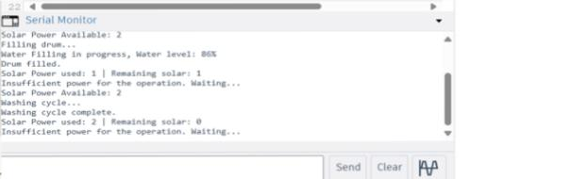
Figure 7: Serial Monitor during washing cycle
The IR sensor value was manually adjusted to represent different sunlight levels like a solar. When the simulated sunlight dropped below the set threshold, the system automatically paused the operation and stopped the cycle until power is available again. Once the sunlight was restored, the program resumed the operation and continued with the next stage. This verified that the power management and pause-resume logic were functioning correctly in the program. The rinsing function followed the same logic as the washing cycle, showing that the software structure was modular and reusable. Both filling and draining behaviors repeat successfully.
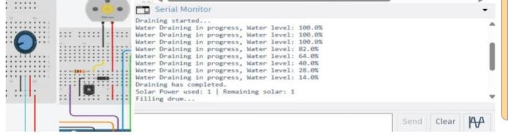
Figure 8: Serial monitor during the draining
The system activates the DC motor as a pump and keeps it running until the water level falls below 10%. The readings gradually decrease, in which it was showing that the analog sensor values were updating correctly. Once the threshold was reached, the pump turned off, and the program advanced to the next cycle.
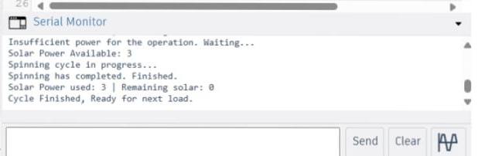
Figure 9: Serial monitor during the spinning and completion cycle

Physical Serial Monitor
The readings confirm that the real hardware behaves like the simulation. The Serial Monitor displays the current cycle name, and the DC motor responds accordingly. When the sunlight level drops, the system pauses to protect the motor from undervoltage and automatically resumes when the level sunlight increases again.
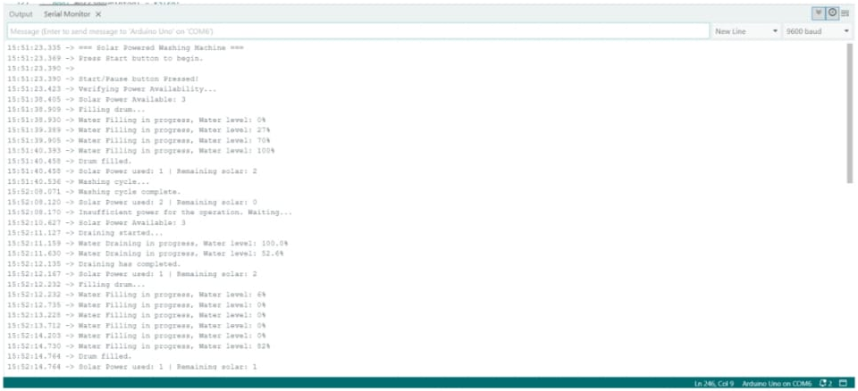
Figure 10: Physical circuit serial monitor (1 of 2)
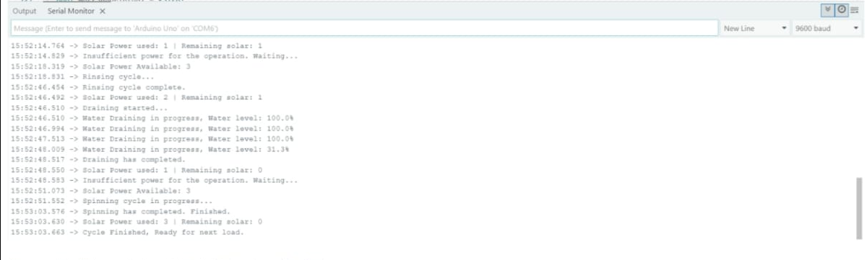
Figure 11: Physical circuit serial monitor (2 of 2)
The Serial Monitor outputs from the physical Arduino circuit from the above two figures they match the simulation results, confirming that the same code executed correctly on real hardware. The only noticeable difference is that the timing delay was caused by the real sensor response and the motor operation. Therefore, only key parts of the physical Serial Monitor outputs are shown here to avoid repetition.

Quantitative Analysis
To evaluate the energy performance, the system was put in a test under three sunlight intensity conditions: 80%, 60%, and 40% irradiance. Voltage and current readings of the DC motor were measured using a multimeter and they were confirmed in a simulation. The collected data is presented in Table 1.
Test Condition | Average Motor Voltage (V) | Average Current (A) | Input Power (W) | Efficiency (%) | Cycle Times (s)
80% irradiance | 4.96 | 1.17 | 5.80 | 77.9 | 60
60% irradiance | 3.72 | 0.88 | 3.27 | 74.1 | 70
40% irradiance | 2.48 | 0.58 | 1.44 | 70.3 | 80

The data shows that the system performs best at 80% irradiance, drawing approximately 1.17 A at 4.96 V. As the irradiance decreases, both the voltage and the current they drop, which reduces the available torque and extends the cycle time. Despite this, the Arduino controller still maintains full operation, automatically pausing when the voltage becomes unstable and resumes when sunlight recovers.
A clear trend was observed where cycle time increases linearly as solar input decreases. The relationship between solar voltage and washing cycle time is illustrated in Figure 11. The behavior confirms that the washing machine adapts effectively to varying sunlight levels while it maintains efficient energy use.
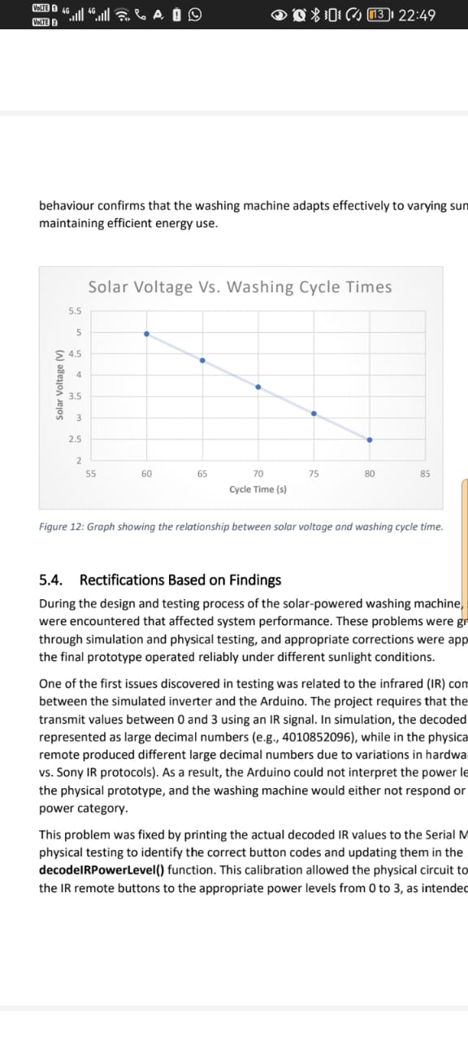
Figure 12: Graph showing the relationship between solar voltage and washing cycle time

Rectifications based on findings
The two things that were not working correctly were the DC motor and the LEDs that act as the stepper motor. The DC motor was not working correctly due to the connection to the Arduino in which the DC moto was drawing power from the Arduino which was burning the Arduino. Connecting the NPN transistor to the DC motor and the positive terminal of the DC motor to the power supply enabled the DC motor to draw power from the power supply. The LEDs were not doing the 1 step/2 step sequence to show the direction of the coils, stating the sequence on the code made the LEDs to work correctly and rotate in the sequence of 1 step/2step.
On the physical circuit the DC motor was not correctly connected to the Arduino, the use of the L293D helped to enable the DC motor to draw more power from the breadboard power supply. The L293D was also not wired correctly which caused faults to the DC motor and the stepper motor, discovered that the jumper wires used to connect were faulty and changed them which resulted in the whole circuit working properly.

Conclusion
The solar-powered washing machine project successfully achieved its goal of operating fully on solar energy without relying on the electrical grid. The system automatically controlled all washing cycles—filling, washing, rinsing, draining, and spinning—based on the amount of solar power that was available. Both the simulated and physical circuits proved that the design could pause when the energy from the sunlight was not enough and resumed the operation once power was enough. This confirmed that renewable energy can be applied practically to household appliances, improving sustainability and reducing costs for users in off-grid and on-grid areas.

Scope and Limitations
Although the washing machine worked as expected, it still had limitations. The design was developed for small-scale testing, meaning it cannot handle a real washing machine motor or heavy mechanical loads. The system also depends on continuous sunlight; during long periods of cloudy weather or at night, it cannot operate unless an external battery is to be added. The Arduino Uno has limited processing power and memory, so advanced features such as load sensing, water heating, or precise energy monitoring were not included. These limitations mean that, while the prototype demonstrates the concept effectively, a real household version would need stronger components and more powerful control system.

Recommendation
For future improvements, several changes can be made, by enhancing the performance and reliability of the system. A dedicated charge controller and larger battery can be added to store excess solar energy and allow operation at night or whenever there is low sunlight. Replacing the DC motor with a brushless motor would improve efficiency and durability for the system. Adding sensors for the temperature, water flow, and drum load could make the washing process smarter and automatic. If the system is redesigned, using a more capable micro-controller such as the ESP32 or STM32 as they can allow better power management and wireless data monitoring. These improvements would make the washing machine more practical for real-world use and further support the goal of promoting renewable energy in household applications.

Appendices

References
Marsh, J., 2024. How many watts does a washing machine use? [online] EnergySage. Available at: https://www.energysage.com/electricity/house-watts/how-many-watts-does-a-washingmachine-use/ [Accessed 6 June 2025].
G, D., 2020. TinkerCAD Part 6. Motors, Transistors, Arduino. [YouTube] Available at: https://www.youtube.com/watch?v=OulgDvPZiUQ&t=137s [Accessed 05 August 2025].
Kim, M. & Suh, T., 2021. Eavesdropping Vulnerability and Countermeasure in Infrared Communication for IoT Devices. ensors , 21(24), p. Article number: 8207.
Nalina, B. S. et al., 2023. Design and Implementation of Embedded Controller-Based. Electronics, 12(2), p. Article 341. Pakula , C. & Stamminger, R., 2023. Electricity and water consumption for laundry washing by washing machine worldwide. Energy Efficiency, 3(4), pp. 365-382.
Persson, T. & Ronnelid, M., 2007. Increasing solar gains by using hot water to heat dishwashers and washing machines. Applied Thermal Engineering, 27(2-3), pp. 646-657.
Student name……………………………………… Student number………………………………………………….
Category |  | Description | Examiner | Moderator | Maximum mark
Record FISA | Circuit Simulation Picture | Communication devices |  |  | 2 | 10
Record FISA | Circuit Simulation Picture | LEDs emulate Direct Drive motor |  |  | 2 | 10
Record FISA | Circuit Simulation Picture | Drum’s “motor” connections to Arduino |  |  | 2 | 10
Record FISA | Circuit Simulation Picture | Water sensor’s connections |  |  | 1 | 10
Record FISA | Circuit Simulation Picture | Valve connections |  |  | 1 | 10
Record FISA | Circuit Simulation Picture | Pump’s connections |  |  | 1 | 10
Record FISA | Circuit Simulation Picture | On/pause button |  |  | 1 | 10
Record FISA | Physical Circuit Picture | Communication devices |  |  | 2 | 10
Record FISA | Physical Circuit Picture | Power is connected correctly to drum motor |  |  | 2 | 10
Record FISA | Physical Circuit Picture | Control signal of drum motor correctly connected |  |  | 1 | 10
Record FISA | Physical Circuit Picture | Power is connected correctly to pump |  |  | 1 | 10
Record FISA | Physical Circuit Picture | Power is connected correctly to Arduino |  |  | 1 | 10
Record FISA | Physical Circuit Picture | Water level sensor |  |  | 1 | 10
Record FISA | Physical Circuit Picture | LED for valve |  |  | 1 | 10
Record FISA | Physical Circuit Picture | On/pause button |  |  | 1 | 10
Record FISA | Software | Drum’s motor moves without library |  |  | 2 | 30
Record FISA | Software | Machine waits for start button to be pressed |  |  | 1 | 30
Record FISA | Software | Drum is filling with water |  |  | 2 | 30
Record FISA | Software | Washing machine pauses when power is not enough |  |  | 2 | 30
Record FISA | Software | Washing machine pauses until power is enough. |  |  | 2 | 30
Record FISA | Software | Washing machine pauses for different power levels |  |  | 2 | 30
Record FISA | Software | Drum is turning |  |  | 2 | 30
Record FISA | Software | Drum is turning in both directions |  |  | 2 | 30
Record FISA | Software | Seemingly no unnecessary code |  |  | 2 | 30
Record FISA | Software | Two LEDs on every second step |  |  | 2 | 30
Record FISA | Software | One LED on every second step. |  |  | 1 | 30
Record FISA | Software | Emptying the drum |  |  | 2 | 30
Record FISA | Software | Spinning |  |  | 2 | 30
Record FISA | Software | All cycles are included |  |  | 2 | 30
Record FISA | Software | Washing machine pauses for power during multiple cycles |  |  | 2 | 30
Record FISA | Software | The Arduino does not burn out during any of these cycles |  |  | 2 | 30
Record FISA | Record layout |  |  |  | 1 | 25
Record FISA | Circuit diagram for simulated circuit | Drum motor |  |  | 2 | 25
Record FISA | Circuit diagram for simulated circuit | pump |  |  | 1 | 25
Record FISA | Circuit diagram for simulated circuit | Valve |  |  | 1 | 25
Record FISA | Circuit diagram for simulated circuit | Water level sensor |  |  | 1 | 25
Record FISA | Circuit diagram for simulated circuit | Communication devices |  |  | 2 | 25
Record FISA | Circuit diagram for simulated circuit | Start button |  |  | 1 | 25
Record FISA | Circuit diagram for physical circuit | Drum motor connections |  |  | 2 | 25
Record FISA | Circuit diagram for physical circuit | Drum motor controller |  |  | 1 | 25
Record FISA | Circuit diagram for physical circuit | Controller to Arduino connections |  |  | 2 | 25
Record FISA | Circuit diagram for physical circuit | Power connections for drum motor |  |  | 1 | 25
Record FISA | Circuit diagram for physical circuit | Pump |  |  | 1 | 25
Record FISA | Circuit diagram for physical circuit | Power connections for pump |  |  | 2 | 25
Record FISA | Circuit diagram for physical circuit | Start button |  |  | 1 | 25
Record FISA | Circuit diagram for physical circuit | valve |  |  | 1 | 25
Record FISA | Circuit diagram for physical circuit | Communication devices |  |  | 2 | 25
Record FISA | Circuit diagram for physical circuit | Water level sensor |  |  | 1 | 25
Record FISA | Renewable energy |  |  |  | 1 | 25
Record FISA | Calculations |  |  |  | 1
Demonstration | Simulated hardware layout | Machine waits for button to be pressed |  |  | 2 | 15
Demonstration | Simulated hardware layout | Water valve functioning |  |  | 2 | 15
Demonstration | Simulated hardware layout | Student knows when to adjust water level |  |  | 2 | 15
Demonstration | Simulated hardware layout | Drum is rotating |  |  | 2 | 15
Demonstration | Simulated hardware layout | Pumping |  |  | 2 | 15
Demonstration | Simulated hardware layout | Student know when to adjust water level for all conditions |  |  | 2 | 15
Demonstration | Simulated hardware layout | Student knows how to send available power level |  |  | 2 | 15
Demonstration | Simulated hardware layout | Demonstrated in designated time |  |  | 1 | 15
Presentation | Timing |  |  |  | 1 | 10
Presentation | Readable |  |  |  | 1 | 10
Presentation | Logical |  |  |  | 3 | 10
Presentation | Pictures |  |  |  | 1 | 10
Presentation | Dressed formal |  |  |  | 1 | 10
Presentation | Answers |  |  |  | 3 | 10
Total |  |  |  |  | 100 | 100

