GA1 Project: Building and Validating an SDN-Driven Virtual Network in GNS3.
Student Name, Surname: | Lubabalo Dlangamandla
Student Number:
Date: | 23 October 2025
Leave Empty for examiner:

EXAMINER NAME
INTERNAL MODERATOR
EXTERNAL MODERATOR
Submit:
Thursday, 16 October 2025, Midnight on Blackboard.
PDF only. No zipped files or Word documents.
Demonstration:
Friday 17 October, 9 AM (demo during class time is critical (9 AM – 12 PM).
All students must report to class at 9 AM.
The demonstration validates the report.
No late demonstrations will be accepted.

Metadata (Complete with your details)
Student Number: 230305601
LAST_DIGIT: 1
SECOND LAST DIGIT: 0
THIRD LAST DIGIT: 6
ROUTER COUNT: 4 (Allowed: 4–7)
PROTOCOL: OSPF (OSPF/EIGRP)
UNIQUE Topology:

1. Introduction
State the enterprise migration problem and why it is broadly defined.
The enterprise problem refers to many complex issues and the constraints that are faced by enterprises when their network structure migrates from the legacy environment to a new environment. The symptoms of the problem are the lack of visibility, unexpected latency, costs and risk of downtime. The cause for the problem is caused when a network often has many devices, undocumented routes and older equipment which make it difficult to migrate safely. Sometimes the legacy network architectures like old WAN links do not translate cleanly into newer architectures like SDNs, this causes the drop in performance, latency and scalability. There are also risks when it comes to migrating controls, monitoring and segmentation.
The reason the problem is broadly defined is because the problem touches many dimensions of the organization, and this is due to the network acting as the underlying ‘glue’ for virtual systems. Network migration is not just moving from one router to another router, it covers many layers and domains which include legacy network equipment, cabling, routing, switching, traffic flows and cloud connectivity. Migrations often expose hidden dependencies that make the migration problem more complex. Also, the networking environment is changing fast since migration is not just migrating what is already there but aiming for what should be on the network environment, which makes the problem broadly defined. The problem is broadly defined as it is not confined to only one device or one link, but it involves technology layers, processes and risks.

As it covers 2. Problem Definition (GA1 – Indicator 1)
Define the migration challenge clearly, identify constraints (router limit, addressing, protocol, SDN integration).
The network migration challenge refers to the difficulty that enterprises face when moving their network infrastructure from one environment to another while maintain performance. The network is between environments, and the main objective of migration is to improve performance, availability, security and scalability during and after migration. The challenge can be faced by enterprises since they have e massive networks which involve multiple transport types. Undocumented independencies like the lack of network visibility and inventory create blind spots which can make planning migration risky. As the network is the foundation of all applications so now any misstep can impact the whole business operations and because of this, the migrations challenge is very broad and cannot be solved by a single tactic.
Constraints | Key challenges
Router Capability | Routers lack support from newer protocols such as OpenFlow and SDN APIs. The replacement of every device is costly and disruptive. Routers cannot just be moved or upgraded because the device capability vis a bottleneck.
IP addressing | Enterprises face challenges of IPv4 exhaustion during migration or when moving between networks. Also, since the role of the IP address is both a locator and identifier, this causes migration issues like when a host location changes now, we must change the IP address.
Protocol | When migration takes place, it means that we have to use different routing protocols with new paradigms and now coordination creates challenges of risks. The protocol compatibility and routing transition must be planned carefully because mismatches can lead to service interruptions.
SDN Integration | Moving to integrating SDNs places demands like placing controllers, ensuring controller latency is acceptable which is like when binding the number of switches to the corresponding SDN controller and that depends on the traffic volume. Also, scalability of SDN controllers can be a constraint when migrating large networks.

3. Formulate Strategies (GA1 – Indicator 2)
Compare static vs dynamic routing, justify your chosen protocol, and present alternatives with pros/cons.
Static Routing | Dynamic Routing
Configuration is done manually by the admin in which the admin will insert the entry routes manually | Configurations are done automatically by using protocols like OSPF, IS-IS, etc.
It is only fixed, meaning it cannot adapt to changes in the topology unless the admin manually changes it to adapt to changes made in the topology | It automatically adapts to any changes in the topology which makes it flexible
Consists of smaller routing table sizes and its routing tables are simpler since it’s number of routes are inserted manually, they can be few of them | Consists of larger routing tables and the routing tables may have multiple possible routes which makes it complex
The routing is suitable for small and stable networks, networks that do not experience changes a lot. | The routing is suitable for large and evolving networks since it can adapt to changes automatically.
This routing is more secure since there is no automatic route sharing among routers. This means that routes are less exposed and routes cannot be just viewed from one router. | This routing has more exposure and is less secure since routes are automatically shared between routers, this means that one router has access to all routes.
The maintenance costs of this routing are low in small networks but are high in large networks | Maintenance costs for this routing are much lower since there is less manual configuration, but the maintenance is complex

The reason to choose OSPF protocol over other protocols is because the OSPF is scalable for large networks and provides manageability on the network. What OSPF does on a large network is that it breaks it down into manageable parts which leads to the reduce in routing table size and computational load. The OSPF uses link-state algorithm and routers maintain a synchronized view of a topology which makes it flexible to adapt to any changes that can be made on the topology and reduce downtime. OSPF supports Equal Cost Multi-Path routing which allows OSPF to use multiple equal-cost paths for load balancing and redundancy and it supports Variable Length Subnet Masking which gives it more flexibility in IP addressing compared to much older protocols like your RIP (Routing Information Protocol). OSPF protocol is much more of a better choice when going for modern enterprises. The things to look out for in using the OSPF protocols is that it requires more CPU since each router runs SPF calculations, more complex to configure and maintain especially in large topologies, and if poorly designed a router may suffer from lack of performance.
Protocol | Pros | Cons
EIGRP (Enhanced Interior Gateway Routing Protocol) | Uses dual algorithm for fast re-calculations of alternate paths for routers.  It considers bandwidth, delay, and reliability rather than just the hop count, which makes it to have flexible metric.  Uses less router CPU overhead than some link-state protocols. | The limitation of being used in multi-vendor environments as it can mostly be used in only Cisco Systems.  Lacks scaling as it does not have the same built-in-area structure that OSPF uses which is helpful in aiding very large networks,  Load balancing is only available in certain conditions, and it adds complexity to the system.
IS-IS (Intermediate System to Intermediate System) | IS-IS was designed for large networks and works well in large complex topologies which make it scalable  Supports multi-protocol operation and has robust links-state behavior. | IS-IS is less common in enterprise networks compared to OSPF because of its complexity, which makes it less familiar to staff.  Troubleshooting the protocol may be harder since fewer enterprises use it compared to OSPF, so community knowledge about the protocol is less
BGP (Border Gateway Protocol) | BGP allows very granular policy enforcement and path manipulation which makes it flexible and policy-rich, and beneficial in complex networks  Designed for inter-domain use in which it can be used for large enterprises, this makes the protocol scalable in large environments like the enterprises. | The configuration, policy design, and troubleshooting are highly complex compared to other protocols.  It is not always optimal for simple interior routing.  Requires more operational discipline and expertise.

4. Analysis & Evaluation (GA1 – Indicator 3)
Provide IP addressing plan, routing adjacency tables, and BGP session evidence.
IP Addressing plan
Network Address | CIDR | Subnet Mask | Usable Host Range | Assignment
10.0.12.0 | /30 | 255.255.255.252 | 10.0.12.1-10.0.12.2 | Link: Router 1 to Router 2
10.0.23.0 | /30 | 255.255.255.252 | 10.0.23.1 - 10.0.23.2 | Link: Router 2 – Router 3
10.0.31.0 | /30 | 255.255.255.252 | 10.0.31.1 - 10.0.31.2 | Link: Router 3 – Router 1
10.0.0.0 | /30 | 255.255.255.252 | 10.0.0.1 - 10.0.0.2 | Link: Router 1 – Router 4
10.0.1.0 | /30 | 255.255.255.252 | 10.0.1.1 - 10.0.1.2 | Link: Router 2 - Router 4
10.0.47.0 | /30 | 255.255.255.252 | 10.0.47.1 - 10.0.47.2 | Link: Router 3 – Router 4
192.168.47.0 | /24 | 255.255.255.255 | 192.168.47.130 - 192.168.47.139 | Cloud: Connected to Router 4
Routing Adjacency Tables
Roter 4
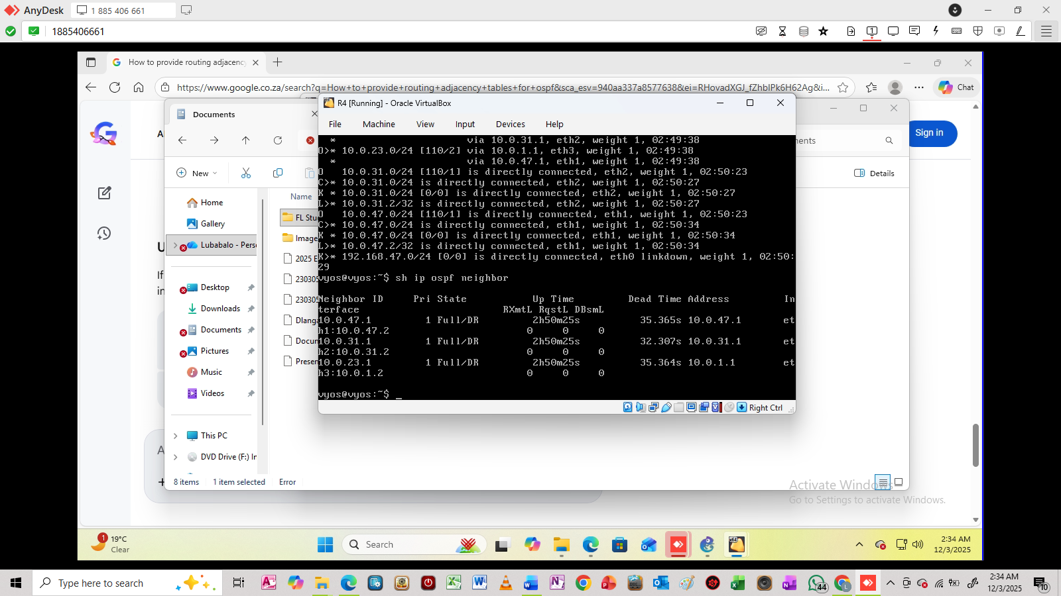
Router 1
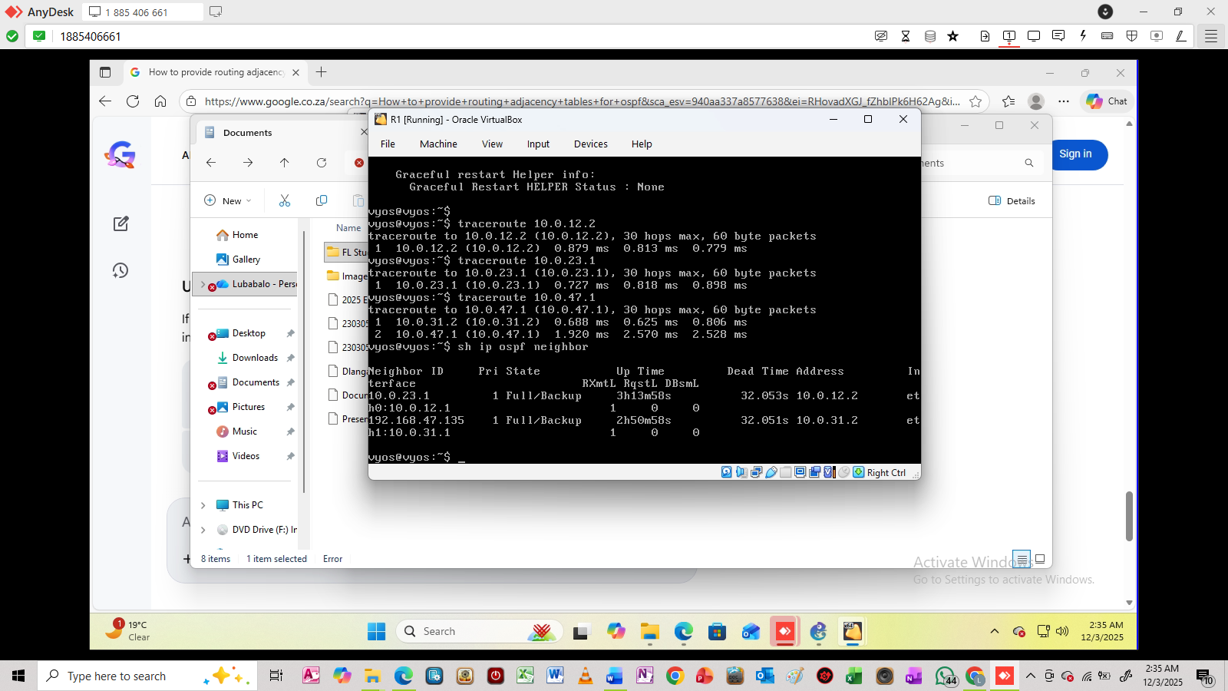
Router 2
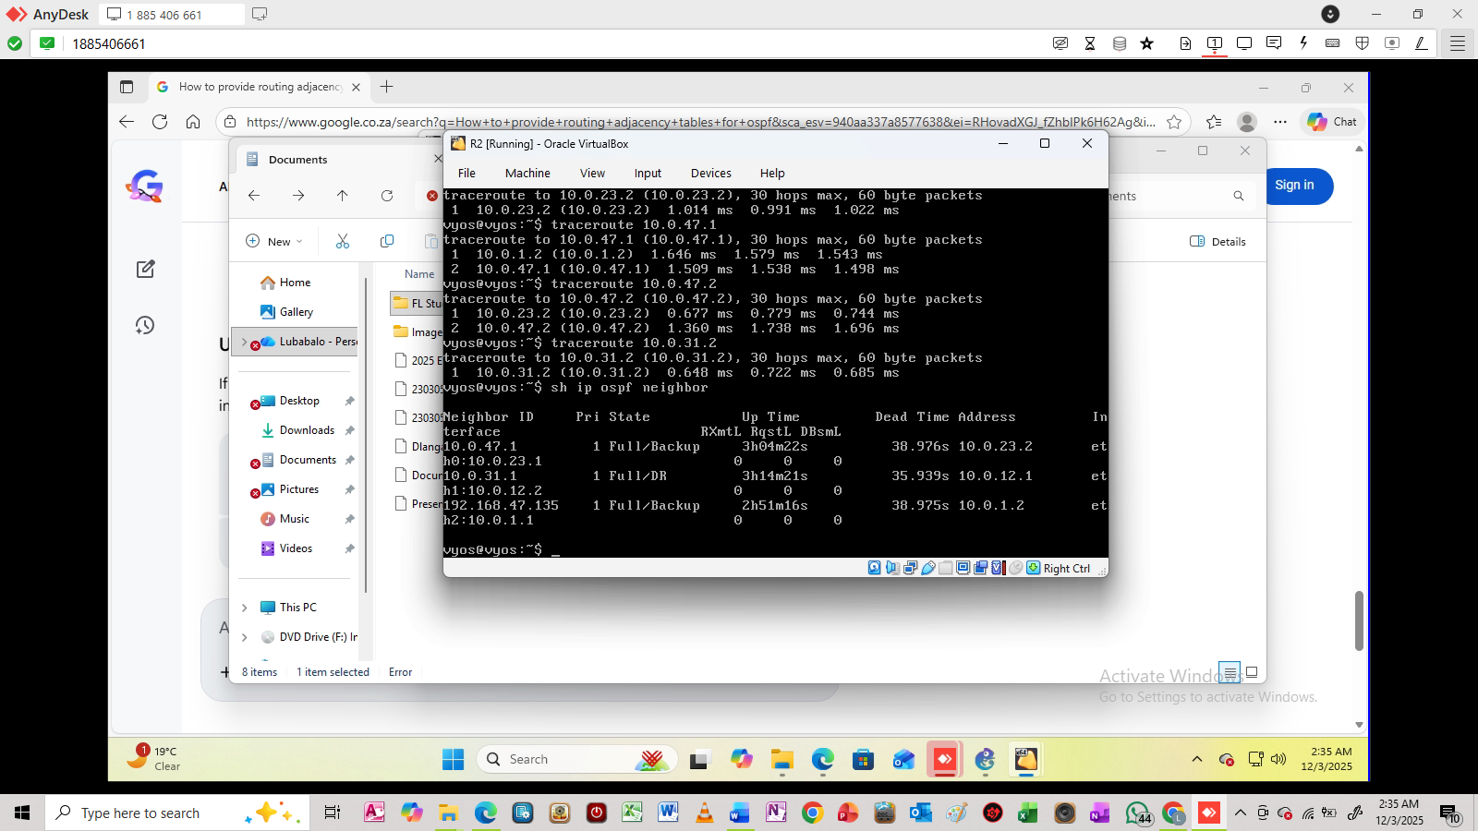
Router 3
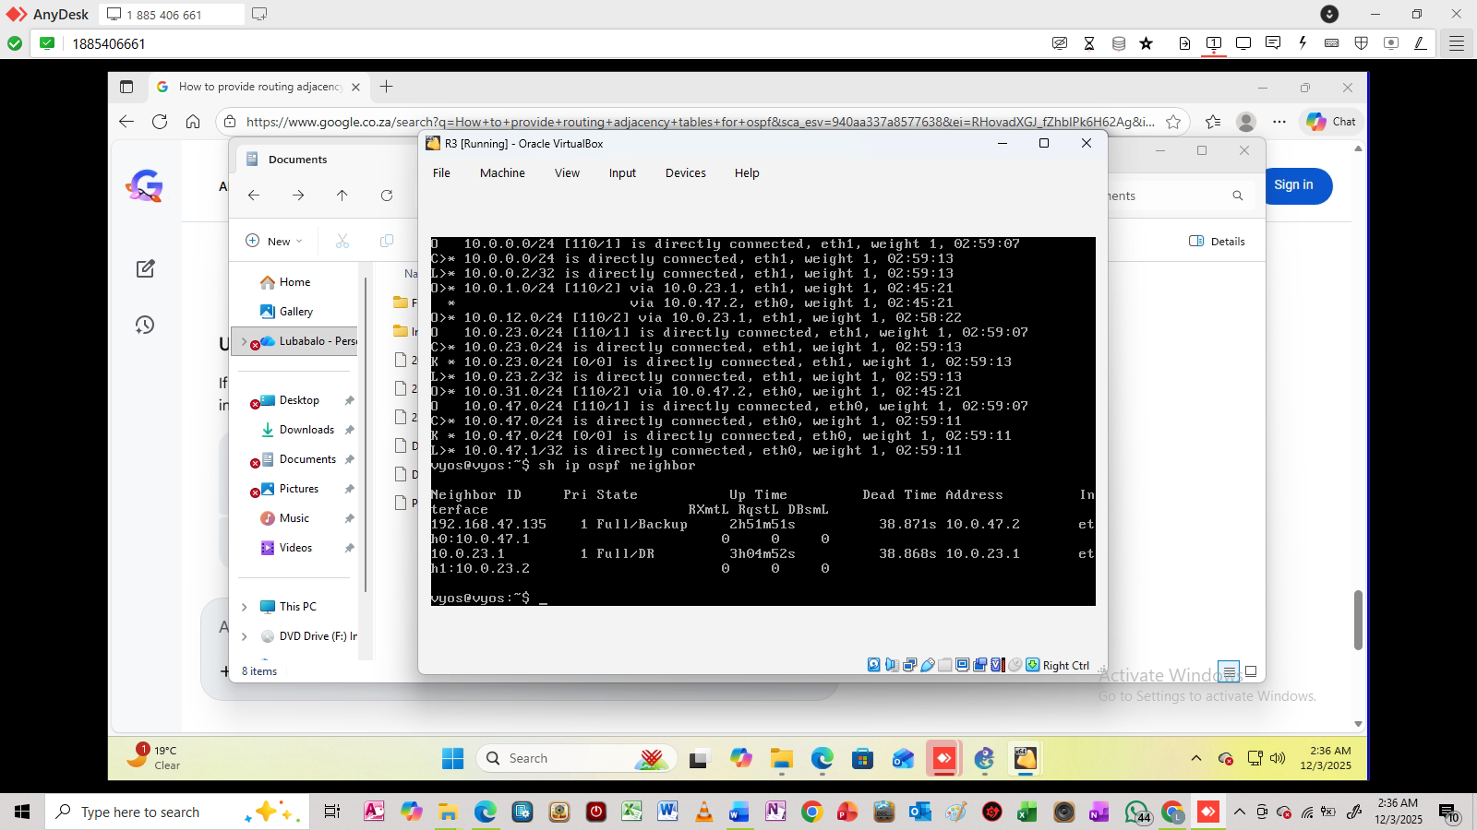

5. Implementation (GA1 – Indicator 4)
Provide VyOS configs, switch config, Postman BGP setup, and Python SDN application details.
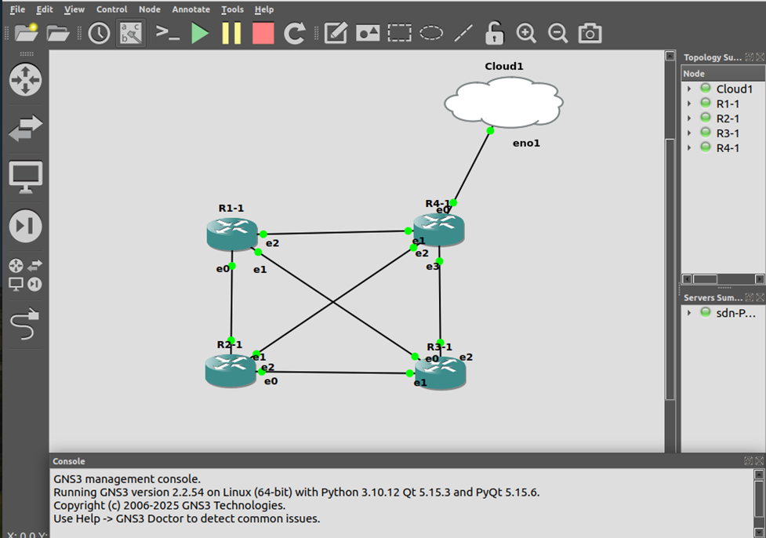
The VyOS configs
Router 1
#Setup the interfaces (eth0, eth1, eth2) in router 1 using the following commands
set interfaces ethernet eth0 address 10.0.12.1/24 #This interface connects to router 2
set interfaces ethernet eth1 address 10.0.31.1/24 #This interface connects to router 4
set interfaces ethernet eth2 address 10.0.0.1/24 #This is the interface connecting to router 3
#Now setup ospf to ensure communication among all routers(We use area 0 as it helps in preventing routing loops and ensures that all OSPF areas are connected)
set protocols ospf area 0 network 10.0.12.0/24 # On this part we only use network only to ensure that it shares the routing information and advertisement of the interface’s network prefix
set protocols ospf area 0 network 10.0.31.0/24
set protocols ospf area 0 network 10.0.0.0/24
Result
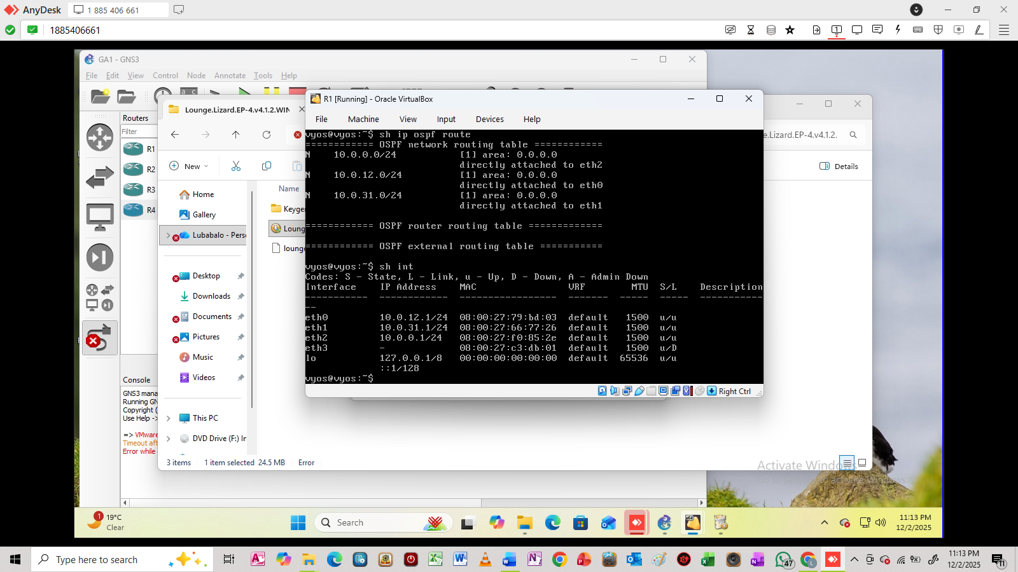

Router 2
#Setup the interfaces (eth0, eth1, eth2) in router 2 using the following commands
set interfaces ethernet eth0 address 10.0.23.1/24 #This interface connects to router 3
set interfaces ethernet eth1 address 10.0.12.2/24 #This interface connects to router 1
set interfaces ethernet eth2 address 10.0.1.1/24 #This is the interface connecting to router 4
#Now setup ospf to ensure communication among all routers(We use area 0 as it helps in preventing routing loops and ensures that all OSPF areas are connected)
set protocols ospf area 0 network 10.0.12.0/24 #On this part we only use network only to ensure that it shares the routing information and advertisement of the interface’s network prefix
set protocols ospf area 0 network 10.0.23.0/24
set protocols ospf area 0 network 10.0.12.0/24
Result
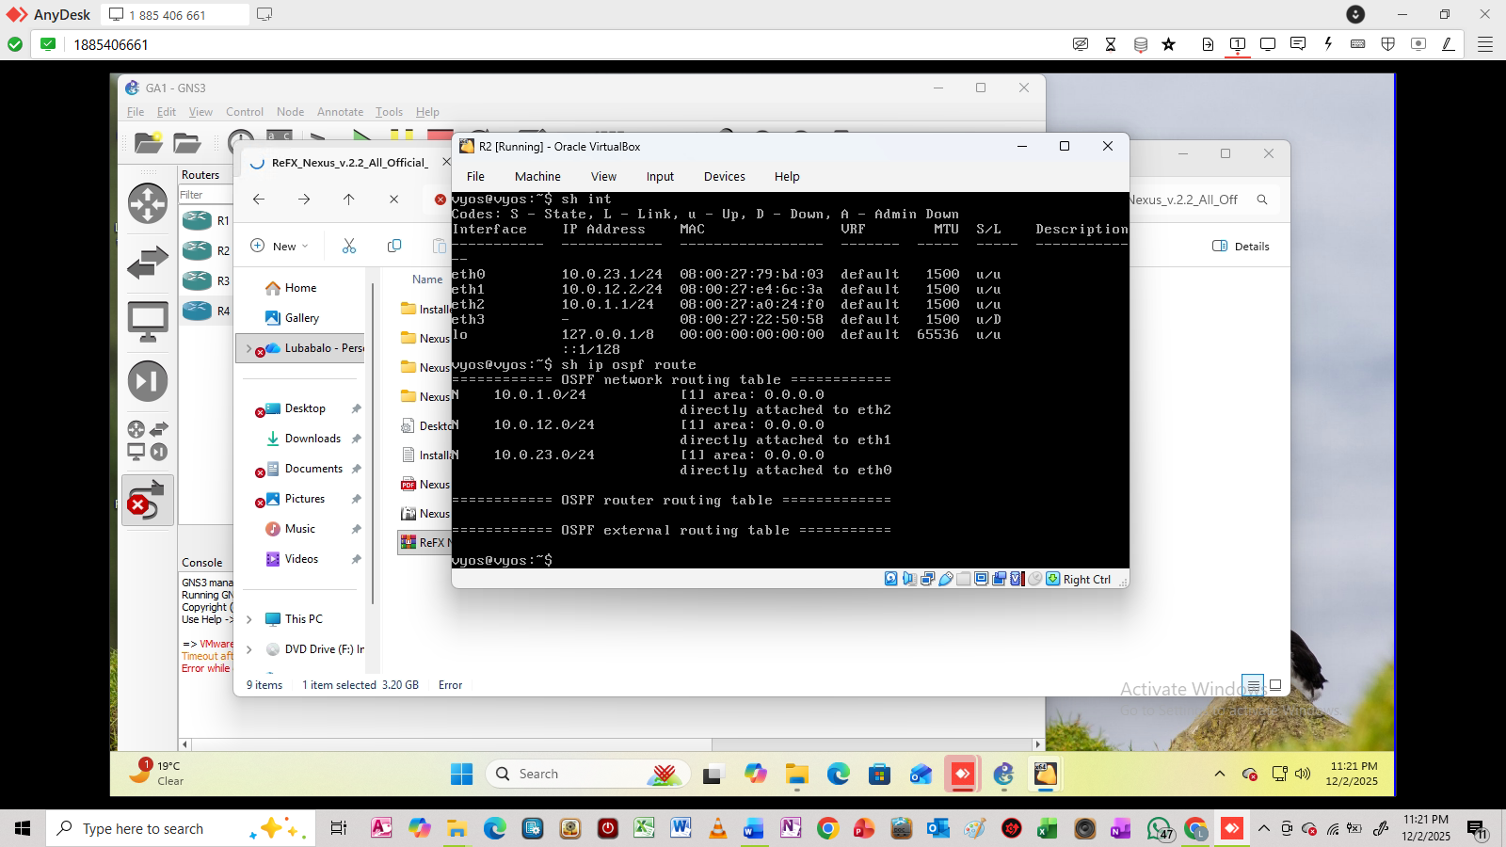
Router 3
#Setup the interfaces (eth0, eth1, eth2) in router 3 using the following commands
set interfaces ethernet eth0 address 10.0.47.1/24 #This interface connects to router 4
set interfaces ethernet eth1 address 10.0.23.2/24 #This interface connects to router 2
set interfaces ethernet eth2 address 10.0.0.2/24 #This is the interface connecting to router 1
#Now setup ospf to ensure communication among all routers(We use area 0 as it helps in preventing routing loops and ensures that all OSPF areas are connected)
set protocols ospf area 0 network 10.0.47.0/24 #On this part we only use network only to ensure that it shares the routing information and advertisement of the interface’s network prefix
set protocols ospf area 0 network 10.0.23.0/24
set protocols ospf area 0 network 10.0.0.0/24
Result
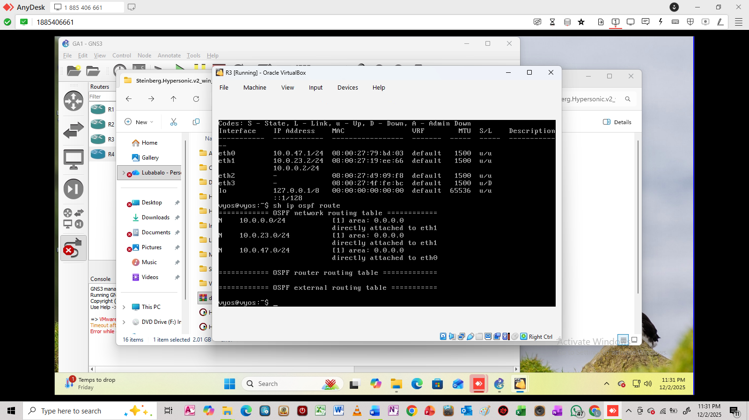
Router 4
#Setup the interfaces (eth0, eth1, eth2, eth3) in router 4 using the following commands
set interfaces ethernet eth0 address 192.168.47.135/24 #This interface connects to the cloud
set interfaces ethernet eth1 address 10.0.47.2/24 #This interface connects to router 3
set interfaces ethernet eth2 address 10.0.31.2/24 #This is the interface connecting to router 1
set interfaces ethernet eth2 address 10.0.1.2/24 #This is the interface connecting to router 2
#Now setup ospf to ensure communication among all routers(We use area 0 as it helps in preventing routing loops and ensures that all OSPF areas are connected)
set protocols ospf area 0 network 10.0.47.0/24 #On this part we only use network only to ensure that it shares the routing information and advertisement of the interface’s network prefix
set protocols ospf area 0 network 10.0.31.0/24
set protocols ospf area 0 network 10.0.1.0/24
set protocols ospf area 0 network 192.168.47.0/24
Result
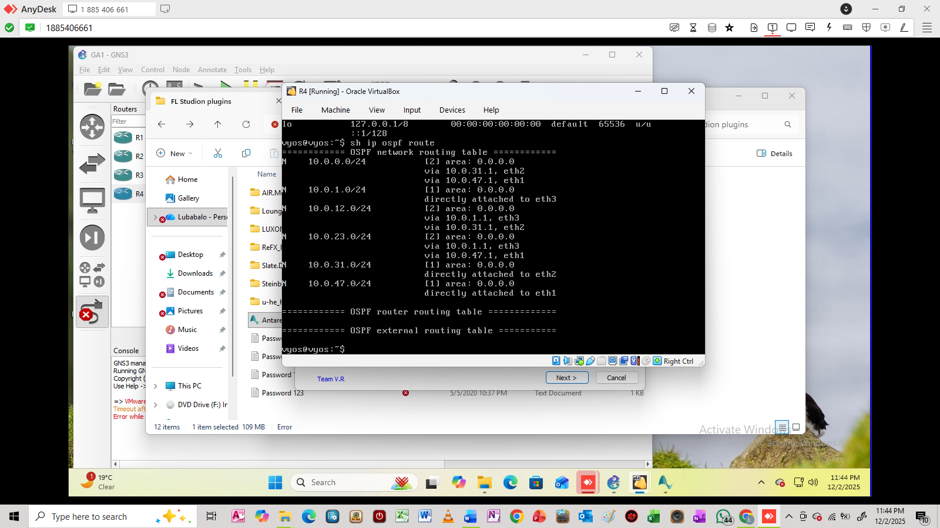
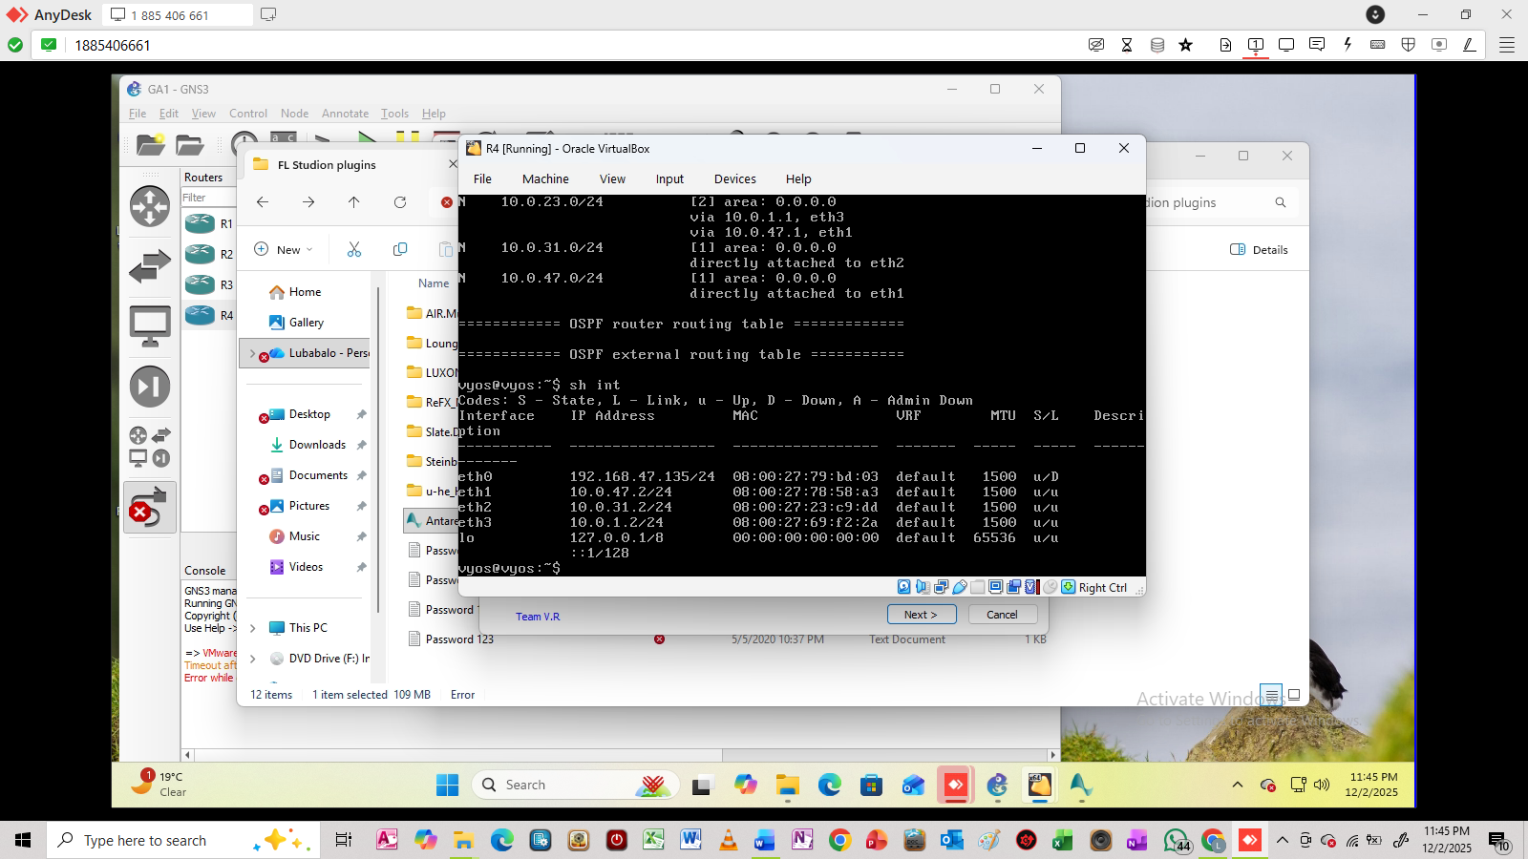
Postman BGP setup

6. Validation & Results
Show ping/traceroute results and confirm Python SDN application outputs match the actual network.
The ping results from router 1 to router 2 interfaces which are 10.0.12.2 and 10.0.23.1
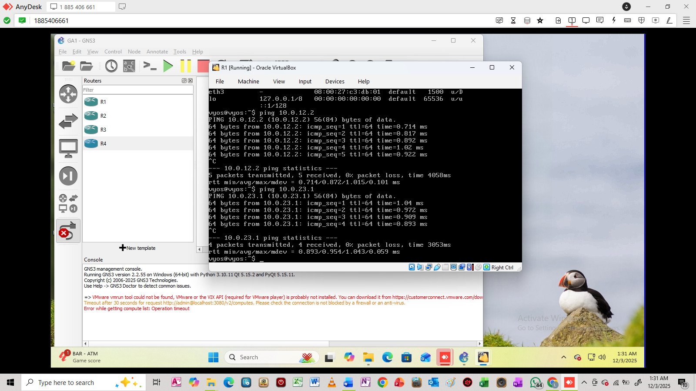
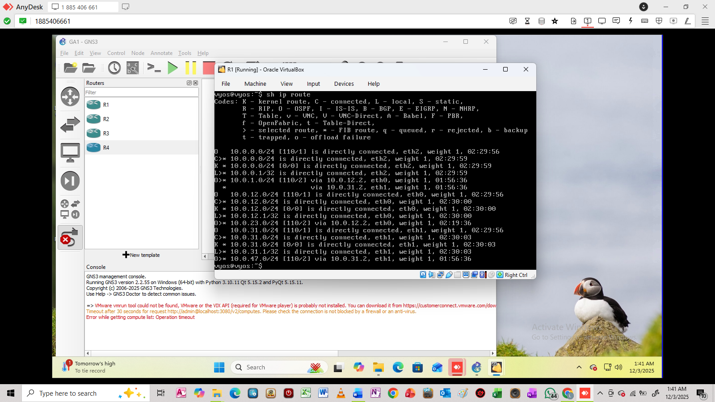
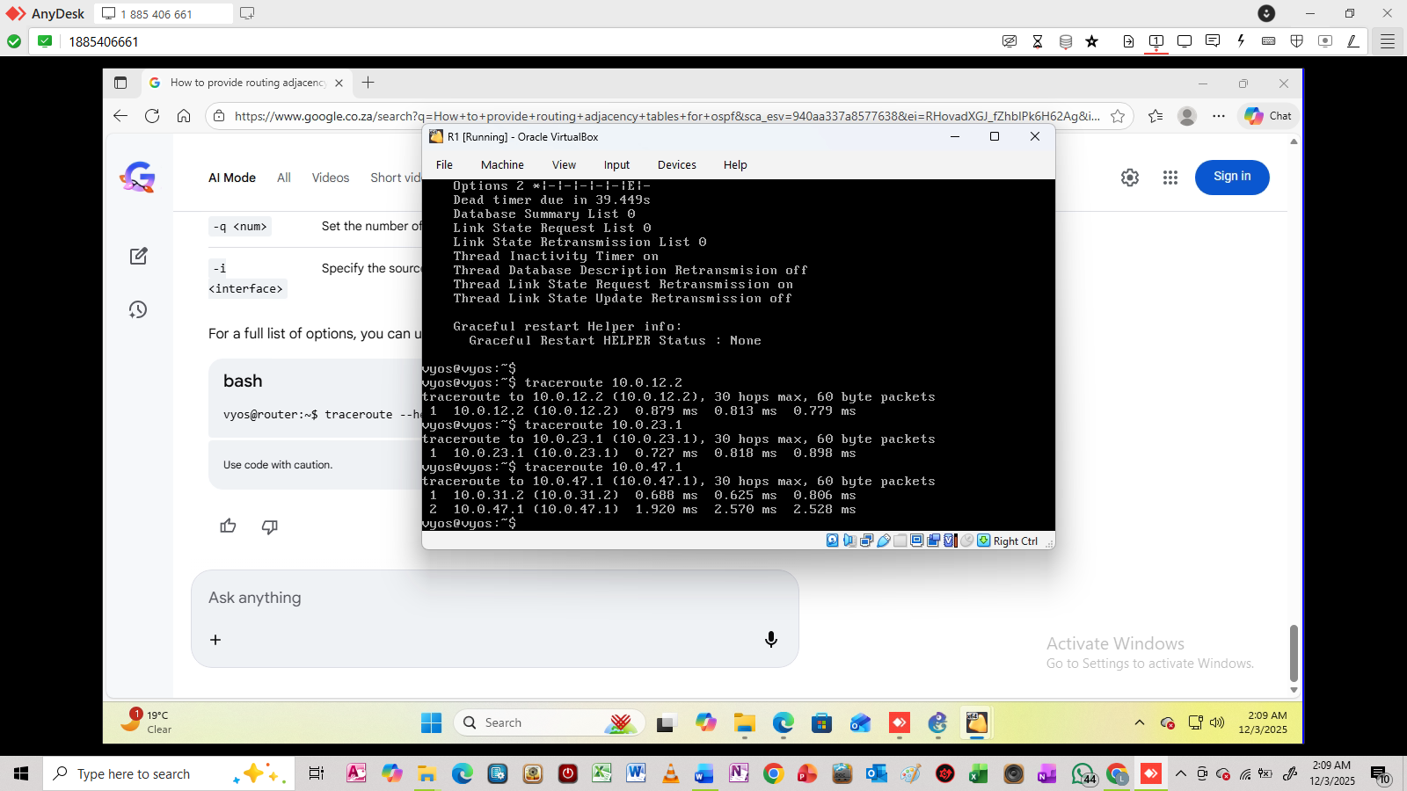
The ping and trace route results for router 2 in which router 2 is pinging to router 1, 3 and 4
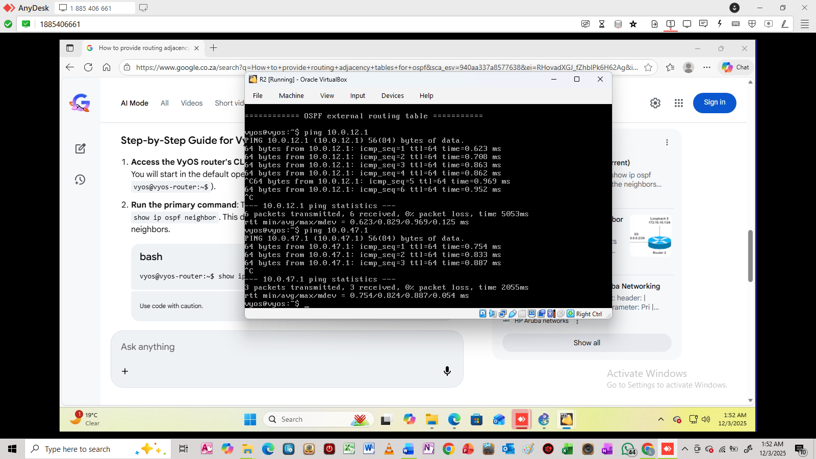
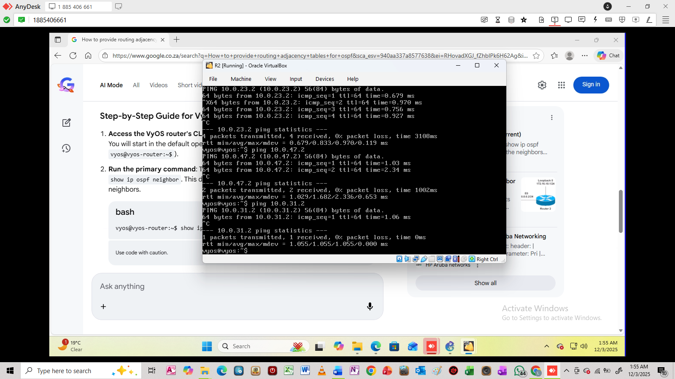
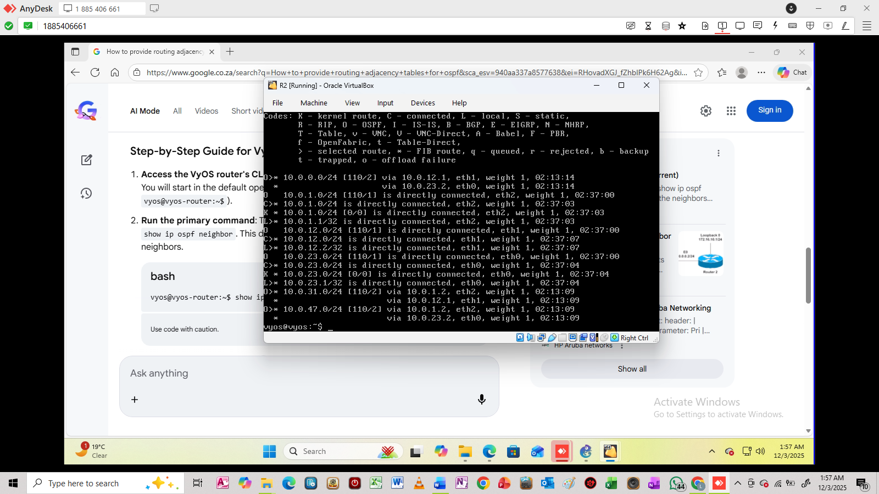
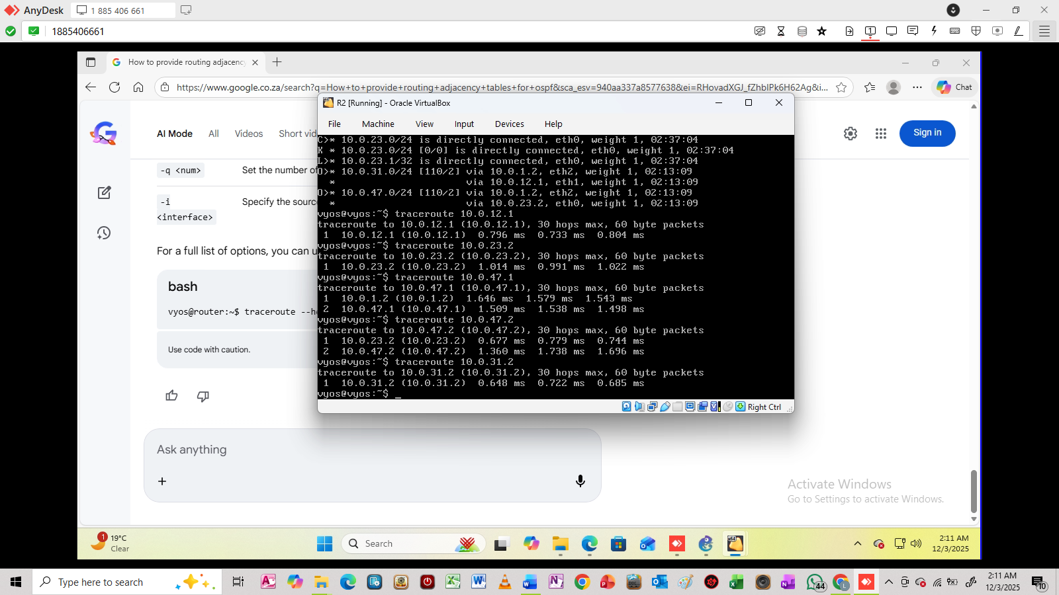
Results for pinging and traceroute for router 3 to router 1, 2, and 4
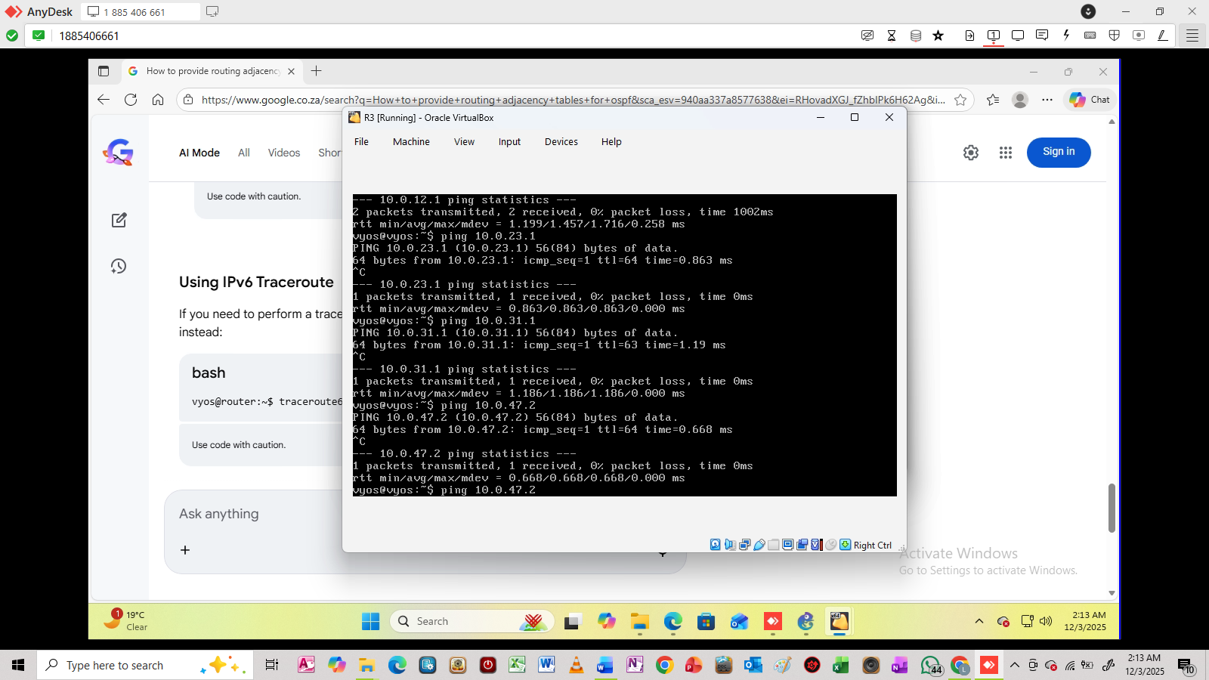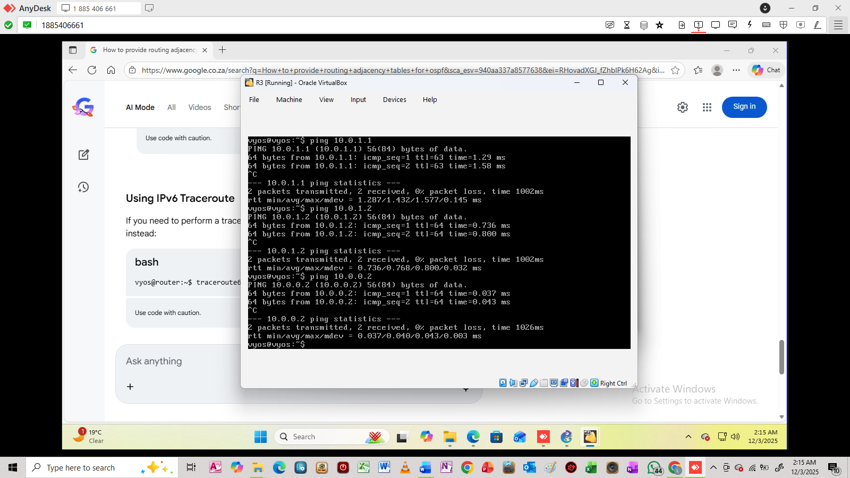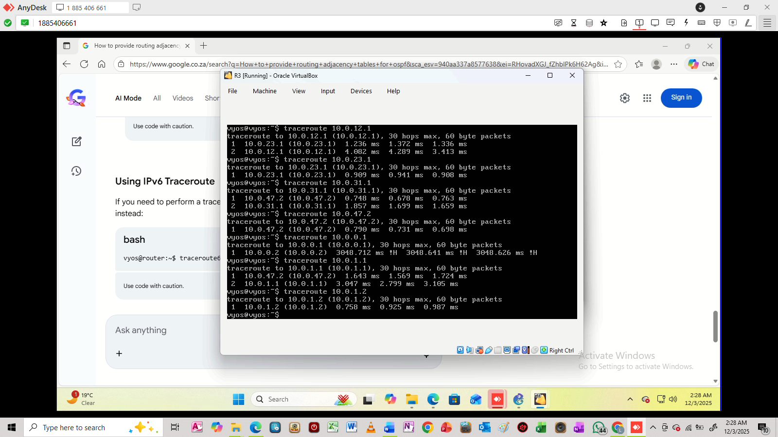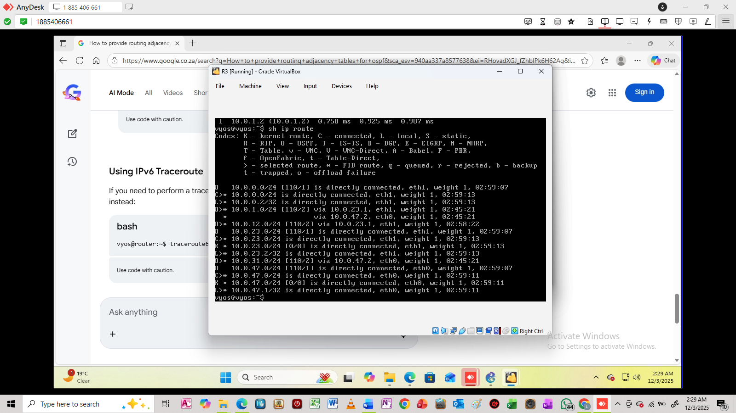
Results for pinging and traceroute for router 4 to router 1, 2, and 3
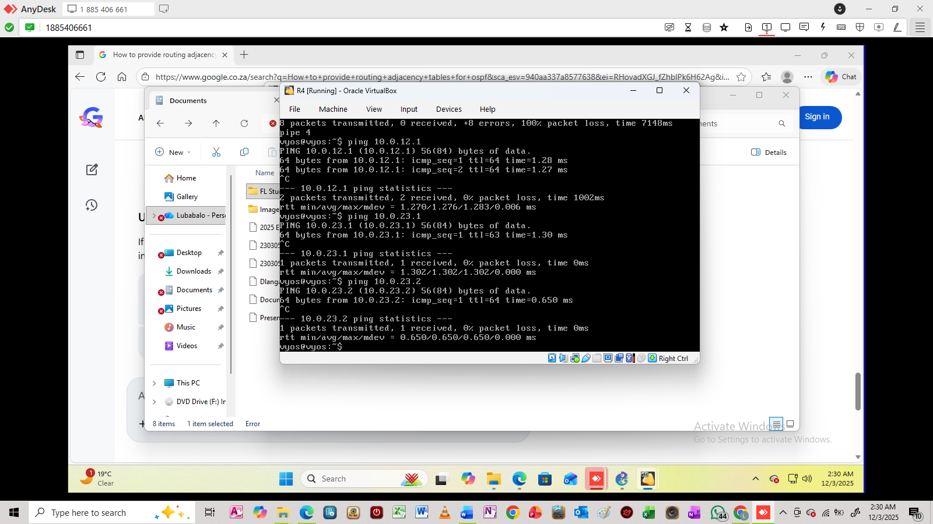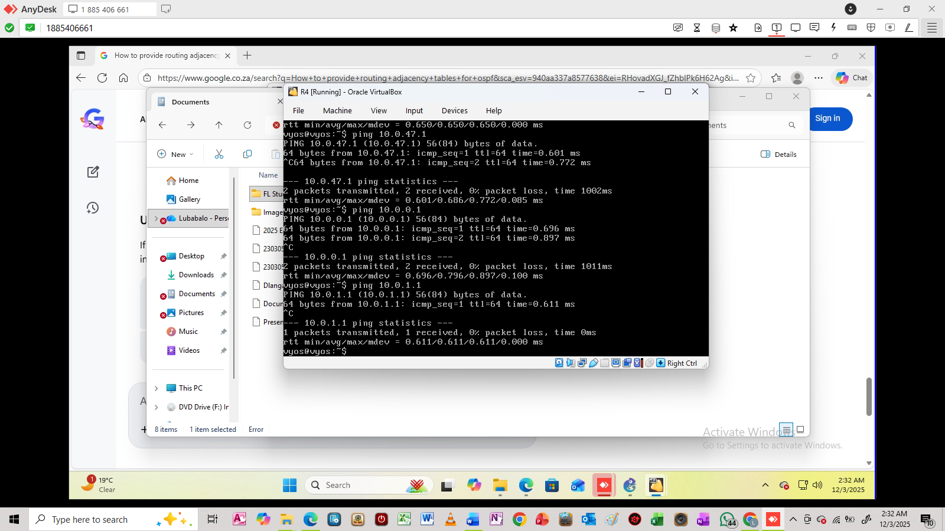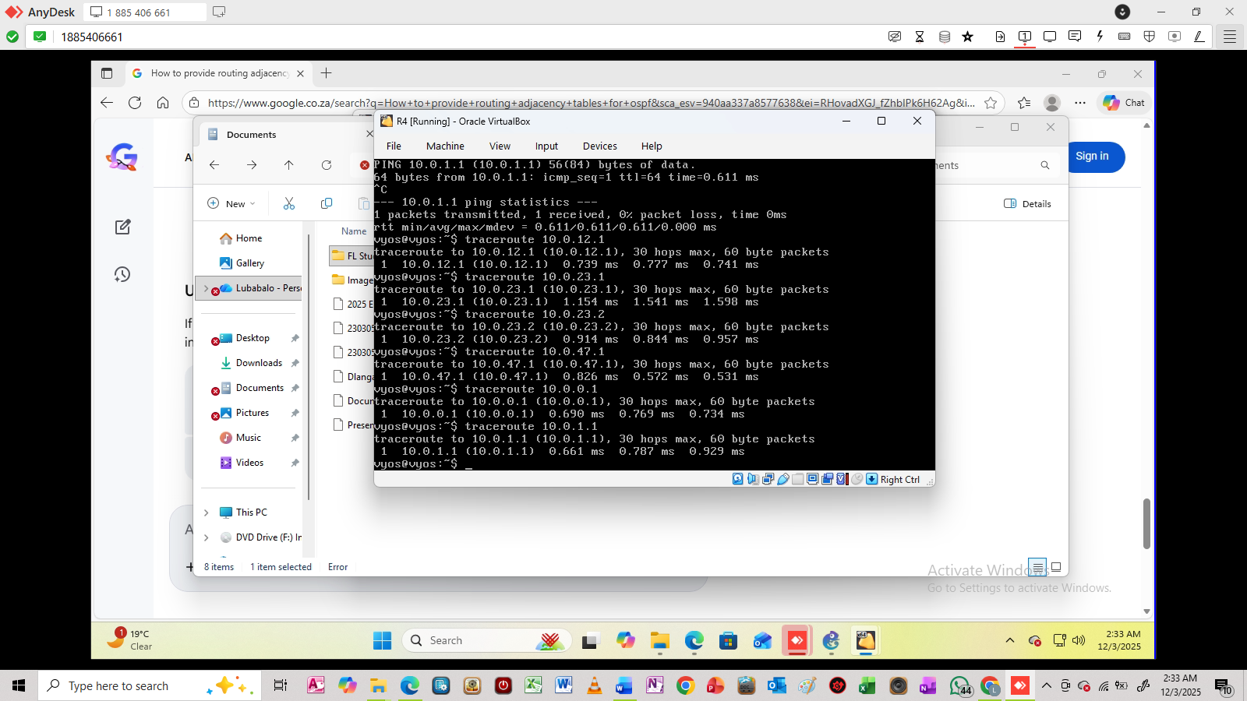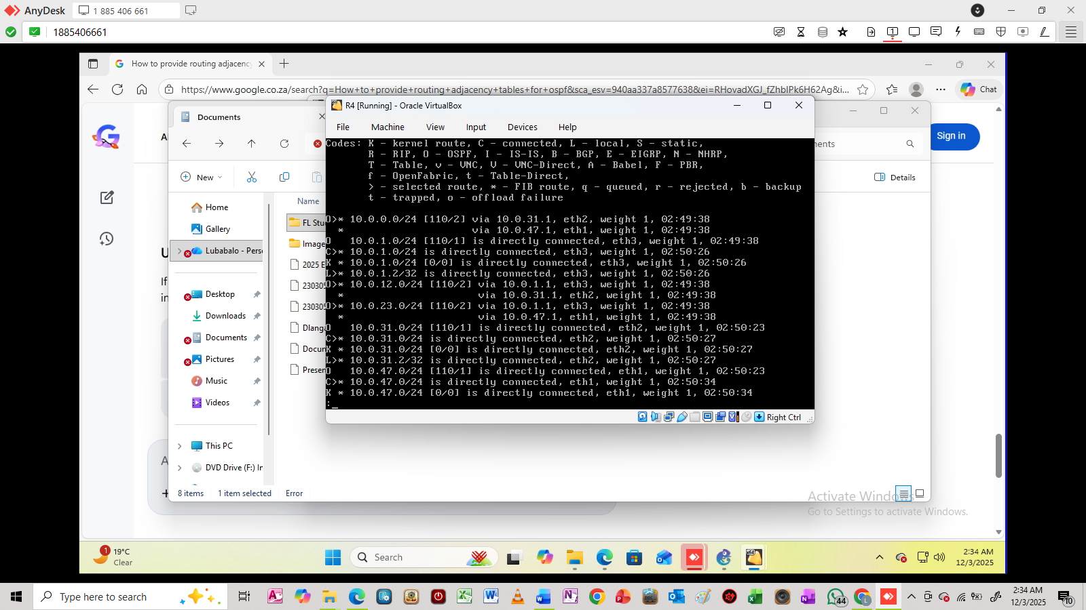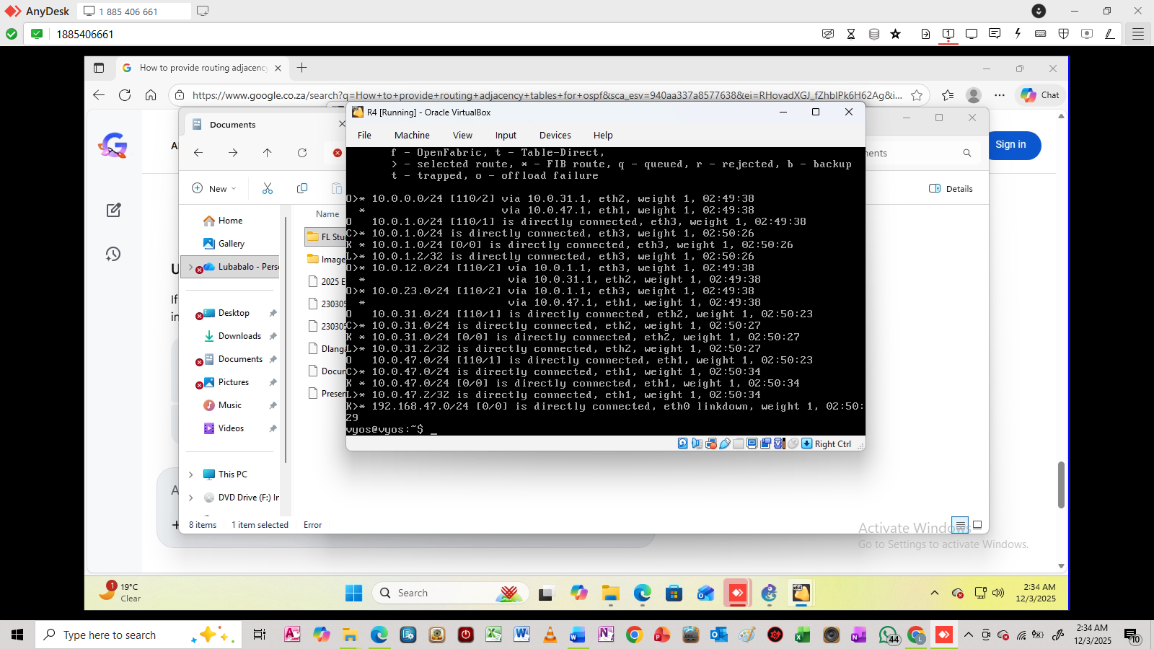

7. Conclusion
Summarise the problem, chosen strategy, analysis, implementation, and lessons learned.
<< Insert your content here >>

8. Bonus: MPLS LSP Path (optional)
Document MPLS configuration and provide LSP path screenshot from ODL GUI.
<< Insert your content here >>

Required Figures / Screenshots
FIG1: GNS3_TOPOLOGY – Insert screenshot of GNS3 topology
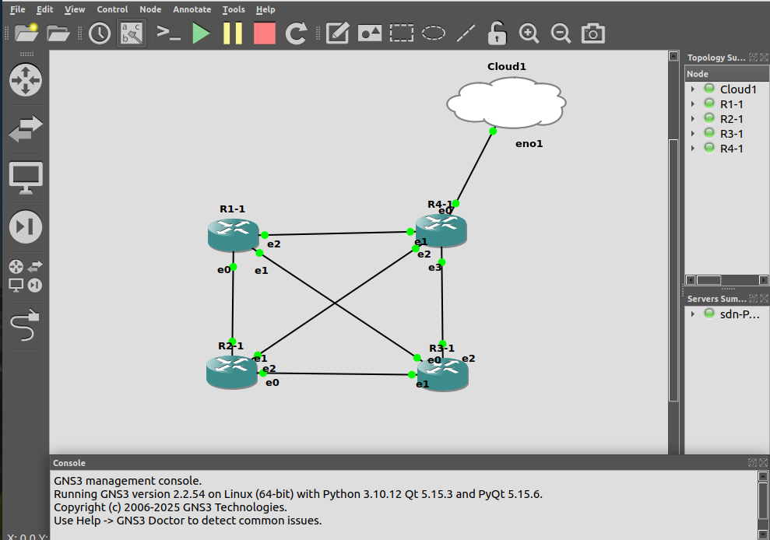

In FIG1 the 4 routers are connected together and router 4 is connected to the cloud whereby the cloud is the SDN controller which is Open Daylight. The 4 routers communicate together via OSPF protocol and there is also BGP session that is established on router 4 to communicate with the Open Daylight.
FIG2: POSTMAN_BGP – Insert screenshot of Postman showing BGP session
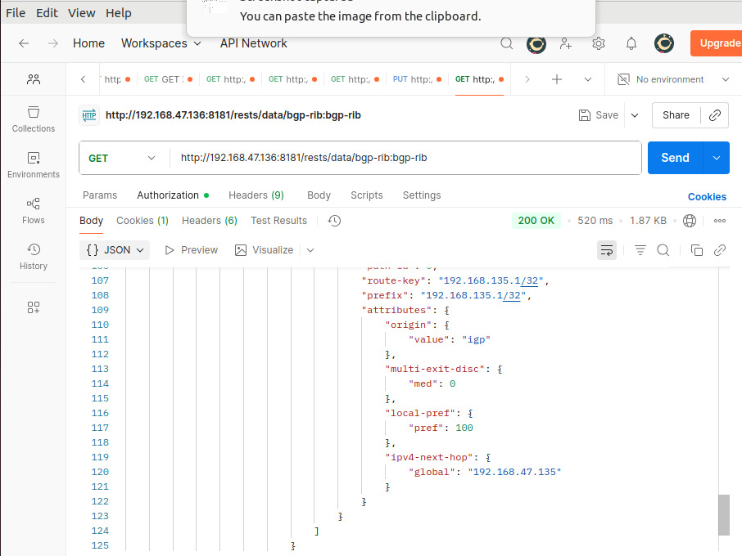

In FIG2 it shows the topology information that is presented in a JSON code, which is retrieved using BGP on the ODL. As long as BGP is up and running we can be able to retrive the topology but if BGP is not up and running then the ODL will not be able to retriev the topology. The tool used to display the information in JSON is the Postamn program which is the one ODL uses to display the results of the network information.
FIG3: PYTHON_APP_TOPOLOGY – Output of Python SDN application: topology
[Figure]
FIG4: PYTHON_APP_DRILLDOWN – Output of Python SDN application: router IP + interface info
[Figure]
[Figure]
FIG5: PYTHON_APP_EXTRA – Output of Python SDN application: extra detail (flows, stats, BGP neighbours, etc.)
[Figure]
[Figure]
FIG6: PING_RESULTS – Screenshot of ping tests
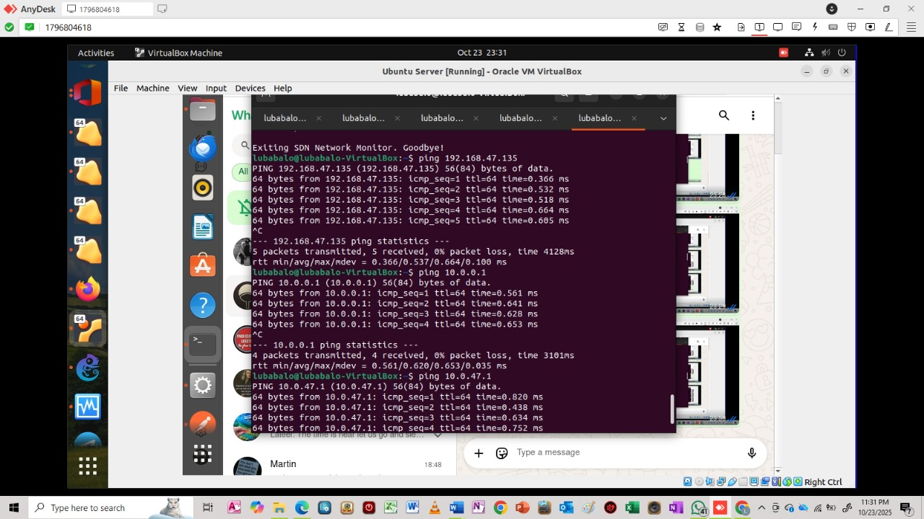
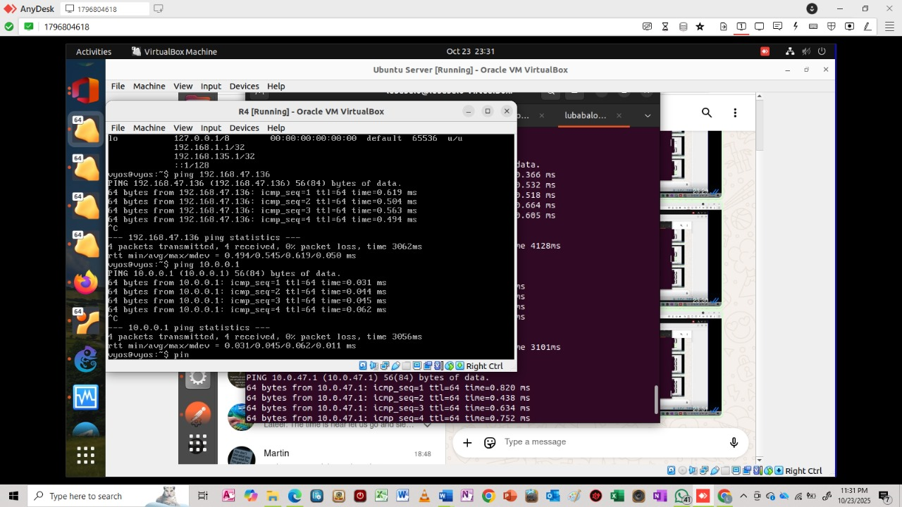

FIG6 shows the pinginging of routers meaning that routers are communicating to one another and also the SDN is also able to communicate to all routers. The packets sent are ICMP traffic and there are 0% packets that are dropped as packets gets sent from the SDN Ubuntu to all the routers on the network. If then routers are able to communicate with one another then it means that OSPF protocol was established and also the BGP is established between router 4 and the SDN Ubuntu.
FIG7: TRACEROUTE_RESULTS – Screenshot of traceroute results
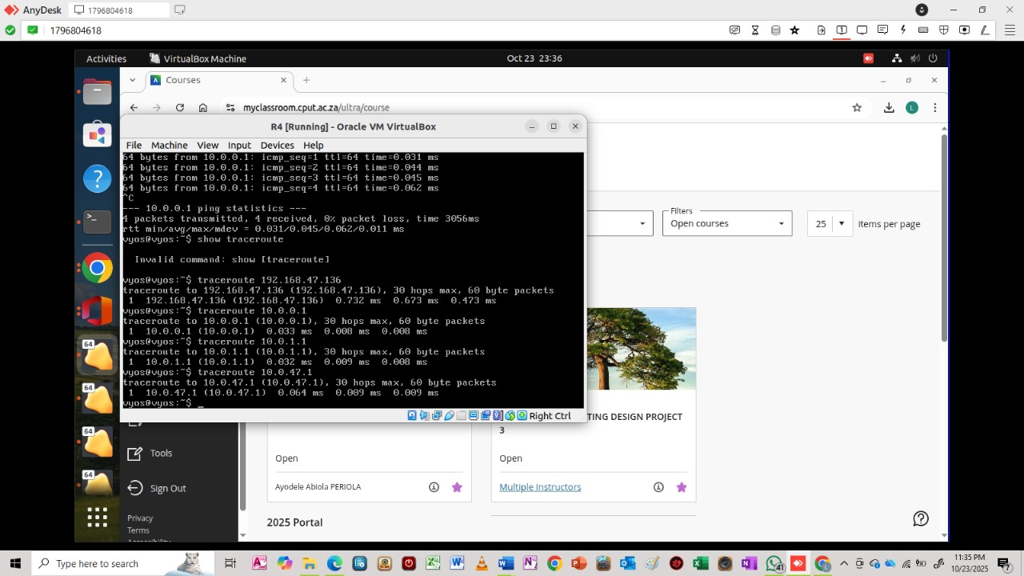
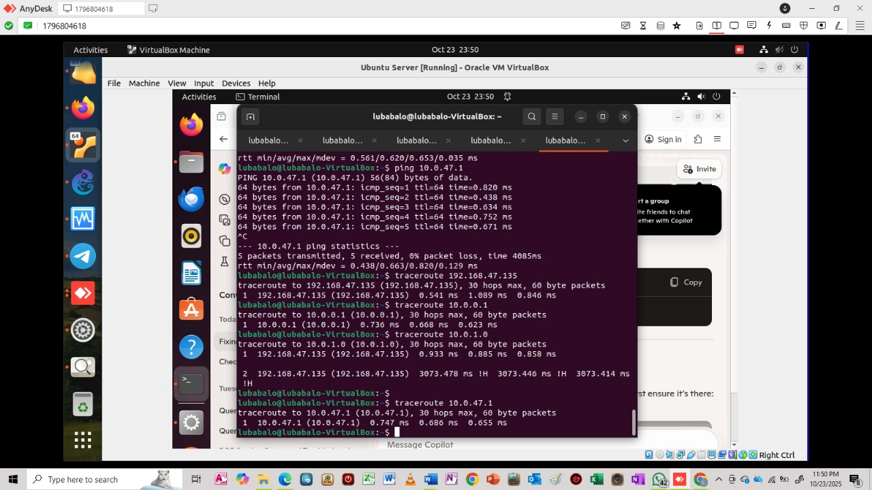
FIG8: MPLS_LSP – (Optional) Screenshot of MPLS LSP path in ODL GUI

NB: Sorry sir I could not put references I was still focusing on the Python applicatoin and I did the research a while ago

